Systematic Review Analysis Report (Flexible Criteria)
Report Date: 2026-08-26 06:58:53

1. Introduction
This report presents the analysis results for the systematic review on monitoring phenological stages and detecting agricultural operations using Sentinel-2 time series.
Flexible accuracy criteria were applied based on application type:
- - Operation, Phenology: RMSE ≤ 30 days, MAE ≤ 20 days, or Days Diff ≤ 15
- - Classification, Stress: Accuracy ≥ 80% or F1 ≥ 0.75
- - Indices: RMSE ≤ 0.10 or R² ≥ 0.70

2. RQ1: Applications, Methods and Indices
What applications, spectral indices and time-series processing methods are used?
Category | Top Items
Applications | Classification (264), Other (688), Phenology (153), Operation (301), Indices (164)
Indices | EVI (449), NDVI (335), SAVI (78), NDWI (47), MSAVI (4)
Methods | RF (812), Time-series (657), SVM (162), CNN (125), Thresholding (80)

3. RQ2: Accuracy Comparison
What is the accuracy of different methods and applications?

Accuracy by Method
Method | Count | Mean RMSE | Min RMSE | Max RMSE
RF | 59 | nan | nan | nan
Time-series | 57 | nan | nan | nan
SVM | 10 | nan | nan | nan
Thresholding | 6 | nan | nan | nan
CNN | 7 | nan | nan | nan

Accuracy by Application
Application | Count | Mean RMSE | Min RMSE | Max RMSE
Classification | 12 | nan | nan | nan
Operation | 24 | nan | nan | nan
Other | 31 | nan | nan | nan
Phenology | 17 | nan | nan | nan
Stress | 2 | nan | nan | nan
Indices | 3 | nan | nan | nan

4. RQ3: Methodological Gaps
What methodological gaps exist?
Gap Type | Count | Percentage
No Ground Truth | 1554 | 94.5%
No Accuracy Reported | 1555 | 94.6%
No Method Specified | 528 | 32.1%
No Indices Specified | 941 | 57.2%

5. Final Selected Articles
Selected 50 articles for systematic review (with Ground Truth, Accuracy, and Detection Method).
ID | Title | Year | Application | Method | RMSE | Metric
A029 | Comparison of Agricultural Crop Typ... | 2025.0 | Classificati | RF; SVM; Tim | NR | Has RMSE
A046 | Multi-spectral remote sensing for c... | 2023.0 | Classificati | RF; Time-ser | NR | Has RMSE
A069 | Fast Dynamic Time Warping and Hiera... | 2025.0 | Classificati | RF; CNN; Tim | NR | Has RMSE
A102 | Yield prediction by machine learnin... | 2020.0 | Classificati | RF | NR | Has RMSE
A127 | Mapping Species at an Individual-Tr... | 2020.0 | Classificati | RF; Time-ser | NR | Has RMSE
A160 | Early-Season Crop Mapping by PRISMA... | 2024.0 | Classificati | RF; CNN; Tim | NR | Has RMSE
A173 | An integrated approach of field, we... | 2021.0 | Classificati | RF | NR | Has RMSE
A187 | Delineation of Orchard, Vineyard, a... | 2023.0 | Classificati | RF; Time-ser | NR | Has RMSE
A235 | DEEP LEARNING BASED MULTI TASK ROAD... | 2023.0 | Classificati | CNN; Time-se | NR | Has RMSE
A305 | RESULTS OF AUTOMATIC COTTON CROPS M... | 2023.0 | Classificati | Time-series | NR | Has RMSE

6. Visual Analysis
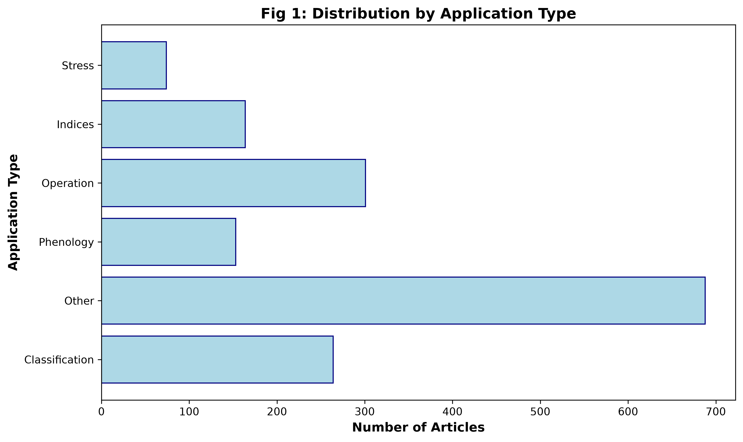

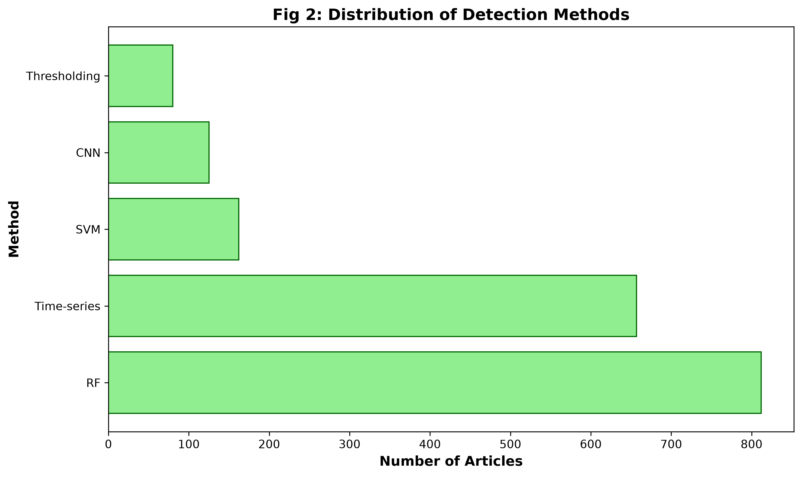

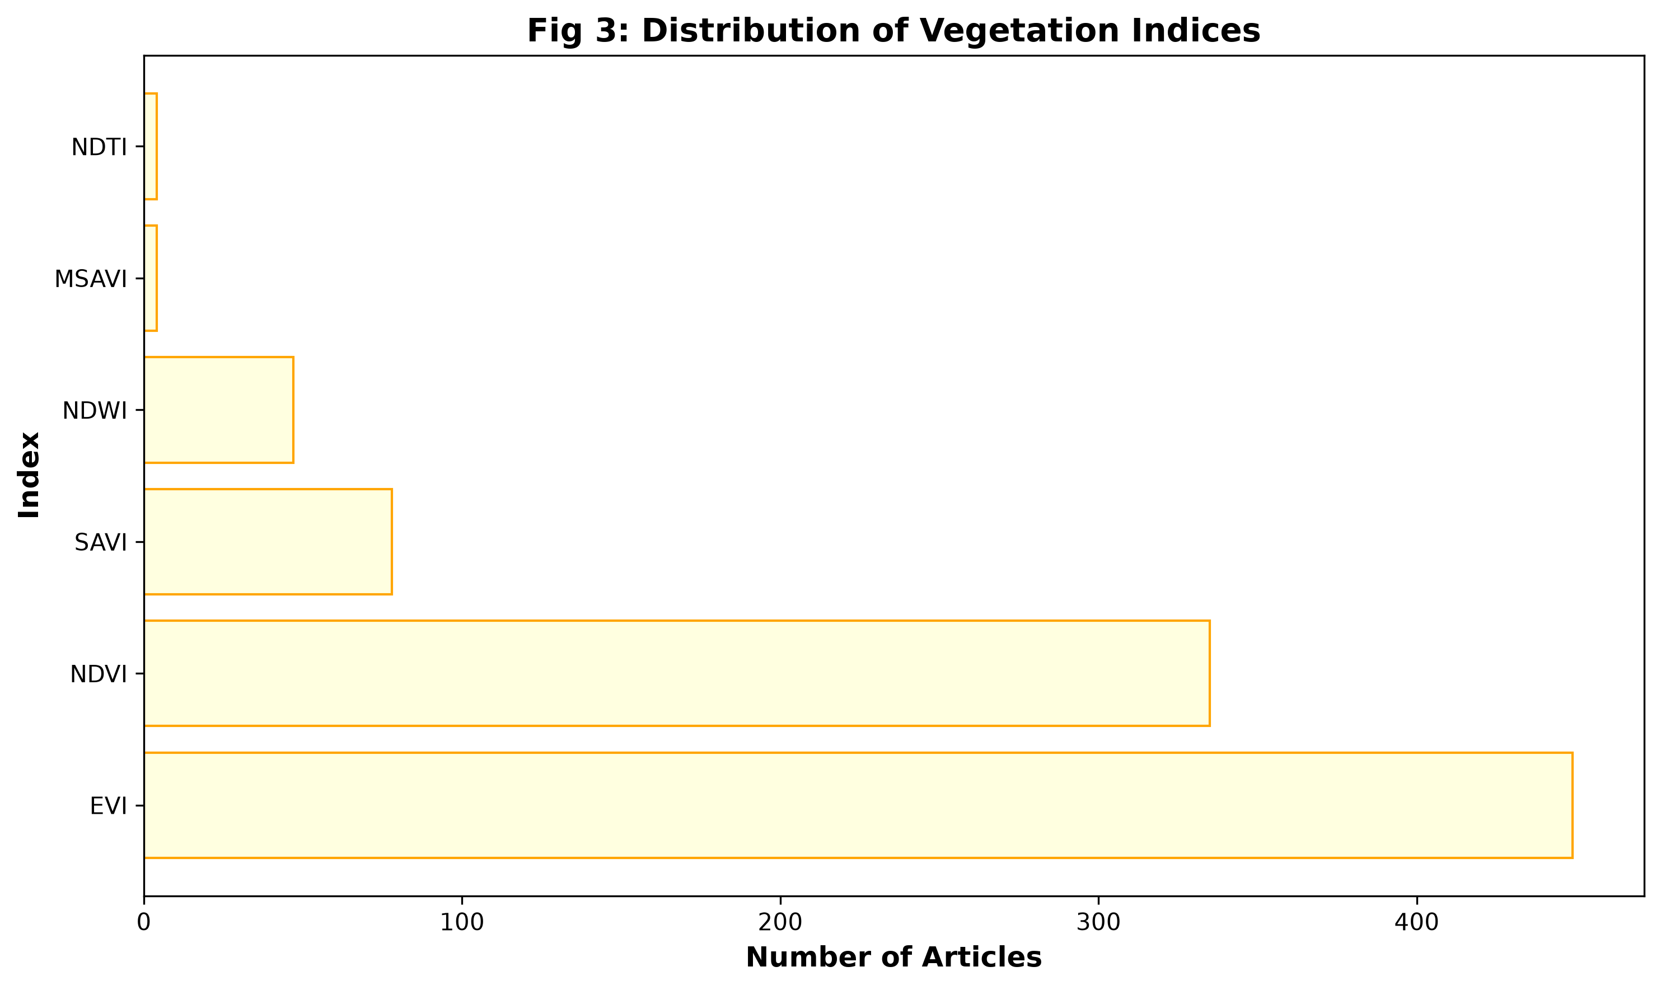

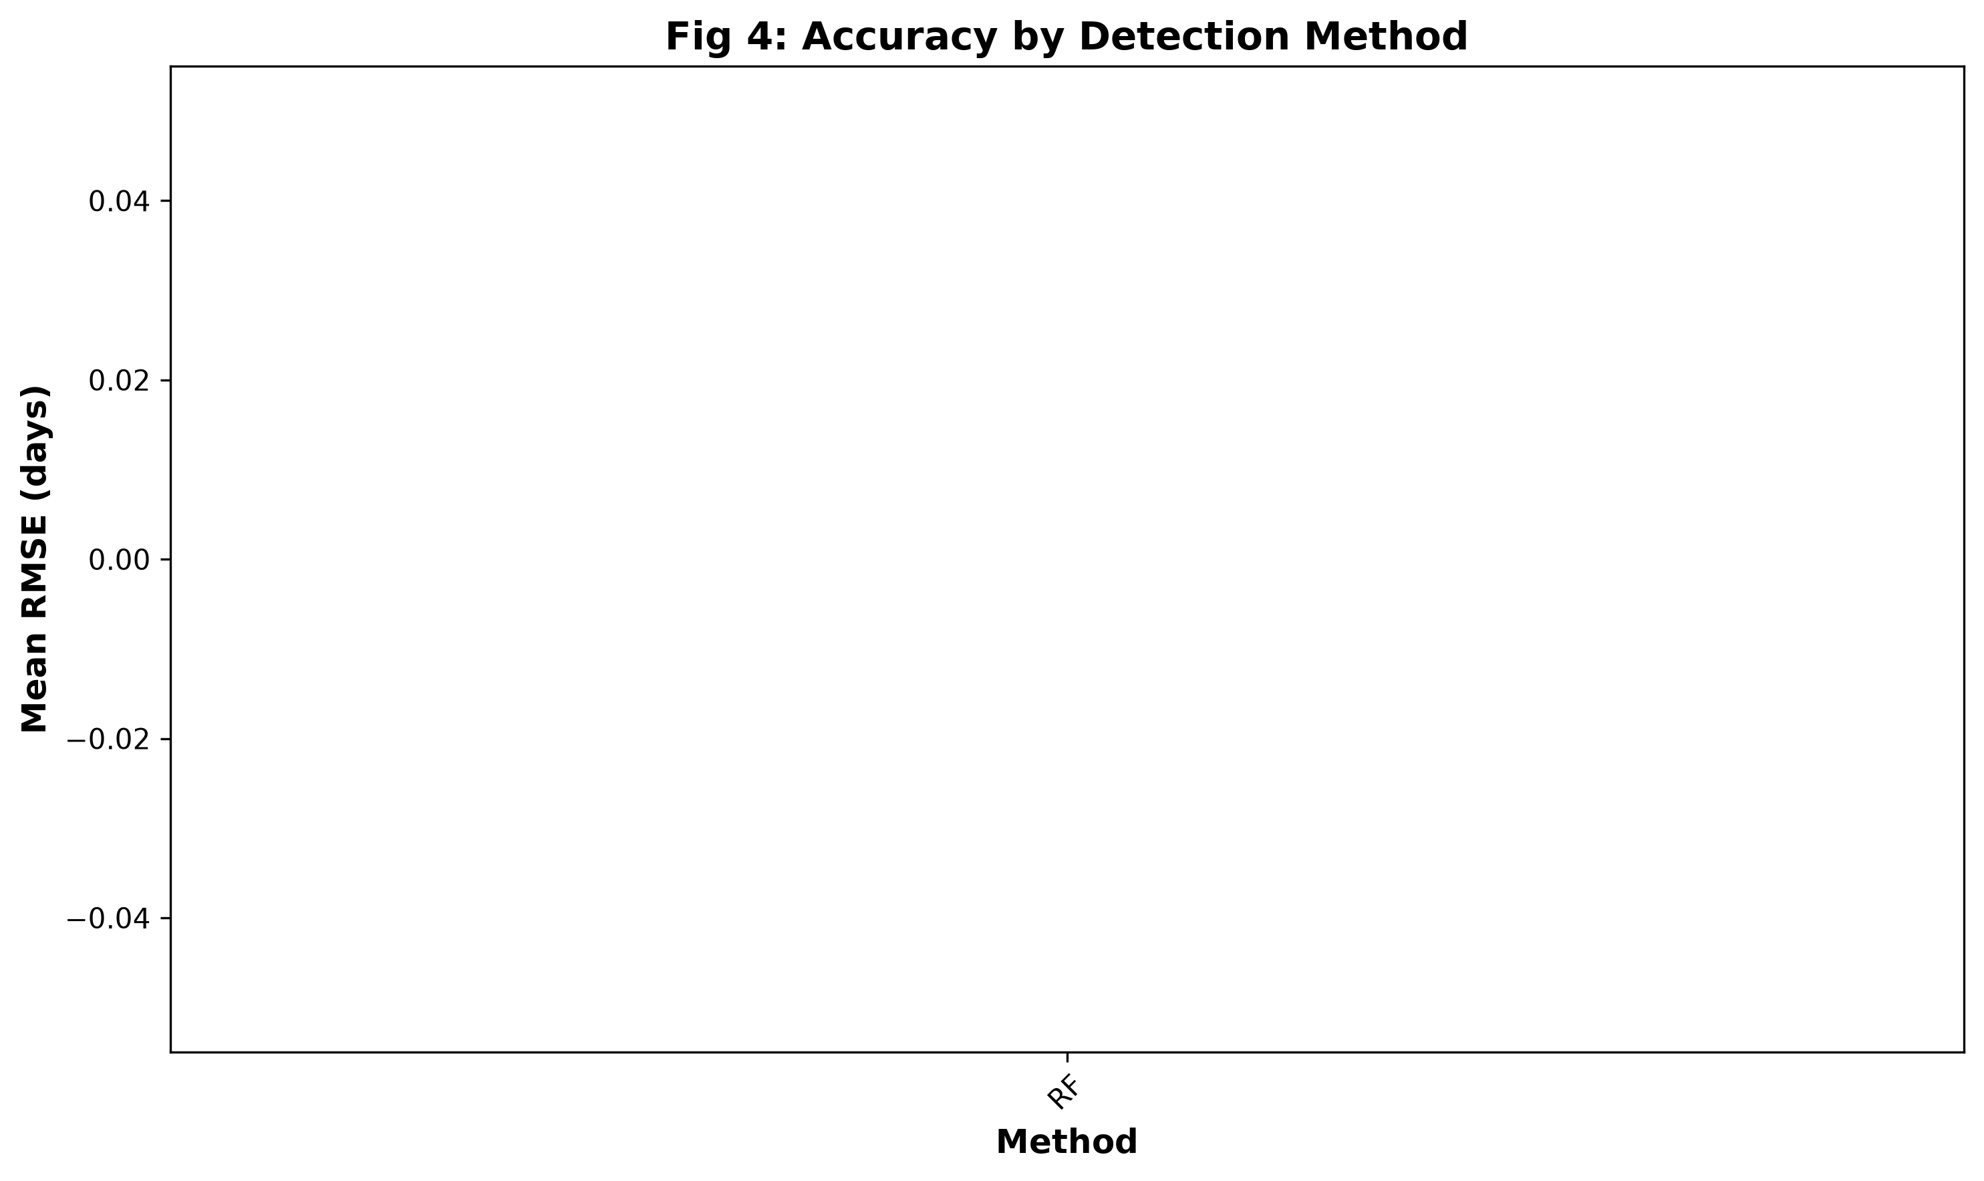

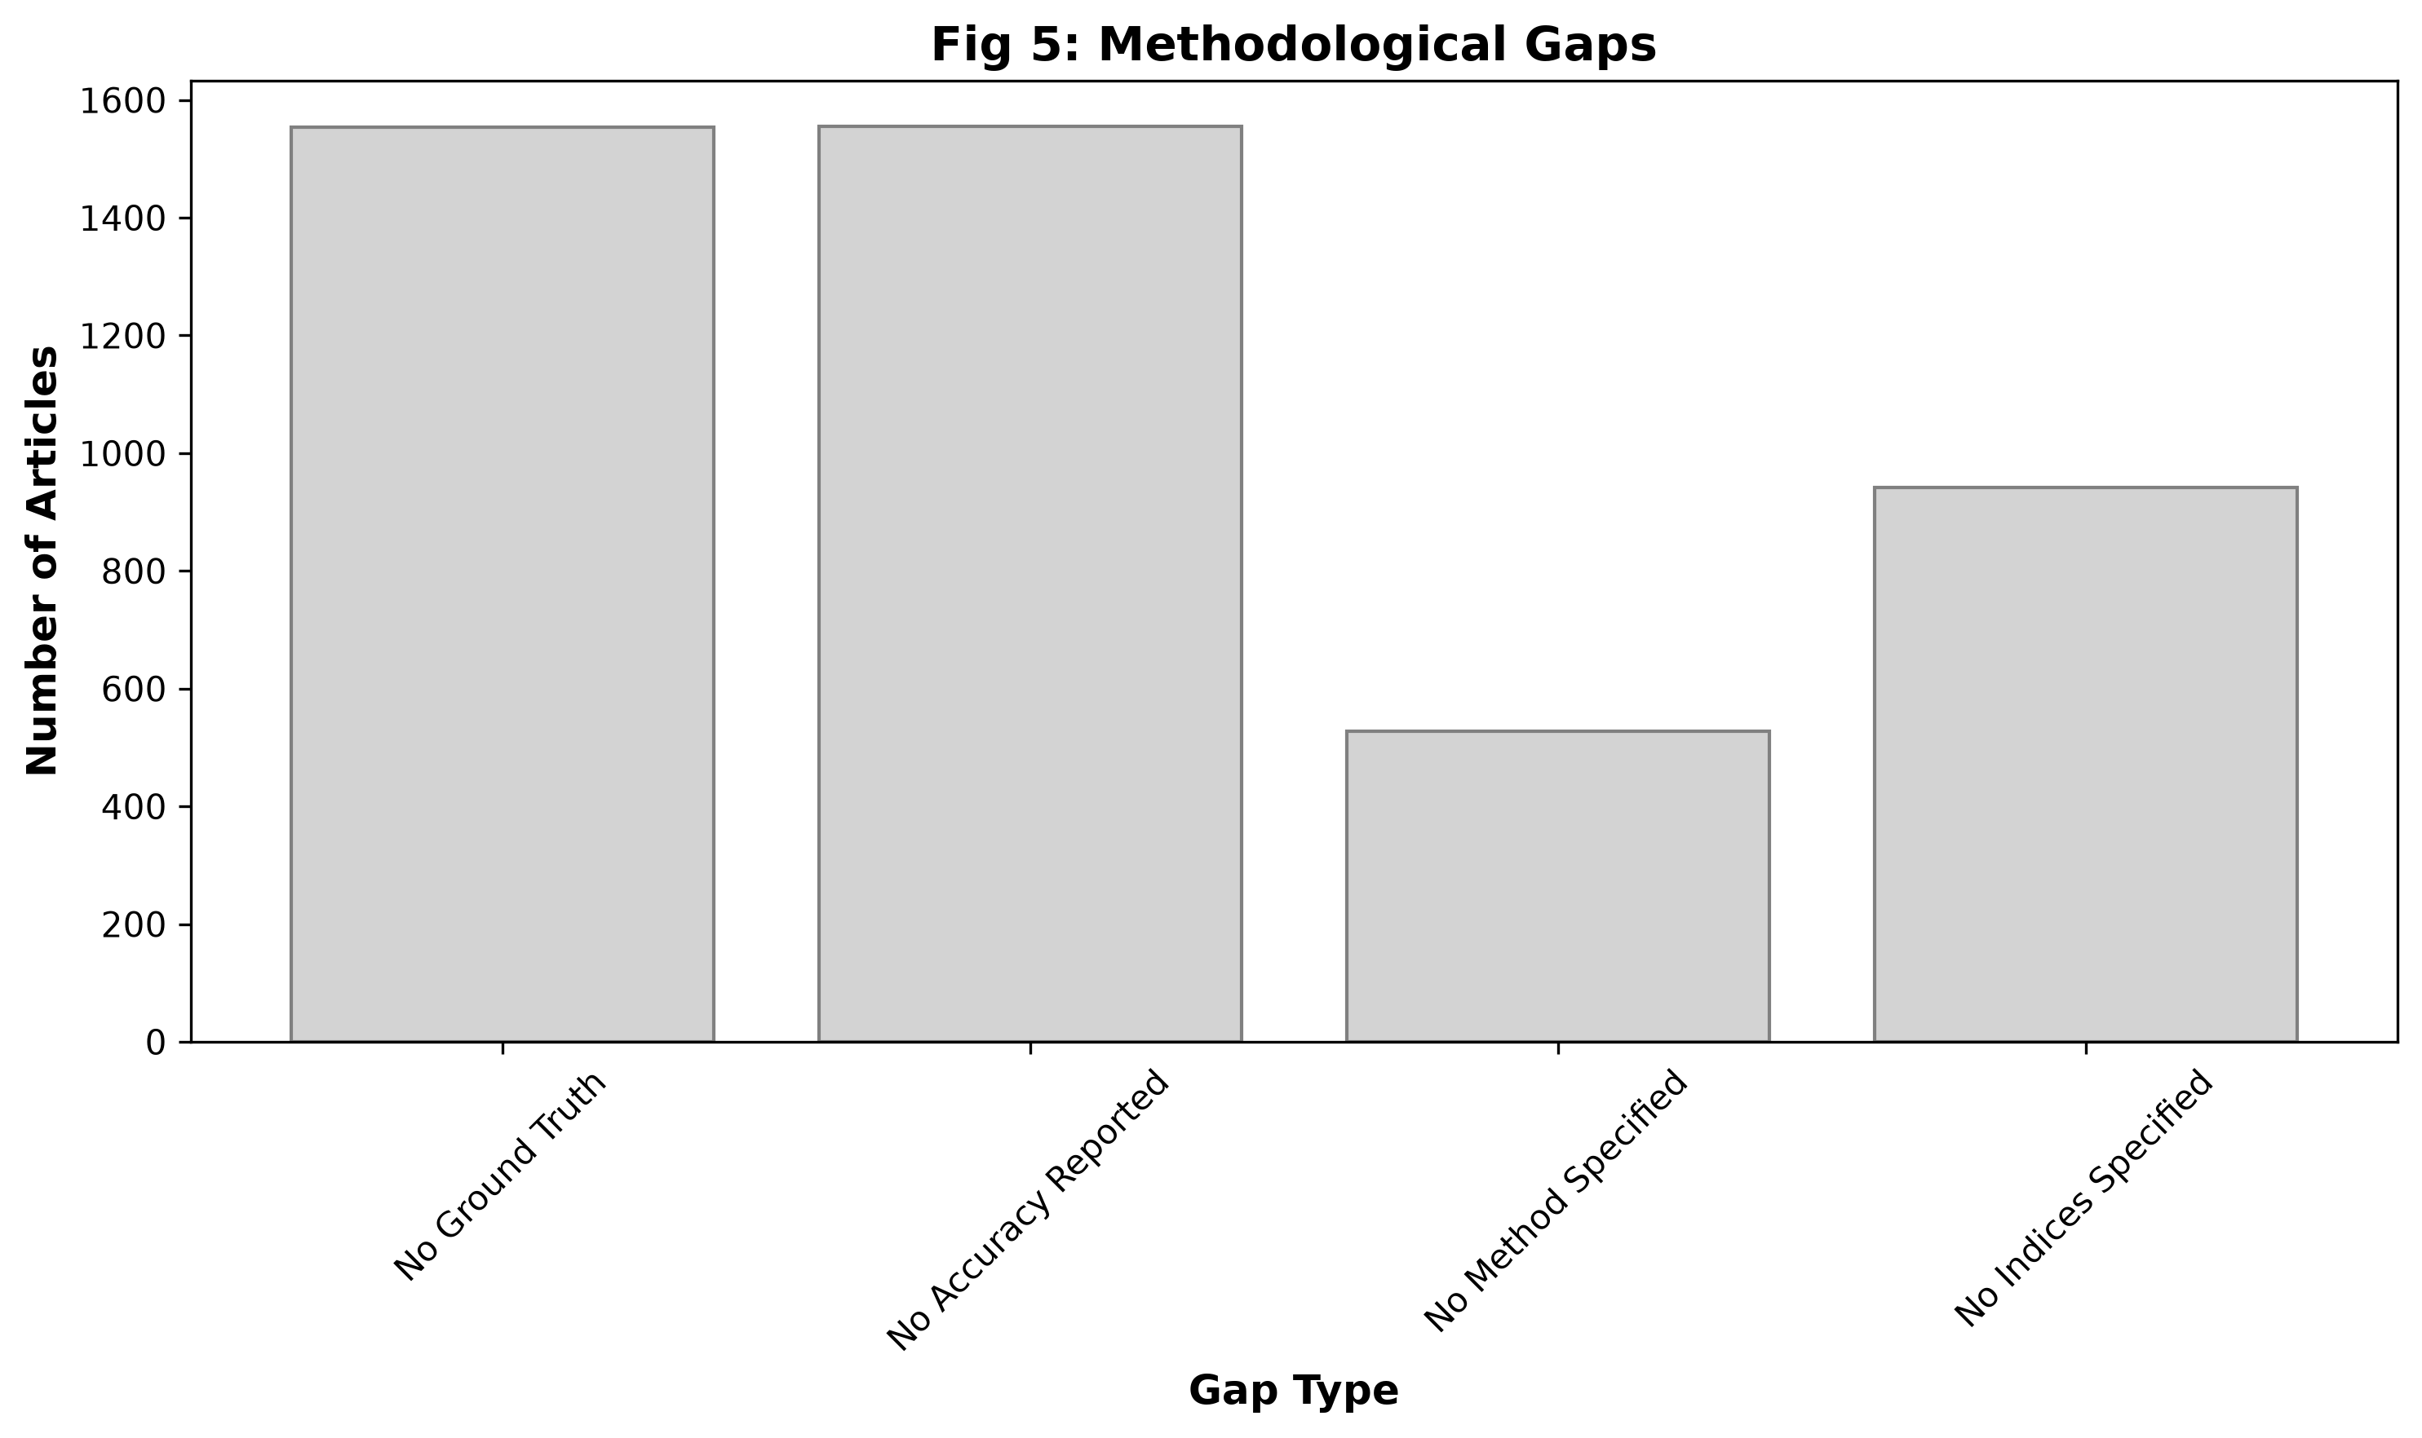

7. Conclusion
Key findings:
- Total articles analyzed: 1644
- Articles with ground truth: 90
- Articles with accuracy reported: 89
- Articles with method specified: 1116
- Articles with indices specified: 703
- Selected for systematic review: 50
- Best performing method: RF (RMSE: nan days)

