PRISMA Screening Report
Report Date: 2026-08-26 06:21:42
Total Records Processed: 1644

1. Executive Summary
Stage | Records | Percentage
Total Records | 1644 | 100.0%
Stage 1 (Title/Abstract) | 237 | 14.4%
Stage 2 (Full Text) | 56 | 3.4%
Final Selection | 46 | 2.8%

2. PRISMA Flow Diagram
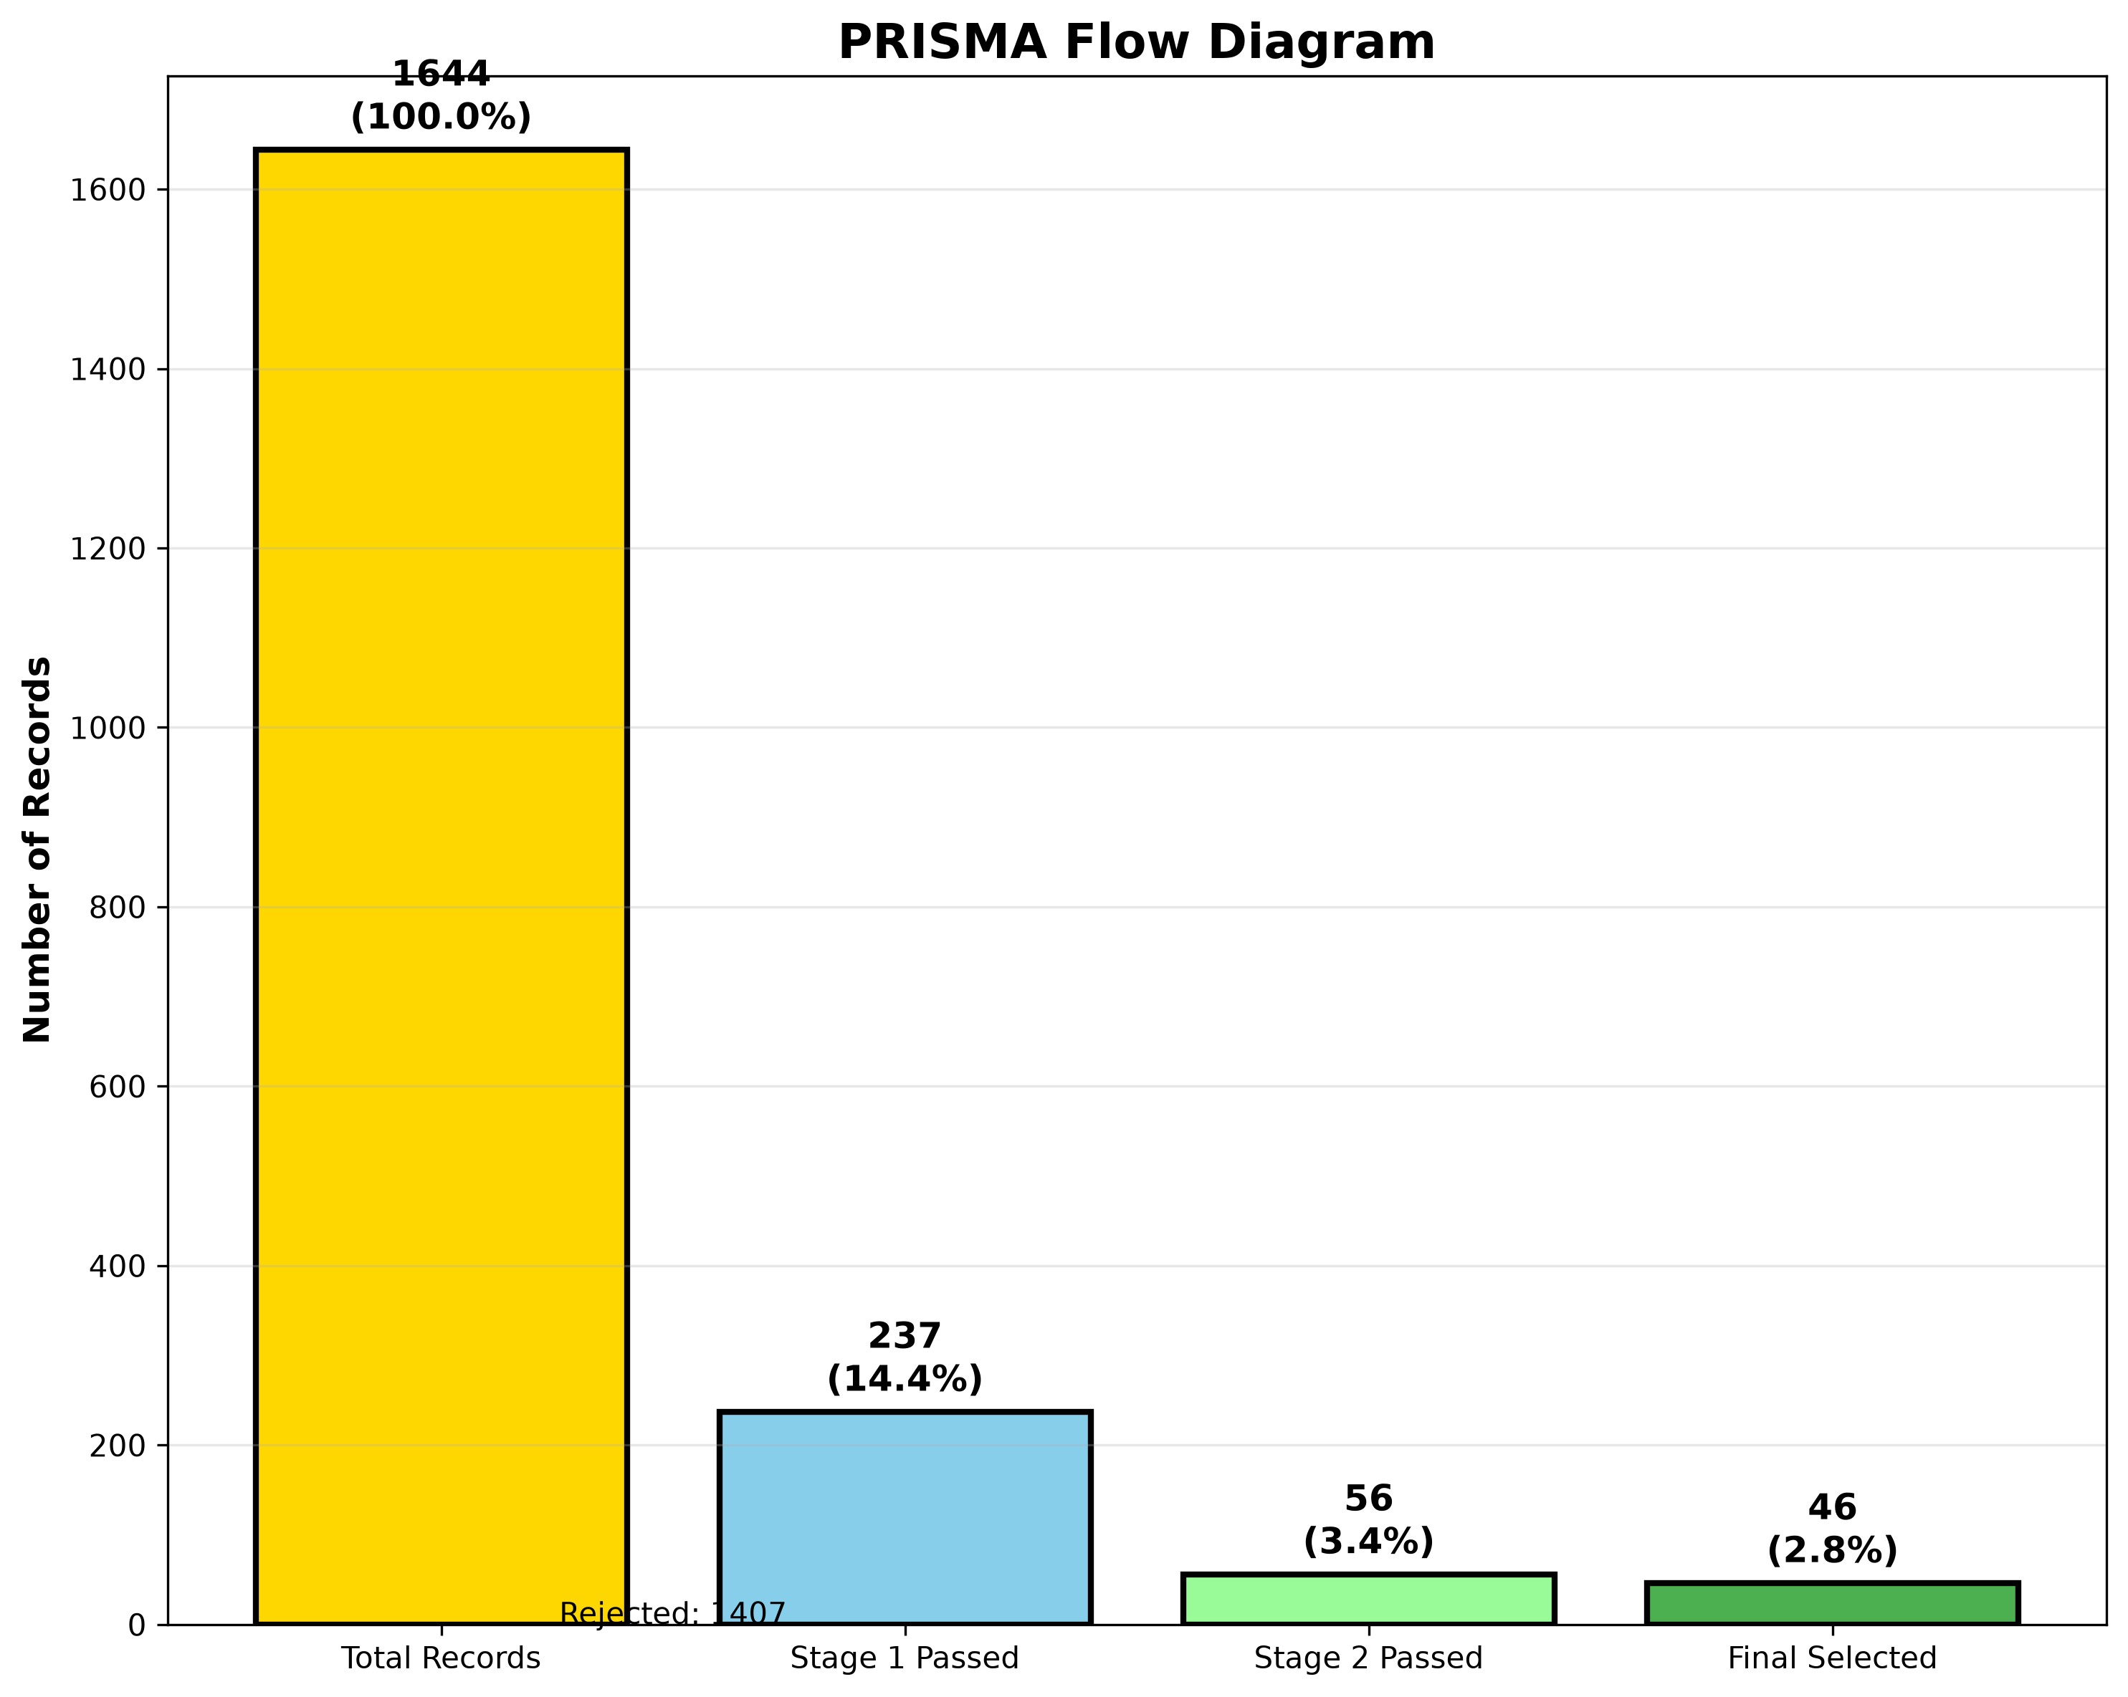

3. Stage 1 Screening: Title and Abstract
This stage checks for Sentinel-2, agricultural operations, and time-series analysis.
Reason | Count
No Sentinel-2; No agricultural operation; No time-series | 383
No Sentinel-2; No time-series | 365
No Sentinel-2 | 231
No time-series | 143
No Sentinel-2; No agricultural operation | 105
No agricultural operation; No time-series | 96
No agricultural operation | 84

4. Stage 2 Screening: Full Text (Abstract + Metadata)
This stage checks for ground truth data, detection methods, and accuracy reporting.
Reason | Count
No ground truth | 89
No ground truth; No detection method | 24
No detection method | 20
No ground truth; No detection method; No accuracy reported | 15
No ground truth; No accuracy reported | 13
No detection method; No accuracy reported | 6
No accuracy reported | 5
No ground truth; No detection method; No accuracy reported; No study area | 5
No ground truth; No detection method; No study area | 1
No detection method; No study area | 1
No ground truth; No study area | 1
No ground truth; No accuracy reported; No study area | 1

5. Quality Assessment (Scoring)
Articles were scored based on 5 criteria: Sentinel-2, Ground Truth, Method, Citations, and Relevance.
Maximum score: 10 points. Minimum required score for inclusion: 6 points.
Statistic | Value
Average Score | 5.46
Min Score | 2.50
Max Score | 8.00
Median Score | 5.50

6. Final Decision Distribution
Decision | Count
Reject | 1598
Keep (High Relevance) | 24
Keep (Sentinel-2 + GT + Method) | 22

7. Selected Articles Summary
Total selected: 46 articles
ID | Title | Year | Score | Citations
A001 | Real-Time Crop Stress Monitoring and Early Warning System fo... | 2026 | 8.0 | 0
A002 | Yield Estimation of Paddy and Maize Crops in Mahabubabad Dis... | 2025 | 8.0 | 0
A003 | A Comparative Assessment of Regular and Spatial Cross-Valida... | 2025 | 7.5 | 0
A004 | Phenology-Based Maize and Soybean Yield Potential Prediction... | 2025 | 7.5 | 0
A005 | A Method to Estimate Surface Soil Moisture and Map the Irrig... | 2021 | 7.5 | 0
A006 | Fast Dynamic Time Warping and Hierarchical Clustering with M... | 2025 | 7.0 | 0
A007 | WHEAT AREA MAPPING AND PHENOLOGY DETECTION USING SYNTHETIC A... | 2019 | 7.0 | 0
A008 | Delineation of Orchard, Vineyard, and Olive Trees Based on S... | 2023 | 7.0 | 0
A009 | Field-level sugarcane yield estimation utilizing Sentinel-2 ... | 2025 | 7.0 | 0
A010 | DEEP LEARNING BASED MULTI TASK ROAD EXTRACTOR MODEL FOR PARC... | 2023 | 6.5 | 0

8. Screening Methodology
The screening process followed PRISMA 2020 guidelines:
- 1. Stage 1 (Identification): Articles were screened based on title and abstract for Sentinel-2, agricultural operations, and time-series analysis.
- 2. Stage 2 (Screening): Articles passing Stage 1 were screened for ground truth data, detection methods, and accuracy reporting.
- 3. Quality Assessment: Articles were scored on 5 criteria (Sentinel-2, Ground Truth, Method, Citations, Relevance) with a maximum of 10 points.
- 4. Final Selection: Articles with score ≥ 6 were selected, with exceptions for high-citation and high-relevance articles.

