Biometric Systems
Detection of Neovascularization on the Disk

Martin Krajňák
xkrajn02

Introduction
The goal of this work is detection of neovascularization from fundus images. Neovascularization is a serious disease and one of the forms of diabetic retinopathy where new blood vessels grow due to extensive lack of oxygen. Severity of the disease is severe as it can lead to total blindness. This work is focused on implementation of several image processing techniques which should in the end be able to detect neovascularization on the disk from retinal image. Process is divided to several steps which are explained in following chapters.

Disk Detection
Since this work is focusing only on the detection of neovascularization on the disk we have to filter other areas of the retina. First approach tried to detect the disk by finding the lightest pixel in the image and automatically select area around the pixels as disk. Testing has proven that this approach has been causing problems as it takes only one brighter area and the algorithm detects the wrong area. Another approach with detecting the largest circle in the image were also not successful as the vessels in the foreground are interfering with the perimeter of the circle. Therefore, this approaches were abandoned and replaced by process displayed on Figure 1 and includes following steps:
- conversion grayscale, dimming the image, so the lightest areas are easier to detect
- conversion to black/white
- detecting edges, converting them to areas
- largest area is the area of the disk, calculate the minimal circle aroud the area
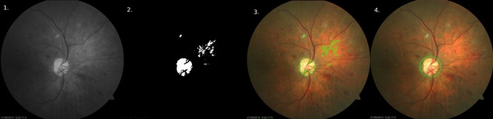Figure 1: Steps to detect disk

Vessel Segmentation
Blood vessels segmentation algorithm is based on algorithm which uses histogram equalisation of the green channel of the image. After channel extraction, several filters are applied which enhance the contours of the vessel in the image which is converted to black and white only. The results contains several smaller areas which are not connected to to any vessels coming from the disk, so they are filtered out. This process is described on Figure 2.
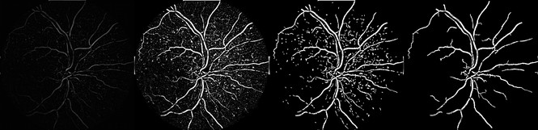Figure 2: Bloodvessels extraction, starting from left to right

Selecting the Region of Interest (ROI) and NVD Detection
Region of interest is in this case represented by the disk area and its nearest surroundings. Filtering the ROI is done by combinating results of disk detection and vessel segmentation, thus the mask of the disk area is created and applied to extracted vessels. The result can be seen on Figure 3. There is no way to properly distiguish which vessels are caused by neovascularization since they looks the same as healthy ones. Assuming that vessels in healthy images are covering less than 22% (value obtained statistically on healthy images from database), every image which has portion of vessels above this threshold contain neovascularization on the disk.
Figure 3: Final result - filtered blood vessels in the disk, file 187.jpg

Testing
This project was developed and tested on fundus images provided Diabetic Retinopathy Database from University of Auckland as these images are marked with diagnosed diseases to ensure proper classification of neovascularization. Program was developed in python3 and built on top of image processing libraries Opencv and numpy.
Usage: $python3 neodetect.py <folder_with_images> [--debug]
- folder with images is compulsory argument, images should be in full color
- --debug is optional parameter which shows debug informations during processing

Output is file results.xml with result for every image, errors are also written to this file, more informations abour setup and libraries can be found in README.md file.

From 10 tested images marked with cofirmed neovascularization on the disk:
- 2 images are skipped as no vessels were detected in the area of the disk
- 7 were marked healthy
- only 1 was marked with neovascularization.

From 23 ramdomly picked healthy images from database:
- 2 were skipped because reported disk radius was too large (Figure 5)
- 1 was skipped as no vessels were detected in the disk area (Figure 6)
- 2 false positives with vessel ratio just above 22% (Figure 4)
- remaining were marked healthy
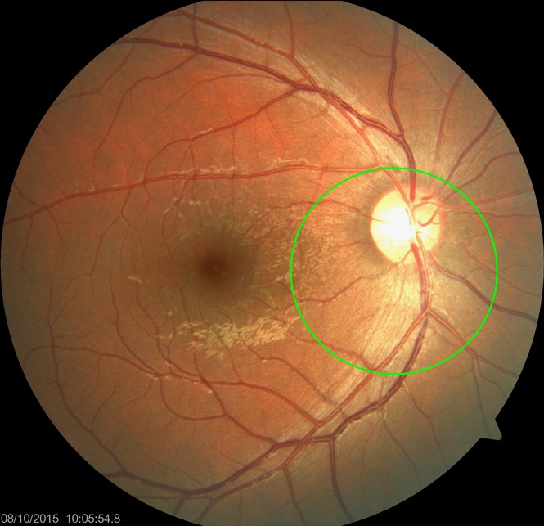Figure 5: Reported disk radius too large, file 158.jpg
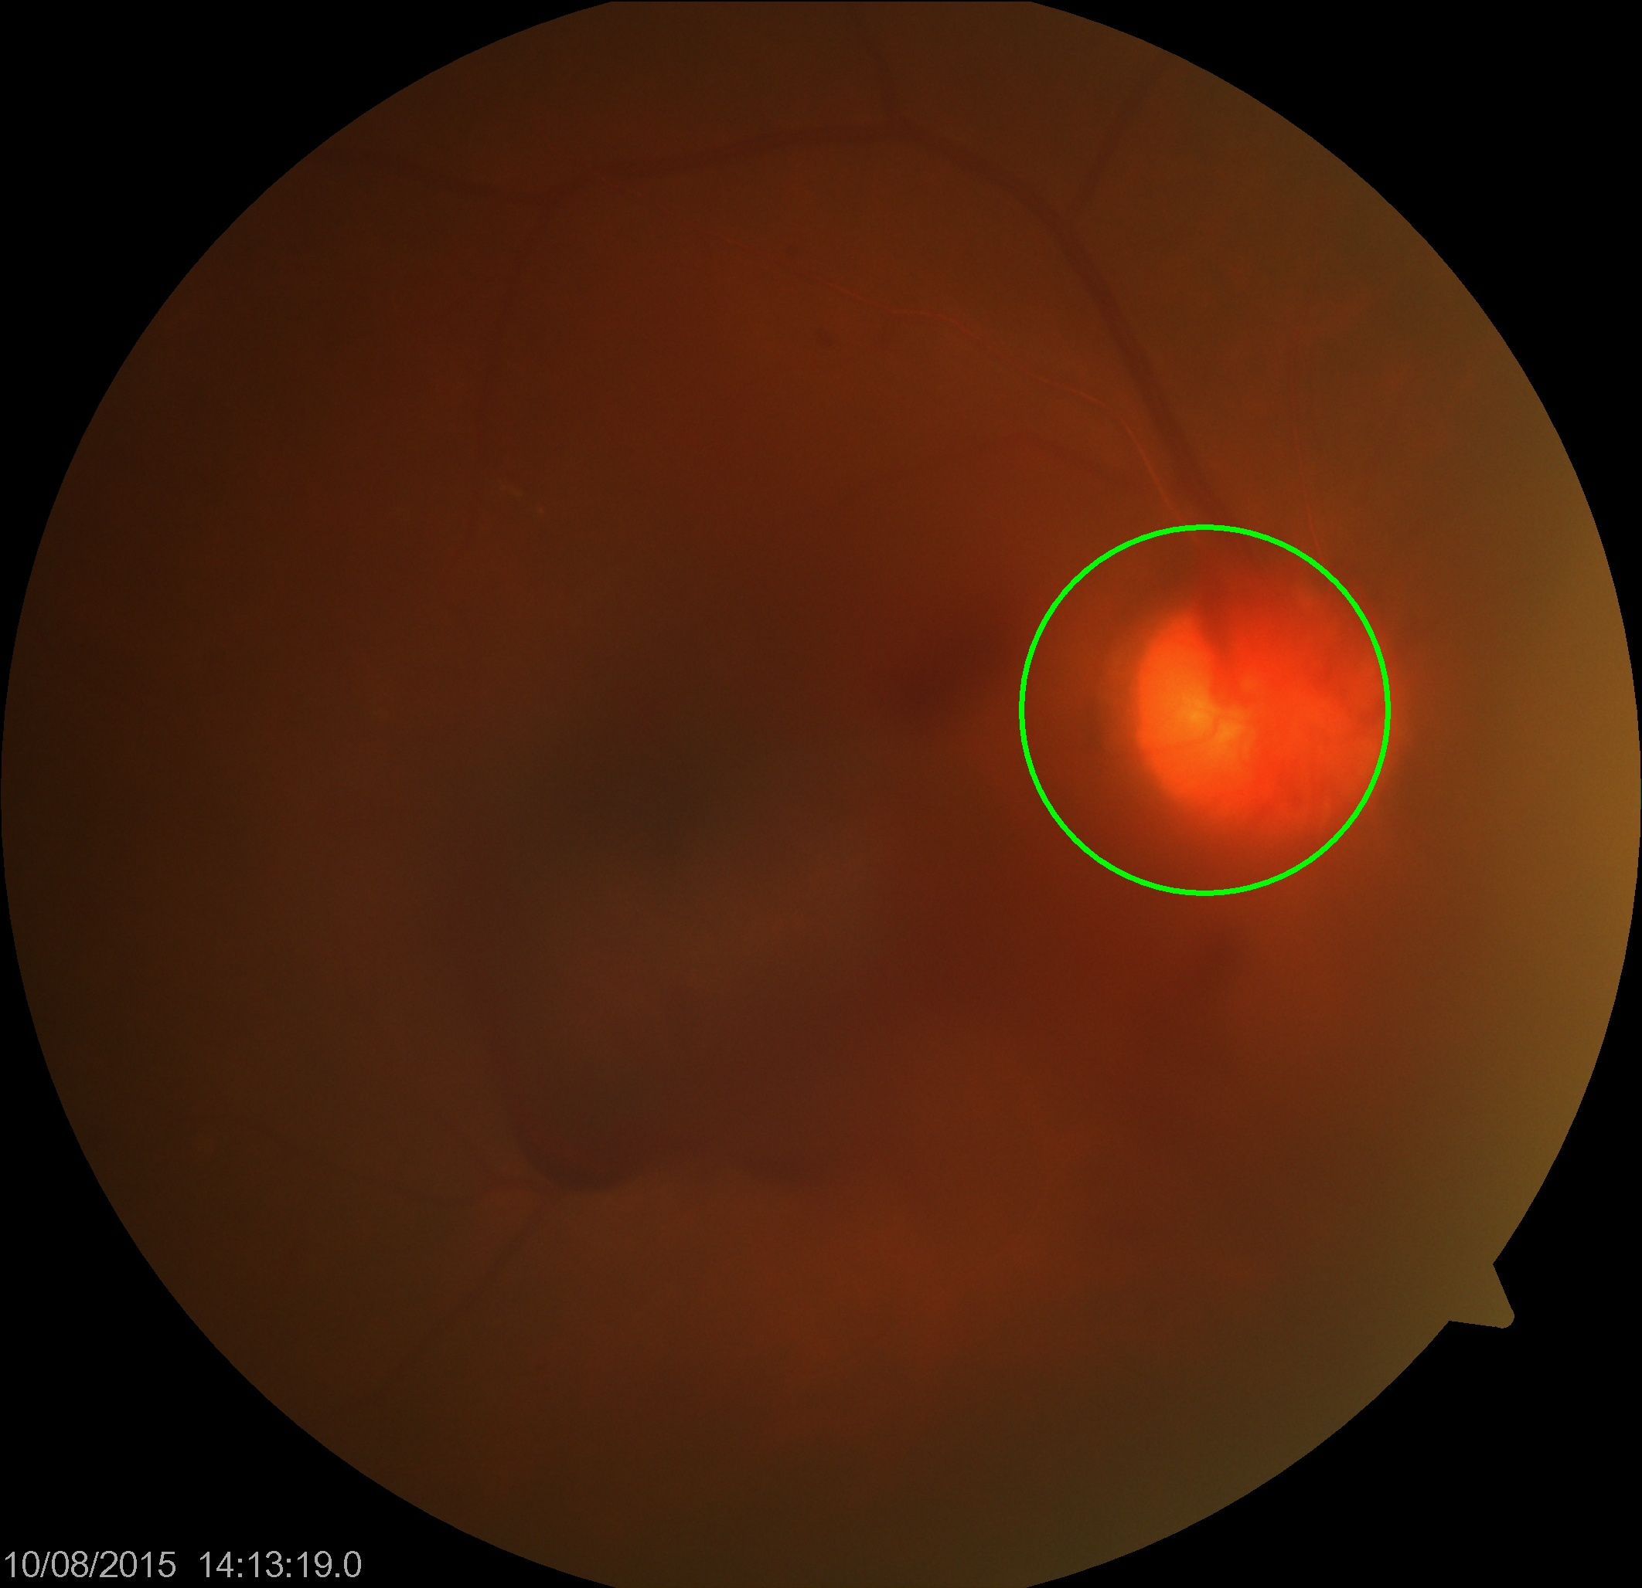Figure 6: No vessels extracted from image, file 195.jpg
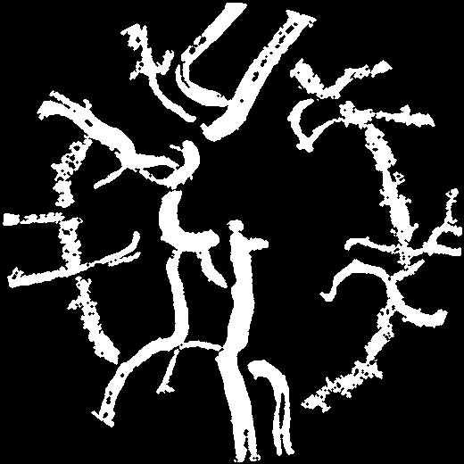Figure 4: False positive case, original file 161.jpg

Conclusion
Diabetic Retinopathy Database from University of Auckland contains 200 folders with 200 retinal images. Each image in the database also has 3 additional images where it has manually segmented vessels, location of optic disk and location of optic disk center. Proposed tool is trying to automate those manual tasks in 3 steps.
The first step is detection of the disk, where approaches like detection of the lightest area and detection of the largest circle failed to deliver reliable result. The approach developed afterwards shows more consistent results but as shown during the testing phase, it fails with very light images.
The second step detects the vessels and testing has shown several problems, the main one is that there is no proper way to distinguish between healthy vessels and neovascularization. Also small vessels which are significant when it comes to diagnosing neovascularization might be lost during processing or in extreme cases the image is so blurred out that no vessels are detected in the disk area.
Third steps is the way neovascularization is detected, vessel ration in the disk. Testing has shown that detected disk area varies too much from image to image which causes trouble to this method of detection.
Considering the results of testing, the proposed tool is not reliable. Both disk detection and vessel extraction must be improved to make results more consistent. The tool tries to at least filter some of the results where radius of the detected disk is suspiciously large or disc area is missing extracted vessels. So to conclude, an amount of errors that has been shown in both healthy images and image with confirmed neovascularization is an evindence that all images must be examined by medical experts before any treatment.

https://www.researchgate.net/publication/51627418_Detection_of_Neovascularization_in_Diabetic_Retinopathy
https://github.com/getsanjeev/retina-features

