**Prerequisites**

1. Html
2. CSS
3. Java Script

**References**

<https://www.w3schools.com/jquery/>

https://www.javatpoint.com/jquery-tutorial

**What & why is jQuery?**

1. It is a Java script Library and open source.
2. Client side code with easy. Allows us to write complex client side interaction code in less time.
3. Write less do more.
4. Support all most all browsers (cross-platform).

**Why?**

1. Modifying HTML/DOM on the fly
2. CSS manipulation
3. Managing event in simple manner.
4. Providing powerful extensible animations engine
5. Easiest support for Ajax.
6. Simple Syntax

**Difference between Java Script & jQuery example**

**Java Script**

<button type="button" onclick="loadDoc()">Change Content</button>

<div id="demo"><h2>Let JavaScript AJAX Change This Text</h2></div>

<script>

function loadDoc() {

var xhttp;

if (window.XMLHttpRequest) {

// code for modern browsers

xhttp = new XMLHttpRequest();

} else {

// code for IE6, IE5

xhttp = new ActiveXObject("Microsoft.XMLHTTP");

}

xhttp.onreadystatechange = function() {

if (this.readyState == 4 && this.status == 200) {

document.getElementById("demo").innerHTML = this.responseText;

}

};

xhttp.open("GET", "ajax_info.txt", true);

xhttp.send();

}

</script>

</body>

</html>

**jQuery**

<html>

<head>

<script src="https://ajax.googleapis.com/ajax/libs/jquery/3.5.1/jquery.min.js"></script>

<script>

$(function(){

$("button").click(function(){

$("#demo").load("http://localhost:9999/Empproject/getEmp.jsp");

});

});

</script>

</head>

<body>

<button>Get Employees</button>

<div id="demo"><h2>Let jQuery AJAX Change This Text</h2></div>

</body>

</html>

**Setting up jQuery**

<https://jquery.com/download/>

<head>  
 <script src="jquery-3.5.1.min.js"></script>  
</head>

**Google CDN:**

<head>  
 <script src="https://ajax.googleapis.com/ajax/libs/jquery/3.5.1/jquery.min.js">

</script>  
</head>

**Micro soft CDN:**

<head>  
 <script src=" https://ajax.aspnetcdn.com/ajax/jQuery/jquery-3.4.1.min.js">

</script>  
</head>

**jQuery Syntax**

Basic syntax is:  **$(*selector*).*action*()**

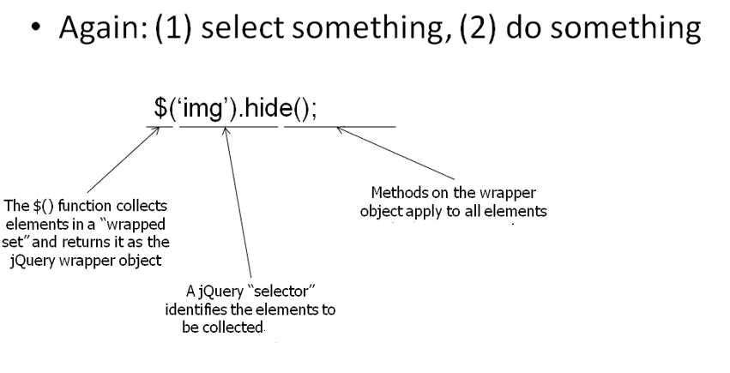

* A $ sign to define/access **jQuery**
* A (*selector*) to "query (or find)" HTML elements
* A jQuery *action*() to be performed on the element(s)

1. We can have multiple selectors.
2. We can call multiple methods on selectors.

**Example:**

$(this).hide () - hides the current element.

$("img").hide () - hides all <img> elements.

$(".class").hide () - hides all elements with class="class".

$("#id").hide () - hides the element with id="id".

**Example:**

<script type=”text/javascript” language="javascript">  
 $(document).ready(function(){  
    *// Client side logic*  
 });

</script>

OR

<script type=”text/javascript” language="javascript">

$(function(){  
   *// Client side logic*  
 });

</script>

**Selectors**

1. **Basic selectors**
   1. $(this).hide () - hides the current element.
   2. $("img").hide () - hides all <img> elements.
   3. $(".class").hide () - hides all elements with class="class".
   4. $("#id").hide () - hides the element with id="id".
2. **Attribute selectors**

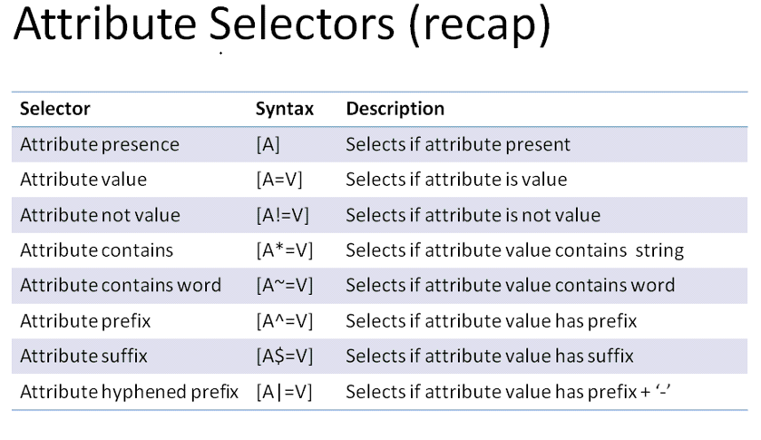

1. **Relation Selectors filters**

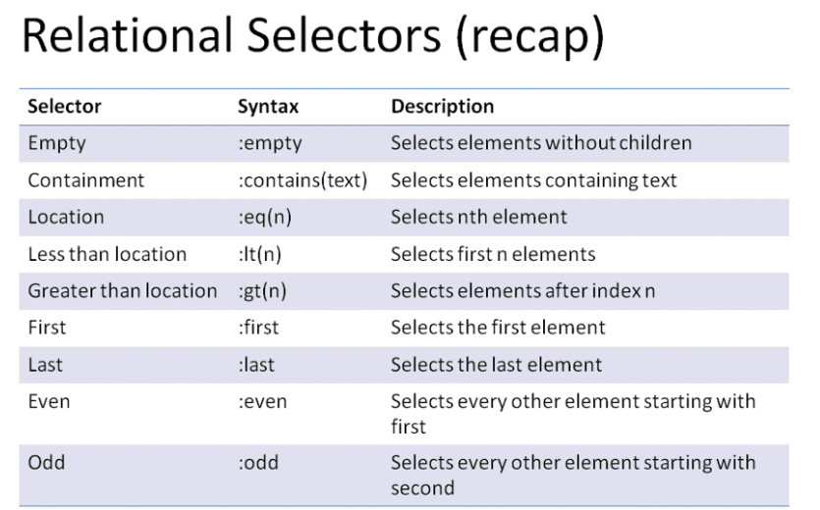

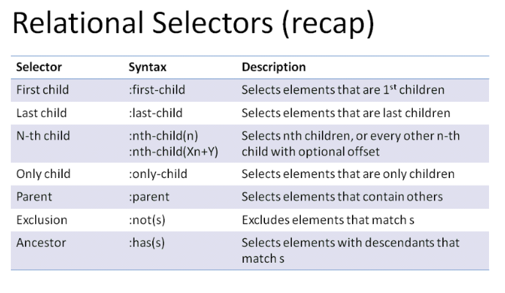

1. **Category Selectors**

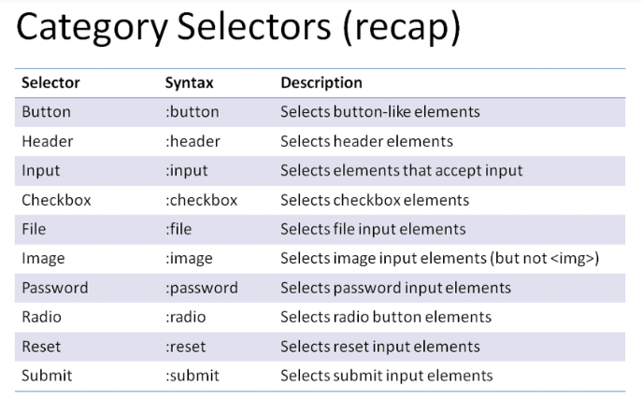

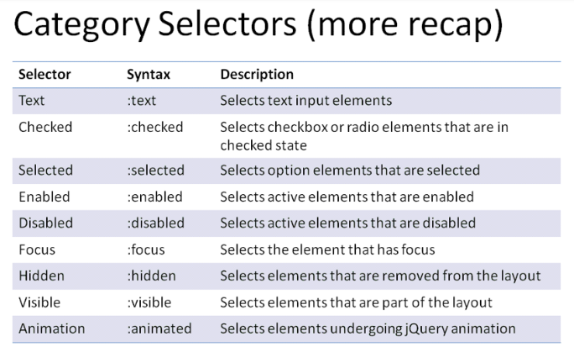

**Combination of selectors:**

: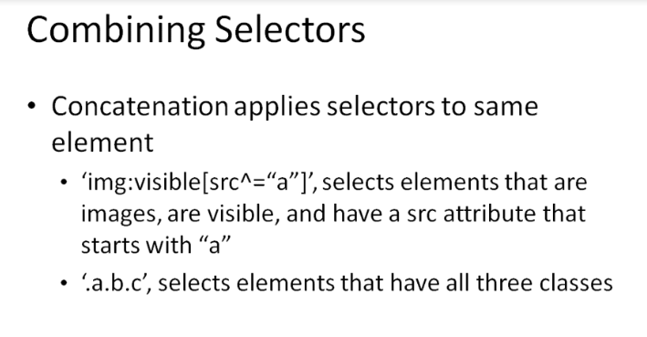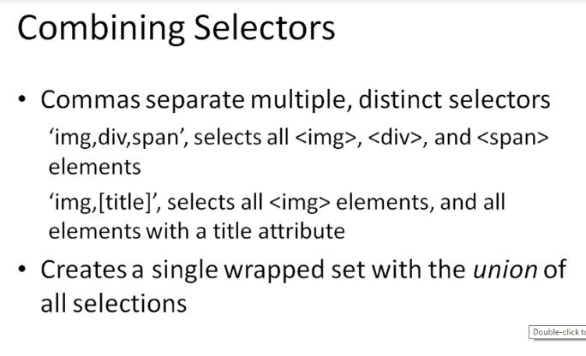

**Making Pages Dynamic**

**.html() – overloaded , can get & set the values into html elements**

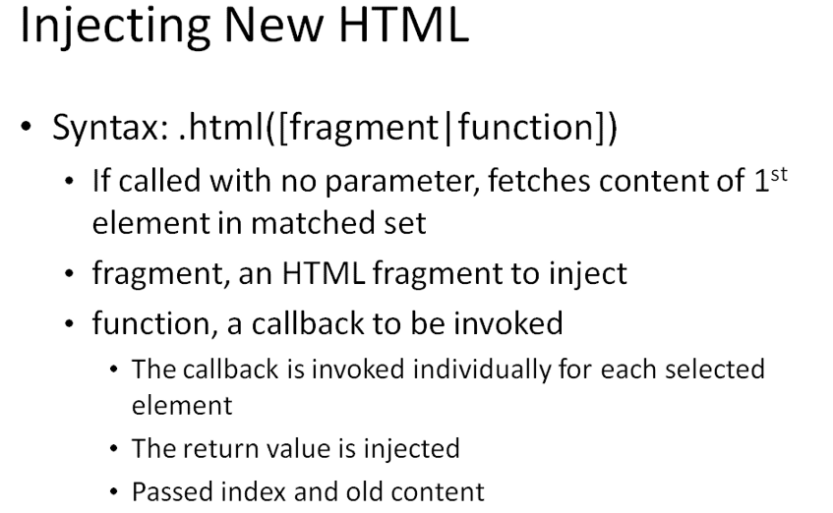

**Example 1:**<!DOCTYPE html>

<html>

<head>

<script src="https://ajax.googleapis.com/ajax/libs/jquery/3.5.1/jquery.min.js"></script>

<script>

$(document).ready(function(){

$("#btn1").click(function(){

alert("Text: " + $("#test").text());

});

$("#btn2").click(function(){

alert("HTML: " + $("#test").html());

});

});

</script>

</head>

<body>

<p id="test">This is some <b>bold</b> text in a paragraph.</p>

<button id="btn1">Show Text</button>

<button id="btn2">Show HTML</button>

</body>

</html>

<!DOCTYPE html>

<html lang="en">

<head>

  <meta charset="utf-8">

  <title>html demo</title>

  <style>

  p {

    margin: 8px;

    font-size: 20px;

    color: blue;

    cursor: pointer;

  }

  b {

    text-decoration: underline;

  }

  </style>

  <script src="https://code.jquery.com/jquery-1.10.2.js"></script>

</head>

<body>

<p>

  <b>Click</b> here to change the <span id="tag">html</span> to text

</p>

<script>

$( "p" ).click(function() {

  var htmlString = $( this ).html();

  $( this ).text( htmlString );

});

</script>

</body>

</html>

**.text()**

<!DOCTYPE html>

<html lang="en">

<head>

  <meta charset="utf-8">

  <title>text demo</title>

  <style>

  p {

    color: blue;

    margin: 8px;

  }

  b {

    color: red;

  }

  </style>

  <script src="https://code.jquery.com/jquery-1.10.2.js"></script>

</head>

<body>

<p><b>Hello! </b>javatpoint.com</p>

<p></p>

<script>

var str = $( "p:first" ).text();

$( "p:last" ).html( str );

</script>

</body>

</html>

**.val()**

<!DOCTYPE html>

<html lang="en">

<head>

  <meta charset="utf-8">

  <title>val demo</title>

  <style>

  p {

    color: red;

    margin: 4px;

  }

  b {

    color: blue;

  }

  </style>

  <script src="https://code.jquery.com/jquery-1.10.2.js"></script>

</head>

<body>

<p></p>

<select id="single">

  <option>Single</option>

  <option>Double</option>

 <option>Triple</option>

</select>

<script>

function displayVals() {

  var singleValues = $( "#single" ).val();

  $( "p" ).html( "<b>Value:</b> " + singleValues);

}

$( "select" ).change( displayVals );

displayVals();

</script>

</body>

</html>

**Adding & replacing the DOM Elements**

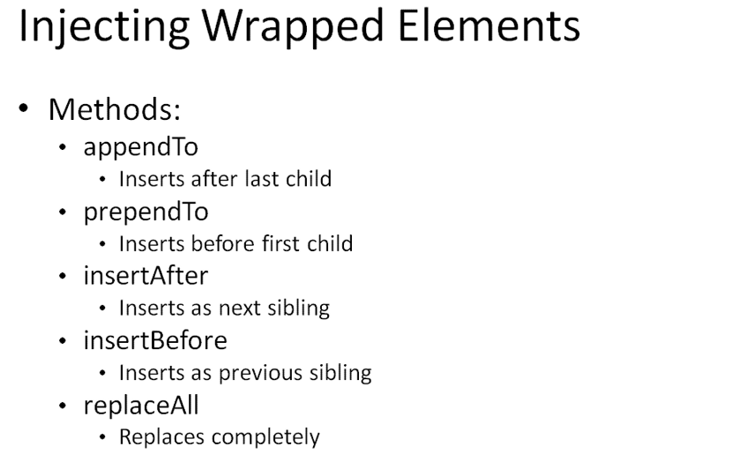

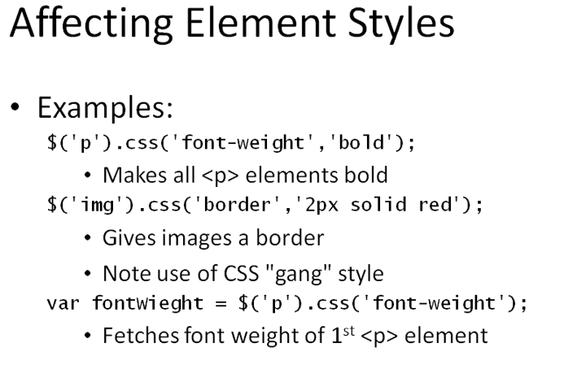

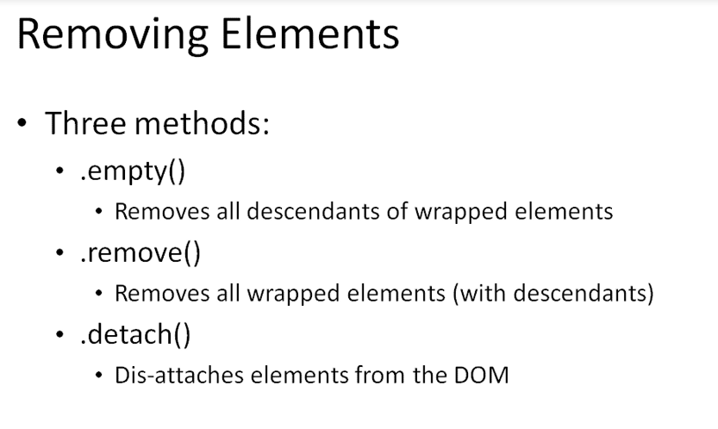

**Event Handling:**

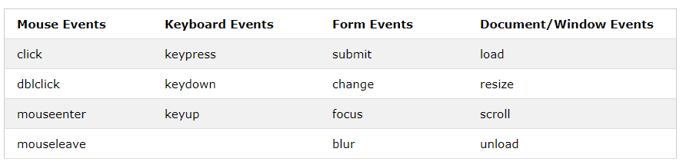

**Click()**

<!DOCTYPE html>

<html>

<head>

<script src="https://ajax.googleapis.com/ajax/libs/jquery/3.5.1/jquery.min.js"></script>

<script>

$(document).ready(function(){

$("p").click(function(){

$(this).hide();

});

});

</script>

</head>

<body>

<p>If you click on me, I will disappear.</p>

<p>Click me away!</p>

<p>Click me too!</p>

</body>

</html>

mouseenter()

<!DOCTYPE html>

<html>

<head>

<script src="https://ajax.googleapis.com/ajax/libs/jquery/3.5.1/jquery.min.js"></script>

<script>

$(document).ready(function(){

$("#p1").mouseenter(function(){

alert("You entered p1!");

});

});

</script>

</head>

<body>

<p id="p1">Enter this paragraph.</p>

</body>

</html>

**On():**

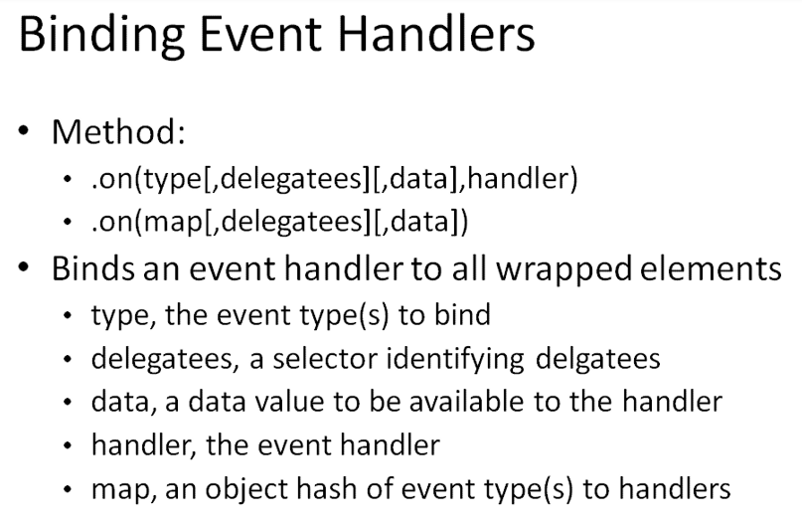

**Example 1**

<!DOCTYPE html>

<html>

<head>

<script src="https://ajax.googleapis.com/ajax/libs/jquery/3.5.1/jquery.min.js"></script>

<script>

$(document).ready(function(){

$("p").on("click", function(){

$(this).hide();

});

});

</script>

</head>

<body>

<p>If you click on me, I will disappear.</p>

<p>Click me away!</p>

<p>Click me too!</p>

</body>

</html>

**Example 2:**

<!DOCTYPE html>

<html>

<head>

<script src="https://ajax.googleapis.com/ajax/libs/jquery/3.5.1/jquery.min.js"></script>

<script>

$(document).ready(function(){

$("p").on({

mouseenter: function(){

$(this).css("background-color", "lightgray");

},

mouseleave: function(){

$(this).css("background-color", "lightblue");

},

click: function(){

$(this).css("background-color", "yellow");

}

});

});

</script>

</head>

<body>

<p>Click or move the mouse pointer over this paragraph.</p>

</body>

</html>