Task 3

From 1st September 2020 to 11th September, I worked about 30 hours a week on the following projects.

Project 1: Apply powerful dimension reduction techniques such as PCA and T-SNE to the output of each layer of a 5 layered deep neural network and visualize the output in 2 Dimensions.

Project 2: Built a simple deep learning-based speech denoiser that takes a noisy speech spectrum (speech plus chip eating noise) and then produces a cleaned-up speech spectrum.

 You can find more detail on how I applied PCA and T-SNE code for the task and model I built to denoise the noisy data into clear voice at https://github.com/mraunak/Research-Assistant-Work-/blob/main/Task3.ipynb

**Project 1: Apply PCA AND T-SNE and visualize high dimensional data to 2-D data.**

1. Trained a fully connected net for MNIST classification It should be with 5 hidden layers each of which is with 1024 hidden units.
2. The accuracy of the model to classify the digits to correct label.
3. Following is the snippet of MNIST data set.

Train MNIST data set contains 60000 images of digits of size 28*28.

Test MNIST data set contains 10000 images of digits of size 28*28.

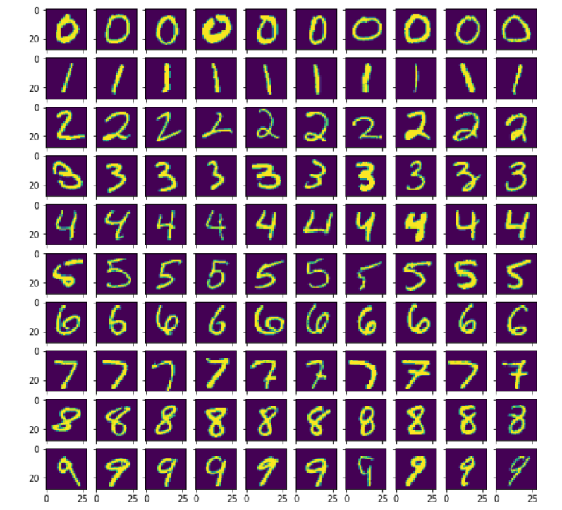

t-Stochastic Neighbor Embedding (t-SNE) or Principal Component Analysis (PCA) are useful tools to reduce the dimension of the data and visualize. By using them, I reduced the dimension of the data, for example, down to 2D space,.

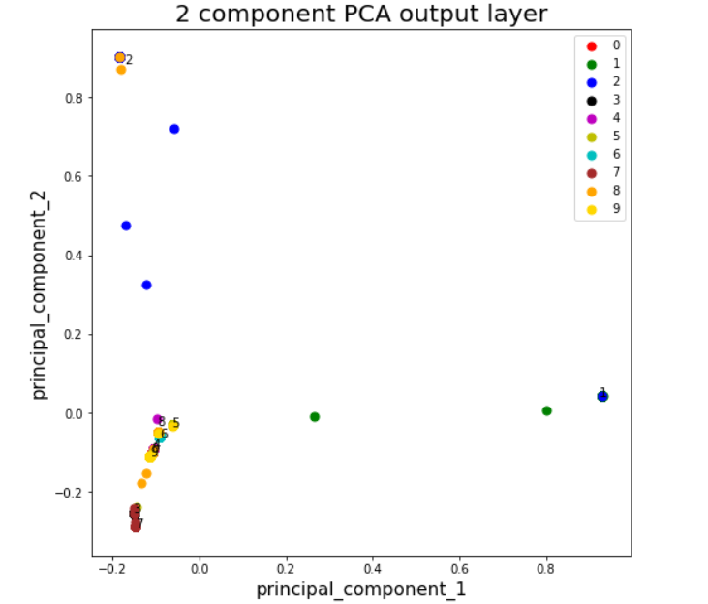

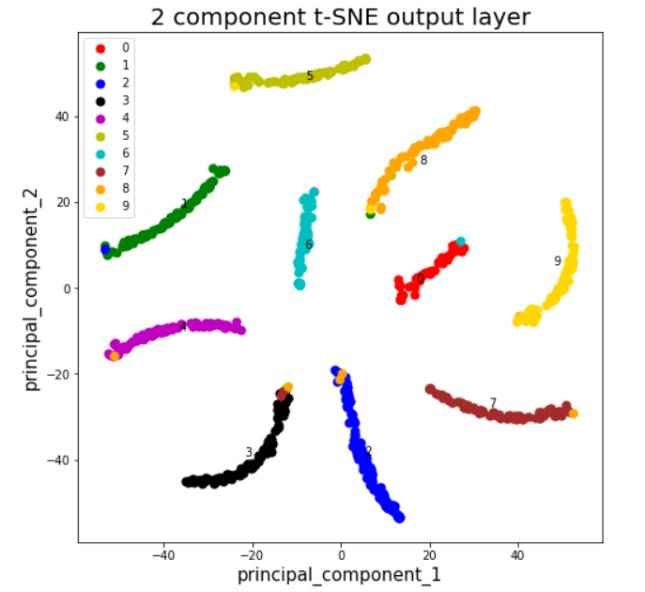

Examination points

Do you think this raw image samples are easy to classify?

Answer: The raw image samples were difficult to classify as we can observe from the PCA and t-SNE plot of the test data with 1000 samples, that there are no(PCA) or few(TSNE) distinct clusters in the plot. But from the output of successive layers, we can observe there is a gradual formation of clusters of different digits. This happens as layers go deep, their ability to learn complex patterns increases. Hence, the successive layers are providing better results and classification becomes easier. These cluster formations are more evident in t-SNE plot. The t-SNE plot of the output of the last layer clearly shows 10 distinct clusters with some rare points that are clustered in wrong class.

Explain your observation for repeated procedure for all the layers including the last one..

Answer: I observed that raw images were difficult to classify. The PCA and t-SNE plot of successive layers gradually gave better results. This is because, as layers go deep, their ability to learn complex patterns increases. They can distinguish between important and non-important features and hence provides better result. The t-SNE plot were better as compared to PCA plot, this may be due to the reason that PCA is a linear feature extraction technique whereas t-sne is nonlinear technique to reduce the dimension. In contrast to PCA, the plot of T-SNE shows almost perfect separation among the digits classes. The t-sne plot shows 10 distinct clusters with only few points that are clustered in wrong class. T-SNE did an impressive job finding clusters in the data, but it is prone to get stuck in local minima as T-SNE contains some points that are clustered with the wrong class, but most of these points correspond to distorted digits which are difficult to identify.

T-SNE took more time to display output as compared to PCA. In PCA plot we can observe that points are overlapping, PCA being linear projections was unable to classify the high dimensional MNIST data perfectly.

**Project 2**

Built a deep learning-based speech denoiser that takes a noisy speech spectrum (speech plus chip eating noise) and then produces a cleaned-up speech spectrum.

Given a speech data with noise and a clean speech data

Converted the voice data into matrix using librosa library.

Applied deep learning model to the matrix and trained it to convert noisy data to clean speech.

Achieved a good Sound to Noise Ratio: 16.43