**Name:** Mary Key Requillo

**Course:** CSIS 1280 – 004 Multimedia Web Development

Final Project

Introduction

It is almost known to everyone that searching for the perfect home or place if not impossible, is challenging. Canada is known to have thousands to millions of immigrants. When people land in a new country, the first thing they will look for is a place to live or stay. This website will help users find a place to stay whether it’s for rental or purchasing a house. They can narrow down their search to Rental or Housing, Location, with parking. Details are also provided to users like the number of bedrooms, living area, kitchen, and more. Most importantly, the price.

Website Layout

**Layout wireframe**

**Home Page**

**Rental and Housing Page**

The website layout composes of several elements and mostly was implemented through flexbox. Form, embedded video, and cards in Rental and Housing pages are implemented through flexbox. Flexbox was used due to its flexibility and adaptability. It has the ability to fill extra space and if the page resolution is adjusted, it adapts as well.

Website Organization

**Home Page**

The Home page consists of tabs, forms that are enclosed in the fieldset, embedded videos from youtube, and an article that is relevant to the Housing Market in British Columbia. Tabs are used to redirect to two more pages which are the Rental and Housing pages that change color and border when hovered. The two fieldset are implemented in flex so their size can adjust depending on the screen size. Inside the fieldset are the form and a space where the details from the form are displayed. The validation on the form is done using javascript. Aside from the validations, it also captures the details inputted by the user to display on the second fieldset. In the future, if databases are implemented, this will be the starting point.

Under the fieldset are the embedded videos, these videos are taken from youtube.com so it can help the users by providing tips in finding the right house to purchase or rent.

Last but not least, an article taken from <https://wowa.ca/bc-housing-market>, will give the user an idea of the current market trends in the housing market in British Columbia.

**Rental Page**

The rental page also consists of tabs that will redirect the user back to the Home page and Housing page. Under the Rental page, it displays cards that have the top rentals of famous locations in British Columbia. Each card consists of, an image, title, information, price, and contact number. These cards are implemented using flexbox row and column with 1 1 300px as grow, shrink and basis.

**Housing Page**

The housing page is implemented the same way as the Rental Page. The difference between the two is the detail that each page consists of. However, you can see that even though the number of cards is different the display still looks presentable. This page solely focuses on the available Housing in British Columbia.

Content Declaration

**Images:**

<https://unsplash.com/@marcuslenk?utm_source=unsplash&utm_medium=referral&utm_content=creditCopyText>

<https://unsplash.com/@rarchitecture_melbourne?utm_source=unsplash&utm_medium=referral&utm_content=creditCopyText>

<https://unsplash.com/ja/@whatdaliz?utm_source=unsplash&utm_medium=referral&utm_content=creditCopyText>

<https://unsplash.com/@lissetelaverdephoto?utm_source=unsplash&utm_medium=referral&utm_content=creditCopyText>

<https://unsplash.com/@mostafasafadel?utm_source=unsplash&utm_medium=referral&utm_content=creditCopyText>

<https://unsplash.com/es/@churchoftodd?utm_source=unsplash&utm_medium=referral&utm_content=creditCopyText>

<https://unsplash.com/@naomi365photography?utm_source=unsplash&utm_medium=referral&utm_content=creditCopyText>

<https://unsplash.com/@fensterschmidinger?utm_source=unsplash&utm_medium=referral&utm_content=creditCopyText>

<https://unsplash.com/@brenoassis?utm_source=unsplash&utm_medium=referral&utm_content=creditCopyText>

**Videos:**

<https://www.youtube.com/watch?v=1i1KYJBPOzo&t=3s>

https://www.youtube.com/watch?time_continue=1&v=7GQF2q4zIA4&feature=emb_logo

Highlight

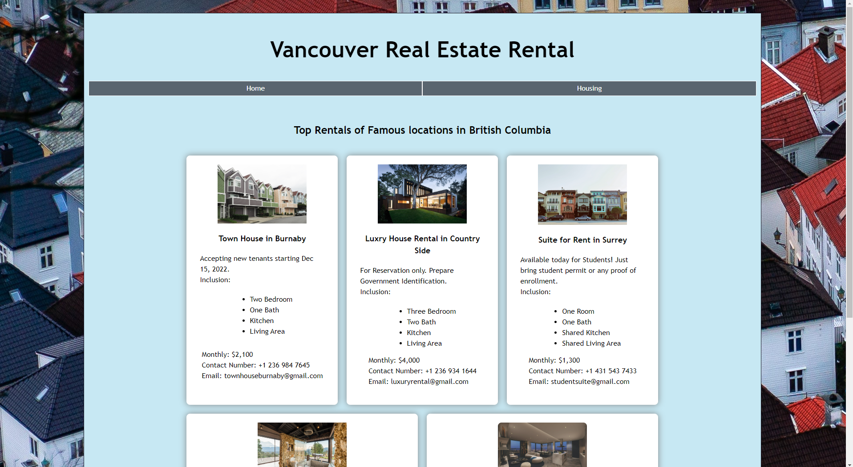

On the Rental and Housing page, flexbox is used in rows for the cards and flexbox columns inside of each card. It takes time to make it looks decent and appealing to the users’ view. If the user uses a different type of device, it will adapt and not distort the cards, images, and text. If the website adds more cards, it will just fill out the spaces so it will look full. At some point when the window size is adjusted, the embedded youtube video overlaps the background, so a responsive css is implemented as well so it will still look intact. The page looked like a real website that you can find on the internet today.

Link to GitHub

<https://github.com/mkrequillo/mkrequillo.github.io/tree/main/Project_MRe49038>

Reference

<https://www.w3schools.com/css/css3_flexbox.asp>

<https://www.w3schools.com/css/css3_flexbox_container.asp>

<https://www.w3schools.com/css/css3_flexbox_items.asp>

https://www.w3schools.com/css/css3_flexbox_responsive.asp