**Best location for car wash centre in Toronto**

**Murali Krishnan Sampath**

**December 2019**

**1.Introduction:**

**Business Problem:**

Starting a car wash business can be interesting, and profitable business. With the right location, and top-notch service, you can draw in numerous customers who need their cars washed quickly, efficiently, and at a good price. Considering this, in this project we will find a best location to open a Car wash centre.

This is a tricky task, because in the city there are already car wash centres exist. So, we need to explore the existing car wash centres to find the best location for new car wash centre. The following steps to needs to be executed to find the best location.

1. Find the existing car wash centres in the entire Toronto city.
2. Find the boroughs which has dense population and less car wash centres.
3. Explore the nearby venues of the existing car wash centres and find which is the better location for new car wash centre.
4. From selected boroughs, Find the neighbourhoods which don’t have any car wash centre. So that stake holder can select a location from these neighbourhoods which have more common venues near to it.

This project is targeted for the stack holders/Businesspeople who wants to open a **Car wash centre** in Toronto, Canada.

**2. Data**

**2.1 Data acquisition and cleaning:**

* **Toronto neighbourhood data:**

The Toronto city neighbourhood information is gathered by web scrapping the [https://en.wikipedia.org/wiki/List_of_postal_codes_of_Canada:_M](https://en.wikipedia.org/wiki/List_of_postal_codes_of_Canada:_M%20) this link. The table scrapped from the web has unassigned neighbourhoods, unassigned boroughs and duplicate postal codes. So, the data has been wrangled and prepared for further analysis.

1. Removed the boroughs which have the value “Not assigned”
2. Removed the neighbourhoods for which the boroughs are “Not Assigned”
3. Combined the neighbourhoods which has same postal code.

* **Boroughs Population:**

The boroughs population is acquired from <https://en.wikipedia.org/wiki/Demographics_of_Toronto>.

* **Geographical data:**

Geographical data is gathered from Geospatial_Coordinates.csv. The longitude and latitude values are required by the foursquare API to search/explore the nearby venues.

* **Foursquare APIs:**

1. To get the car wash centres in entire Toronto city, search Foursquare API call has been invoked with category id. The category id for **car wash centre** is **4f04ae1f2fb6e1c99f3db0ba**. Car wash centres within 10km radius of neighbourhood has been fetched. After getting the details, the duplicate venues have been removed and unique car wash centre details has been stored to find car wash centres per borough.
2. The nearby venues of the car wash centre have been fetched using the explore foursquare api call to see where exactly these existing car wash centres located and for applying the clustering algorithm to find the commonality.

**2.2 Data prepared for analysis:**

a) After removing the duplicates, there were **191 unique car wash centres** already exist in the city. The below is the folium map which shows existing car wash locations.

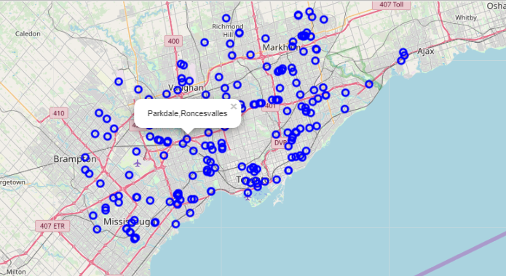

Figure 1

b) Nearby venues gathered around these car wash centres within 10 Kms for analysis. There are around 3065 venues have been identified near the car wash centres. Please refer **nearByVenues.csv.**

**3.Methodology:**

The analysis has been done on the prepared data to find the best car wash location.

**3.1 Exploratory data analysis:**

The unique car wash centres have been grouped based on boroughs to see the number of car wash centre per borough. The below image shows the car wash centres per borough. 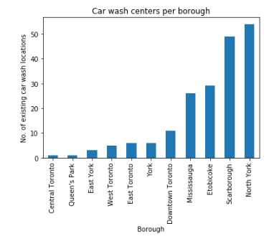 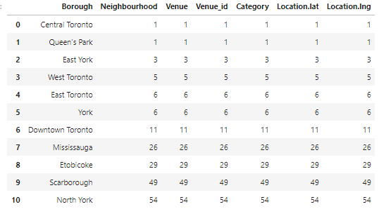

Figure 2

**Map of the existing car wash centre by borough:**

In the map,

1. North York and Scarborough are marked in Red colour

2. Downtown toronto, Etobicoke, Mississauga are marked in Green colour.

3. Others are marked in Yellow colour.

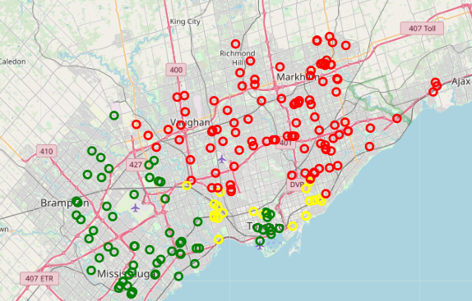

Figure 3

As per the images above, the **boroughs North York and Scarborough** has more car wash centres than any other boroughs. So, we can skip these boroughs. The boroughs **East toronto, East York, Queens park, West toronto, York, Central toronto** are smaller boroughs, so we can skip them as well. The best location would be **Downtown toronto, Etobicoke, Mississauga** to open a car wash centre. Because these boroughs are bigger and has dense population.

Since we have identified the boroughs to open a car wash centre, now we need to analyse the nearby venues of the existing car centres to find what are the common nearby venues.

**3.2 Exploration of nearby venues:**

3.2.1 **Nearby car wash centres grouped:**

The nearby venues have been grouped, and count of the nearest venue is identified for each car wash centre. The below is the image shows that.

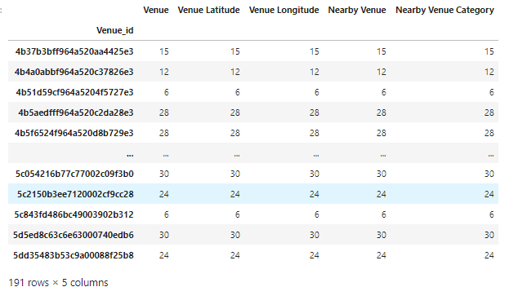

Figure 4

**3.2.2 Dummies created for nearby venues for analysis:**

The dummies have been created for nearby venues. This is for grouping and applying machine learning algorithm. The below image shows that.

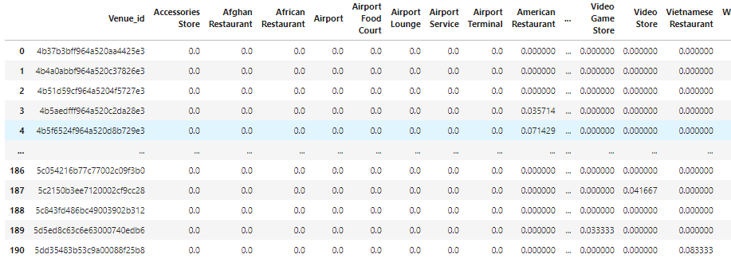

Figure 5

**3.2.3 Common venues near the car wash centre:**

For opening a carwash centre, it’s important to understand the commonality of the existing car wash centre locations. Nearby venues need to be identified to see where exactly these centres are located. Top ten common venues have been found near the car wash centres. The figure shows the top ten common venues.

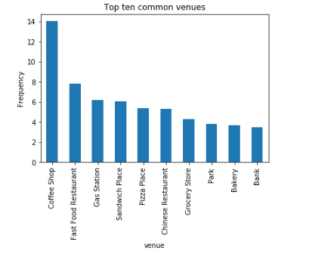

From the figure it’s clear that most of the car wash centres are nearby Coffee shop, Restaurant or Gas station. So, for new car wash centre suggested location should be near to these top venues. The same must confirmed by applying the clustering algorithm.

**3.3Applying the KMeans algorithm:**

The KMeans algorithm is used here for clustering the car wash centres based on the nearby venues. This algorithm is applied on the data set and the below result has been obtained. As per the results, the cluster “0” and “4” has more values. The KMeans algorithm also confirms the same findings above.

``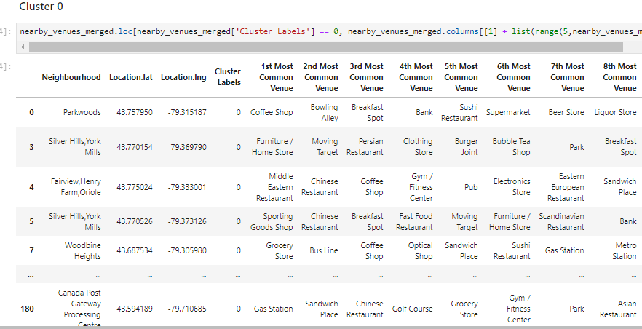 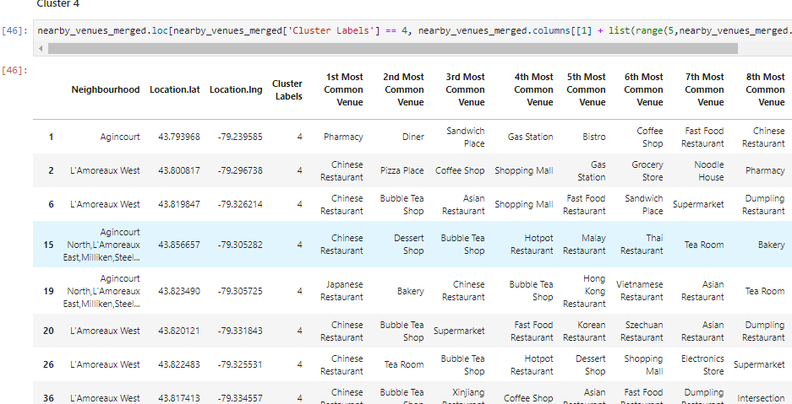

The analysis has been done and figured out the most common near by venues. For the new location its been suggested that new shop can be located near these venues.

**4.Results:**

The neighbourhoods of Scarborough and Etobicoke which have very less car wash centre within the radius of 2km has been identified. Suggestion for the stakeholder is to pick one of the locations with less car wash centres for opening new car wash centre. As per analysis done, the new car wash centre can be placed near by the above suggested top common venues.

**4.1 Neighbourhoods with less/no car wash centres:**

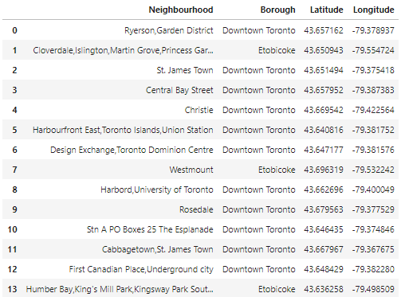

The shown neighbourhoods don’t have car wash centres. Its suggested for the stakeholders to pick location from one of these neighbourhoods which has more common venues mentioned in the report,

**Existing car wash centres near the selected neighbourhoods:**

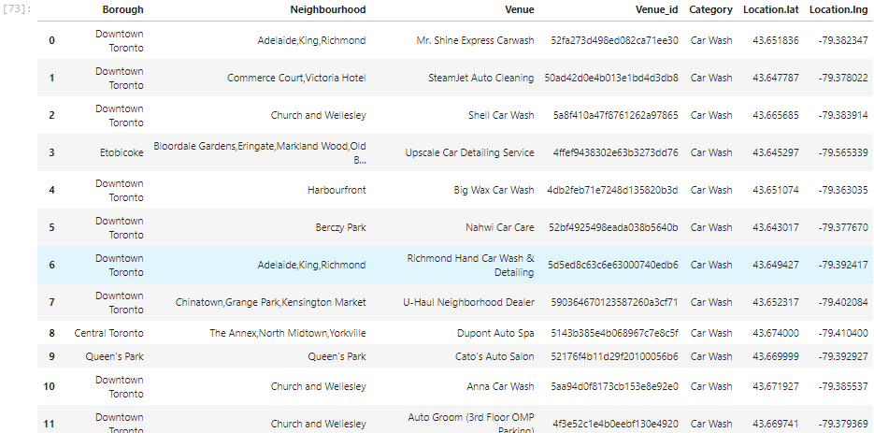

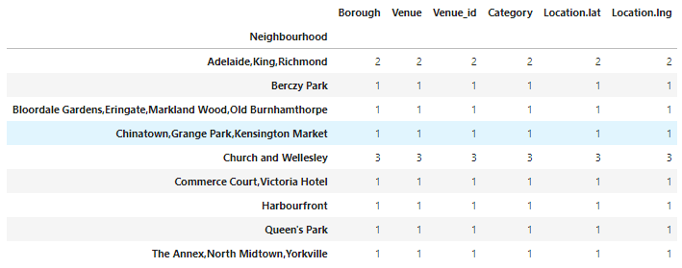

**Map of the existing car wash centres of the selected neighbourhoods:**

In the map,

1. The selected neighbourhoods are marked in blue.
2. The near by car wash centres are marked in red.

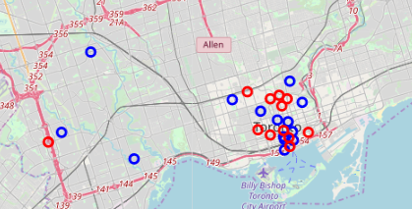

**5.Discussions and future directions:**

The further analysis can be done on the type of car wash centres, ratings, price. There are many types of car wash centres, (i.e.) **Self-service car wash, Tunnel car washes, Automotive car wash, Hand wash service, Bikini car wash etc.**

The analysis can be carried based on the types of car wash centre, user ratings, price etc. Since the foursquare API response doesn’t have any information or less information for these features, the analysis couldn’t be done. When this information is available, we can further enhance the results.

**6. Conclusion:**

In this study, I have analysed the entire Toronto city car wash centres to find the best location for the new car wash centre. The top nearby venues have been identified near the existing car locations to find exactly where the car centres are located. After identifying the common locations near the car wash centres, the neighbourhoods of **Downtown toronto, Etobicoke, Mississauga** which have very less/no car wash centres have been identified and selected for opening the new car wash centre. As part of the study, I tried to identify the car wash centre types, price etc, which I felt very essential for the analysis, But I couldn’t able to get the proper information, so I left that work for future.