Items:

1. Startup Screen  
   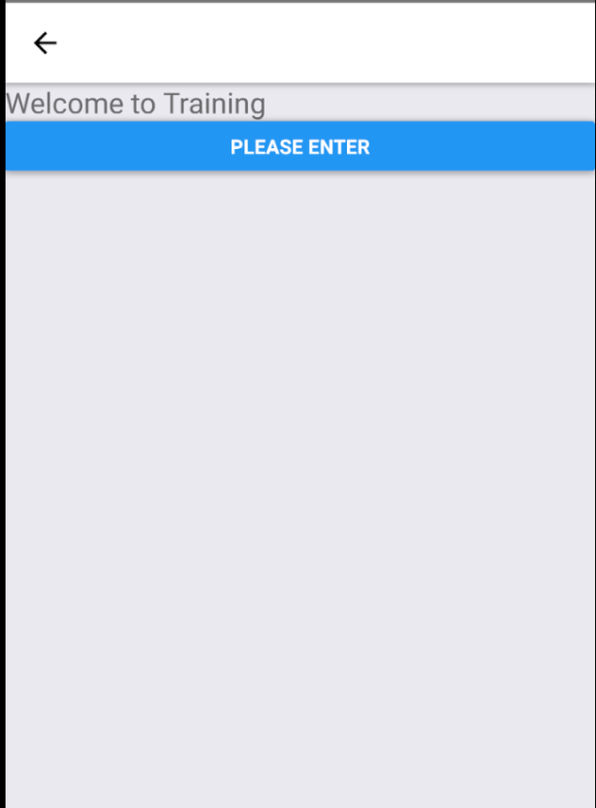
2. Login Screen  
   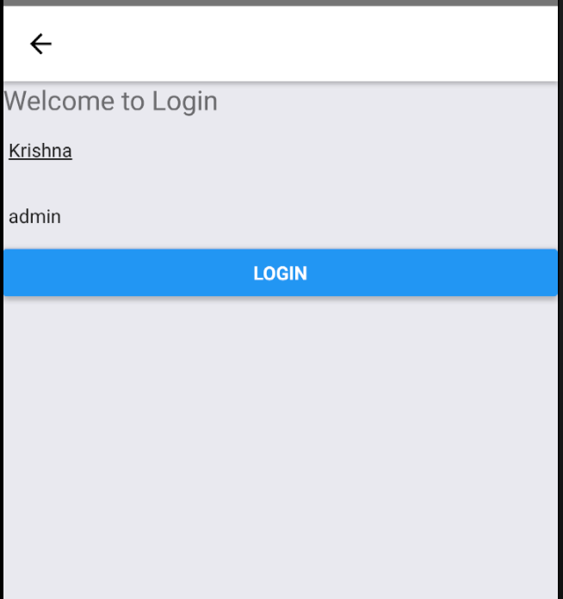
3. Main Screen  
   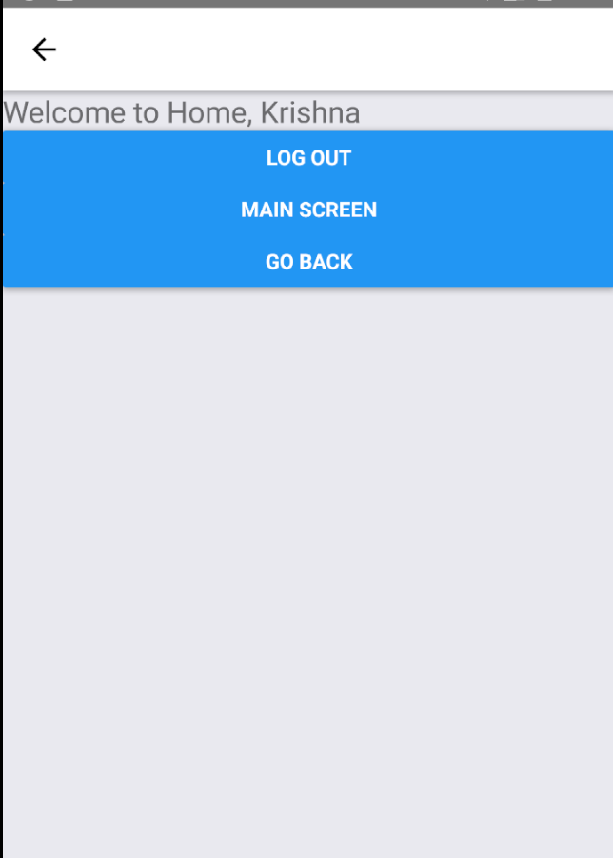
4. <Switch onValueChange={this.rememberMe.bind(this)} value={this.state.rememberMe}/>  
   