Health Maintenance World

User Guideline 2019/06/17

1. **SOMETHING you need to take care of when you enter meals you eat today**

Part 1: Food amount calculation

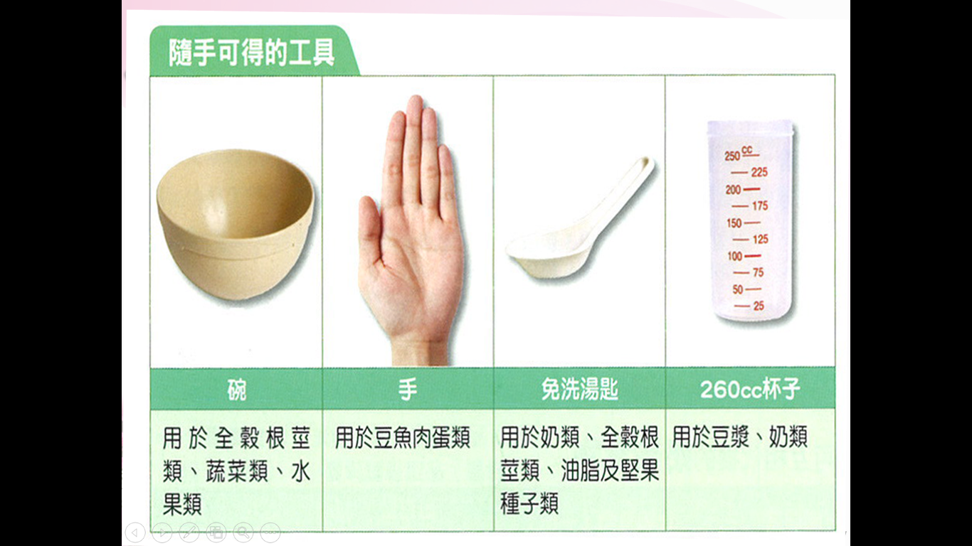

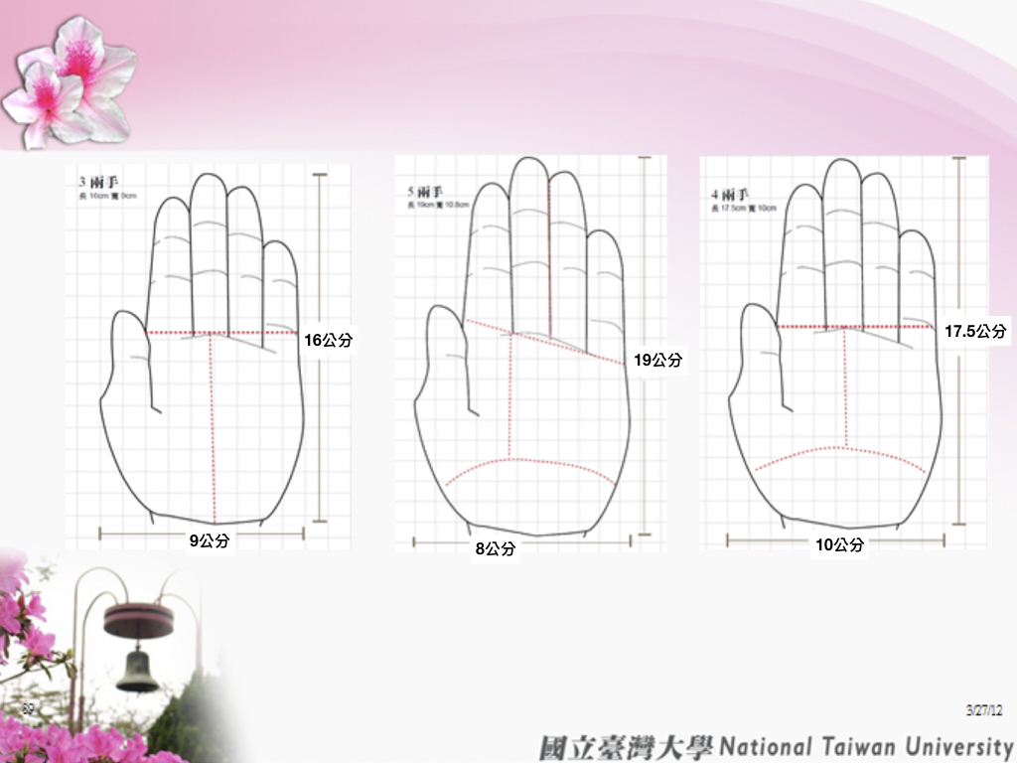

* One region means one *hectogram (37.5 g in Taiwan)*.

Part2: When entering Meals

* Because the app calculates once after you enter what you eat today, you need to list and calculate all kinds and amounts of food you eat previously.
* Same category (There are six in the app), same food nutrient composition.

1. For example, if you eat a bowl of rice and a steamed bun, both contain 280 kcal, then the nutrient composition for both is carbohydrate 60g and protein 8g.
2. And if you eat a bowl of rice porridge, which contains 140 kcal, then nutrient composition is carbohydrate 30g and protein 4g. The nutrient composition is half of that of a steamed bun with 280 kcal.

* So you can add food with same calorie into same food and double the amount.
* Or you can calculate in proportion to the calories that the food has and sum up.

For example, if you eat a bowl of rice porridge (140 kcal) and a steamed bun (280 kcal), then total calorie and nutrient you take equals to THREE bowls of rice porridge.

1. **About TDEE calculation and the goal you set**

* After entering your information and setting the goal (Ex. Lose/Gain Weight), the app will give you ACTUAL calories you take today.
* You can eat following the suggestion for one week and see if you gain or lose weight. If not, the reason may be that TDEE is just estimated and it is not real calorie consumption for you every day. And the solutions can be:

1. If your goal is to gain weight: After eating for one week but you still maintain weight, then you can eat more for your actual TDEE might being higher than calculation.
2. If your goal is to lose weight: After eating for one week but you still maintain weight, then you can eat less or exercise more. But exercising is better.

* The suggested actual calories you take every day is set +300 or -300 kcal of TDEE according to your goal.