# Wireframy

## Main page

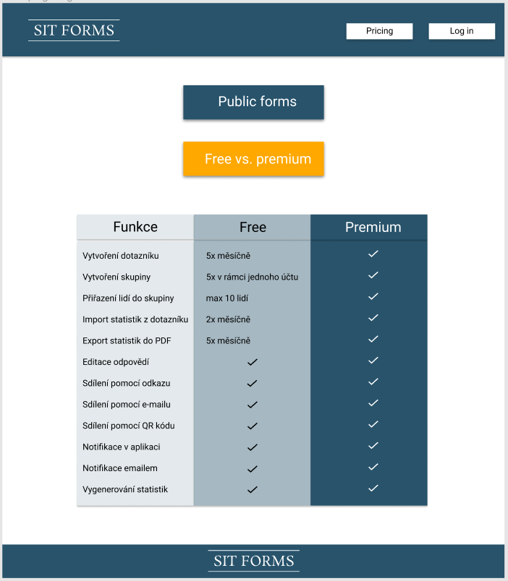

Odhad pracnosti: 30 m

## Log in

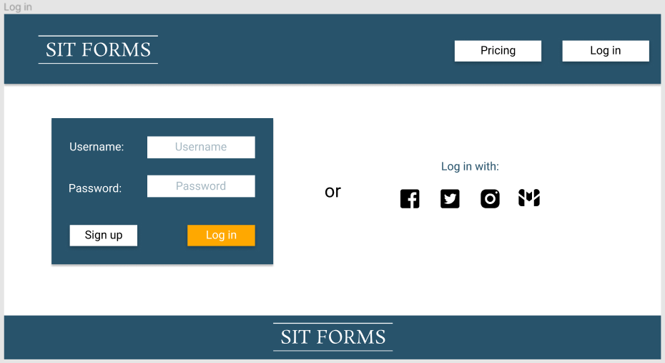

Odhad pracnosti: 20 m

## Sign up

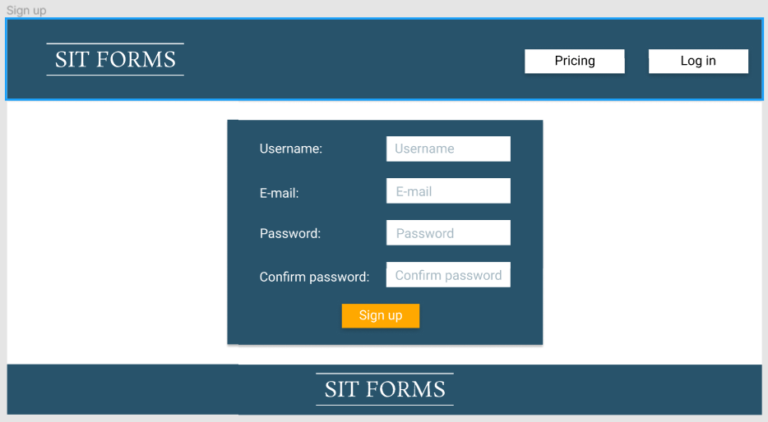

Odhad pracnosti: 15 m

## Log Out

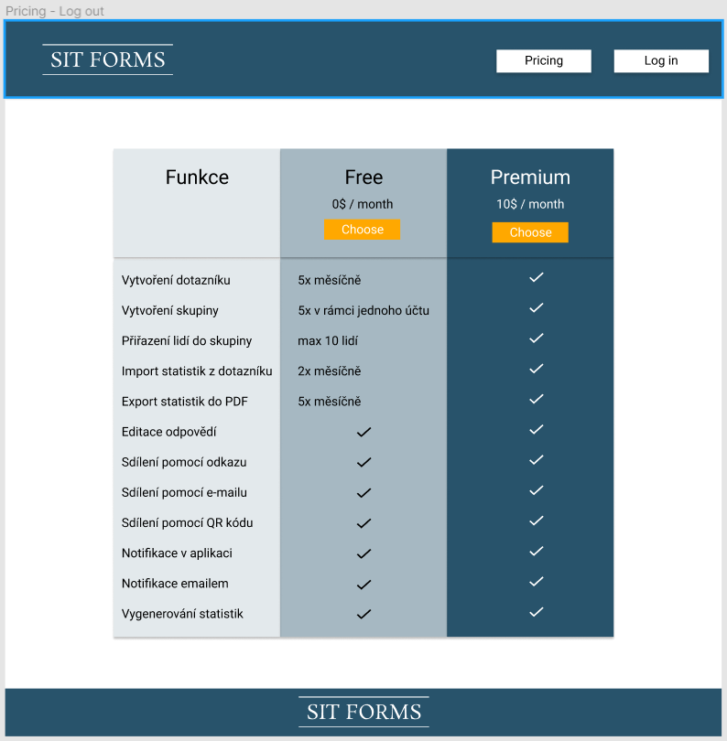

Odhad pracnosti: 20m

## Public form - log out

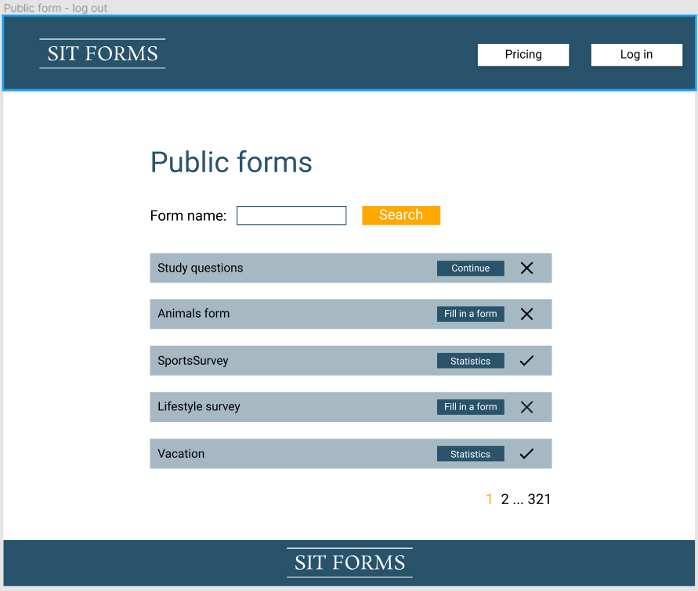

Odhad pracnosti: 60 min

## Form example without logging (public form)

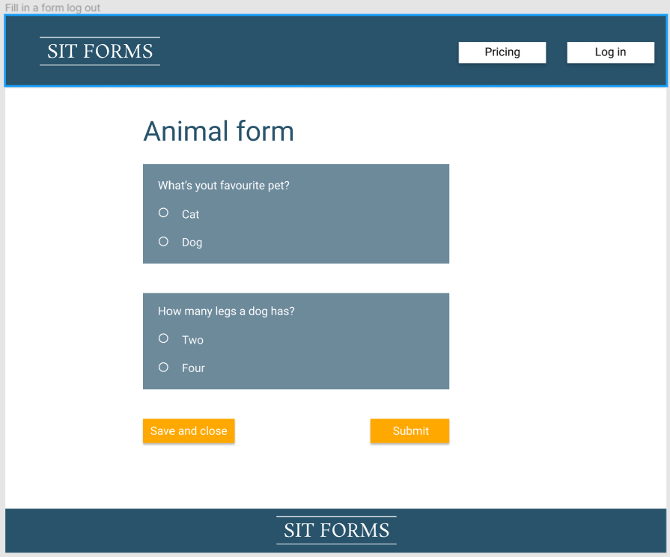

Odhad pracnosti: 30m

## Fill form - example

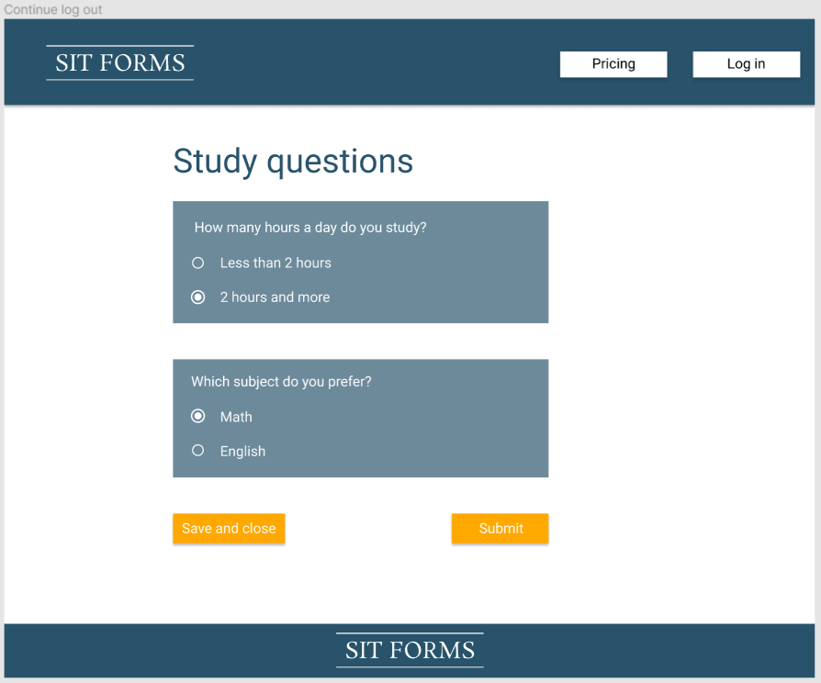

Odhad pracnosti: 30m

## Statistics after submitting

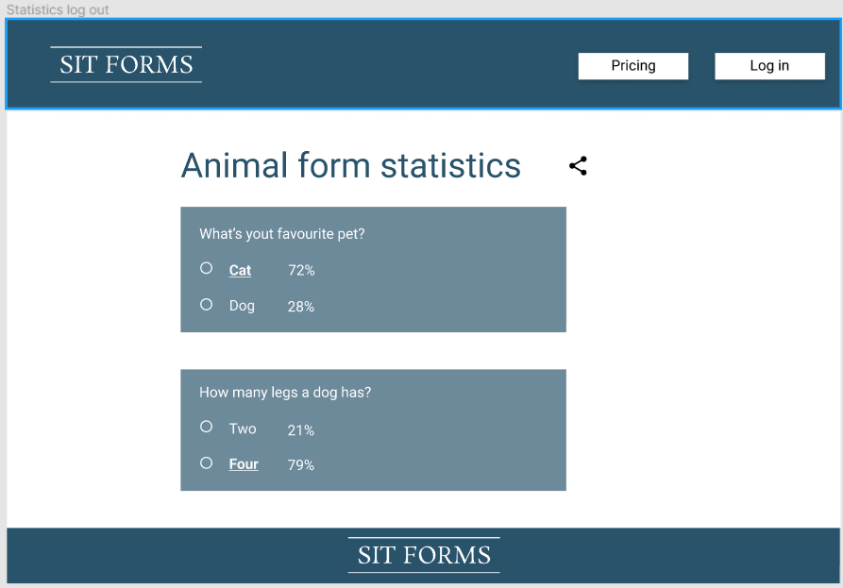

Odhad pracnosti: 30m

## Share statistics

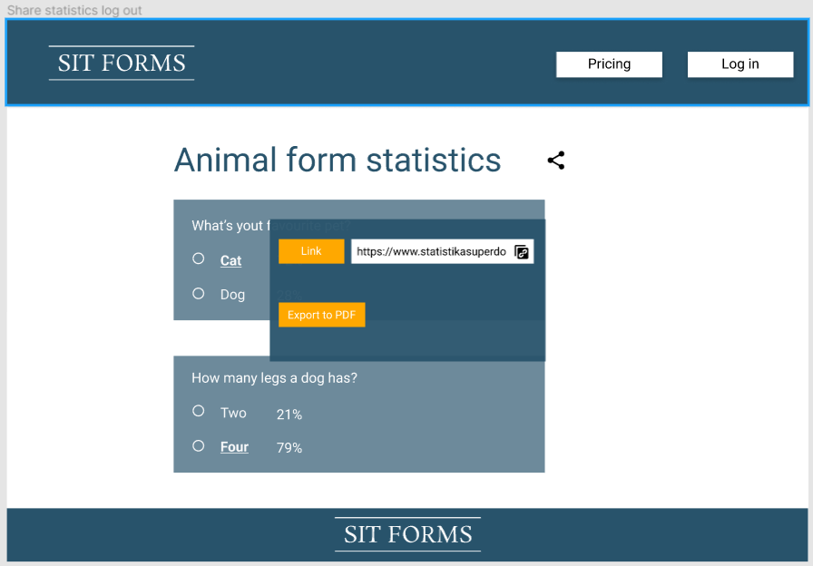

Odhad pracnosti: 20m

## Notification list

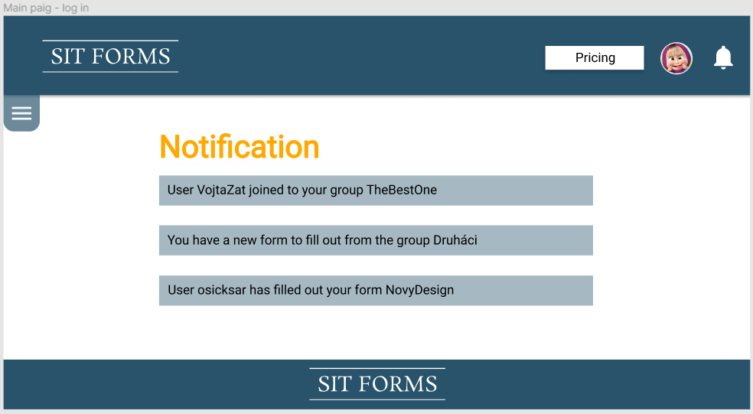

Odhad pracnosti: 20m

## Pricing

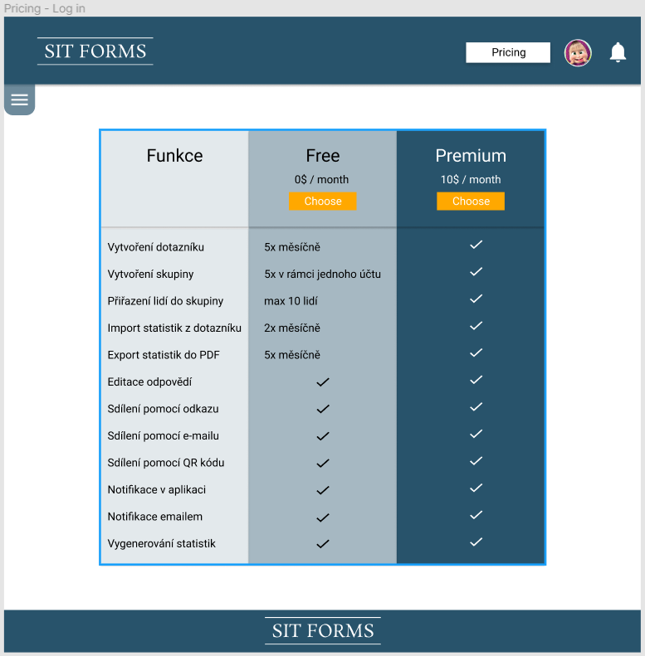

Odhad pracnosti: 5m

## User profile

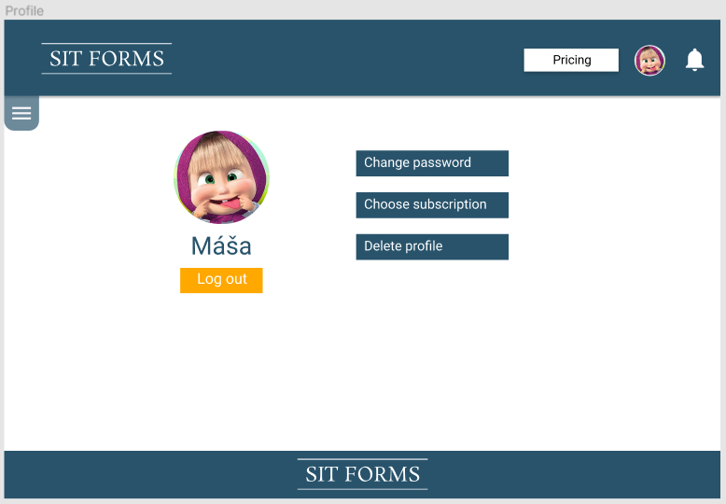

Odhad pracnosti: 10m

## Change password

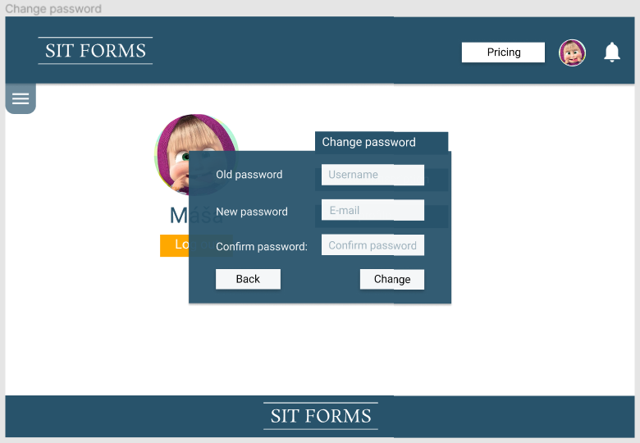

Odhad pracnosti: 15m

## Left menu bar

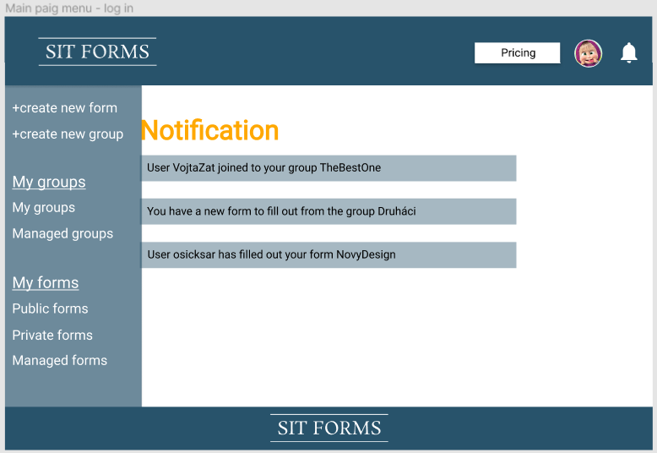

Odhad pracnosti: 30m

## Left menu-bar, but on longer page :D

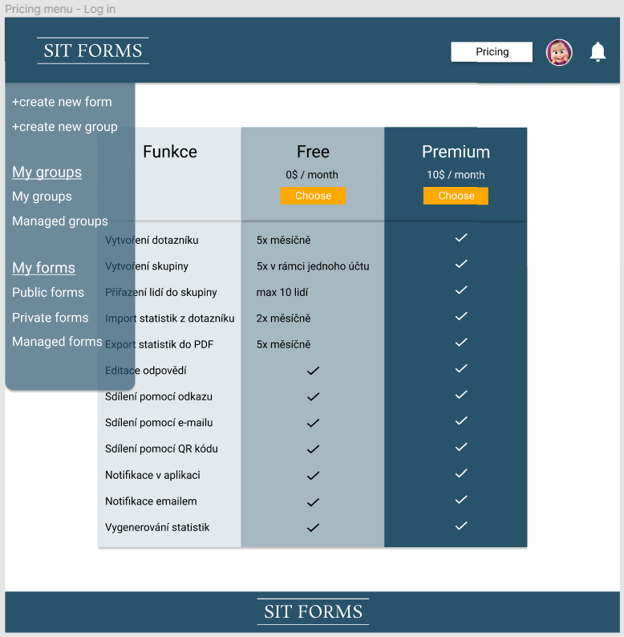

Odhad pracnosti: 0m

## User profile - left menu

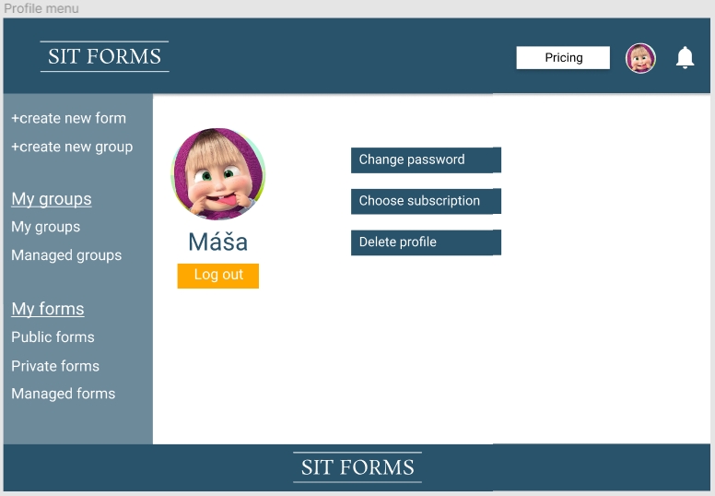

Odhad pracnosti: 0m

## Form creator

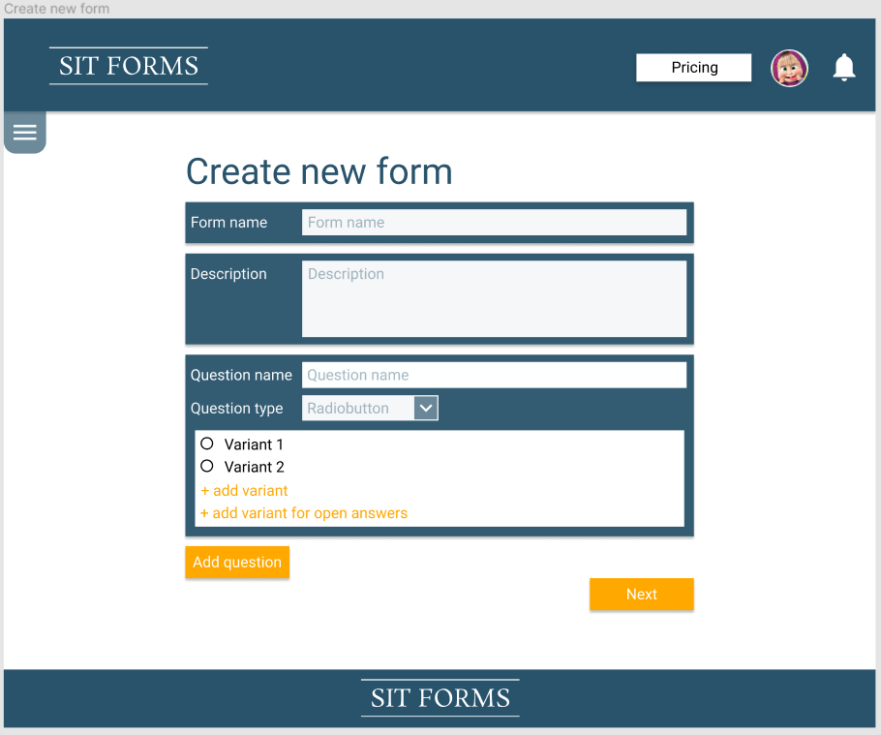

Odhad pracnosti: 2h

## Form creator - question type

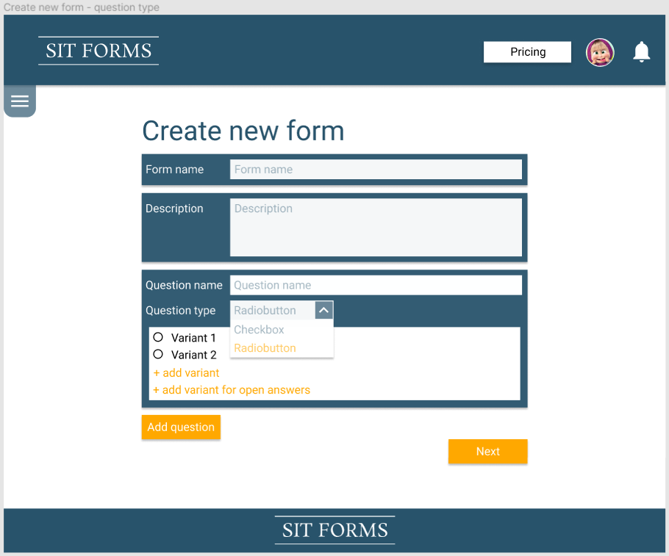

Odhad pracnosti: 0m

## Form creator - form settings

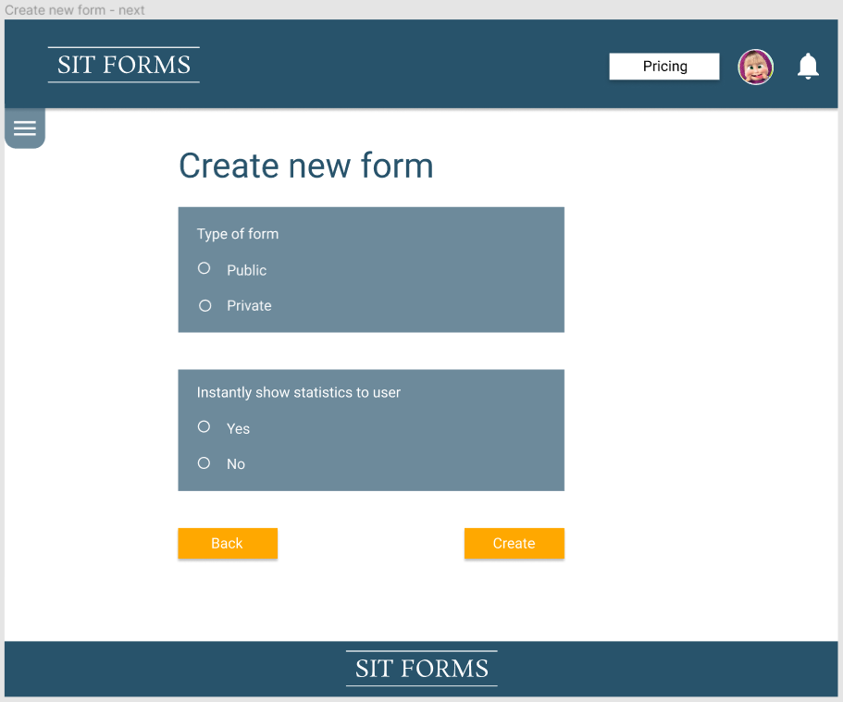

Odhad pracnosti:0m

## Form creator - grant permission

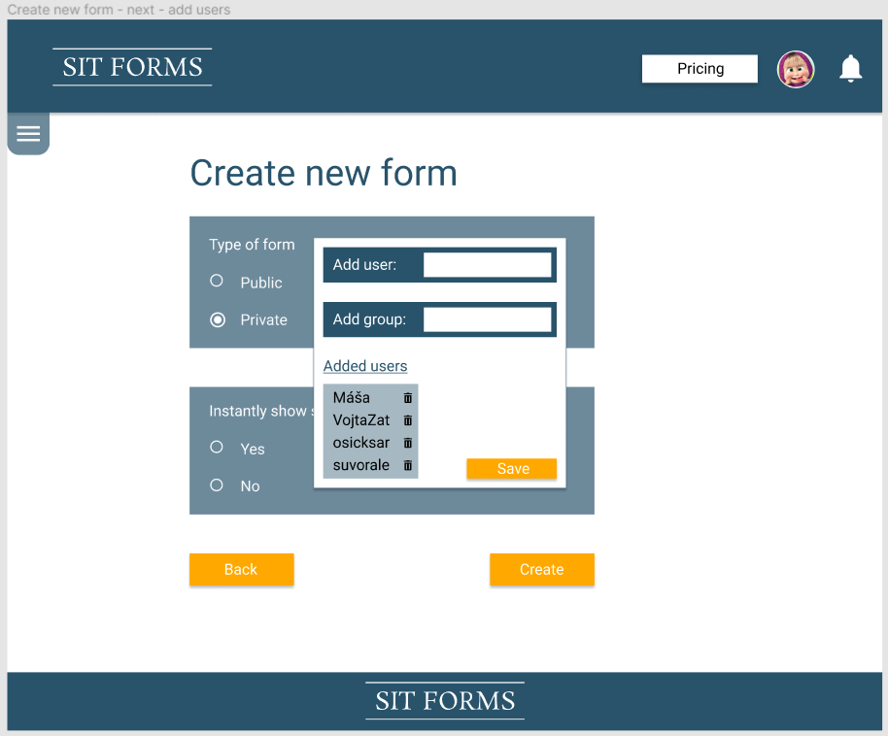

Odhad pracnosti: 20m

## Form creator - after granting permissions

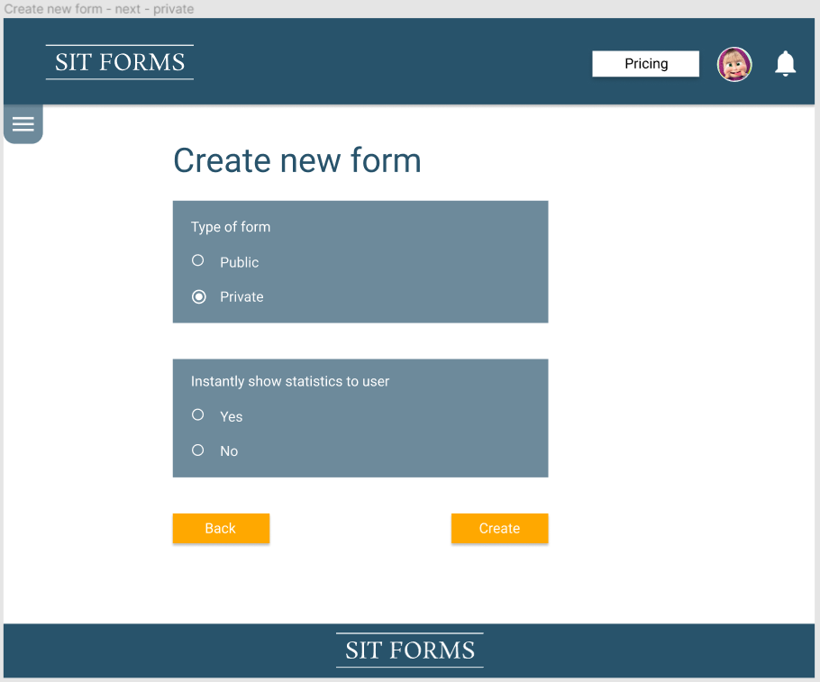

Odhad pracnosti:0

## Public forms list - logged in

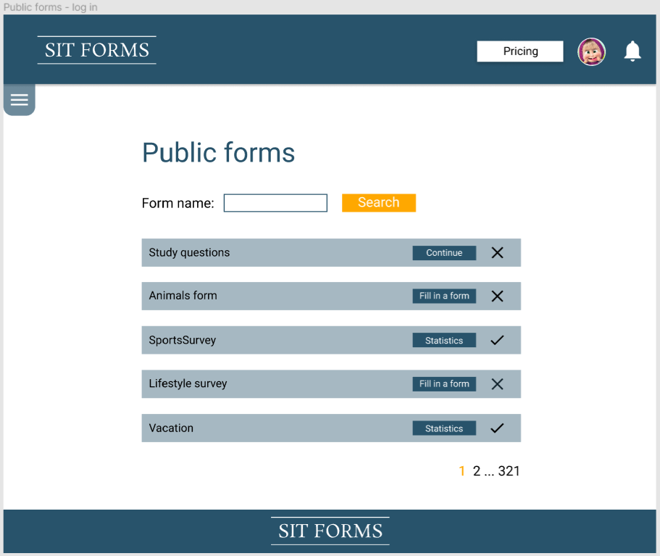

Odhad pracnosti:0

## List of private (shared with respondent) forms

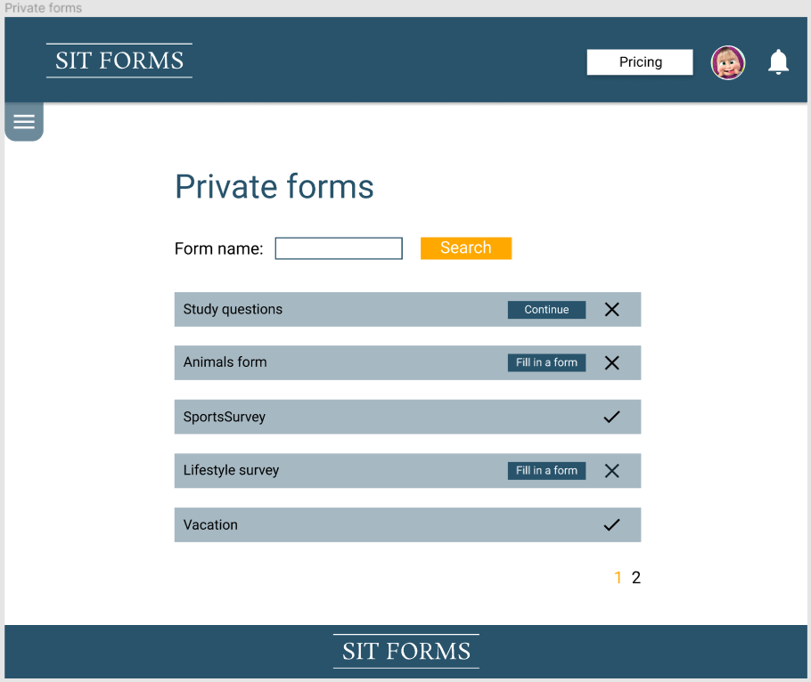

Odhad pracnosti:0

## List of user’s forms

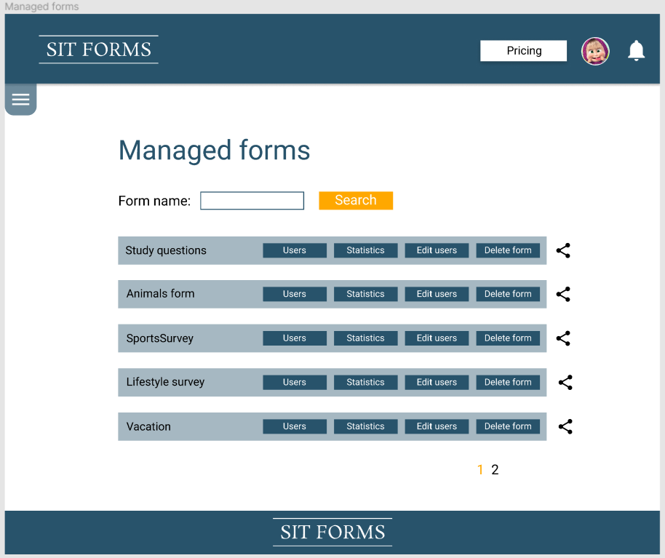

Odhad pracnosti:15m

## List of form’s respondents

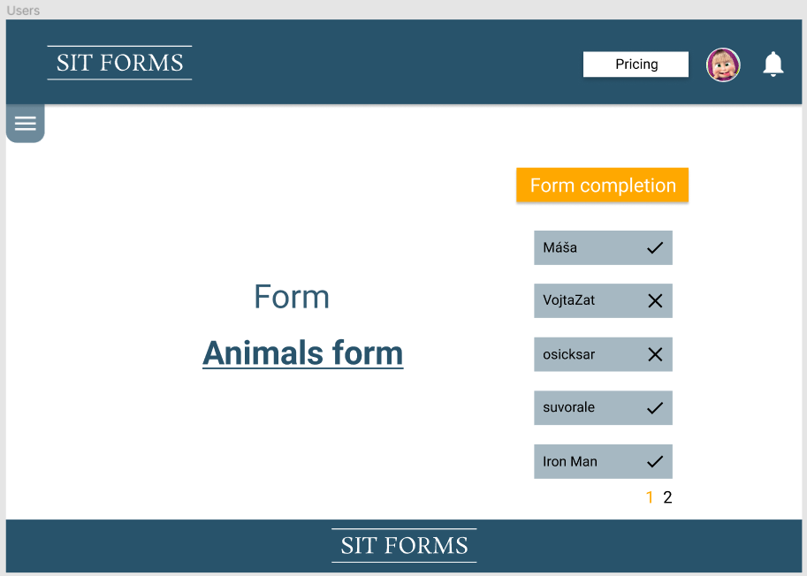

Odhad pracnosti:15m

## Edit list of form’s respondents

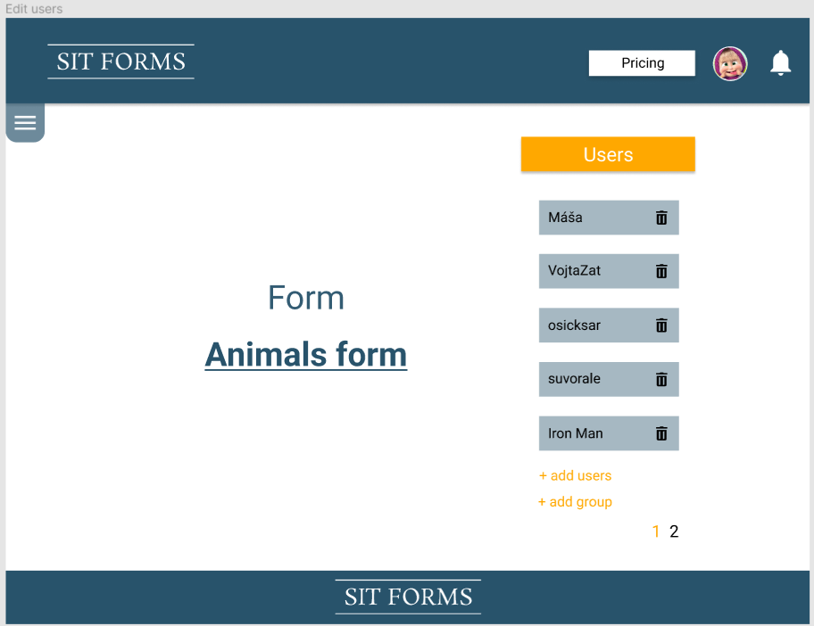

Odhad pracnosti: 10m

## Grant permission to user

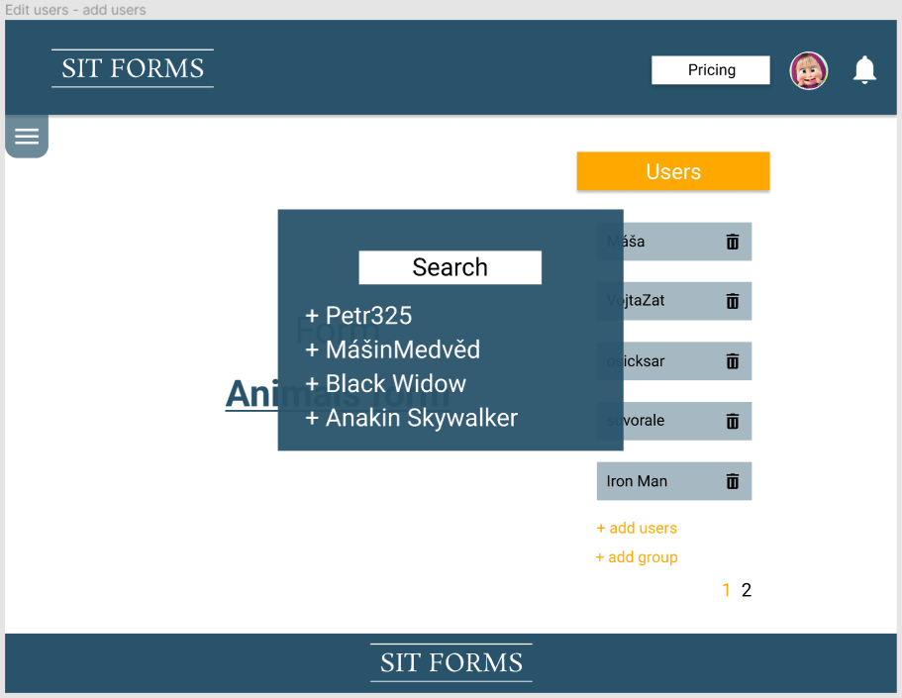

Odhad pracnosti: 10m

## Grant permission to a group

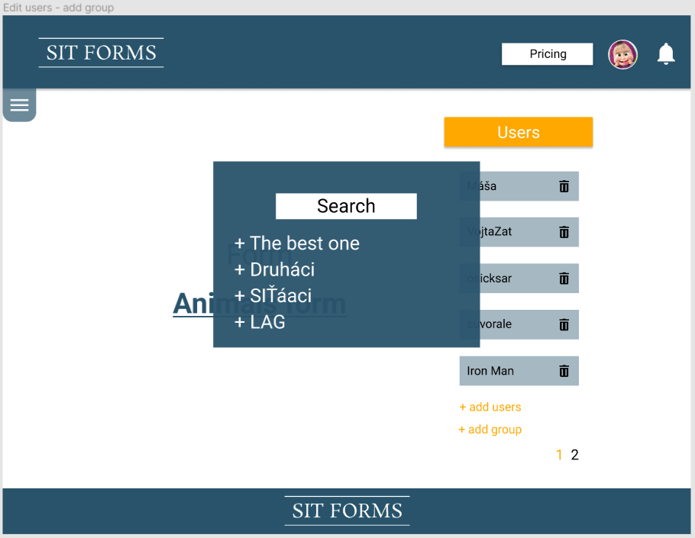

Odhad pracnosti: 15m

## Fill form - logged in example

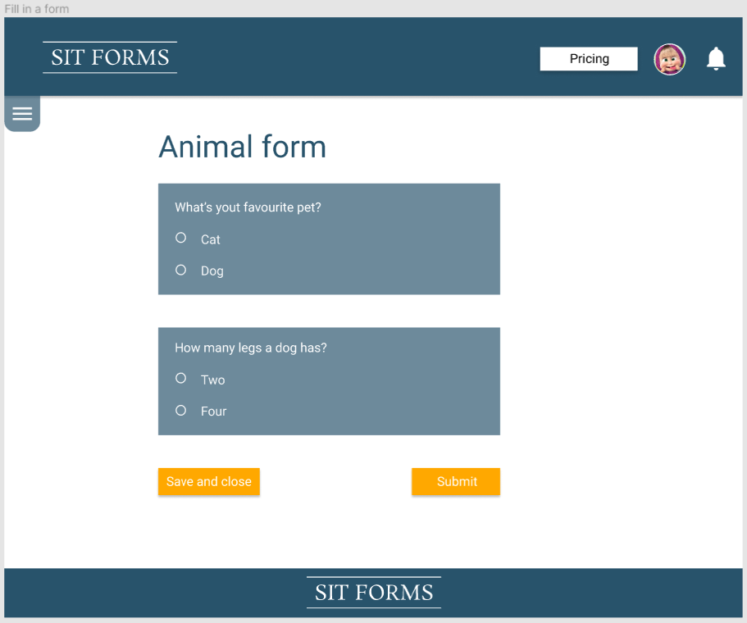

Odhad pracnosti: 0m

## Fill form - logged in example 2

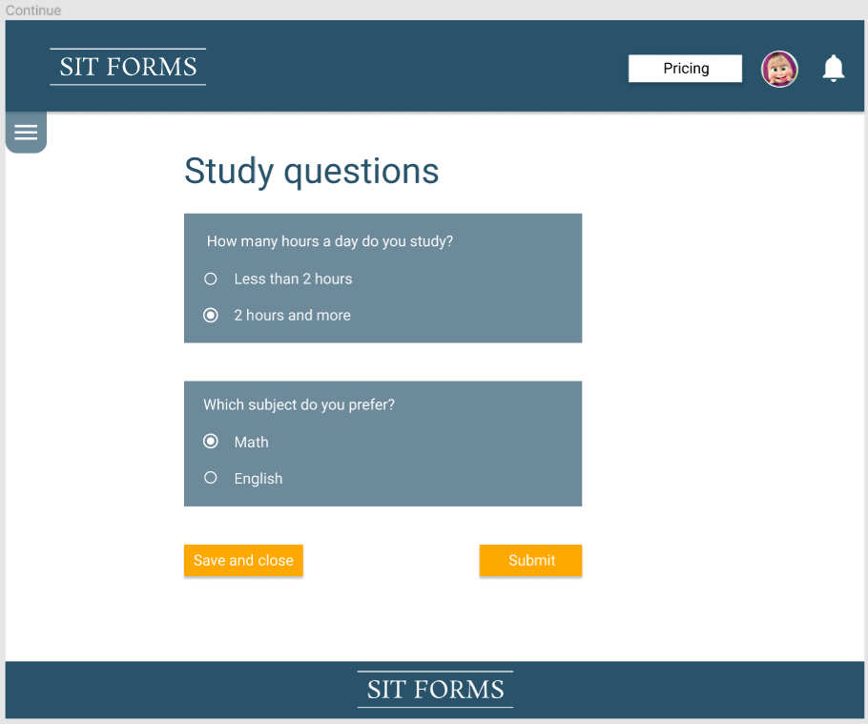

Odhad pracnosti: 0m

## Statistics - logged in

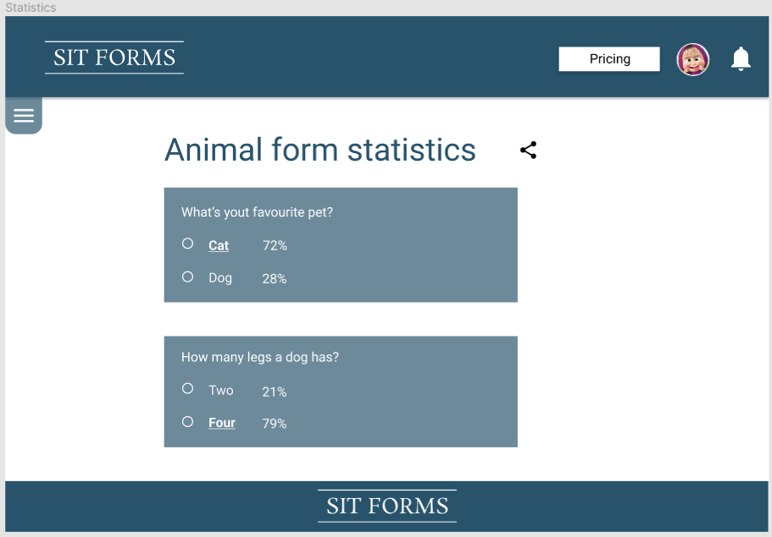

Odhad pracnosti: 0m

## Share statistics - logged in

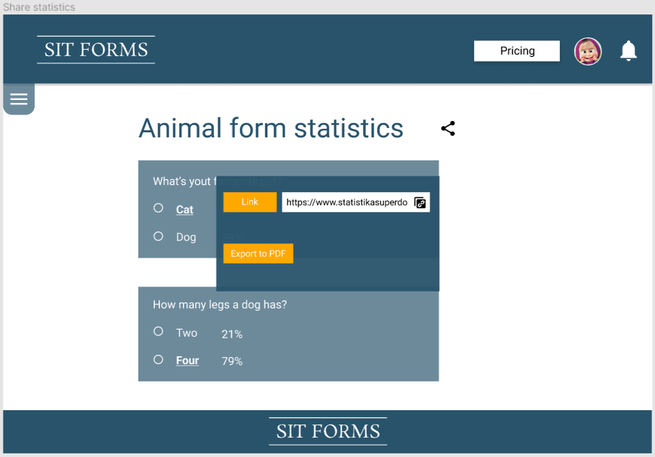

Odhad pracnosti: 0m

## Managed form - share

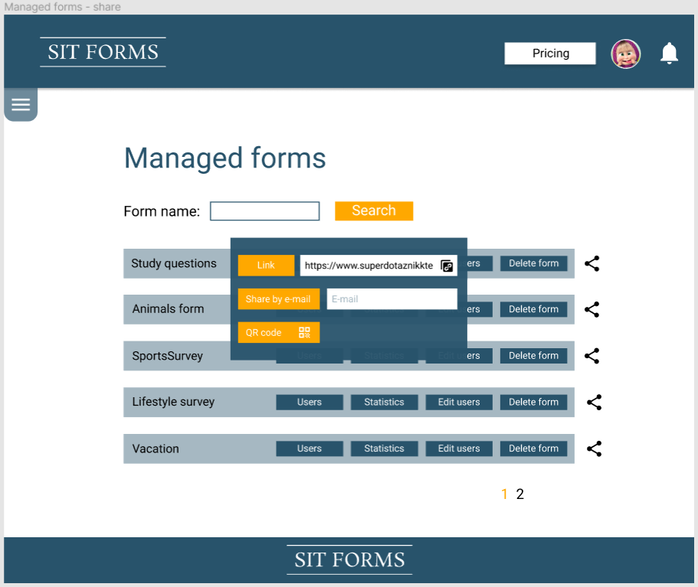

Odhad pracnosti: 10m

## Form creator with left menu bar

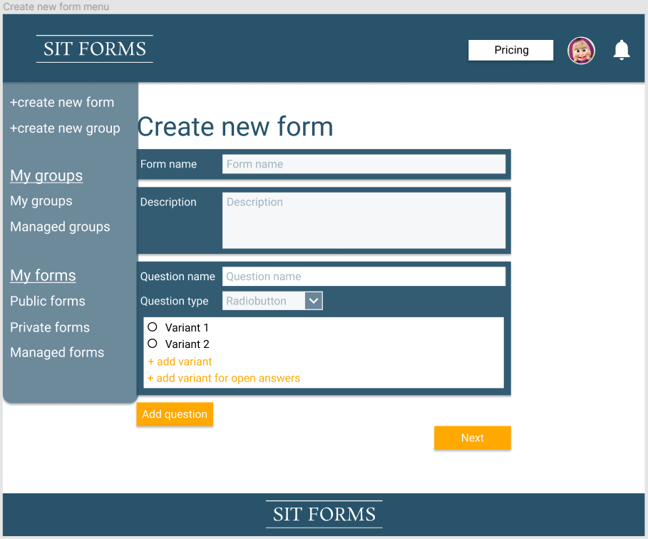

Odhad pracnosti: 0m

Form creator - left menu bar - choose question type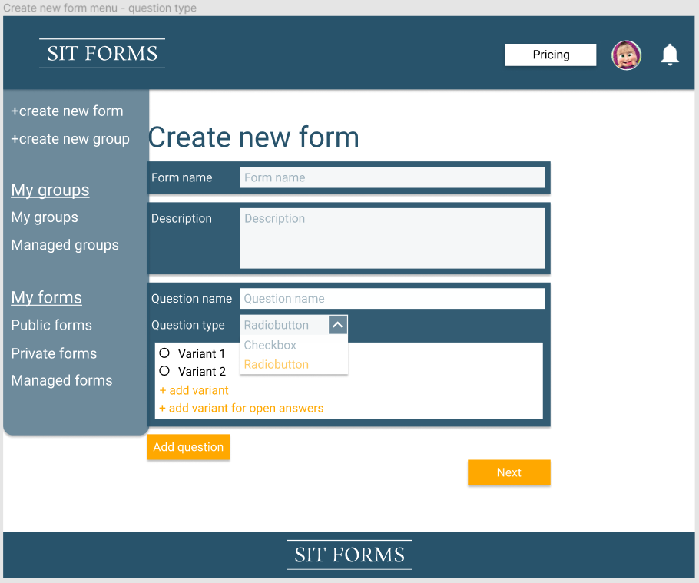

Odhad pracnosti: 0m

## Form creator with left menu bar - form settings

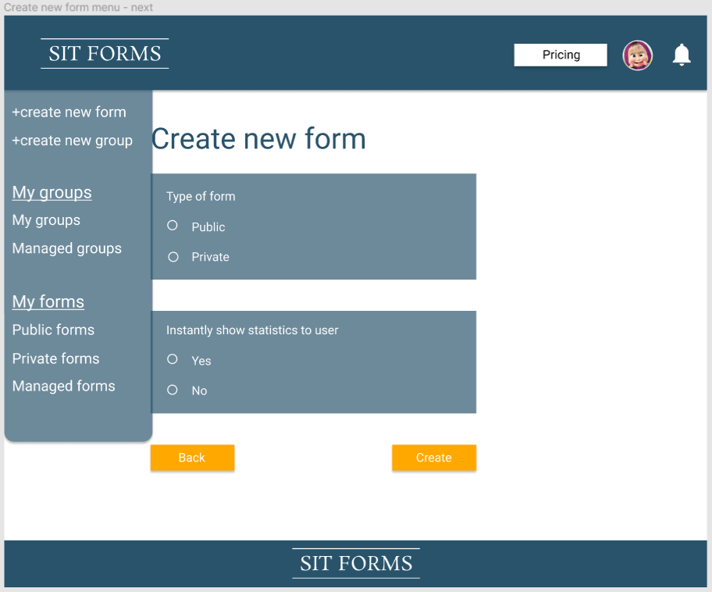

Odhad pracnosti:0m

## Form creator - grant permission to users

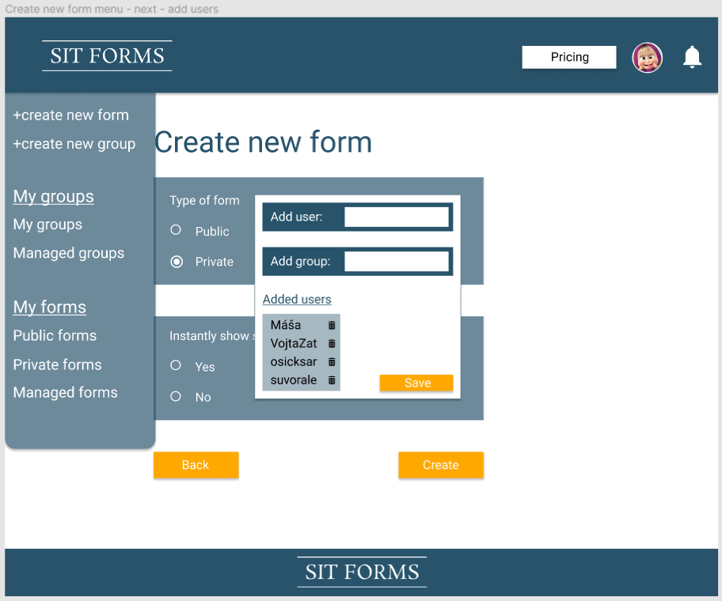

Odhad pracnosti:0m

## Form creator with left menu - form settings, choose private type

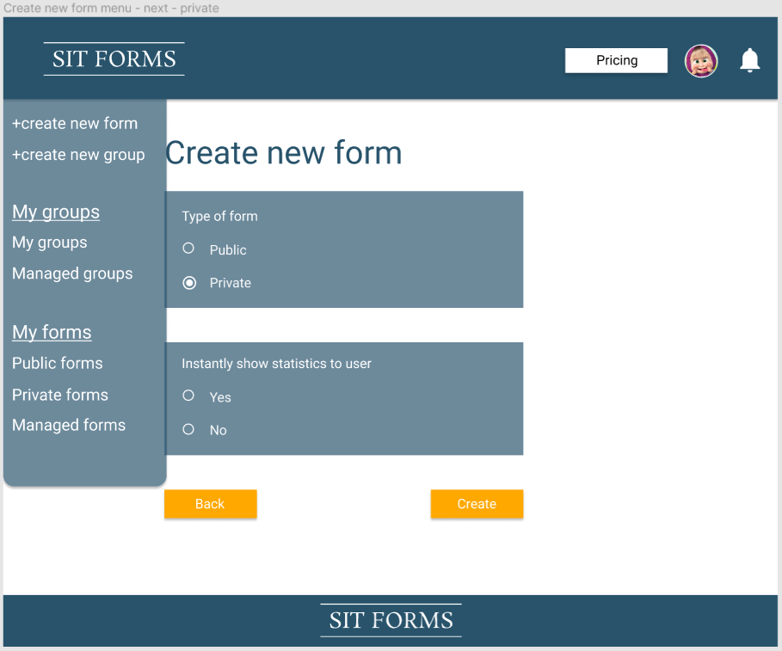

Odhad pracnosti:0m

## Public forms list logged in with left menu bar

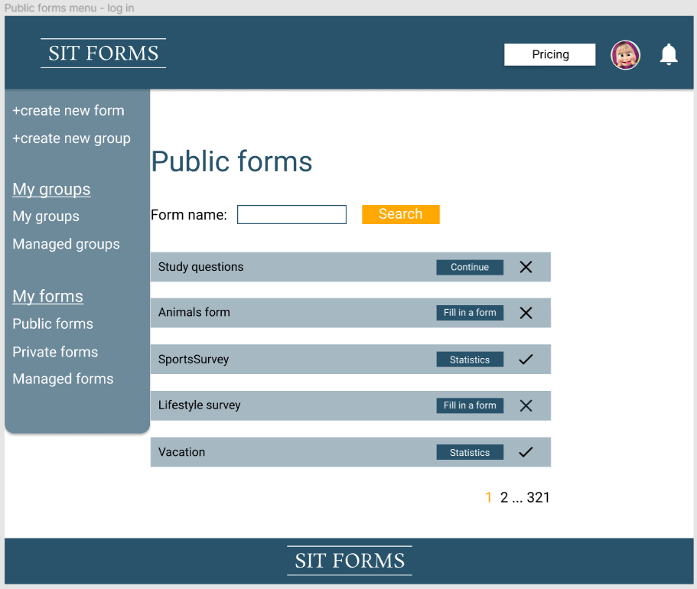

Odhad pracnosti:0m

## Private forms list with left menu bar

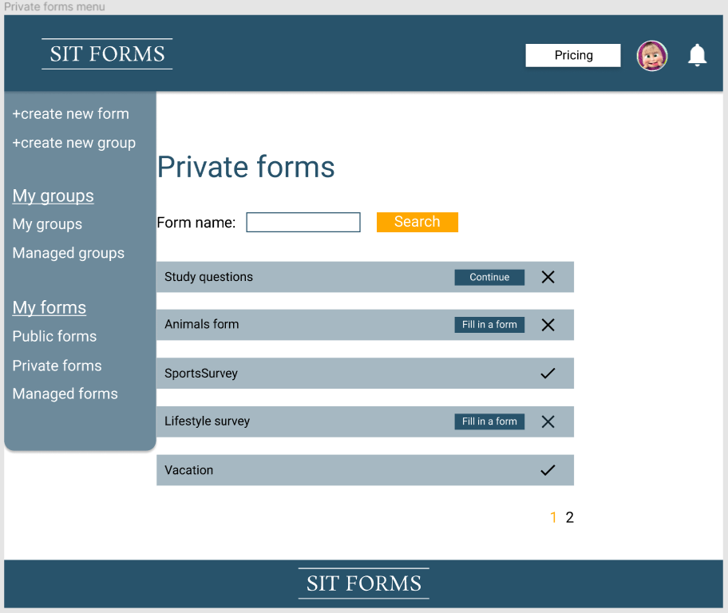

Odhad pracnosti:0m

## Managed forms with left menu bar

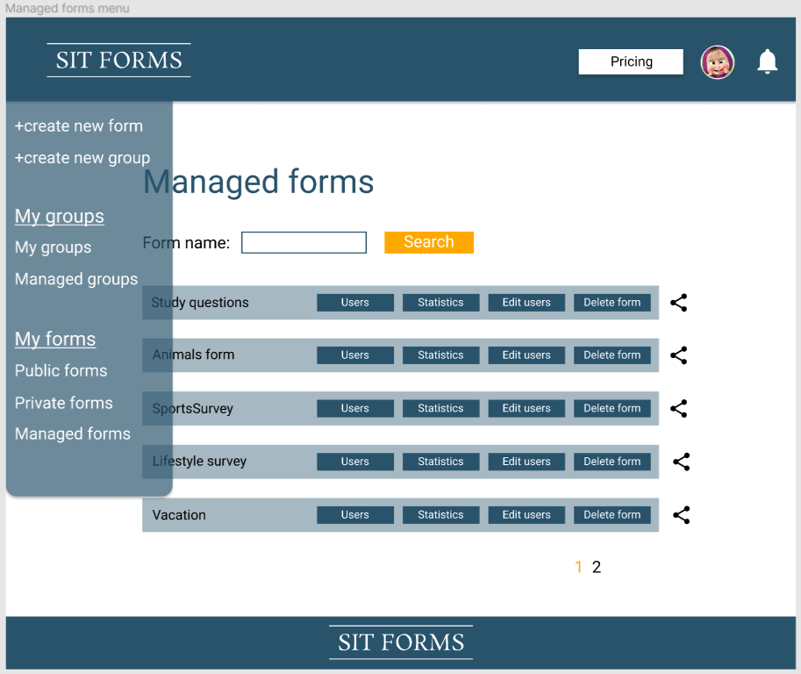

Odhad pracnosti:0m

## List of form’s respondents with left menu bar

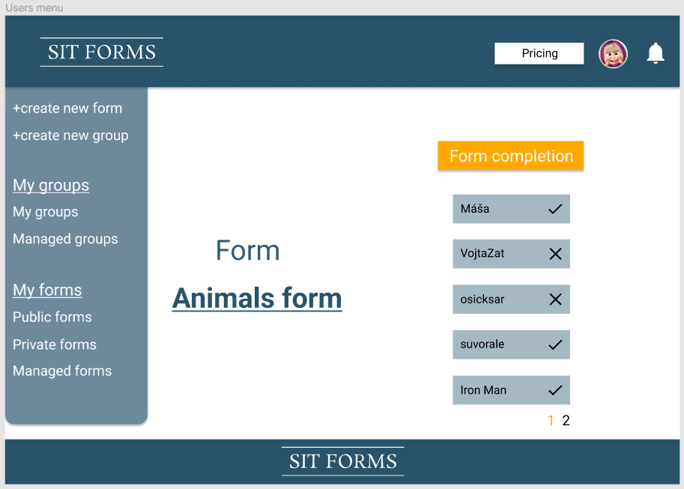

Odhad pracnosti:0m

Edit list of form’s respondents (left menu bar)

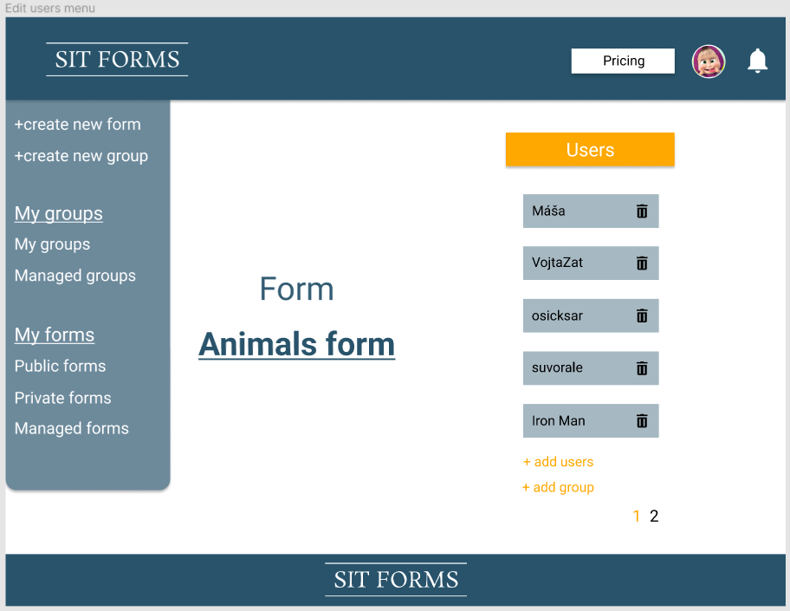

Odhad pracnosti:0m

## Grant permission to user (left menu bar)

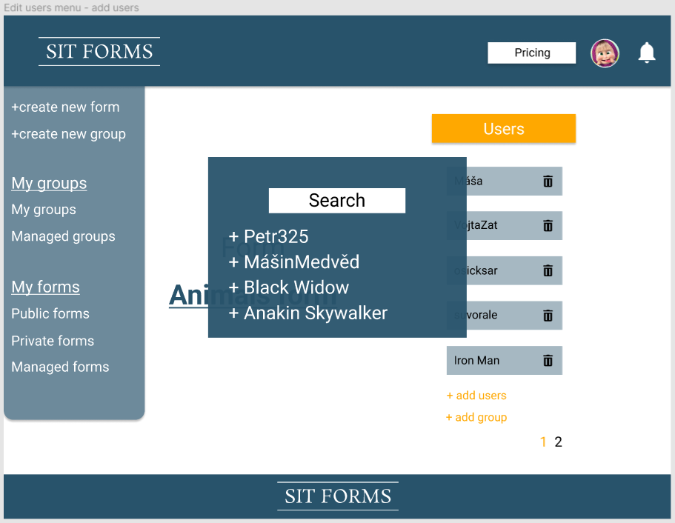

Odhad pracnosti:0m

## Grant permission to group

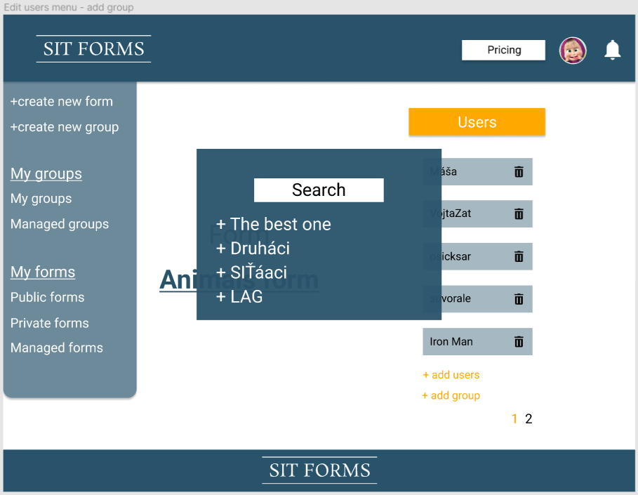

Odhad pracnosti:0m

## Fill a form (left menu bar)

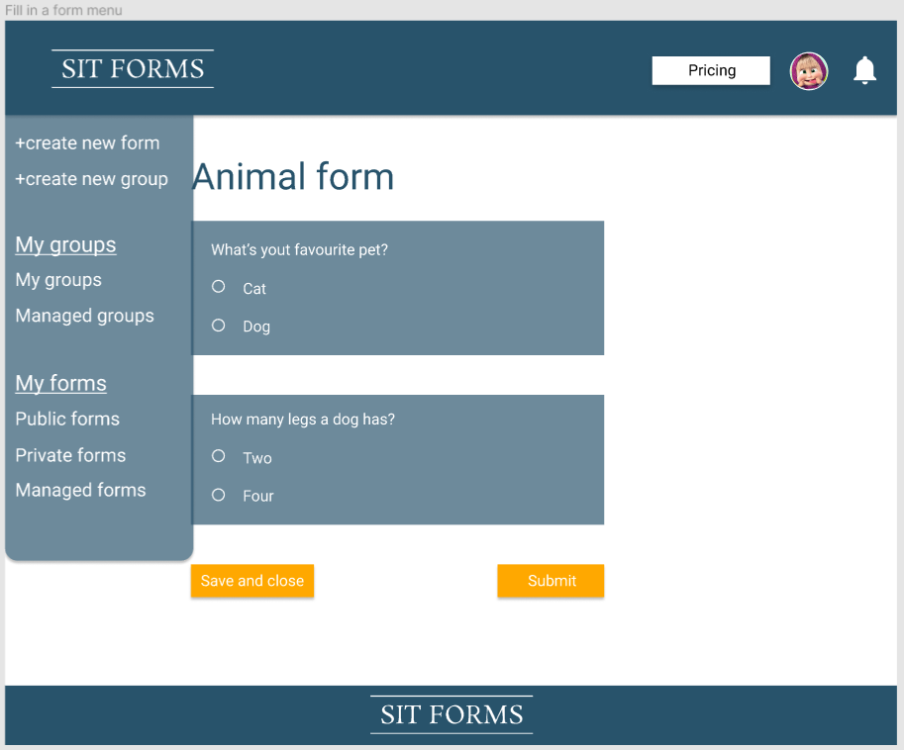

Odhad pracnosti:0m

## Continue menu

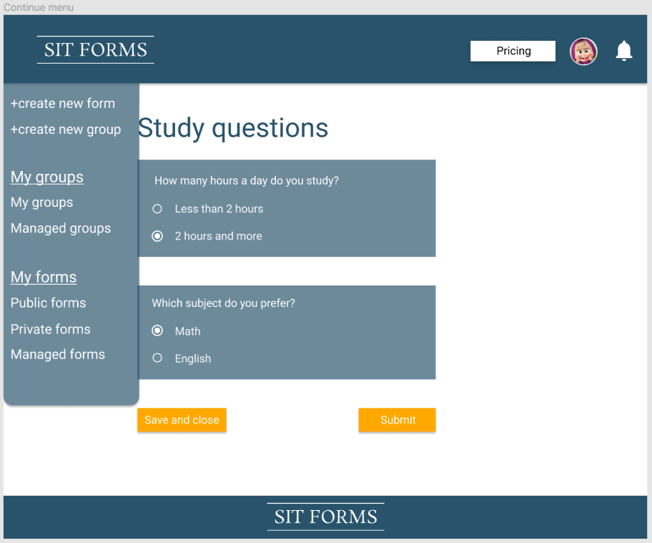

Odhad pracnosti:0m

## Statistics menu

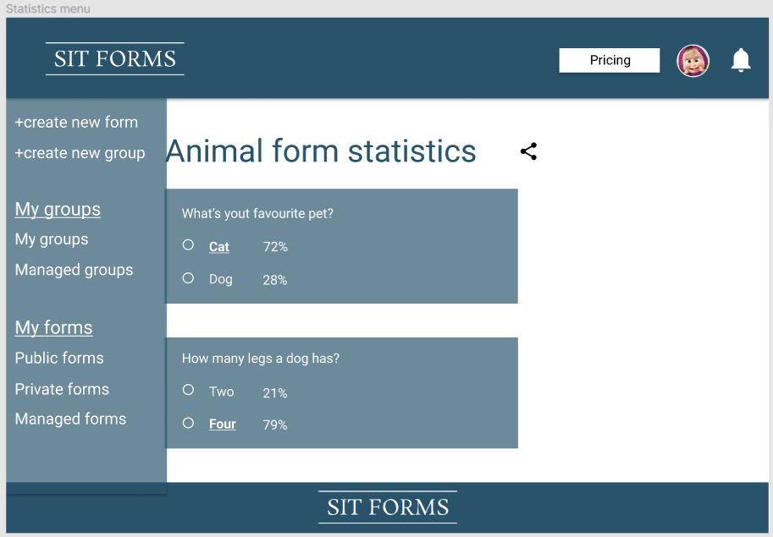

Odhad pracnosti:0m

## Share statistics menu

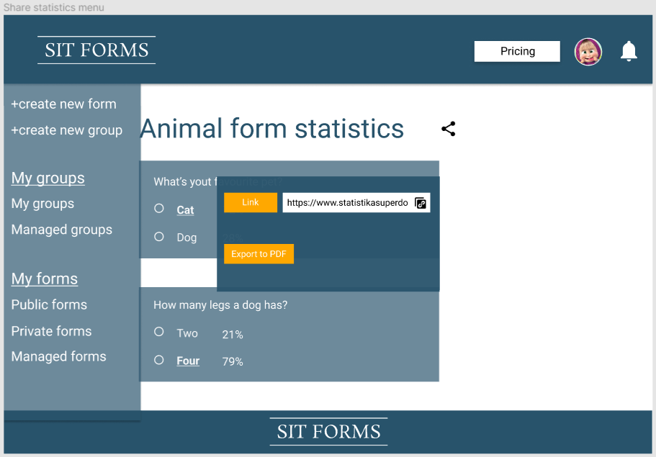

Odhad pracnosti:0m

## Managed forms menu - share

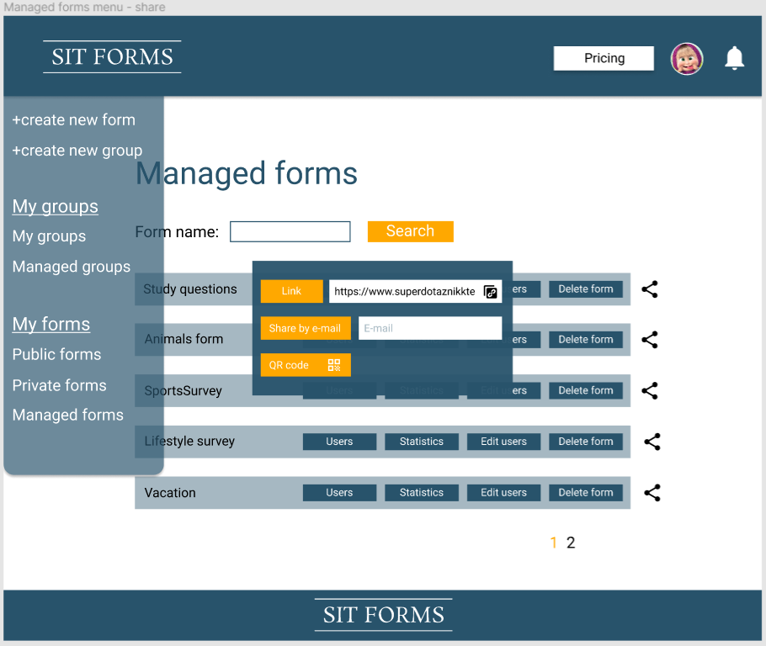

Odhad pracnosti:0m

## Create new group

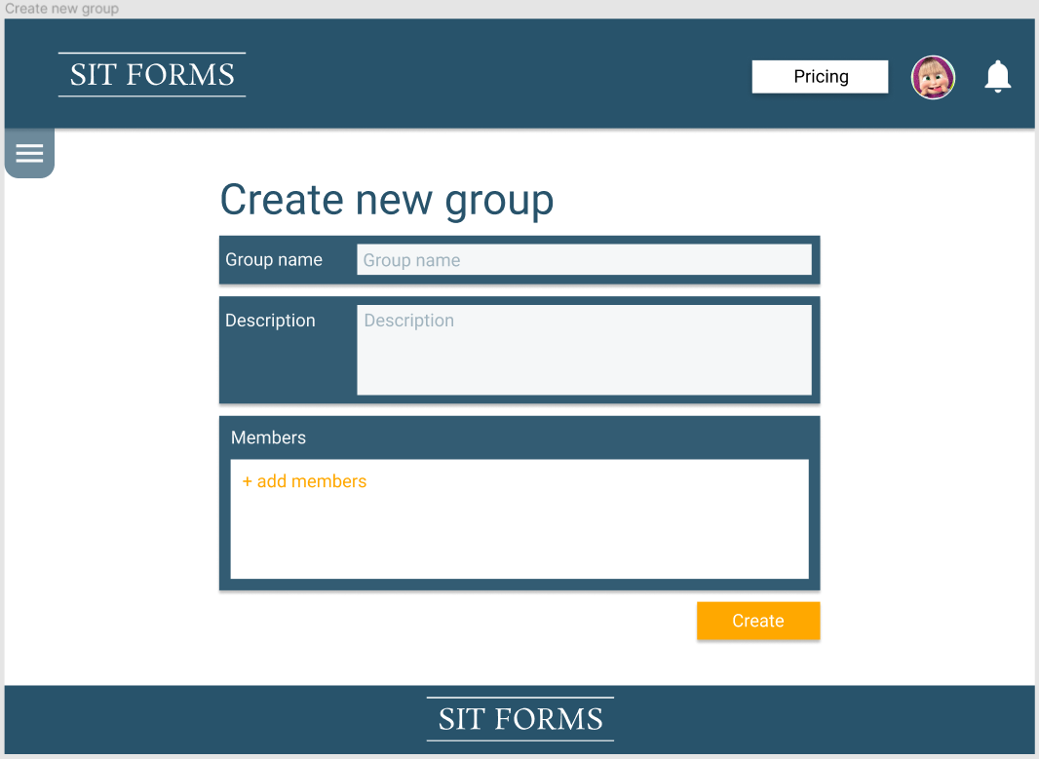

Odhad pracnosti: 30m

## My groups

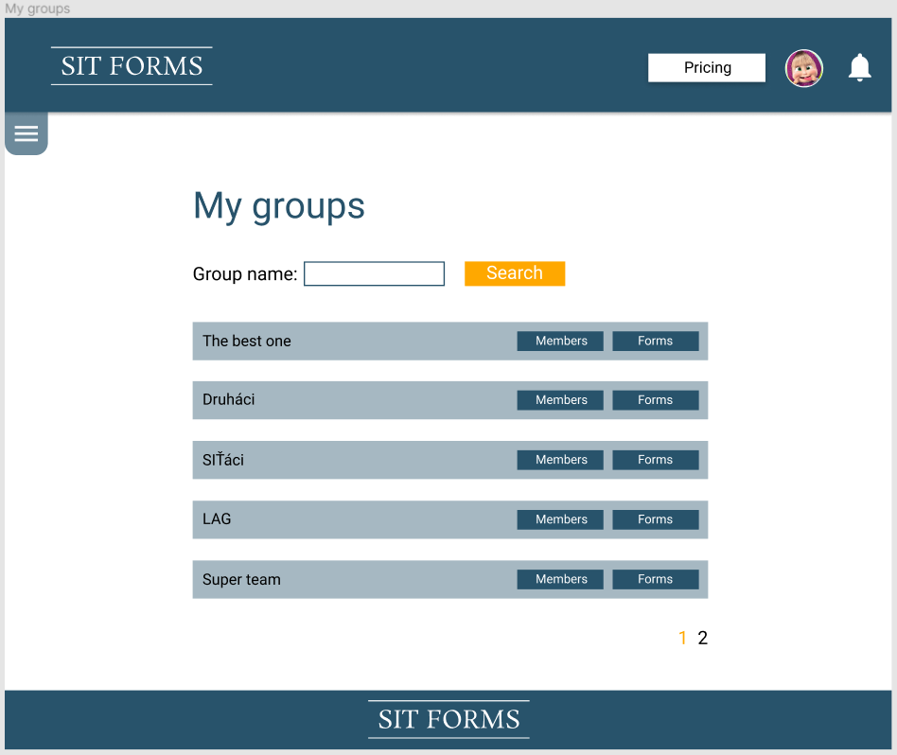

Odhad pracnosti: 20m

## Group members

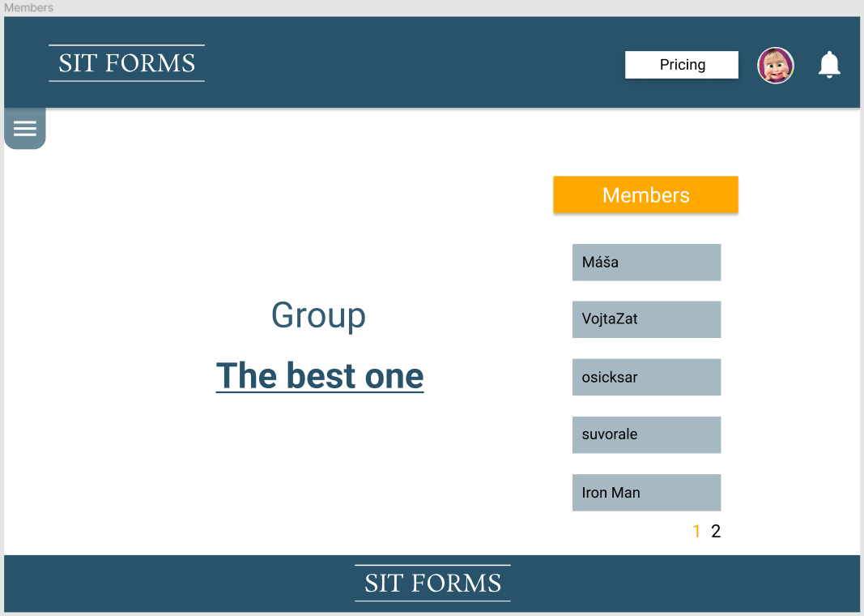

Odhad pracnosti: 20m

## Group forms

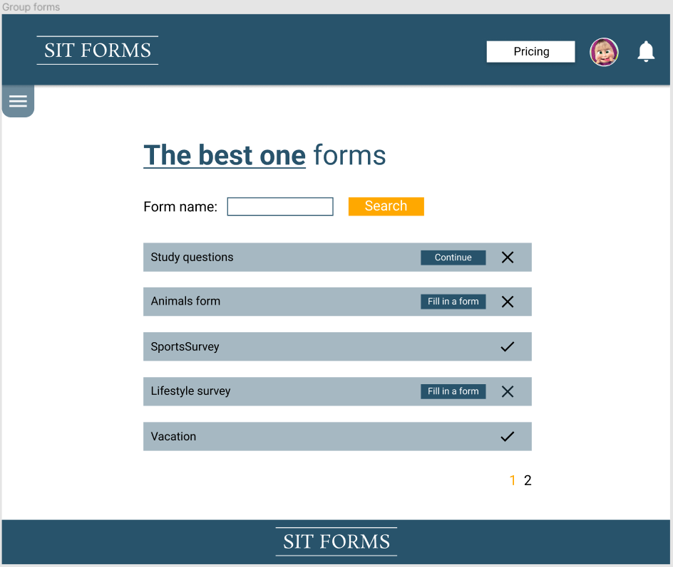

Odhad pracnosti: 20m

## Managed groups

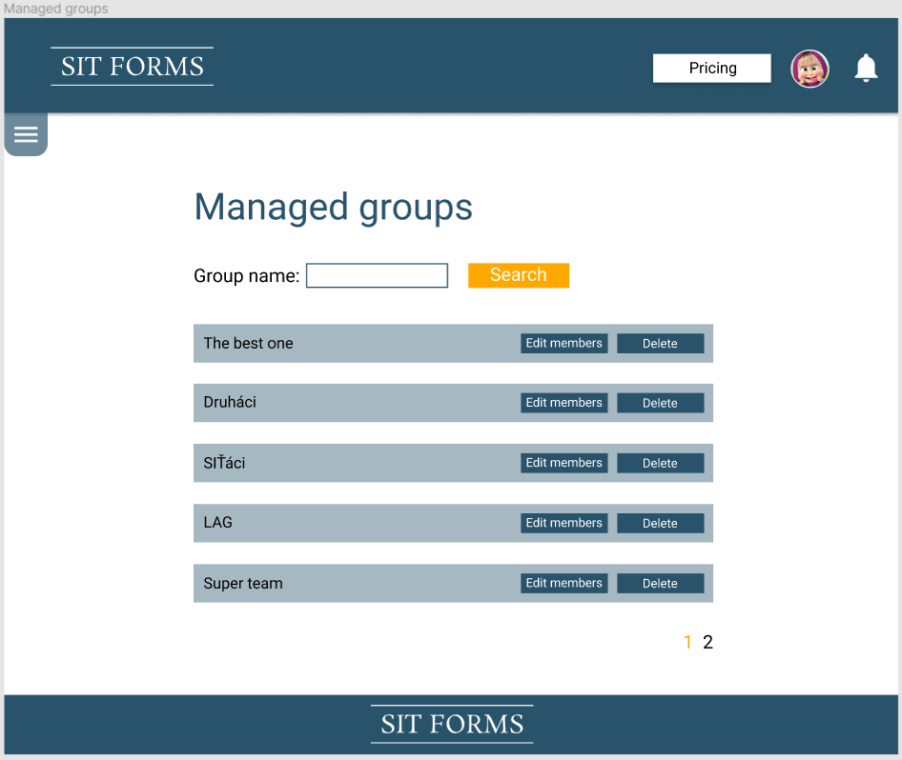

Odhad pracnosti: 15m

## Edit group members

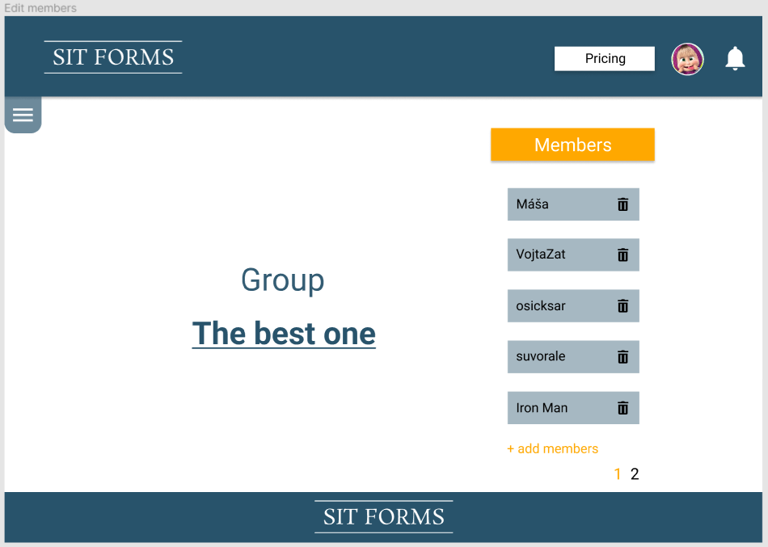

Odhad pracnosti: 15m

## Edit member - add member

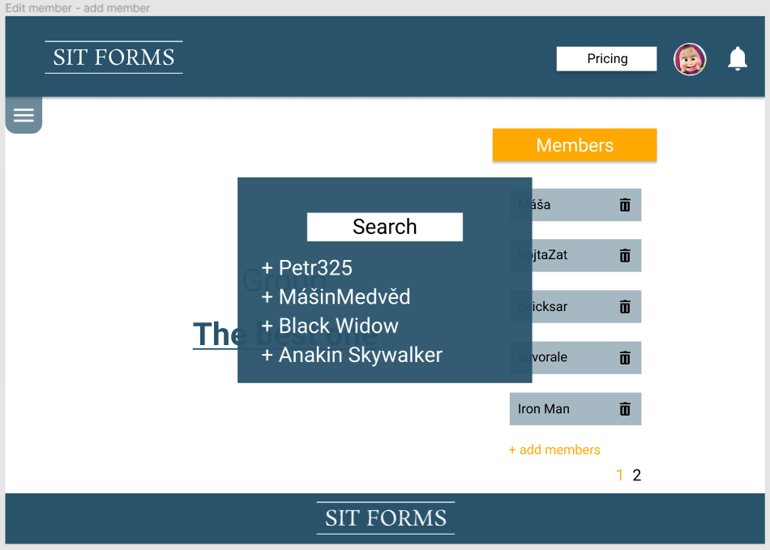

Odhad pracnosti: 15m

## Create new group menu

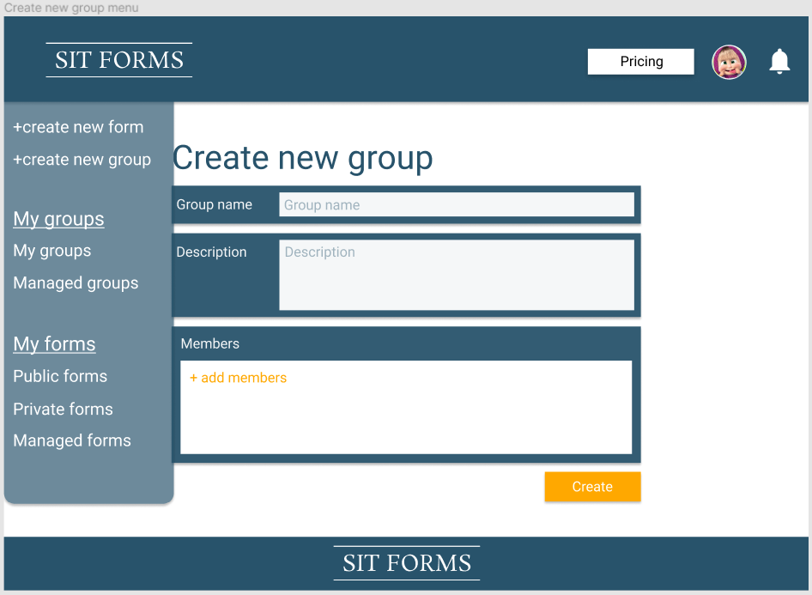

Odhad pracnosti: 0m

## My groups menu

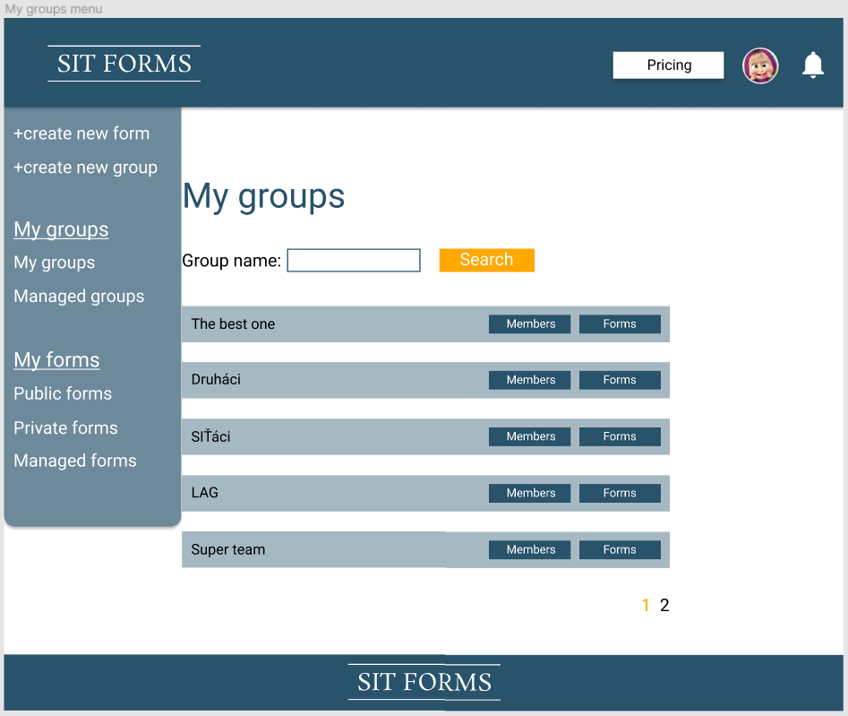

Odhad pracnosti:0m

## Members menu

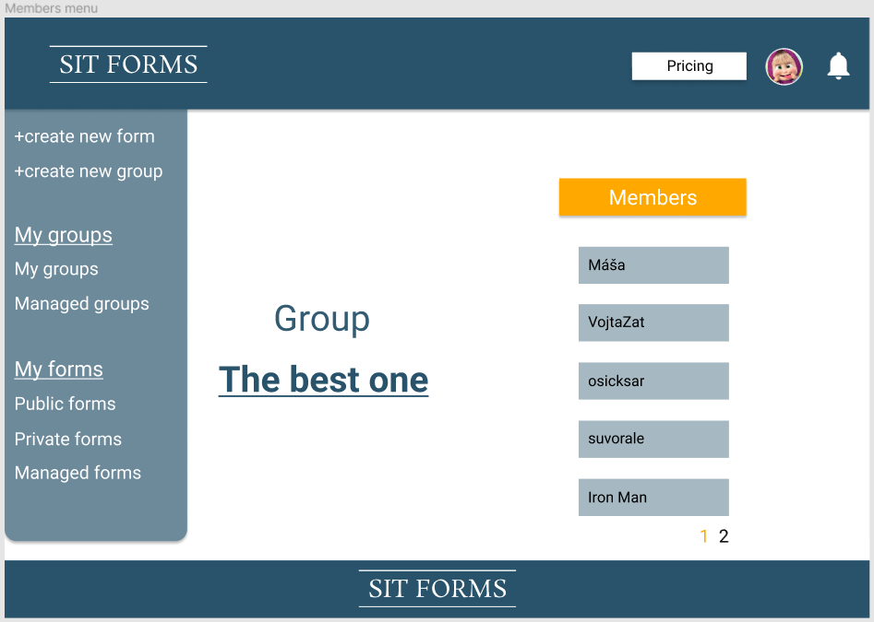

Odhad pracnosti:0m

## Group forms menu

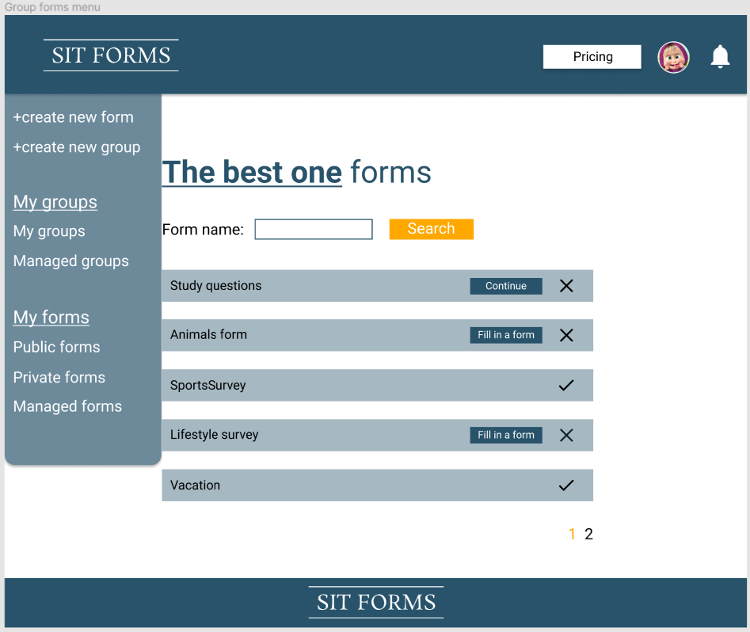

Odhad pracnosti:0m

## Managed group menu

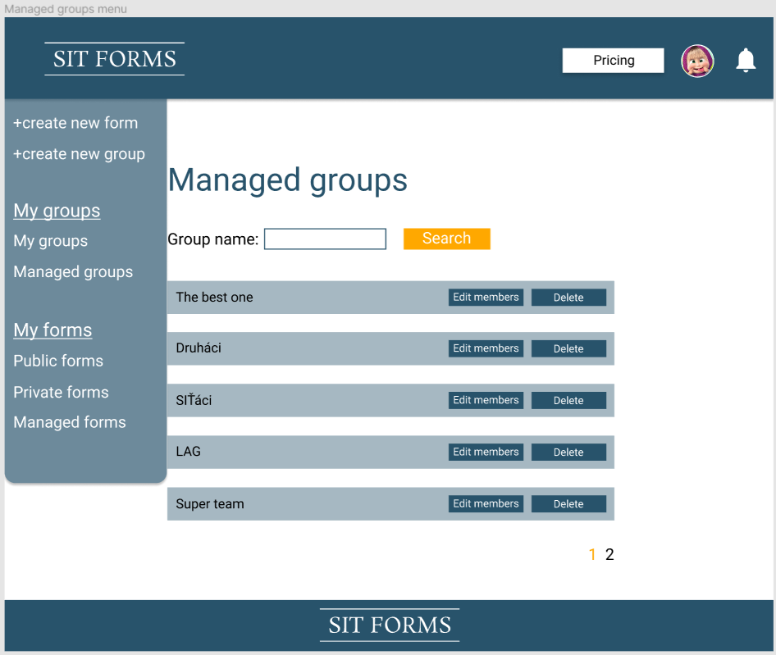

Odhad pracnosti:0m

## Edit members menu

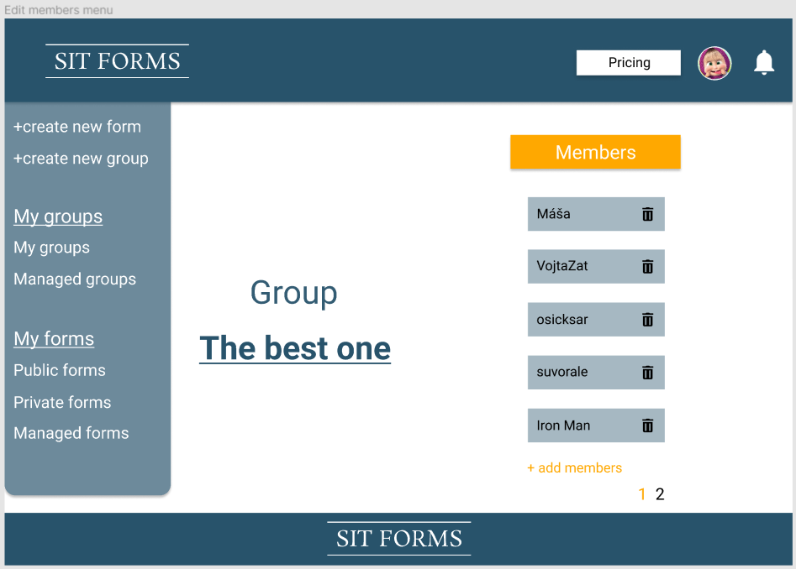

Odhad pracnosti: 0m

## Edit members menu - add member

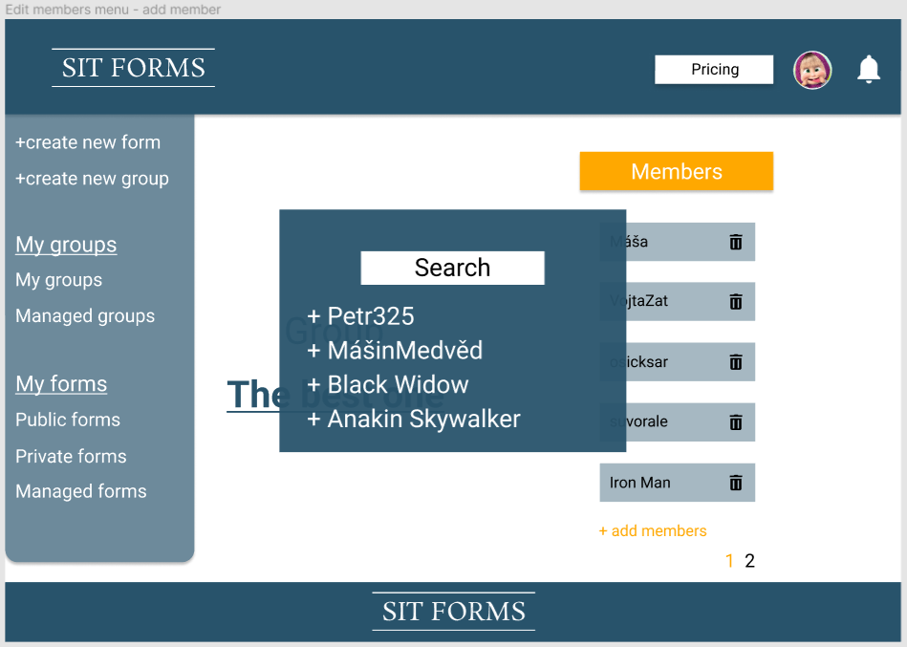

Odhad pracnosti: 0m