I am using EF code first approach so perform migrations

Change connection string in Web.config I am using SqlServer , create ORDER Database

<connectionStrings>

<add name="OrderDB" connectionString="Data Source=MUKTAR;Integrated Security=True;Database=ORDER" providerName="System.Data.SqlClient" />

</connectionStrings>

perform migration

using commands - unable-migrations and update-database

Register User (api/user/register)

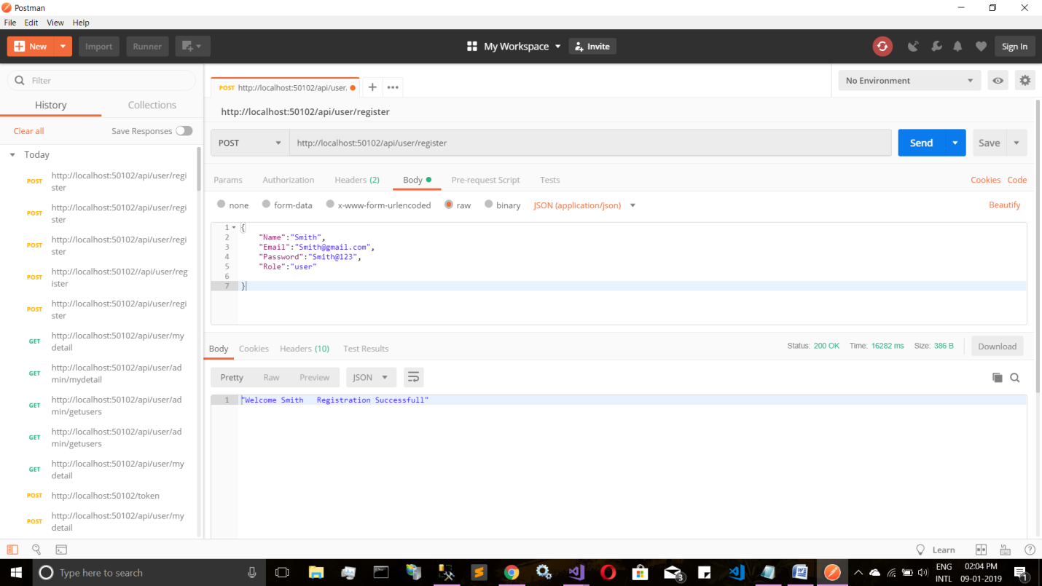

Get authentication Token for user

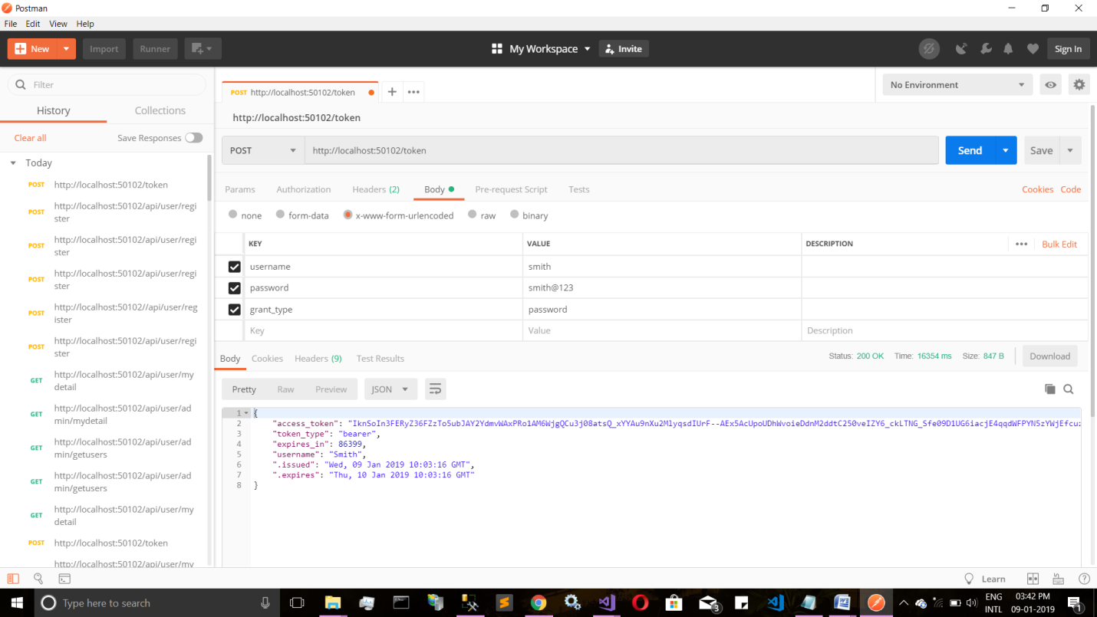

Pass in Header Using Authorization Key With value(token)

Bearer <paste Token>

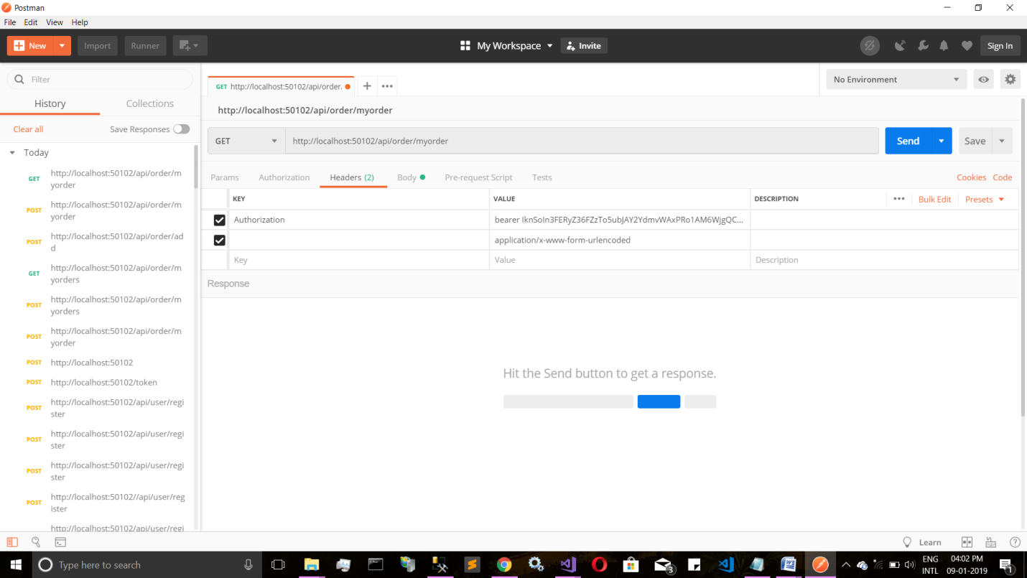

First Post order

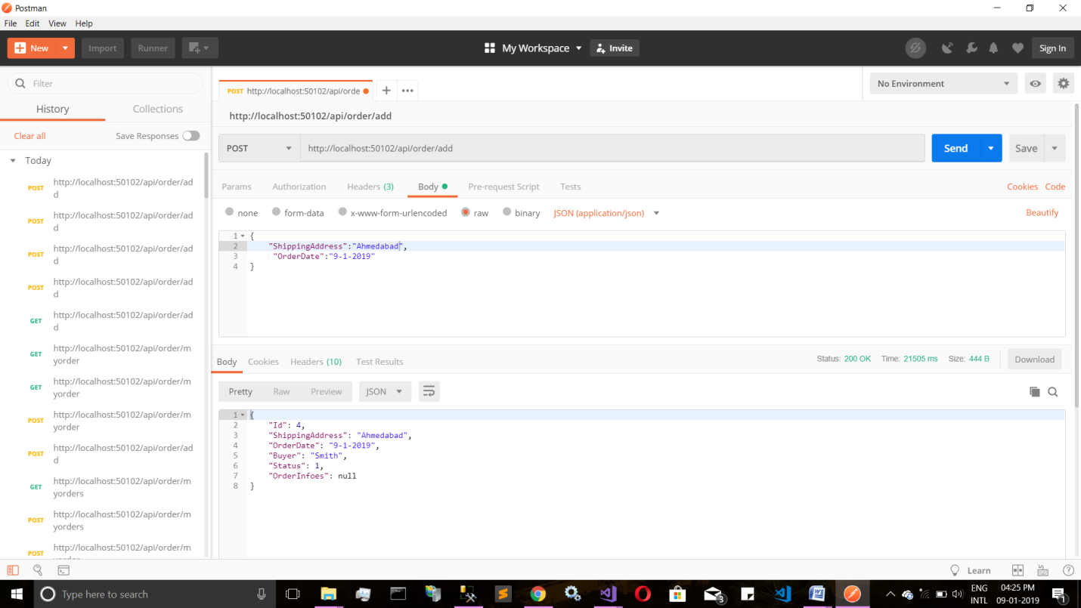

Get MyOrders Only

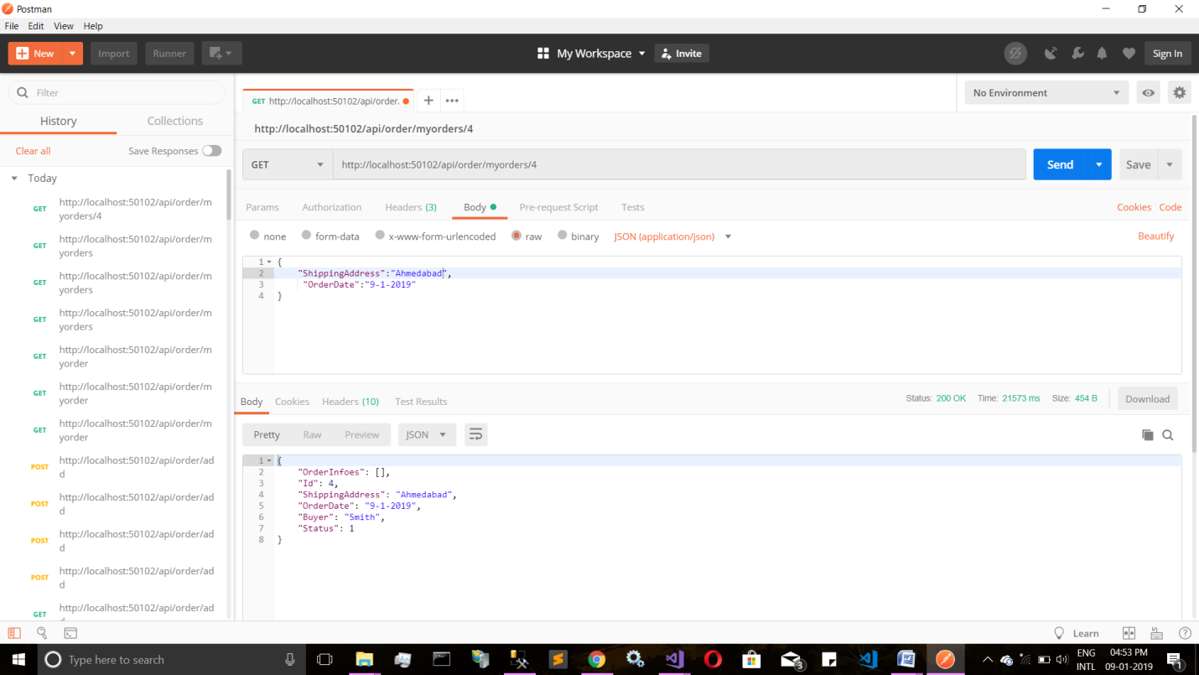

Update My Order

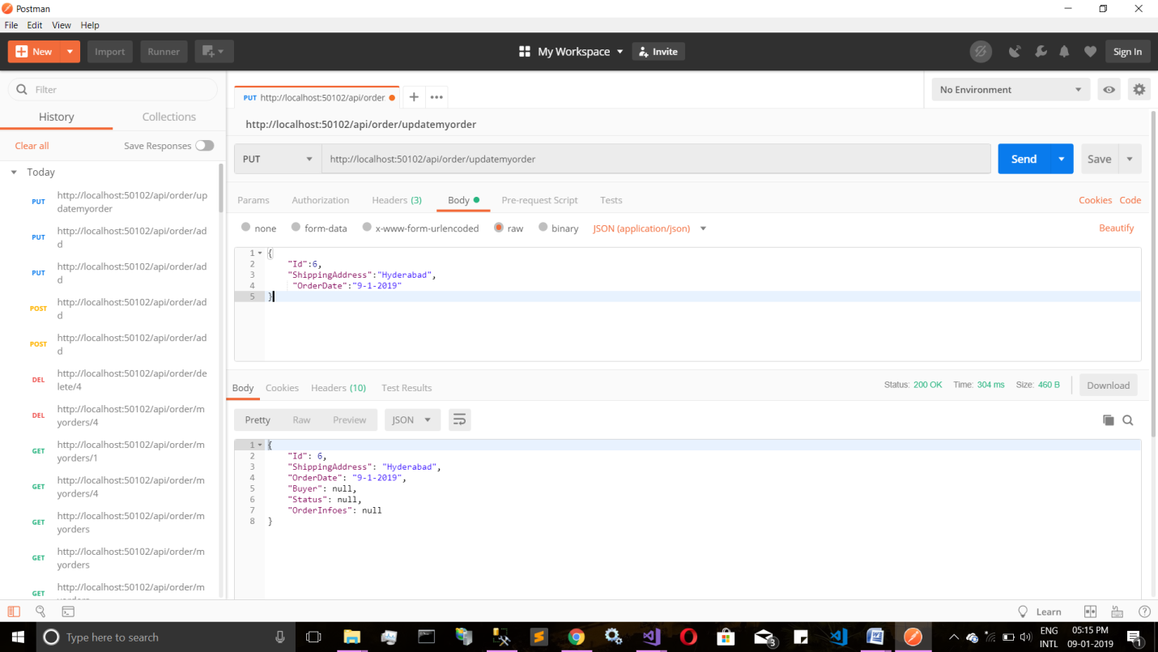

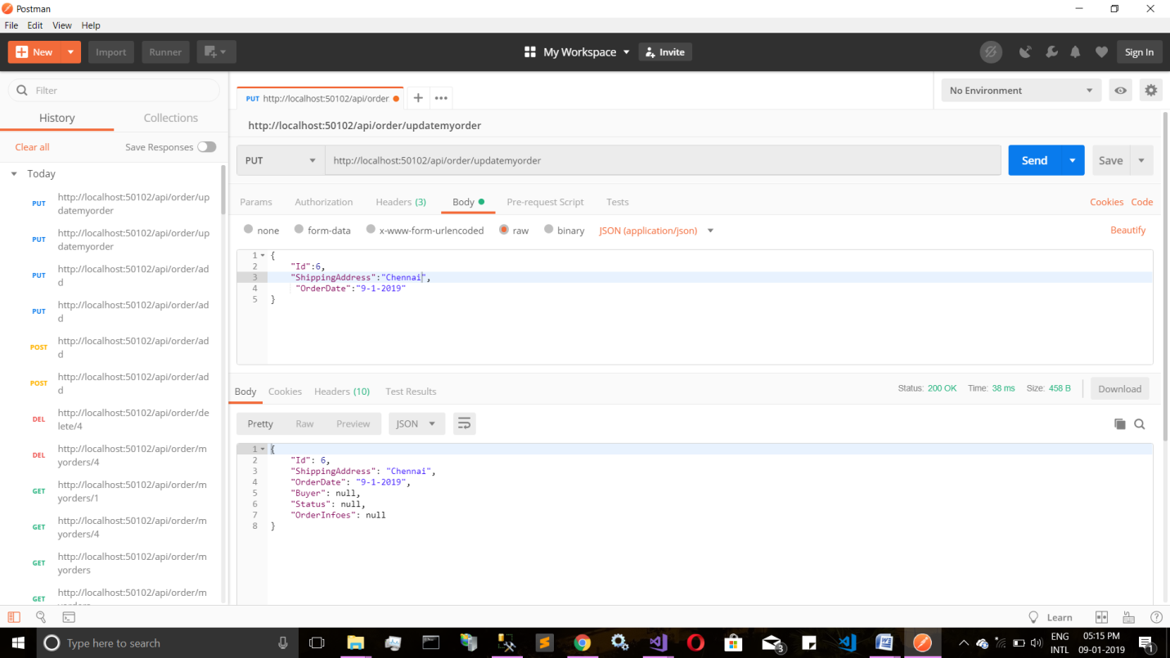

Delete my Order

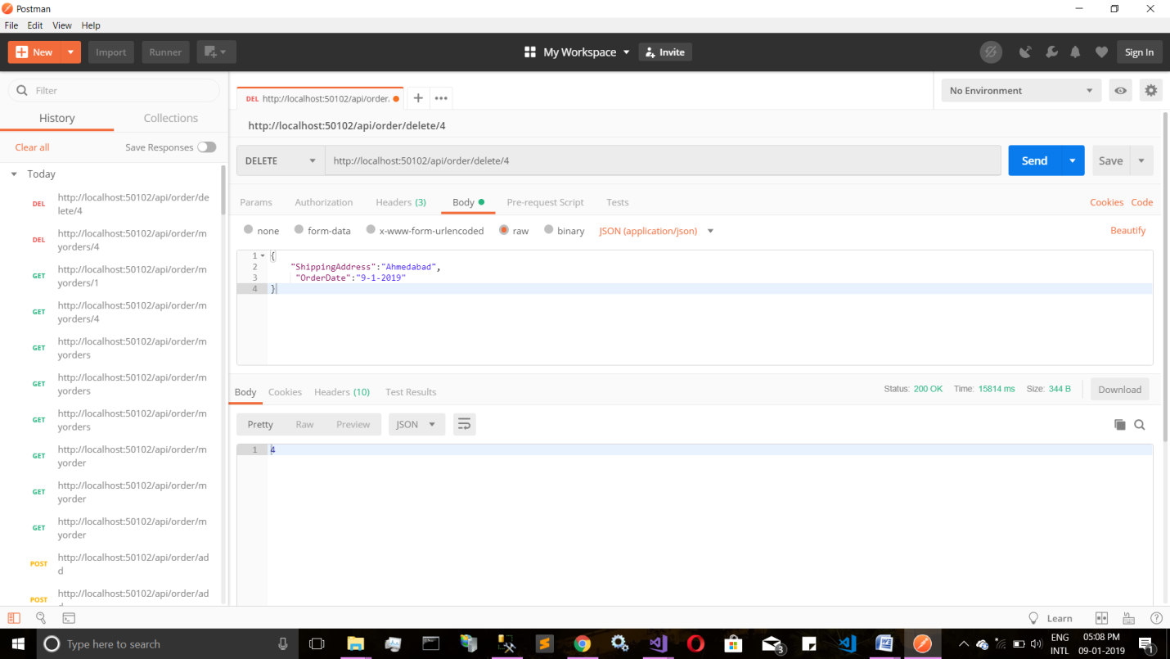

Get Token Fro Admin Access

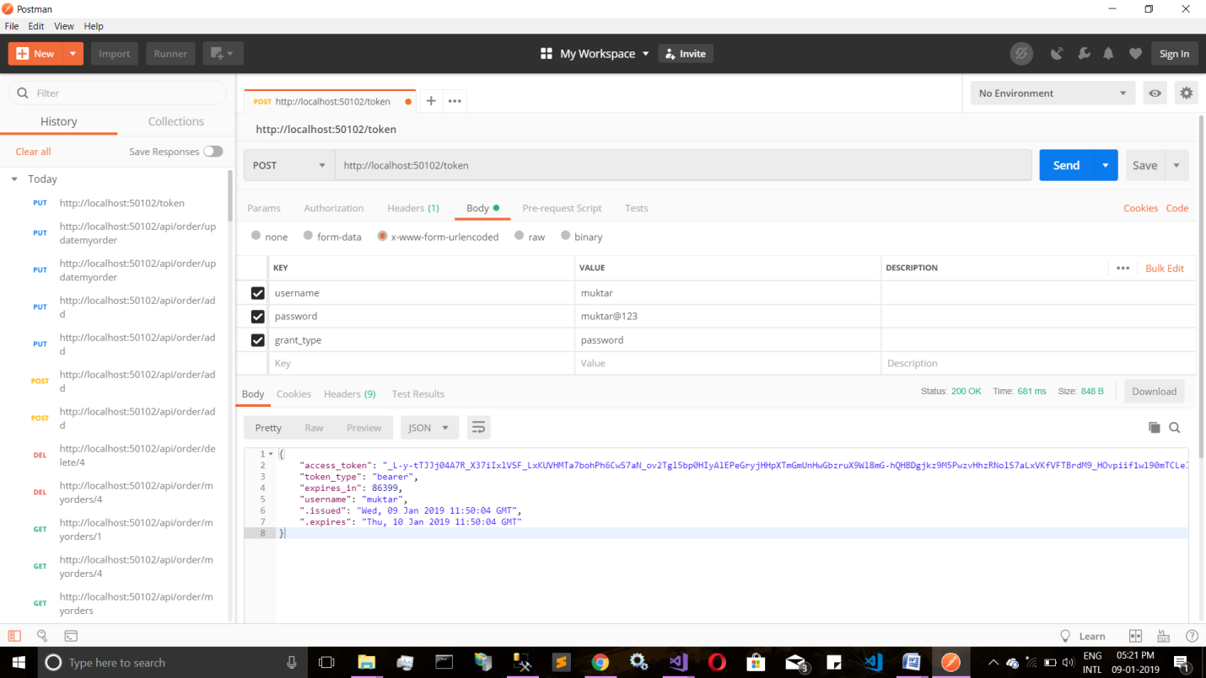

Admin Can See All The Orders

