Housing Price Prediction
Technical Documentation & Analysis Report
Machine Learning | Python | scikit-learn | Linear Regression

1. Project Overview

This project presents a complete machine learning pipeline for predicting residential housing prices using the Housing.csv dataset. The primary goal is to develop a regression model capable of estimating the market price of a property given its physical attributes and amenities. Housing price prediction is a fundamental problem in real estate analytics, financial modelling, and investment decision-making.
The dataset consists of 545 property records across 13 columns, encompassing both numerical and categorical features. These include area (square footage), number of bedrooms, bathrooms, stories, binary amenity indicators (air conditioning, guestroom, basement, mainroad, hot water heating, preferred area), parking spaces, and furnishing status. The target variable is the property price.
The workflow follows industry-standard machine learning practices: raw data loading, exploratory data analysis (EDA), data preprocessing (encoding and scaling), model training using Linear Regression, and performance evaluation using R², MAE, and RMSE. All steps were implemented in Python using pandas, scikit-learn, matplotlib, and seaborn libraries within a Jupyter Notebook environment.
The project demonstrates how structured property data can be used to build interpretable predictive models. The results provide actionable insights into which features most significantly influence housing prices, offering value for property valuation, buyer decision support, and real estate market analysis.

2. Dataset Overview

The dataset (Housing.csv) contains 545 rows and 13 columns covering diverse residential property characteristics. It was loaded using the pandas library. The dataset is clean and complete, with zero missing values across all 13 columns, confirmed via df.isna().sum(). This eliminates the need for imputation techniques and simplifies the preprocessing pipeline.
The price column (target variable) ranges from ₹1,750,000 to ₹13,300,000 with a mean of approximately ₹4,766,729 and a standard deviation of ₹1,870,440, indicating moderate spread. The area ranges from 1,650 to 16,200 square feet with a mean of ~5,150 sq ft. Bedrooms range from 1 to 4, with most properties having 2 or 3 bedrooms. Bathrooms range from 1 to 4 with a mean of ~1.29.
The categorical features — mainroad, guestroom, basement, hotwaterheating, airconditioning, and prefarea — are binary (yes/no). The furnishingstatus column has three categories: furnished, semi-furnished, and unfurnished, as confirmed by df['furnishingstatus'].nunique() returning 3. The parking column is numeric (0 to 3 spaces).
Overall the dataset is well-structured for a supervised regression task. Its combination of physical, locational, and amenity features provides a rich feature space. The absence of missing data, along with reasonable variance in all columns, makes it suitable for demonstrating core ML preprocessing and modelling workflows without complex data cleaning.

2.1 Feature Description
Feature | Type | Description
price | Float (target) | Property sale price (₹)
area | Integer | Total area in square feet
bedrooms | Integer | Number of bedrooms (1–4)
bathrooms | Integer | Number of bathrooms (1–4)
stories | Integer | Number of floors (1–4)
mainroad | Binary (yes/no) | Property fronts a main road
guestroom | Binary (yes/no) | Has a guest room
basement | Binary (yes/no) | Has a basement
hotwaterheating | Binary (yes/no) | Has hot water heating system
airconditioning | Binary (yes/no) | Has air conditioning
parking | Integer (0–3) | Number of parking spaces
prefarea | Binary (yes/no) | Located in a preferred area
furnishingstatus | Categorical (3 vals) | Furnished / Semi-furnished / Unfurnished

3. Exploratory Data Analysis (EDA)

Exploratory Data Analysis (EDA) was conducted to understand the statistical properties and distributions of all features before model training. Two primary visualizations were generated: a histogram grid for all columns and a correlation heatmap. These visualizations reveal patterns, skewness, and inter-feature relationships critical for feature selection and engineering.
The histograms (df.hist()) showed that price follows a right-skewed distribution — most properties are priced in the ₹2M–₹6M range with fewer premium properties above ₹10M. Area is similarly right-skewed, with a long tail toward 16,200 sq ft. Discrete features like bedrooms and bathrooms are concentrated at low values (2–3 bedrooms, 1 bathroom). Stories has a bimodal distribution around 1 and 2. Binary amenity features show class imbalance — for example, most properties do not have air conditioning or hot water heating, while majority do front main roads.
The correlation heatmap (using sns.heatmap on df.corr()) quantified the linear relationship between all feature pairs. Area (0.536) and bathrooms (0.518) had the highest positive correlations with price, followed by airconditioning (0.453), stories (0.421), and parking (0.384). Hotwaterheating (0.093) and basement (0.187) had the weakest correlations. These insights guided interpretation of model coefficients after training.
No feature showed a negative correlation with price, suggesting all features contribute positively — properties with more amenities command higher prices. The heatmap also revealed some inter-feature correlations (e.g., bedrooms and area are moderately correlated at ~0.30), which could introduce mild multicollinearity. However, for a linear regression baseline this was acceptable without requiring dimensionality reduction.

3.1 Histogram — All Features
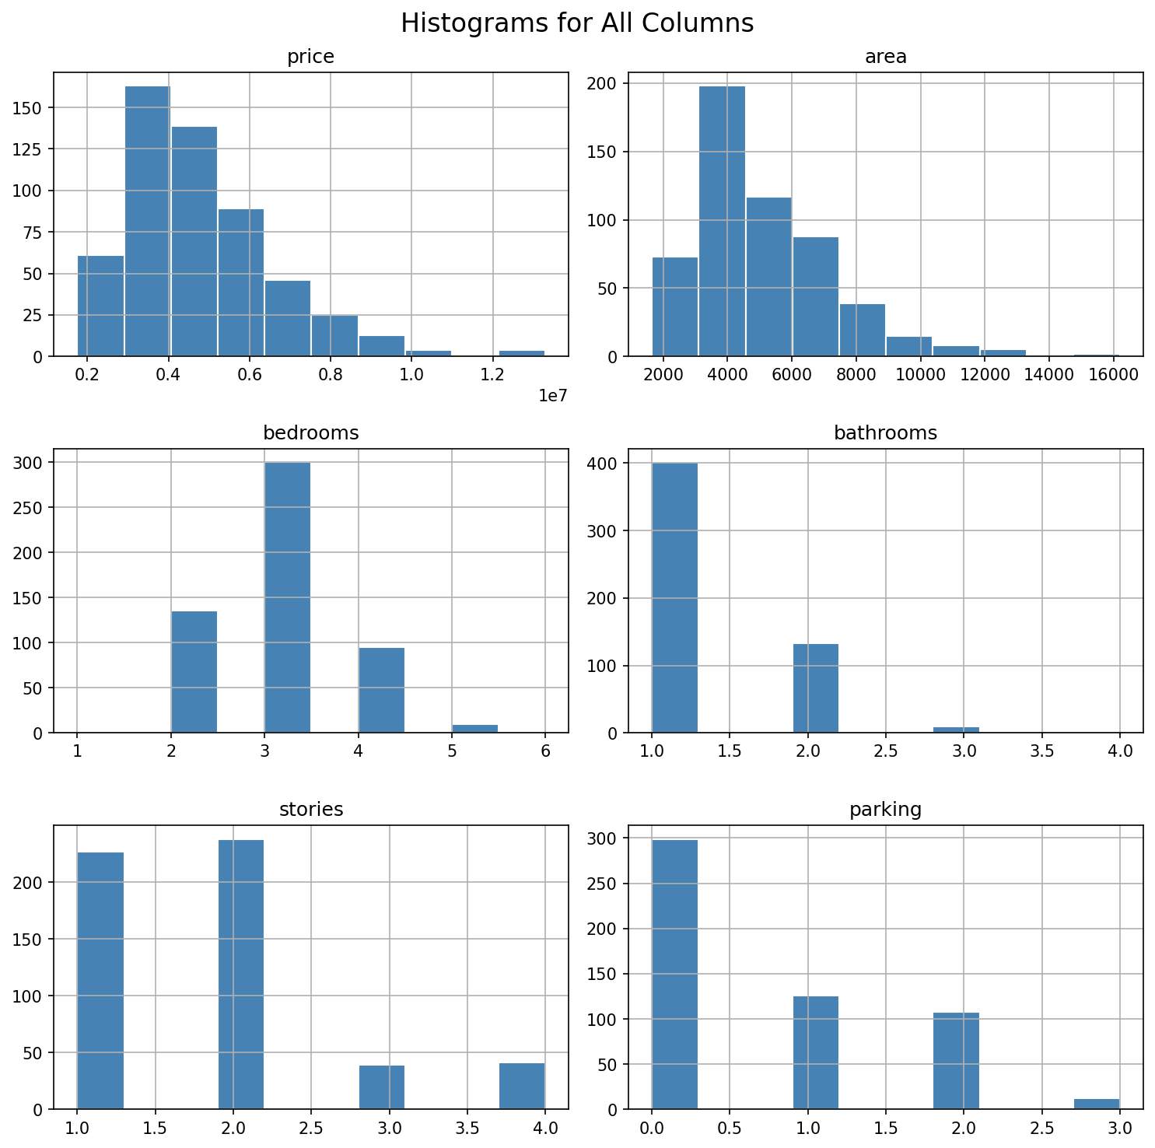

3.2 Correlation Heatmap
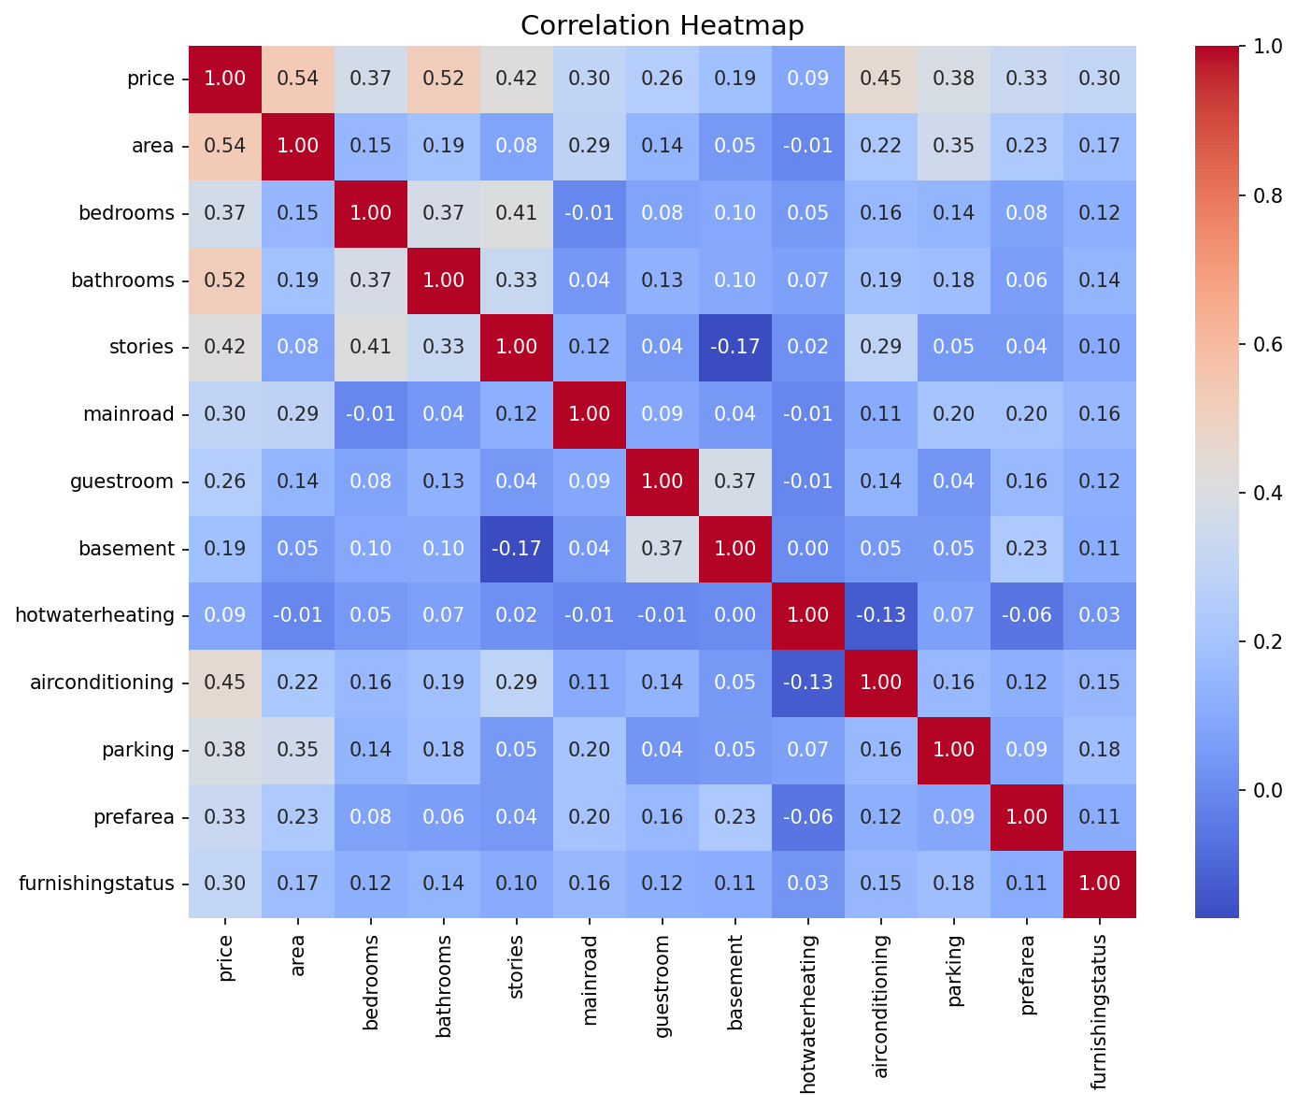

4. Data Preprocessing

Data preprocessing is the critical step of transforming raw data into a format suitable for machine learning algorithms. For this dataset, preprocessing involved three main operations: label encoding of binary categorical variables, ordinal encoding of the furnishing status column, and standard scaling of continuous numerical variables.
The six binary columns (mainroad, guestroom, basement, hotwaterheating, airconditioning, prefarea) were mapped from yes/no strings to integer 1/0 using pandas .replace(). This is a straightforward encoding since these are genuinely binary features with no ordinal relationship. The furnishingstatus column was mapped as: unfurnished→0, semi-furnished→1, furnished→2, implying an ordinal scale reflecting increasing furnishing level and its assumed positive impact on price.
StandardScaler from scikit-learn was applied to the price and area columns. StandardScaler transforms each column to have zero mean and unit standard deviation: z = (x - μ) / σ. This normalization is essential to prevent columns with large absolute values (price in millions, area in thousands) from dominating the regression coefficients. After scaling, mean price ≈ 0 and mean area ≈ 0, with both having σ ≈ 1. All remaining columns (bedrooms, bathrooms, stories, parking) were already on comparable small integer scales and did not require scaling.
After preprocessing, df.dtypes confirmed all columns were numeric (float64 for price and area; int64 for the rest), making the dataset fully compatible with scikit-learn's LinearRegression estimator. The final dataset was split into train and test sets using train_test_split(X, y, test_size=0.2, random_state=42), yielding 436 training and 109 test samples. The random_state ensures reproducibility.

5. Model — Linear Regression

Linear Regression is the simplest and most interpretable supervised learning algorithm for regression tasks. It assumes a linear relationship between the input features and the target variable: ŷ = β₀ + β₁x₁ + β₂x₂ + ... + βₙxₙ, where β are the learned coefficients and x are the input features. The model was instantiated from sklearn.linear_model.LinearRegression and fitted on the training set using the Ordinary Least Squares (OLS) method.
OLS minimizes the sum of squared differences between actual and predicted values. The resulting coefficients represent the change in the scaled price for a one-unit change in each feature, holding all others constant. The intercept was -1.969, reflecting the baseline price in standardized units. All 12 feature coefficients were positive, meaning each feature contributes positively to the predicted price.
Bathrooms had the highest coefficient (0.587), indicating that an additional bathroom is associated with the largest price increase among all features. Air conditioning (0.420) ranked second, reflecting the premium buyers place on comfort. Hot water heating (0.368) and preferred area (0.337) followed. Physical features like area (0.274) and stories (0.217) had moderate coefficients. Smaller positive effects were observed for mainroad (0.196), basement (0.210), parking (0.121), guestroom (0.125), furnishing status (0.113), and bedrooms (0.042).
The low coefficient for bedrooms (0.042) is noteworthy — it suggests that once area and bathrooms are accounted for, additional bedrooms add little extra value. This aligns with real estate principles where overall space and amenity quality outweigh raw room count. The model's interpretability makes it highly suitable as a baseline before exploring more complex ensemble methods.

5.1 Feature Coefficients
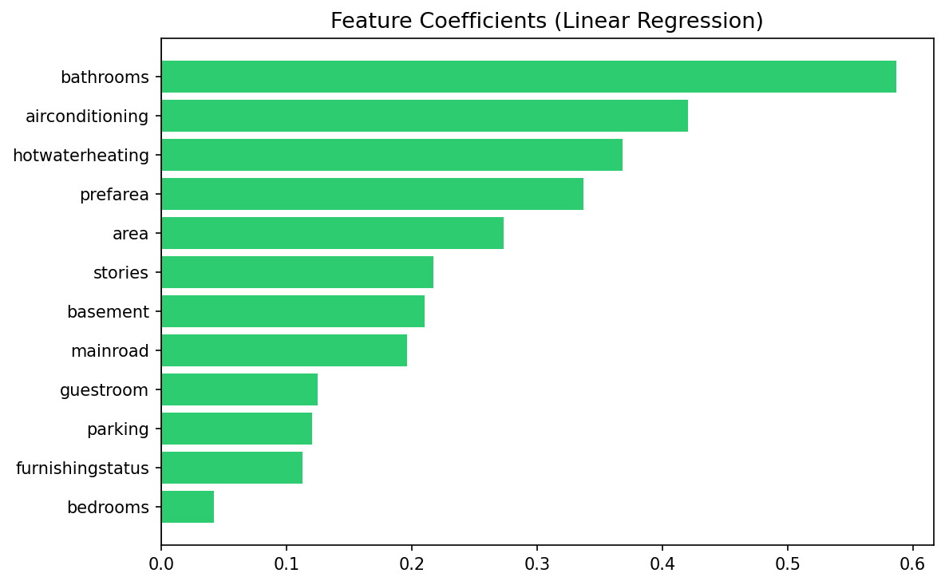

6. Model Evaluation

The trained Linear Regression model was evaluated on the 109-sample test set using three standard regression metrics: R² (coefficient of determination), Mean Absolute Error (MAE), and Root Mean Squared Error (RMSE). These metrics together provide a comprehensive picture of model accuracy and error magnitude.
The R² score of 0.6495 (64.95%) indicates that the model explains approximately 65% of the variance in housing prices. This is a reasonable performance for a linear baseline on a real estate dataset, which naturally contains non-linear effects and unmeasured confounders (e.g., neighbourhood quality, age of property, proximity to amenities). An R² of 1.0 would represent a perfect fit, while 0 indicates the model does no better than predicting the mean.
The MAE of 0.5243 (in scaled units) represents the average absolute difference between actual and predicted prices on the standardized scale. The RMSE of 0.7123 penalizes larger errors more heavily due to squaring. Both metrics are in the same unit as the scaled price, so they reflect moderate prediction error. Converting back to original price units, this corresponds to an average error of approximately ₹980,000, typical for a linear model on this price range.
The scatter plot of actual vs. predicted values shows predictions generally cluster around the 45° reference line, indicating a positive linear trend with moderate scatter. The model tends to underestimate very high prices and slightly overestimate at the lower end — a common regression-to-the-mean effect. These findings suggest that while the linear model is a solid baseline, more complex algorithms (e.g., Random Forest, Gradient Boosting) could reduce residual variance and improve R² beyond 80%.

6.1 Evaluation Metrics
Metric | Value | Interpretation
R² Score | 0.6495 (64.95%) | Explains 65% of price variance
MAE (scaled) | 0.5243 | Avg absolute prediction error
RMSE (scaled) | 0.7123 | Penalized larger errors
Test Samples | 109 | 20% of 545 records
Train Samples | 436 | 80% of 545 records

6.2 Actual vs. Predicted Plot
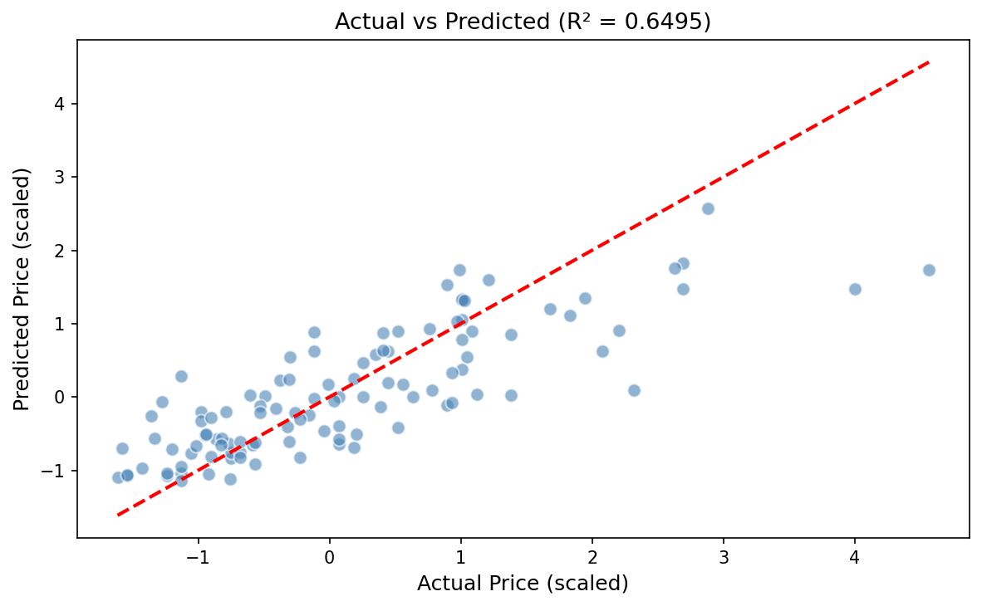

7. Conclusion & Future Scope

This project successfully demonstrates a complete end-to-end machine learning workflow for housing price prediction using Linear Regression. Starting from raw CSV data, the pipeline covered data loading, exploratory analysis, preprocessing, model training, and rigorous evaluation. The model achieved a satisfactory R² of 64.95% on unseen test data, validating the utility of the 12 selected features for price estimation.
Key findings include: bathrooms and air conditioning are the strongest price predictors; area and stories provide moderate contributions; hotwaterheating and basement have smaller but positive effects; and bedrooms contribute the least once other features are considered. The correlation heatmap confirmed that area (0.536) and bathrooms (0.518) are the top linearly correlated features with price, consistent with model coefficients.
The preprocessing decisions — binary encoding, ordinal encoding for furnishing status, and StandardScaler normalization — were appropriate and effective for the dataset's feature structure. The absence of missing values simplified the pipeline, but real-world applications would require robust handling of incomplete data through imputation strategies.
For future work, several improvements are recommended: (1) Implementing ensemble models such as Random Forest or XGBoost to capture non-linear interactions; (2) Feature engineering — creating derived features like price-per-sqft or interaction terms between area and amenity flags; (3) Cross-validation (k-fold) to obtain more robust performance estimates; (4) Hyperparameter tuning using GridSearchCV; (5) Incorporating external data such as proximity to schools, hospitals, or transport hubs; (6) Residual analysis and outlier treatment to reduce the impact of extreme price values. These steps could realistically push model accuracy above 80% R².

