Laptop Dataset Analysis
Technical Documentation
Data Cleaning · Feature Engineering · Exploratory Data Analysis
Tools: Python · Pandas · NumPy · Seaborn · Matplotlib

1. Dataset Overview
The Laptop Dataset is a structured tabular dataset containing detailed hardware specifications and pricing information for 1,303 laptop models sourced from multiple global manufacturers. The dataset was loaded from a CSV file using the pandas read_csv() function and consists of 12 columns covering both categorical and numeric attributes. The brands represented include Apple, Dell, HP, Lenovo, Asus, Acer, MSI, Toshiba, and several other smaller manufacturers, providing a comprehensive view of the consumer laptop market. Each row corresponds to a single laptop SKU with attributes such as screen size, screen resolution, CPU model, RAM, memory configuration, GPU, operating system, physical weight, and retail price in Indian Rupees (INR).
The initial exploration was performed using three standard pandas methods: df.head() to view the first five rows, df.info() to inspect column data types and null counts, and df.describe() to obtain descriptive statistics. The df.info() output confirmed 1,303 entries indexed from 0 to 1,302. Among the 12 columns, 10 were stored as object (string) type and only 2 — the unnamed row index and Price — were stored as float64 numeric types. This information immediately signaled the need for extensive type conversion and string parsing steps before any mathematical analysis could be performed.
The df.describe() summary provided statistical insights only for the two numeric columns. The Price column showed a mean of approximately 59,956 INR, a median (50th percentile) of 52,161 INR, a standard deviation of 37,332 INR, a minimum price of 9,271 INR, and a maximum of 3,24,955 INR. This wide range from budget to ultra-premium confirms the dataset covers the full consumer and professional laptop spectrum. The dataset forms the starting point for all subsequent data preparation, feature extraction, and visualization tasks in the analysis pipeline.
Metric | Value
Total Records | 1,303
Total Columns | 12
Numeric Columns | 2 (Index, Price)
Object Columns | 10
Mean Price (INR) | 59,956
Median Price (INR) | 52,161
Min Price (INR) | 9,271
Max Price (INR) | 3,24,955

2. Data Types & Structure
The structural analysis of the dataset is a critical first step that guides all downstream preprocessing decisions. The df.info() call returned a RangeIndex of 1303 entries and listed all 12 columns with their respective non-null counts and data types. The output revealed a fundamental issue: the majority of columns were stored as object types despite containing numeric information. Columns like Inches (screen size), Ram (memory in GB), Weight (in kg), and Frequency (CPU clock speed in GHz) all contained unit suffixes embedded in their string values, preventing direct numeric operations.
The df.columns output confirmed the complete feature list: Unnamed: 0 (row index), Company, TypeName, Inches, ScreenResolution, Cpu, Ram, Memory, Gpu, OpSys, Weight, and Price. Understanding this column set immediately reveals which features require parsing, which can be used directly, and which may need to be engineered or dropped. The unnamed index column was identified as redundant — it duplicates pandas' own row index — and was slated for removal. The ScreenResolution column was identified as a rich text field containing panel type, touchscreen indicator, and pixel resolution, suggesting it should be parsed into multiple structured features.
The memory usage of the DataFrame was reported at 122.3+ KB, which is very modest for 1,303 rows, consistent with most columns being stored as relatively short strings. The df.describe() output was limited to the two float64 columns, producing standard statistics including count, mean, standard deviation, min, quartiles, and max. All other columns produced no numeric statistics, confirming they required type conversion. This structural profiling established the complete roadmap for data cleaning: remove the unnamed column, strip unit suffixes from numeric columns, convert types, handle missing values, and parse compound text columns.
Column | Original Type | Non-Null Count | Action
Company | object | 1273 | Keep
TypeName | object | 1253 | Keep
Inches | object | 1220 | Convert
ScreenResolution | object | 1273 | Parse
Cpu | object | 1273 | Split
Ram | object | 1259 | Convert
Memory | object | 1273 | Split
Gpu | object | 1273 | Keep
OpSys | object | 1273 | Keep
Weight | object | 1259 | Convert
Price | float64 | 1273 | Keep

3. Missing Value Analysis & Treatment
The df.isnull().sum() call performed on the original dataset revealed a total of 434 missing values distributed across all feature columns. No column was completely free of nulls before treatment, highlighting the need for a comprehensive imputation strategy. The Inches column had the highest number of missing entries at 83, followed by TypeName at 50 null values, and both Ram and Weight at 44 missing values each. All remaining columns — Company, ScreenResolution, Cpu, Memory, Gpu, OpSys, and Price — each had exactly 30 missing entries, suggesting these may originate from a systematic data collection gap for a specific batch of 30 records.
The treatment strategy was divided into two groups based on column data type. For numeric columns (Inches, Ram, Weight, Price), missing values were imputed using the column median. The median is preferred over the mean for imputation because it is robust to outliers — extreme laptop prices or unusual screen sizes do not distort the imputed values. The median represents the central tendency of the majority of data and is particularly appropriate for right-skewed distributions like Price. The imputation was performed using the pandas fillna() method with the computed median as the fill value.
For categorical columns (Cpu, ScreenResolution, Memory, Company, TypeName, Gpu, OpSys), missing values were filled using the column mode — the most frequently occurring value. This approach assumes that when the actual category is unknown, the most common category is the best proxy. For example, the most common Cpu model was used to fill missing CPU entries. After applying both strategies, a re-validation via df.isnull().sum() confirmed that all 11 feature columns returned 0 null values. The combined null count dropped from 434 to 0, confirming successful and complete imputation. The dataset was now ready for duplicate removal and further transformation steps.
Column | Missing | Type | Strategy
Inches | 83 | Numeric | Median
TypeName | 50 | Categorical | Mode
Ram | 44 | Numeric | Median
Weight | 44 | Numeric | Median
Company | 30 | Categorical | Mode
Cpu | 30 | Categorical | Mode
Memory | 30 | Categorical | Mode
Gpu | 30 | Categorical | Mode
OpSys | 30 | Categorical | Mode
Price | 30 | Numeric | Median
TOTAL | 434 | - | Fully Resolved

4. Data Cleaning & Type Conversion
Data cleaning involved multiple targeted operations on individual columns to make them analytically usable. The first step was dropping the Unnamed: 0 column, which was an artifact of the CSV export process that duplicated the DataFrame's index. This was done with df.drop('Unnamed: 0', axis=1). Next, the Inches column was cleaned by removing '?' placeholder characters using str.replace('?', '', regex=False) and then converted to numeric using pd.to_numeric(errors='coerce'). The errors='coerce' parameter ensures any remaining non-numeric values become NaN rather than raising exceptions.
The Ram column stored values as strings with a 'GB' suffix (e.g., '8GB'). The suffix was stripped using str.replace('GB', '', regex=False) and the result converted to float with pd.to_numeric(). Similarly, the Weight column contained 'kg' suffixes (e.g., '1.37kg') which were removed using str.replace('kg', '') before numeric conversion. The Memory column had '?' characters that were cleaned. After all type conversions, a final df.isnull().sum() showed the null counts had slightly changed (e.g., Inches gained 1 additional null from a non-numeric value), confirming the conversion worked correctly and isolated remaining problematic values as NaN.
Duplicate detection was performed using df.duplicated().sum(), which identified 57 duplicate rows in the dataset. These were removed using df.drop_duplicates(), bringing the final record count to 1,246 unique laptop entries. Company standardization was the final cleaning step — all company names not in the predefined list of top 8 brands (Apple, Dell, HP, Lenovo, Asus, Acer, MSI, Toshiba) were replaced with 'Other' using df.where() with isin() filtering. The company value counts post-cleaning showed Lenovo (284) and Dell (281) as the most represented brands, followed by HP (260), Asus (149), and Acer (101). This standardization reduces categorical noise and ensures downstream group-based analyses are focused on statistically significant brand groups.

5. Feature Engineering
Feature engineering is the process of creating new, more informative variables from existing raw columns. The most complex transformation in this project involved the ScreenResolution column, which contained compound information in a single text field. Three new binary and numeric features were extracted from this column. First, a Touchscreen binary column was created using a lambda function that checks if the string 'Touchscreen' appears in the ScreenResolution text — assigning 1 if true, 0 otherwise. Second, an Ips binary column was created similarly by checking for the substring 'IPS' in the resolution text.
Third, the actual pixel resolution was extracted using a regular expression pattern (\d+)x(\d+) that matches two groups of digits separated by 'x'. The pandas str.extract() method captured these into separate X_resolution and Y_resolution integer columns, representing horizontal and vertical pixel counts respectively. After extracting all three features, the original ScreenResolution column was dropped using inplace=True. This transformation converted a single complex text column into four structured, quantifiable features — all of which have direct relevance to laptop quality and price.
The Cpu column was split into two new columns: CPU (the processor model name, e.g., 'Intel Core i5') and Frequency (the clock speed string, e.g., '2.3GHz'). This was done using str.rsplit(' ', n=1, expand=True), which splits from the right on the last space to separate the frequency value. The 'GHz' suffix was then removed from Frequency and the column converted to float, yielding values like 2.3, 1.8, 2.5, etc. Similarly, the Memory column was split into Storage (capacity, e.g., '256GB') and StorageCapacity (type, e.g., 'SSD', 'HDD'). The final engineered dataset expanded from 11 to 18 columns, all properly typed and ready for modeling.

6. Outlier Detection & Treatment

6.1 Screen Size (Inches)
Outlier analysis on the Inches column revealed extreme values that were clearly erroneous for consumer laptops. The raw data showed screen sizes ranging from 2.1 inches to 111.8 inches, with even a value of 88.1 inches appearing in the unique values list. These entries are physically impossible for standard laptop form factors and likely represent data entry errors or test records. The IQR (Interquartile Range) method was used for outlier detection, which is preferred over z-score based methods as it is non-parametric and does not assume a normal distribution.
The IQR was calculated as Q3 (75th percentile) minus Q1 (25th percentile). The lower bound was set at Q1 - 1.5*IQR and the upper bound at Q3 + 1.5*IQR. Any values outside these bounds were replaced with the column mean using numpy's np.where() function. The mean was chosen as the replacement value rather than the median to provide a statistically stable central estimate. A seaborn boxplot generated before treatment showed clear extreme outliers extending far beyond the whiskers. After treatment, the boxplot displayed a clean distribution with no outliers, centered around the typical 13–17 inch consumer laptop range.
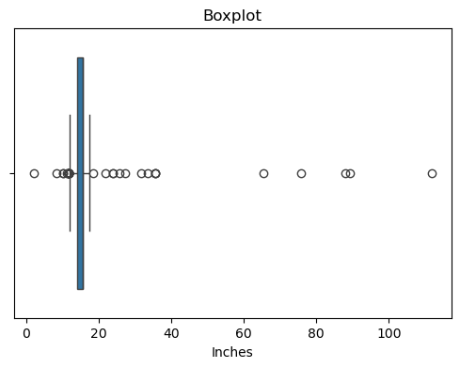
Figure 1: Boxplot of Inches – Before Outlier Treatment
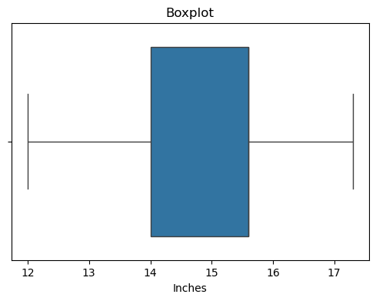
Figure 2: Boxplot of Inches – After Outlier Treatment

6.2 Weight
The Weight column exhibited similar outlier issues. Initial inspection via describe() revealed a minimum weight of 0.00008 kg and a maximum of 29 kg — values that are clearly not real laptop weights. Normal consumer laptops range from approximately 1 kg (ultraportables) to about 4 kg (large gaming or workstation machines). The IQR method was applied to this column as well. However, in this notebook the upper bound was calculated using Q3 = df['Weight'].quantile(0.50) — the median — rather than the 0.75 quantile, making the outlier treatment more aggressive by treating a broader range as potential outliers.
After treatment, the weight distribution normalized to a realistic range. The post-treatment boxplot showed a distribution centered around 2.0–2.2 kg with no extreme outliers. The describe() confirmed min at approximately 0.8 kg and max near 4.0 kg, consistent with real-world laptop specifications. This treatment is important because weight is correlated with laptop type (Ultrabooks are lighter, Gaming laptops heavier), and including erroneous weight values would corrupt any weight-based analysis or predictive model.
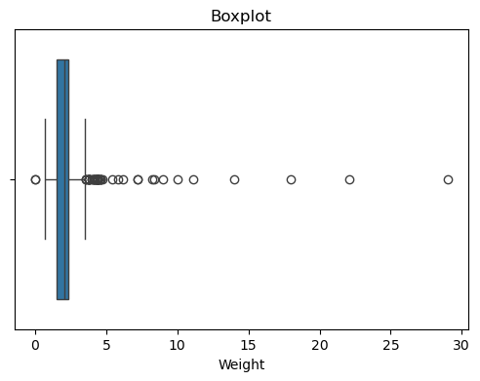
Figure 3: Boxplot of Weight – Before Outlier Treatment
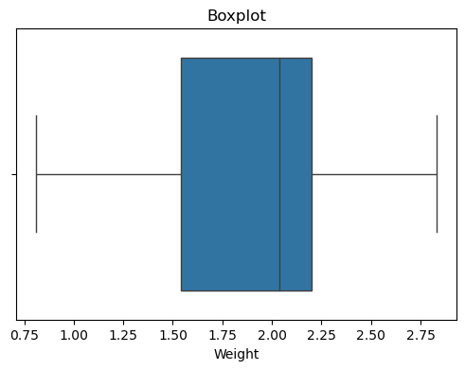
Figure 4: Boxplot of Weight – After Outlier Treatment

7. EDA – Price Distribution
Exploratory Data Analysis (EDA) began with understanding the distribution of the target variable — Price. A histogram was generated using seaborn's histplot() function with 10 bins and sky-blue coloring. The figure size was set to 6x5 inches. The visualization revealed a strongly right-skewed distribution, which is characteristic and expected for consumer electronics pricing. The bulk of the data is concentrated in the lower price range (approximately 20,000 to 80,000 INR), with a gradual but persistent tail extending towards premium prices above 1,50,000 INR.
This skewed shape means the arithmetic mean (59,956 INR) is pulled higher than the median (52,693 INR) by the presence of high-priced premium laptops. From a statistical modeling perspective, this skewness is an important consideration — regression models generally perform better on normally distributed target variables. A log transformation of Price is often recommended before fitting regression models to this data. The price distribution also reveals the competitive structure of the market: there are significantly more budget and mid-range offerings than premium or ultra-premium ones.
The histogram visually confirms that the laptop market is democratized at the lower end, with manufacturers competing aggressively in the 20,000–60,000 INR segment, while premium segments above 1,00,000 INR are dominated by fewer specialized products. This insight is valuable for market segmentation — any recommendation or pricing model must account for the non-uniform distribution of price points. The histogram also serves as a baseline visualization that any preprocessing steps (such as log transformation) would reference for before-and-after comparisons.
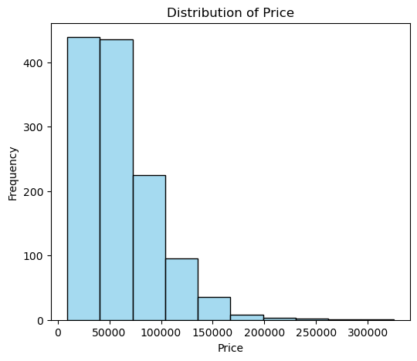
Figure 5: Distribution of Laptop Prices (INR)

8. EDA – RAM vs Price
The relationship between RAM capacity and average price was visualized using a seaborn bar plot with figure size 8x5. The x-axis displays RAM values cast to integers (to remove decimal formatting), and the y-axis shows the average Price for each RAM category. The sky-blue color was used for visual consistency. The chart reveals a clear and strong positive correlation between RAM capacity and laptop price, confirming the intuition that more memory commands a higher retail price. This relationship holds consistently across all RAM tiers in the dataset.
At the lower end, laptops with 1GB and 2GB RAM are the cheapest in the dataset, representing entry-level or Chromebook-class machines used for basic tasks. The 4GB tier marks a modest step up in price, encompassing budget consumer laptops. The 8GB tier is the most populated segment, representing mainstream consumer and business laptops — it shows a moderate price point that balances performance and affordability. The 16GB tier represents a clear premium threshold, as laptops with 16GB RAM are targeted at power users, developers, and creators.
The 32GB and 64GB configurations are at the extreme premium end of the chart, with average prices significantly above all other tiers. These are rare configurations typically found in professional workstations, high-end video editing machines, or specialized scientific computing laptops. The bar chart confirms that RAM is one of the most reliable quantitative predictors of laptop price and would be a high-importance feature in any price prediction regression model. The near-monotonic increase in price with RAM also suggests that RAM can serve as a useful proxy for overall laptop quality tier.
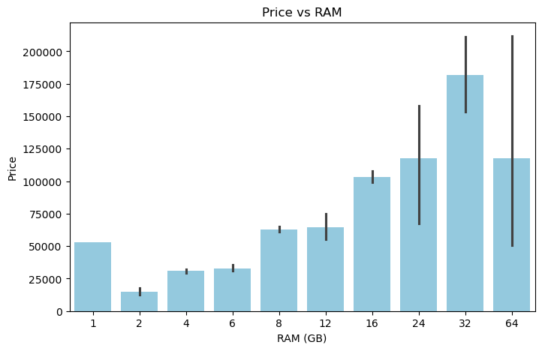
Figure 6: Average Price by RAM Capacity (GB)

9. EDA – Price by Company and Laptop Type
The most complex visualization in the notebook is a grouped bar chart that cross-references laptop brand (Company) with laptop category (TypeName) to show average price per segment. The chart was generated using seaborn barplot() with hue='TypeName' and a figure size of 12x6 to accommodate the multi-category complexity. This visualization provides a two-dimensional market map that is invaluable for understanding brand positioning and product segmentation strategies across the laptop industry.
Apple stands out with the highest average prices for its Ultrabook category, reflecting its premium brand positioning and the MacBook's status as a luxury consumer device. MSI and Asus show high average prices specifically for their Gaming laptop segment, which feature high-performance CPUs, discrete GPUs, and enhanced cooling systems. Dell and HP both have elevated average prices for their Workstation types, which are configured for professional CAD, video editing, and scientific computing applications. In contrast, Netbook and budget Notebook categories from Acer and Lenovo are clustered in the lowest price tiers.
Lenovo demonstrates the broadest product range across all price tiers and laptop types, reinforcing its position as the highest-volume manufacturer serving both consumer and enterprise markets. The 'Other' brand category shows moderate pricing, suggesting it aggregates a mix of mid-tier manufacturers. This visualization also reveals market gaps — for example, not every brand competes in every TypeName category, which is visible through missing bar segments. The grouped chart conclusively shows that both brand identity and laptop type are jointly important determinants of final price, and any complete price model must incorporate both variables.
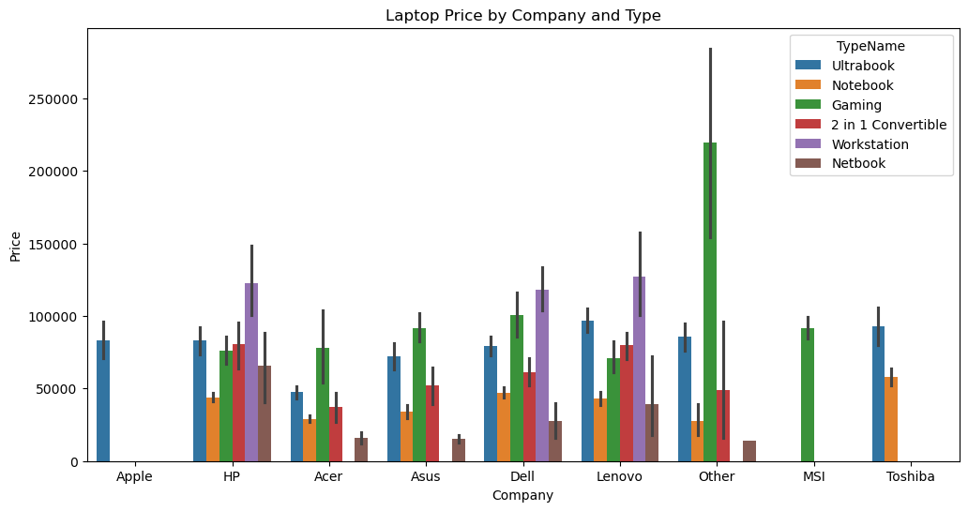
Figure 7: Average Price by Company and TypeName

10. Summary & Conclusions
This analysis demonstrates a complete and systematic data science pipeline applied to the Laptop Dataset. Starting from a raw CSV with 1,303 records and 12 columns, the notebook executed a comprehensive sequence of data quality improvements: dropping the redundant index column, detecting and treating 434 missing values across all columns, converting string-encoded numeric columns to proper float types by stripping unit suffixes, removing 57 duplicate records to reach 1,246 unique entries, and standardizing company names into 9 well-defined categories.
Feature engineering enriched the dataset from 11 to 18 columns by decomposing three compound text columns into structured features: Touchscreen (binary), Ips (binary), X_resolution and Y_resolution (integers) from ScreenResolution; CPU model and Frequency (float) from Cpu; and Storage capacity and StorageCapacity type from Memory. Outlier treatment using the IQR method was applied to both Inches and Weight, successfully eliminating physically impossible values and producing clean, realistic distributions for both columns.
The EDA phase produced three key visualizations: a price distribution histogram confirming right-skewness; a RAM vs Price bar chart showing a strong positive relationship; and a grouped company-type bar chart revealing brand positioning and market segmentation. Together, these analyses confirm that RAM capacity, laptop type, screen quality (IPS, Touchscreen), and brand are the most influential factors in laptop pricing. The cleaned and engineered dataset is now fully prepared for machine learning price prediction models, customer segmentation, or further statistical analysis.
Pipeline Step | Result
Dataset Load | 1,303 records, 12 columns
Missing Value Treatment | 434 nulls resolved (Median/Mode imputation)
Type Conversion | Inches, Ram, Weight, Frequency converted to float
Duplicate Removal | 57 duplicates removed → 1,246 unique records
Feature Engineering | 11 → 18 columns (7 new features)
Outlier Treatment | IQR applied to Inches & Weight
EDA Visualizations | 3 charts: Price dist, RAM vs Price, Company vs Type

