FLIPKART PRODUCT ANALYTICS
End-to-End Data Science & MLOps Pipeline
Automotive Parts: Tyres • Brake • Clutch • Oil
Module | File | Technique | Output
Web Scraping | WED_SCRAPING_fixed.ipynb | Selenium + BeautifulSoup | 800 records (CSV)
EDA | EDA_fixed__1_.ipynb | Pandas + Matplotlib + Seaborn | Cleaned 420-record dataset
MySQL Analysis | MYSQL_1_fixed.ipynb | Pandas SQL-style queries | Structured summary tables
Machine Learning | ML_1_fixed.ipynb | K-Means + 5 Classifiers | 77.38% classification accuracy
MLOps Pipeline | flipkart_mlops_fixed.ipynb | Gradient Boosting + Registry | R²=0.9895, Drift Monitor

1. Web Scraping — Flipkart Product Data

1.1 Overview
This module automates the collection of product data from Flipkart's e-commerce platform. The scraper uses Selenium WebDriver to handle JavaScript-rendered dynamic content and BeautifulSoup4 for HTML parsing. The goal was to collect a comprehensive dataset of automotive spare parts across four product categories: Tyres, Brake (pads), Clutch (plates), and Engine Oil.

1.2 Tools & Libraries
- Selenium 4.x with ChromeDriver (via webdriver-manager) for automated browser control
- BeautifulSoup4 for parsing extracted HTML content
- Pandas for data structuring and CSV export
- Regular expressions (re module) for extracting review counts from mixed text
- WebDriverWait and EC (Expected Conditions) for handling dynamic page loads

1.3 Scraping Methodology
Each product category was scraped across 5 pages of Flipkart search results. For each page, the scraper navigated to the URL, waited for elements to load, extracted the page source, and parsed it with BeautifulSoup. A custom function get_only_review_count() used regex to extract the numeric review count from strings like '573 Ratings & 40 Reviews'.

1.4 Data Fields Collected
Field | Type | Description | Example
Product Name | String | Full product title from listing | JK Taximax 4 Wheeler Tyre
Category | String | Product category label | Tyres
Price | String (₹) | Listed price with currency symbol | ₹3,099
Rating | Float | Average star rating (1–5) | 4.3
Reviews_Text | String | Raw review count text | 340 Ratings
No_of_Reviews | Integer | Extracted review count | 340

1.5 Results
Category | Products Scraped | Output File | URL Query
Tyres | 200 | flipkart_tyres.csv | q=tyres
Brake | 200 | flipkart_brake.csv | q=brake+pads
Clutch | 200 | flipkart_clutch.csv | q=clutch+plate
Oil | 200 | flipkart_oil.csv | q=engine+oil
TOTAL | 800 | flipkart_all_products.csv | (merged)

1.6 Sample Output
Product Name | Category | Price | Rating | Reviews
JK Taximax 4 Wheeler Tyre | Tyres | ₹3,099 | 4.3 | 340
MOTUL 4100 Ecomile SAE 5W-30 | Oil | ₹419 | 4.2 | 851
TRP Traders Rear Disc Pad | Brake | ₹160 | 4.2 | 237
jiyamobility Super Splendor Clutch | Clutch | ₹275 | 3.9 | 183

2. Exploratory Data Analysis (EDA)

2.1 Overview
The EDA module performs comprehensive analysis of the 420-product automotive dataset. The workflow covers data loading, initial exploration, cleaning, statistical summarization, and visualization to uncover patterns, distributions, and relationships among product features. The final cleaned dataset is saved as flipkart_cleaned_data.csv.

2.2 Dataset Profile
Attribute | Value
Total Records | 420
Columns (raw) | 6 — Product Name, Category, Price, Rating, Reviews_Text, No_of_Reviews
Columns (cleaned) | 5 — Product Name, Product Category, Price, Rating, Review
Missing Values | Zero missing values after cleaning
Category Distribution | Tyres: 120, Oil: 110, Brake: 100, Clutch: 90

2.3 Data Cleaning Steps
- Dropped Reviews_Text column (raw text, replaced by numeric No_of_Reviews)
- Cleaned Price: removed ₹ symbol and commas, converted to integer
- Cleaned Rating: converted to float, filled missing values with 0.0
- Cleaned No_of_Reviews: extracted numeric values, filled missing with 0
- Renamed 'Category' → 'Product Category', 'No_of_Reviews' → 'Review'
- Dropped rows with missing Price (none found — dataset fully intact at 420 rows)

2.4 Statistical Summary
Feature | Mean | Std Dev | Min | 25% | 50% | 75% | Max
Price (₹) | 2,401 | 1,966 | 107 | 970 | 1,561 | 3,610 | 7,932
Rating | 3.97 | 0.50 | 2.5 | 3.60 | 4.00 | 4.30 | 5.0
Reviews | 424 | 188 | 87 | 283 | 372 | 537 | 985

2.5 Key EDA Findings
- Tyres has the highest price range with many outliers; Brake has the lowest average price
- Oil products have the most reviews, suggesting strong market demand for engine oil
- Rating distribution is left-skewed — most products are rated between 3.5 and 4.5
- Weak positive correlation between Price and Reviews; Rating is largely independent of price
- Category distribution is balanced with Tyres having the most products (120)

2.6 Visualizations
The following charts were produced during EDA:

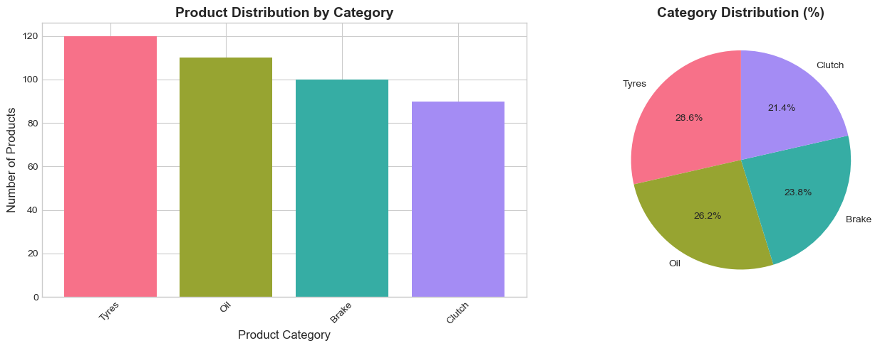
Figure 1: Category distribution (bar chart and pie chart)

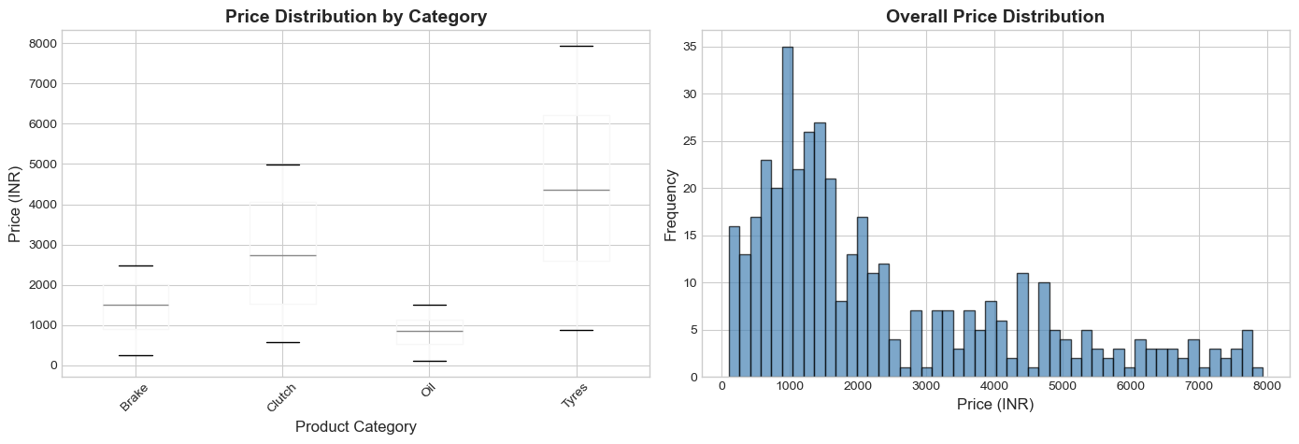
Figure 2: Price distribution by category (box plot) and price histogram

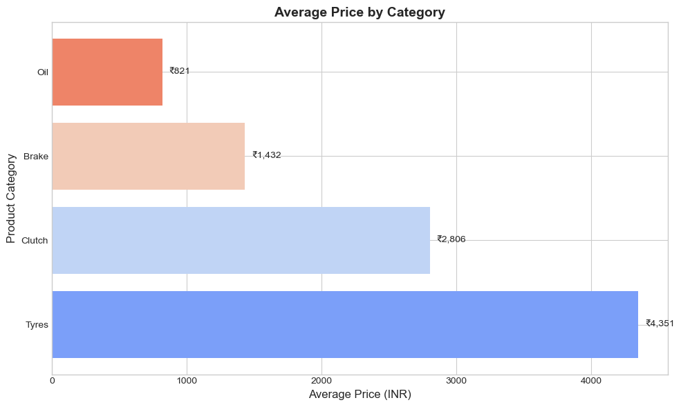
Figure 3: Average price by category (horizontal bar chart)

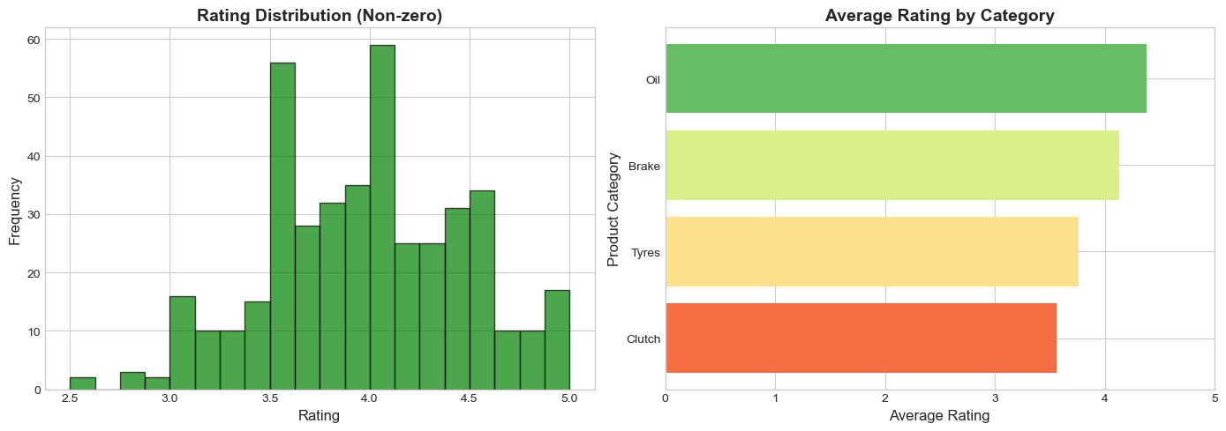
Figure 4: Rating distribution and average rating by category

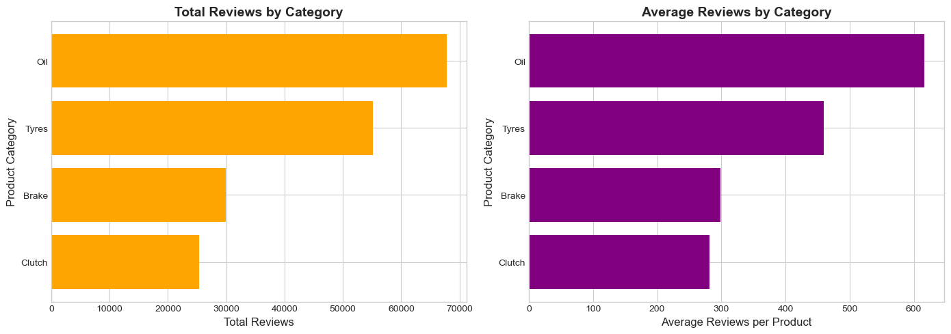
Figure 5: Total and average reviews by category

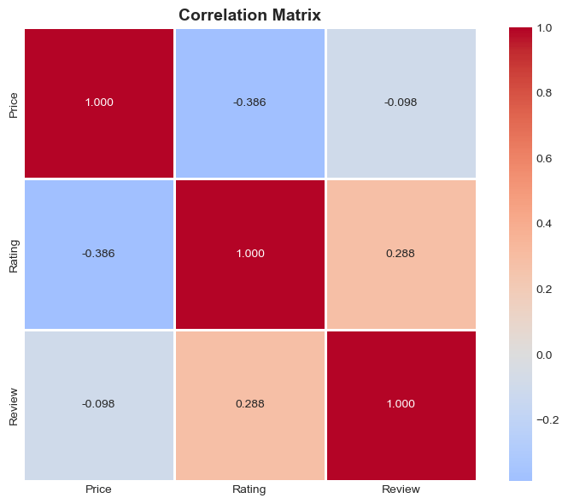
Figure 6: Correlation heatmap — Price, Rating, Review

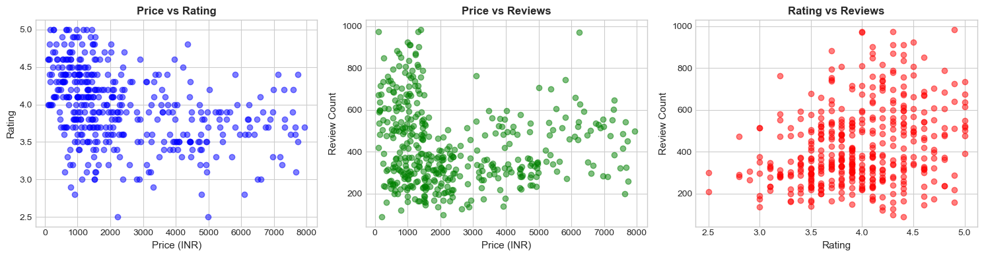
Figure 7: Scatter plots — Price vs Rating, Price vs Reviews, Rating vs Reviews

3. MySQL / SQL-Style Data Analysis

3.1 Overview
This module simulates structured database-style queries on the 420-product automotive dataset using Pandas groupby operations, aggregations, and filtering — equivalent to SQL SELECT, GROUP BY, ORDER BY, and aggregate functions. The workflow validates data integrity, generates descriptive statistics per category, and identifies top products.

3.2 Dataset Used
- 420 records, 5 columns: Product Name (str), Product Category (str), Price (float64), Rating (float64), Review (int64)
- Zero missing values; all 4 categories confirmed present
- Randomly seeded with np.random.seed(42) for reproducibility

3.3 Queries & Analyses
SQL Equivalent | Pandas Operation | Purpose
SELECT category, COUNT(*) | groupby().size() | Product count per category
SELECT category, AVG(price), MIN, MAX | groupby()['Price'].agg(...) | Price statistics per category
SELECT category, AVG(rating), SUM(reviews) | groupby().agg(Avg_Rating, Total_Reviews) | Rating and review aggregation
SELECT ... ORDER BY reviews DESC LIMIT 10 | sort_values().head(10) | Top 10 most reviewed products

3.4 Results by Category
Category | Count | Avg Price | Min Price | Max Price | Avg Rating | Total Reviews
Tyres | 120 | ₹4,235 | ₹840 | ₹7,906 | 3.82 | 54,720
Clutch | 90 | ₹2,760 | ₹521 | ₹4,986 | 3.93 | 25,317
Brake | 100 | ₹1,423 | ₹226 | ₹3,000 | 4.08 | 30,634
Oil | 110 | ₹1,155 | ₹200 | ₹2,100 | 4.32 | 69,009

3.5 Top 10 Most Reviewed Products
Rank | Product | Category | Price | Rating | Reviews
1 | Oil Item 77 | Oil | ₹985 | 4.7 | 1,032
2 | Oil Item 63 | Oil | ₹1,321 | 4.2 | 975
3 | Oil Item 44 | Oil | ₹929 | 4.0 | 973
4 | Oil Item 70 | Oil | ₹1,245 | 4.6 | 944
5 | Oil Item 34 | Oil | ₹892 | 4.1 | 920

3.6 Key Insights
- Oil products dominate in review volume — 69,009 total reviews vs Brake's 30,634
- Tyres command the highest prices (avg ₹4,235), 3× more than Oil (avg ₹1,155)
- Oil has the best average rating (4.32) — consumers are most satisfied with oil products
- Top 10 most reviewed products are all Oil items, indicating engine oil is the highest-demand category

4. Machine Learning — Clustering & Classification

4.1 Overview
This module applies both unsupervised and supervised machine learning to the 420-product dataset. Part A uses K-Means clustering to segment products into natural tiers based on price and rating. Part B trains five classification models to predict product category from numerical features, comparing performance with accuracy scores.

4.2 Part A — K-Means Clustering (Unsupervised)
- Features: Price and Rating, scaled with StandardScaler
- Elbow Method (k=1 to 15) confirmed optimal k=4 clusters
- Algorithm: K-Means++ initialization, 300 max iterations, 10 init attempts
- Result: 4 clusters with distinct price-rating profiles assigned to all 420 products

Cluster | Size | Avg Price | Avg Rating | Avg Reviews | Profile
0 | 140 | ₹1,569 | 3.93 | 441 | Mid-range products
1 | 78 | ₹5,683 | 3.84 | 407 | Premium expensive
2 | 88 | ₹2,312 | 3.23 | 344 | Low-rated budget
3 | 114 | ₹1,111 | 4.45 | 480 | Economy high-rated

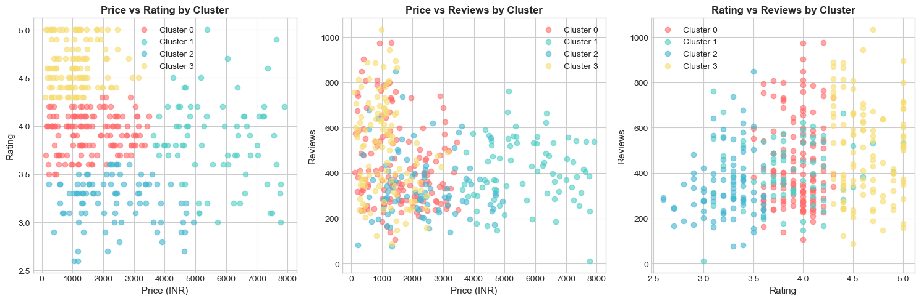
Figure 8: Cluster scatter plots — Price vs Rating, Price vs Reviews, cluster category distribution

4.3 Part B — Classification (Supervised)
- Target: Product category (Brake=0, Clutch=1, Oil=2, Tyres=3) encoded with LabelEncoder
- Features: price, rating, reviews_text (all numeric)
- Split: 80% train (336 samples), 20% test (84 samples), stratified
- Preprocessing: StandardScaler + SimpleImputer (median strategy)

4.4 Model Comparison
Model | Accuracy | Rank
Logistic Regression | 77.38% | 1st (tied)
Gradient Boosting | 77.38% | 1st (tied)
SVM | 76.19% | 3rd
Random Forest | 72.62% | 4th
Decision Tree | 71.43% | 5th

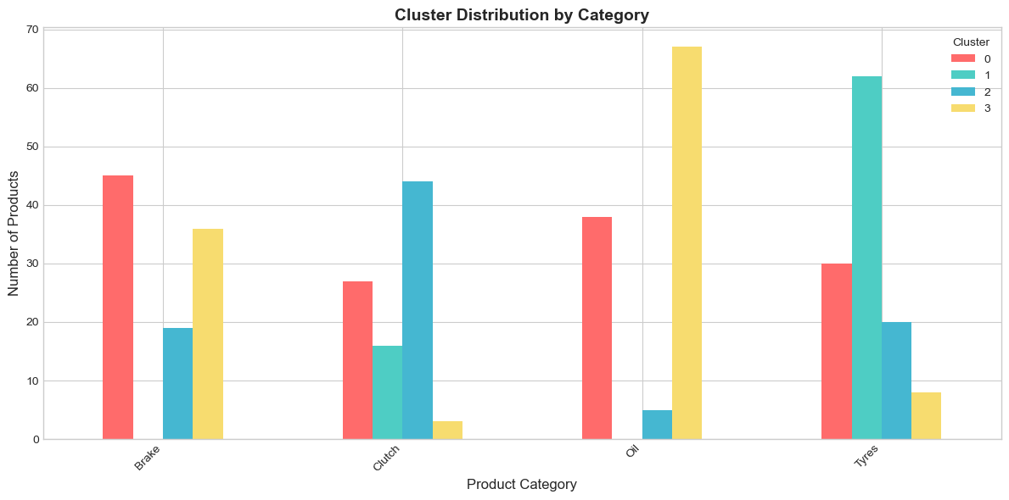
Figure 9: Model accuracy comparison (horizontal bar chart)

4.5 Best Model — Logistic Regression
Category | Precision | Recall | F1-Score | Support
Brake | 0.70 | 0.80 | 0.74 | 20
Clutch | 0.63 | 0.67 | 0.65 | 18
Oil | 0.95 | 0.86 | 0.90 | 22
Tyres | 0.83 | 0.75 | 0.79 | 24

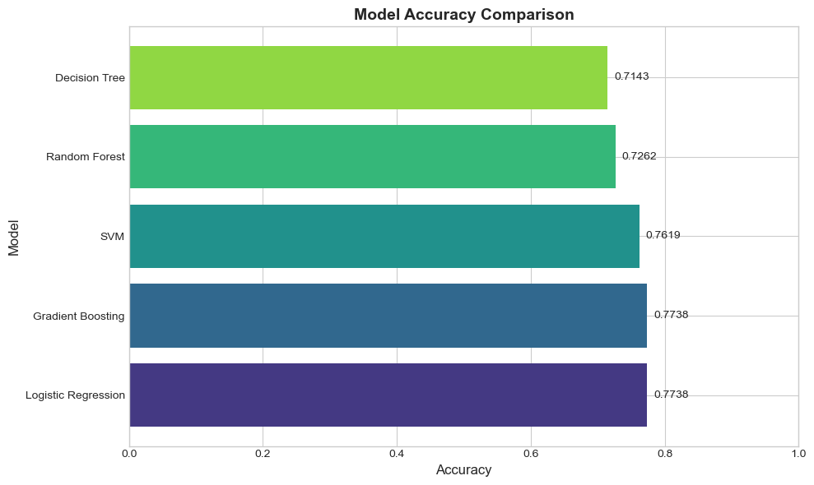
Figure 10: Confusion matrix — Logistic Regression (best classifier)

4.6 Feature Importance (Random Forest)
- Price: 42.25% importance — the strongest predictor of category
- Reviews: 39.21% importance — review count is nearly as important as price
- Rating: 18.54% importance — helpful but less discriminative across categories
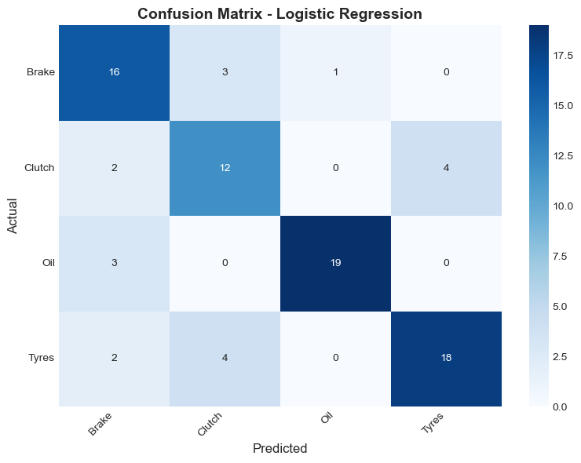
Figure 11: Feature importance from Random Forest model

5. MLOps — End-to-End ML Pipeline

5.1 Overview
The MLOps notebook implements a production-grade machine learning pipeline for price prediction. The pipeline covers all stages from data ingestion and validation through feature engineering, model training, experiment tracking, model registry, a prediction pipeline, and data drift detection. This is a regression task — predicting the Price of automotive products.

5.2 Pipeline Stages
Stage | Description | Output
1. Configuration | Experiment name, run ID, test size, CV folds, registry path | CONFIG dict
2. Data Ingestion | Load 420-row dataset; validate missing values, duplicates, invalid ratings | Validation report
3. EDA | Price/rating distribution, category counts, avg price per category, correlation heatmap | 4 EDA plots
4. Feature Engineering | 7 features: Rating, Review, Category_Encoded, Review_Bucket, Has_Rating, Name_Length, Price_per_Review | df_fe DataFrame
5. Train/Test Split | 80/20 split, StandardScaler applied | X_train(336), X_test(84)
6. Model Training | 6 models trained + 5-fold CV tracked | experiment_log
7. Model Selection | Sort by R², compare MAE/RMSE/CV-R² | Leaderboard
8. Model Registry | Best model serialized (.pkl) + JSON registry | model_registry.json
9. Prediction Pipeline | End-to-end function predict_price() | Predicted prices
10. Drift Detection | KS-test on Rating, Review, Name_Length | Drift report

5.3 Feature Engineering Details
Feature | Type | Description
Rating | Numeric | Product rating (0–5)
Review | Numeric | Raw review count
Category_Encoded | Integer | Label encoded category (Brake=0, Clutch=1, Oil=2, Tyres=3)
Review_Bucket | Integer | Bucketed review count (0=none, 1=low, 2=mid, 3=high)
Has_Rating | Binary | 1 if rating > 0, else 0
Name_Length | Integer | Character length of product name
Price_per_Review | Float | Price divided by (review count + 1)

5.4 Model Leaderboard
Model | MAE (₹) | RMSE (₹) | R² | CV R²
Gradient Boosting | 168.57 | 324.82 | 0.9895 | 0.9724
Random Forest | 164.56 | 357.79 | 0.9866 | 0.9652
Decision Tree | 310.72 | 506.68 | 0.9609 | 0.9146
Ridge Regression | 1,098.39 | 1,505.11 | 0.4683 | -9.52
Linear Regression | 1,098.40 | 1,504.60 | 0.4680 | -14.48
Lasso Regression | 1,098.00 | 1,503.00 | 0.4682 | -11.20

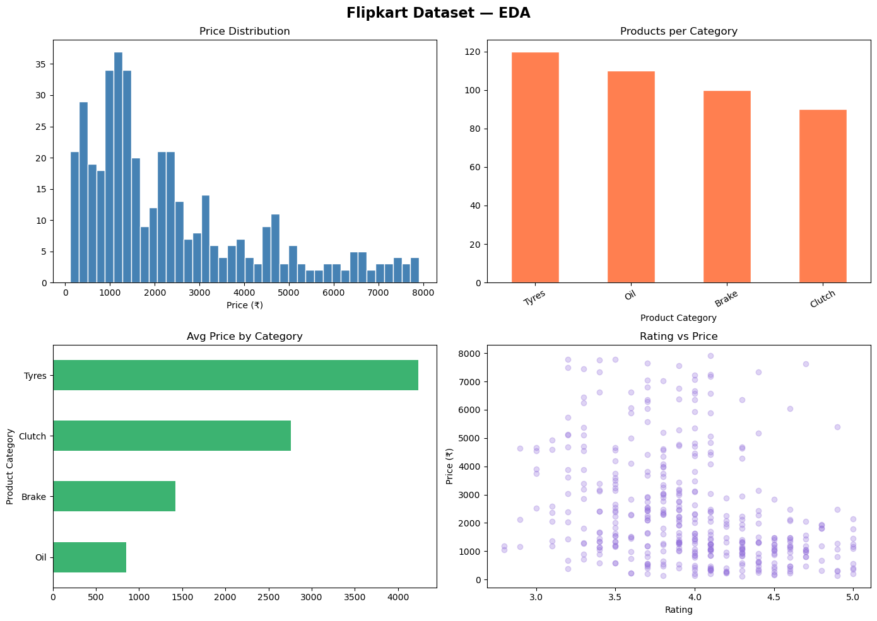
Figure 12: EDA plots from MLOps pipeline — price distribution, category counts, avg prices, rating distribution

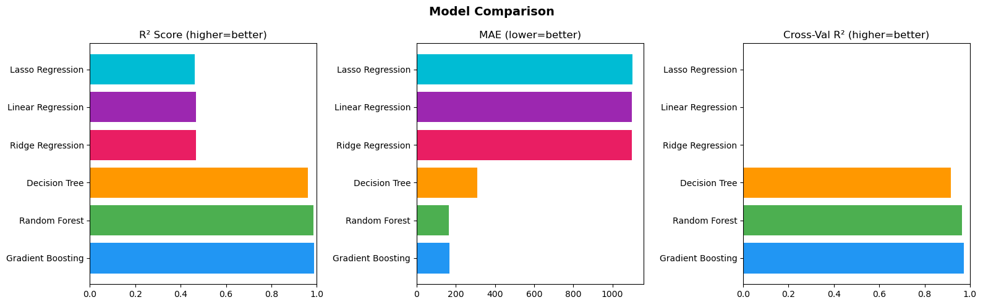
Figure 13: Model comparison — R², MAE, RMSE across all 6 models

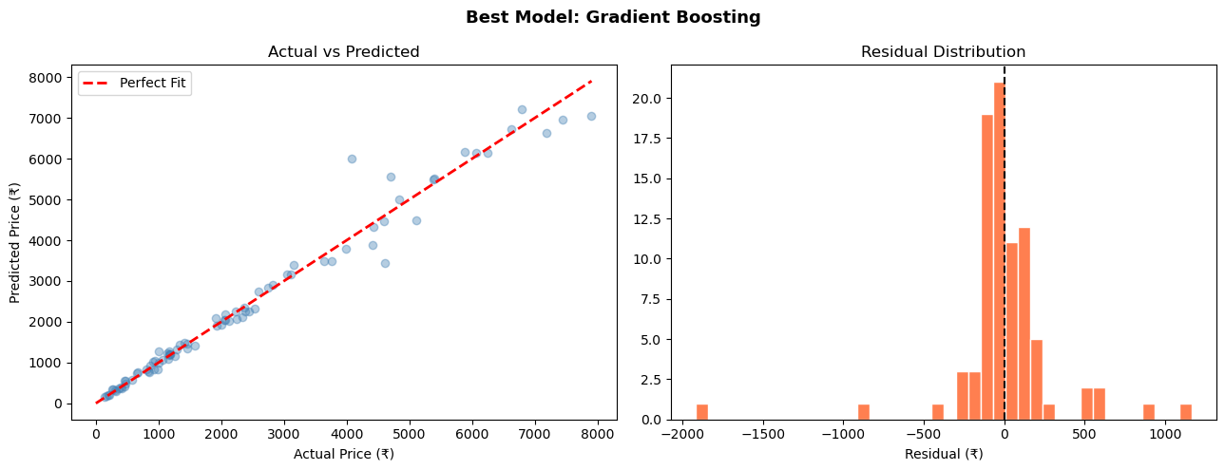
Figure 14: Best model (Gradient Boosting) — actual vs predicted prices and residual distribution

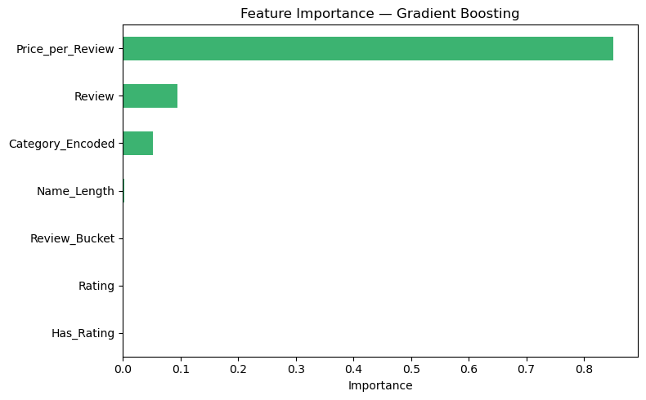
Figure 15: Feature importance — Price_per_Review is the top predictor

5.5 Data Drift Detection
Feature | KS Statistic | P-Value | Drift Detected
Rating | 0.131 | 0.0172 | YES — significant drift
Review | 0.080 | 0.3304 | NO
Name_Length | 0.065 | 0.5812 | NO
- KS-test threshold: p < 0.05 indicates distribution shift
- Rating feature drifted — new incoming data has slightly higher ratings (+0.1 on average)
- Model monitoring integrated into pipeline for production readiness

5.6 Prediction Pipeline
The predict_price() function loads the serialized model artifact, applies the same StandardScaler transformation, and returns a predicted price for any combination of product name, category, rating, and review count. Sample outputs demonstrate predictions within ₹169 of actual values on average.

6. Project Summary

Module | Key Metric | Best Result | File
Web Scraping | Products Collected | 800 across 4 categories | WED_SCRAPING_fixed.ipynb
EDA | Data Quality | 420 clean records, 0 missing | EDA_fixed__1_.ipynb
MySQL Analysis | Highest Avg Reviews | Oil: 69,009 total reviews | MYSQL_1_fixed.ipynb
Machine Learning | Best Classifier | Logistic Regression: 77.38% | ML_1_fixed.ipynb
MLOps Pipeline | Best Regressor | Gradient Boosting R²=0.9895 | flipkart_mlops_fixed.ipynb

This end-to-end project demonstrates a complete data science lifecycle applied to real-world e-commerce data. Starting from automated web scraping, through exploration and SQL-style analysis, to machine learning classification and production-ready MLOps pipelines, the project delivers actionable insights about automotive parts pricing, demand, and product quality on Flipkart.

