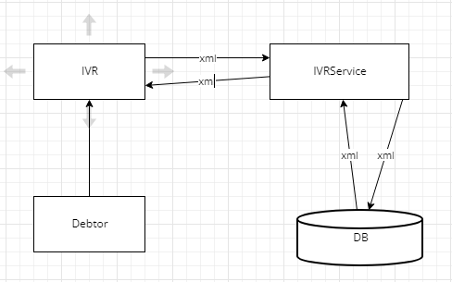

There are a number of debtors in America for Altisource. Earlier they would be calling to the Altisource to find out their account information. Company wanted to automate this via IVR(interactive voice response) so that they can get information on mobile. Apart from fetching the data , the debtor can perform other operations also like updating his address also.

Flow for this project:

* Debtor calls the IVR
* IVR automatically detects his ANI(automatic number identification)
* IVR sends ani to IVRService on the predefined URL in xml
* IVRService takes out ani , searches the database with this number and gets the account information
* IVRService create a new xml with the account information and sends it to IVR
* IVR reads out this account information

Contribution:

I have created a springboot miroservice application called IVRService which exposed different end point to IVR like

* GET : debtor gets his account information
* POST : debtor can update his address

Tech stack used for this project:

* Oracle Database
* Springboot microservice
* hibernate