**Environment / Tools requirements**

**OS**: Any

**SDK**: jdk-17.0.12

**Build Tool**: apache-maven-3.9.9

**Design and assumptions**

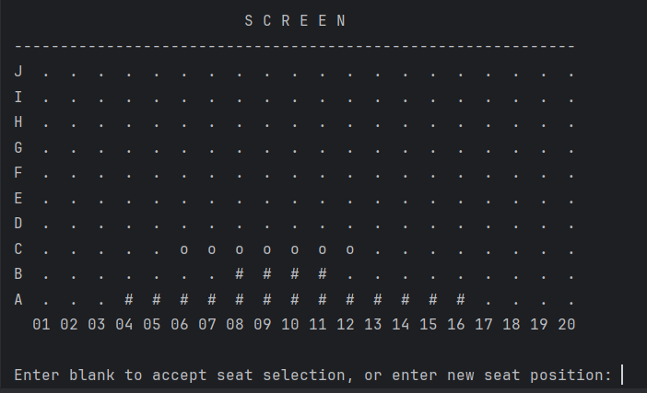

**Assumptions**

* The Column numbers are denoted with 2 digits, to maintain the equal space.
* Current Booking is indicated with “o”
* Other Bookings are denoted with “#”
* Available seats are denoted with “.”

**Execution Instructions**

* Build the project using Maven [mvn clean install]. There are 2 dependencies in pom, “junit-jupiter” and “mockito-core”.
* Once build successful, execute one of the below commands to execute the program.
  + java -jar .\target\cinemas-booking.jar



* + java -cp .\target\classes gic.cinema.Main

