**Environment / Tools requirements**

**OS**: Any

**SDK**: jdk-22.0.1

**Build Tool**: apache-maven-3.9.9

**Design and assumptions**

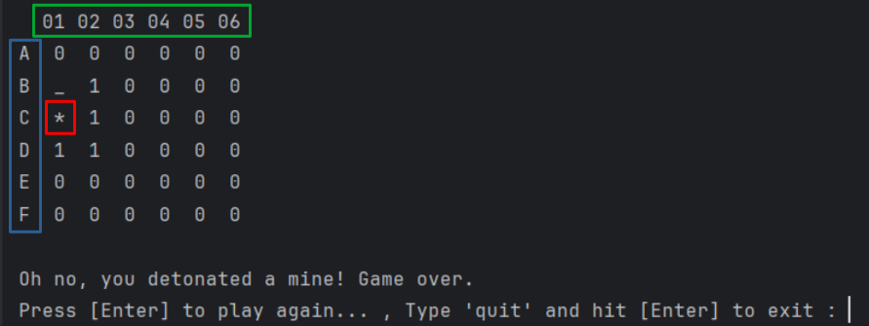

**Assumptions**

* The maximum range for rows will be from A-Z since needed to denote the rows with readable characters.
* The maximum range for columns will be from 01-26 according to the given requirement to maintain the same size.
* The Column numbers denoted with 2 digits to maintain the alignment.
* Once the game is over, the revealed Bomb will be denoted with * character. There was no such requirement but added to make it more clearer.
* Once the game is over either by Win or Lose, can restart the game by pressing “ENTER” or can exit by typing “quit” (case insensitive) and pressing “ENTER”.

**Execution Instructions**

* Build project using Maven. There is only 1 dependency in pom, which is “junit-jupiter”.
* Once build successful, execute the **Main** class under “src/main/java folder”.