HIGH-LEVEL DESIGN DOCUMENT
Project Profitability & Margin Risk Intelligence System
Version | 1.0
Date | April 29, 2026
Status | Draft
Classification | Internal / Confidential

Table of Contents

1. Introduction

1.1 Purpose
This document provides the high-level design (HLD) for the Project Profitability & Margin Risk Intelligence System. It outlines the system architecture, data design, functional flows, and technical approach to guide development, testing, and future enhancement efforts.

Intended Audience
- Product owners and business stakeholders
- Development and QA teams
- Solution architects
- Operations and deployment teams
- Executive sponsors

1.2 Scope

In Scope
- Executive dashboard with real-time KPIs and visualizations
- Project profitability analysis and margin tracking
- Risk scoring engine with anomaly detection
- Scope creep tracking and resource efficiency monitoring
- Root cause explanation engine with natural language insights
- Corrective action recommendation engine
- Multi-dimensional filtering and search capabilities
- Responsive, production-quality web interface

Out of Scope
- Integration with external ERP systems (SAP, Oracle) — deferred to future phases
- Machine learning model training infrastructure
- Real-time push notifications
- Mobile native applications
- Multi-tenant SaaS deployment

1.3 Definitions, Acronyms, and Abbreviations
Term | Definition
KPI | Key Performance Indicator
API | Application Programming Interface
UI | User Interface
UX | User Experience
REST | Representational State Transfer
JSON | JavaScript Object Notation
CRUD | Create, Read, Update, Delete
MVC | Model-View-Controller
SPA | Single Page Application
ROI | Return on Investment
PM | Project Manager
Margin Erosion | Gradual decline in profit margin over project lifecycle
Scope Creep | Uncontrolled expansion of project scope without corresponding adjustments
Anomaly Detection | Identification of data points that deviate significantly from expected patterns

1.4 References
Document | Description
Software Requirements Specification (SRS) | Detailed functional and non-functional requirements
UI/UX Wireframes | Visual mockups and interaction flows
Data Dictionary | Comprehensive field-level definitions
API Specification | REST endpoint documentation
Risk Scoring Algorithm Specification | Detailed scoring methodology

2. System Overview

2.1 Problem Statement
Organizations managing multiple projects face significant challenges in maintaining profitability:

- Delayed Risk Detection:
- Cost overruns and margin erosion often go unnoticed until projects are significantly impacted, limiting corrective options.
- Fragmented Data:
- Budget, resource, timeline, and scope data exist in disparate systems, making holistic analysis difficult.
- Reactive Decision-Making:
- Without early warning signals, project managers respond to problems rather than prevent them.
- Lack of Root Cause Visibility:
- When margins decline, stakeholders struggle to identify specific drivers without manual investigation.
- Inconsistent Risk Assessment:
- Different project managers apply varying criteria to assess project health, leading to inconsistent escalation.
- Resource Inefficiency:
- Underutilized or over-allocated resources directly impact project margins but remain hidden in aggregate reporting.

2.2 Proposed Solution
SOLUTION | The Project Profitability & Margin Risk Intelligence System is an intelligent financial analytics platform that continuously monitors project health, detects early financial risks through anomaly detection, explains profitability drivers in plain business language, and recommends timely corrective actions — enabling proactive margin management and informed executive decision-making.

2.3 Goals and Objectives
Goal | Success Metric
Early Risk Detection | Identify margin-at-risk projects 30+ days before critical thresholds
Root Cause Transparency | Provide explainable risk factors for 100% of flagged projects
Decision Support | Generate actionable recommendations for every high-risk project
Executive Visibility | Deliver real-time KPIs accessible within 3 clicks
Operational Efficiency | Reduce manual reporting effort by 70%
Consistent Risk Assessment | Apply uniform scoring methodology across all projects

2.4 Assumptions and Constraints

Assumptions
- Project data (budget, actuals, resources, scope changes) is available and accurate
- Users have modern web browsers (Chrome, Firefox, Safari, Edge — latest two versions)
- Initial deployment supports single organization with up to 500 concurrent users
- Mock data sufficiently represents real-world project characteristics

Constraints
- Frontend-first implementation with mock JSON data for initial release
- No external system integrations in Phase 1
- Anomaly detection uses rule-based algorithms (ML deferred to future phase)
- SQLite or in-memory data store for local development; PostgreSQL for production path

3. System Architecture

3.1 Architecture Overview
The system is structured across four primary layers: Client Layer, Presentation Layer, Business Logic Layer, and Data Layer, with a Future Integration Layer reserved for Phase 2 connectivity with ERP and PM tools.

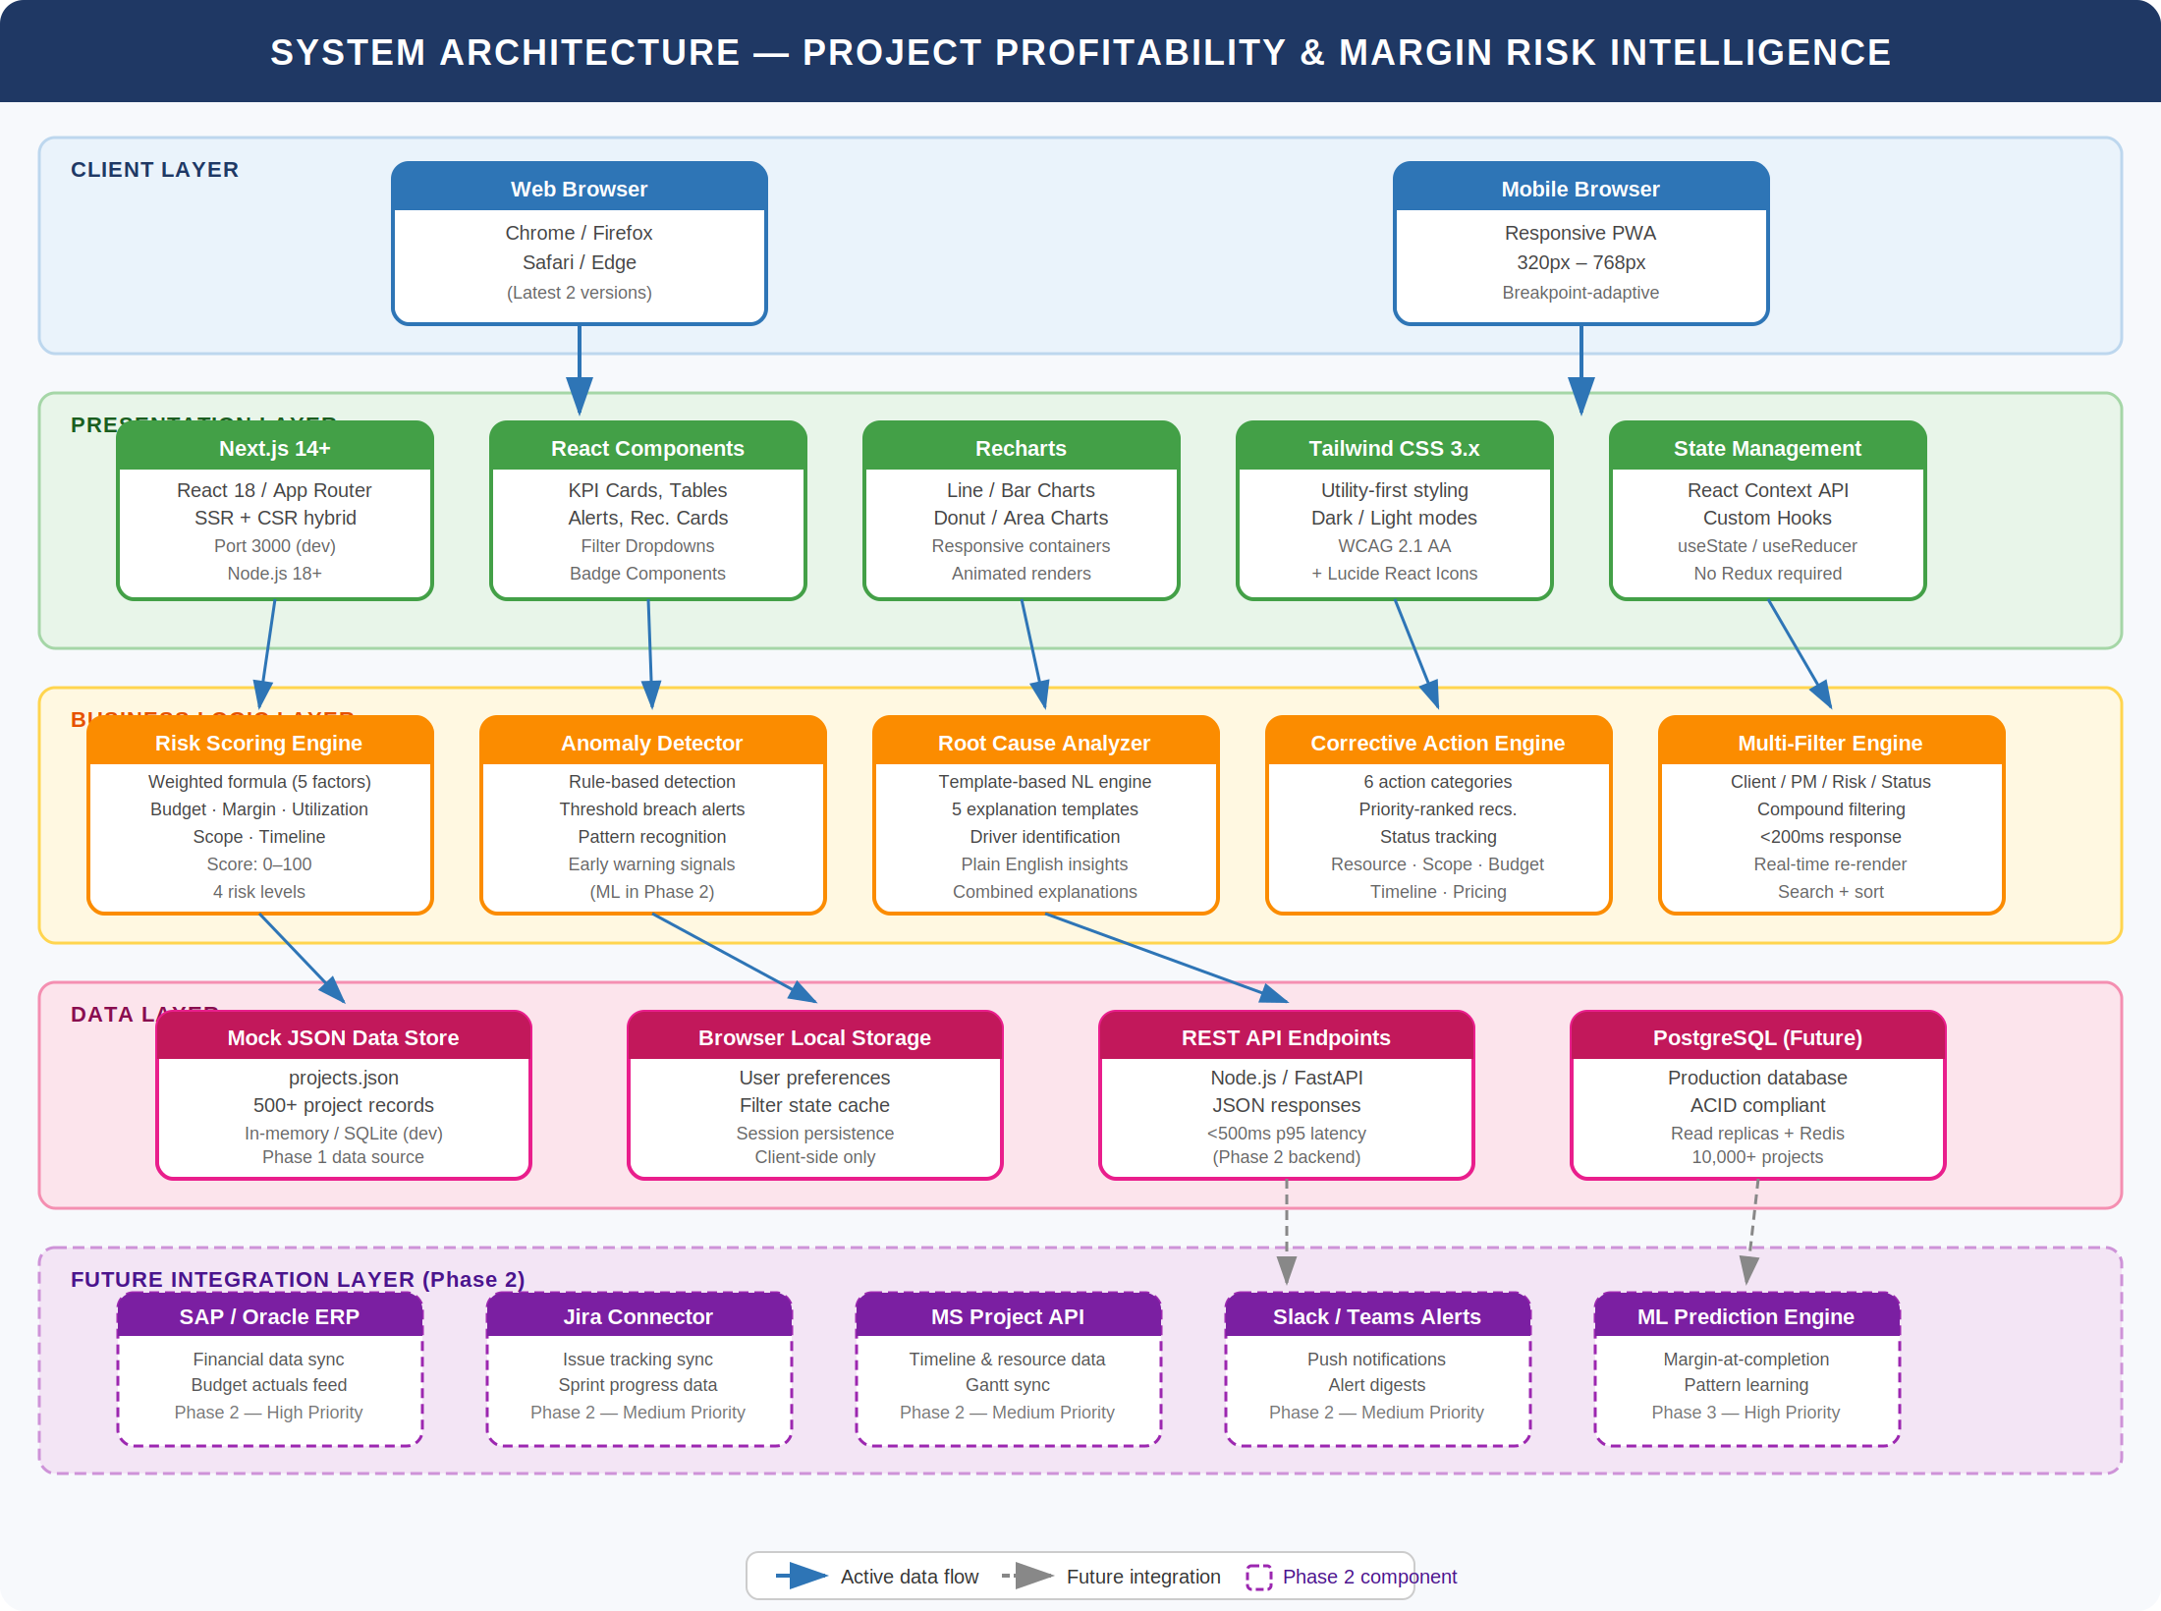
Figure 1: System Architecture — Project Profitability & Margin Risk Intelligence System
Layer | Components
Client Layer | Web Browser, Mobile Browser
Presentation Layer | Next.js Application, React Components, Recharts, Tailwind CSS
Business Logic Layer | Risk Scoring Engine, Anomaly Detection, Root Cause Analyzer, Corrective Action Engine, Filter Engine
Data Layer | Mock JSON Data Store, Browser Local Storage, REST API Endpoints
Future Integration Layer | SAP, Jira, MS Project, PostgreSQL

3.2 Technology Stack
Layer | Technology | Rationale
Frontend Framework | Next.js 14+ (React 18) | SSR, file-based routing, optimized performance
Styling | Tailwind CSS 3.x | Utility-first, rapid prototyping, consistent design system
Charting | Recharts | React-native, declarative, responsive charts
Icons | Lucide React | Modern, consistent icon library
State Management | React Context + Hooks | Lightweight, sufficient for frontend-only architecture
Data Format | JSON | Portable, readable, easy to mock
Future Backend | Node.js/Express or FastAPI | REST API support, easy integration
Future Database | PostgreSQL | Production-grade, ACID compliance, scalability

3.3 Design Approach
The system follows a component-based architecture with clear separation of concerns:

Pattern | Application
Component-Based UI | Reusable React components for cards, charts, tables, filters
Service Layer | Dedicated modules for risk scoring, anomaly detection, recommendations
Data Access Layer | Centralized data fetching and transformation utilities
Presentation/Logic Separation | UI components consume processed data from service functions

Key Design Principles
- Single Responsibility: Each module handles one specific concern
- Open/Closed: New risk factors or recommendation types can be added without modifying core logic
- Dependency Injection: Services receive data dependencies, enabling easy testing and mocking

3.4 Deployment View

Development Environment
- Local machine with Node.js 18+
- Next.js development server on port 3000
- Hot module replacement for rapid iteration

Production Deployment Path
- Containerized deployment (Docker)
- Horizontal scaling with load balancer
- CDN for static asset delivery
- Managed PostgreSQL instance

4. Database Design

4.1 Entity Relationships
The data model is organized around the PROJECT entity, which maintains relationships with CLIENT, PROJECTMANAGER, SCOPECHANGE, COSTENTRY, RESOURCEALLOCATION, RISKASSESSMENT, and RECOMMENDATION entities.

4.2 Table Schemas

PROJECT Table
Column | Data Type | Description
projectid | VARCHAR(20) PK | Unique project identifier
projectname | VARCHAR(200) | Project display name
clientid | VARCHAR(20) FK | Associated client
projectmanagerid | VARCHAR(20) FK | Assigned PM
budget | DECIMAL(15,2) | Approved budget amount
actualcost | DECIMAL(15,2) | Cumulative actual spend
revenue | DECIMAL(15,2) | Expected/actual revenue
plannedmarginpct | DECIMAL(5,2) | Target profit margin %
currentmarginpct | DECIMAL(5,2) | Calculated current margin %
resourceutilizationpct | DECIMAL(5,2) | Average resource utilization
timelineprogresspct | DECIMAL(5,2) | Completion percentage
scopechangecount | INTEGER | Number of scope changes
riskscore | DECIMAL(5,2) | Calculated risk score (0–100)
deliverystatus | VARCHAR(20) | On Track / At Risk / Delayed / Completed
startdate | DATE | Project start date
plannedenddate | DATE | Planned completion date
actualenddate | DATE | Actual completion date
createdat | TIMESTAMP | Record creation timestamp
updatedat | TIMESTAMP | Last modification timestamp

SCOPECHANGE Table
Column | Data Type | Description
changeid | VARCHAR(20) PK | Unique change identifier
projectid | VARCHAR(20) FK | Associated project
changetype | VARCHAR(50) | Addition / Modification / Removal
description | TEXT | Change description
costimpact | DECIMAL(15,2) | Estimated cost impact
daysimpact | INTEGER | Timeline impact in days
changedate | DATE | Date change was logged
approvalstatus | VARCHAR(20) | Pending / Approved / Rejected

RISKASSESSMENT Table
Column | Data Type | Description
assessmentid | VARCHAR(20) PK | Unique assessment identifier
projectid | VARCHAR(20) FK | Associated project
riskscore | DECIMAL(5,2) | Calculated score (0–100)
risklevel | VARCHAR(20) | Low / Medium / High / Critical
riskfactors | JSON | Contributing factor breakdown
rootcauses | JSON | Identified root causes
assessedat | TIMESTAMP | Assessment timestamp

4.3 Data Dictionary

Risk Score Values
Score Range | Risk Level | Color Code | Action Required
0–25 | Low | Green | Monitor
26–50 | Medium | Yellow | Review
51–75 | High | Orange | Investigate
76–100 | Critical | Red | Immediate escalation

Delivery Status Values
Status | Definition
On Track | Timeline and budget within acceptable variance
At Risk | One or more metrics approaching threshold
Delayed | Timeline exceeded planned milestones
Completed | Project delivered and closed
On Hold | Temporarily paused

5. Functional Flow

5.1 Actor Descriptions
Actor | Description | Primary Use Cases
Executive | Senior leadership requiring portfolio-level insights | Dashboard, Alerts, Reports
Project Manager | Responsible for individual project delivery | All operational use cases
Financial Analyst | Conducts detailed profitability analysis | Analysis, Root Cause, Reports
System Admin | Configures thresholds and system settings | Configuration

5.2 Risk Assessment Activity Flow
The risk assessment process follows these sequential steps:

- Fetch project data from data store
- Calculate key metrics: budget variance, margin delta, utilization efficiency, scope change impact, timeline slippage
- Apply weighted scoring formula to each factor
- Calculate final composite risk score (0–100)
- Categorize risk level: Low (0–25), Medium (26–50), High (51–75), Critical (76–100)
- Generate alerts for High and Critical projects
- Identify root causes for flagged projects
- Generate corrective action recommendations
- Update dashboard with latest scores and alerts

5.3 Project Detail Analysis Flow
When a user navigates to a project detail view, the following flow executes:

- User selects a project from the dashboard or project list
- System loads project header and key metrics
- Parallel data load: cost history, scope changes, resource allocation, risk history
- Render trend charts, scope timeline, utilization view, and risk panel
- Display AI-generated insights alongside visualizations
- Show root cause explanations and corrective action recommendations
- Log any actions the user acknowledges or acts upon

6. User Interface Design

6.1 Navigation Structure
The application follows a hierarchical navigation model: Login Page → Executive Dashboard → Project List → Project Detail. Alerts and Recommendations pages are accessible from both the Dashboard and Project Detail views.

6.2 Key Page Layouts

Executive Dashboard
- Header: Logo, Search, Notifications, User Profile
- KPI Cards Row: Total Projects, Avg Margin, High Risk Count, Budget Overrun, Scope Creep
- Charts Row: Margin Trend Chart, Budget vs Actual Bar Chart
- Charts Row: Risk Distribution Donut, Resource Utilization Chart
- Top 5 Risky Projects Table with action links

Project List Page
- Filter Bar: Client, PM, Risk Level, Status, Margin Range dropdowns
- Sortable project table: Name, Client, Budget, Actual, Margin, Risk Score, Status
- Status badges and risk indicators inline
- Pagination for large datasets

Project Detail Page
- Project header: Name, Client, PM, Status Badge, Health Score, Risk Level
- Key metrics row: Budget Variance, Current Margin, Utilization, Timeline Status
- Cost Trend Chart alongside Root Cause Panel
- Scope Change Log alongside Recommendations Panel

6.3 Component Library
Component | Purpose | Variants
KPI Card | Display single metric with trend | Default, Positive Trend, Negative Trend
Risk Badge | Show risk level | Low (green), Medium (yellow), High (orange), Critical (red)
Status Badge | Show delivery status | On Track, At Risk, Delayed, Completed
Data Table | Sortable, filterable project list | Compact, Full
Line Chart | Trend visualization | Single series, Multi-series
Bar Chart | Comparison visualization | Vertical, Horizontal, Stacked
Donut Chart | Distribution visualization | With center metric, Without
Filter Dropdown | Multi-select filtering | Single, Multi-select
Alert Card | Risk notification | Warning, Critical, Info
Recommendation Card | Action item with status | Pending, In Progress, Completed

7. Non-Functional Requirements

7.1 Security
Requirement | Implementation
Authentication | JWT-based session management
Authorization | Role-based access control (RBAC)
Password Storage | bcrypt hashing with salt
Session Management | Secure HTTP-only cookies, 30-minute timeout
Data Transmission | HTTPS/TLS 1.3 required
Input Validation | Server-side validation for all inputs
XSS Prevention | React's built-in escaping, CSP headers
CSRF Protection | Token-based request verification

Role Permissions Matrix
Feature | Executive | PM | Analyst | Admin
View Dashboard | Yes | Yes | Yes | Yes
View Project Details | Yes | Yes | Yes | Yes
Acknowledge Alerts | Yes | Yes | Yes | Yes
Execute Recommendations | No | Yes | No | Yes
Configure Thresholds | No | No | No | Yes
Export Reports | Yes | Yes | Yes | Yes
Manage Users | No | No | No | Yes

7.2 Performance
Metric | Target
First Contentful Paint | < 1.5 seconds
Time to Interactive | < 3 seconds
API Response Time | < 500ms (95th percentile)
Chart Render Time | < 1 second for datasets up to 1,000 points
Filter Response Time | < 200ms

7.3 Scalability
Aspect | Current | Future Path
Data Volume | 500 projects | 10,000+ projects
Concurrent Users | 100 | 1,000+
Data Store | JSON / SQLite | PostgreSQL with read replicas
Caching | Browser cache | Redis distributed cache
Computation | Client-side | Server-side with worker queues
Static Assets | Local | CDN distribution

7.4 Reliability
Requirement | Target
Uptime | 99.5% (excluding planned maintenance)
Data Backup | Daily automated backups
Recovery Time Objective (RTO) | 4 hours
Recovery Point Objective (RPO) | 1 hour
Error Rate | < 0.1% of requests

7.5 Usability
Requirement | Specification
Responsive Design | Breakpoints: 320px, 768px, 1024px, 1440px
Browser Support | Chrome, Firefox, Safari, Edge (latest 2 versions)
Page Load Time | < 2 seconds for dashboard
Interaction Feedback | Visual response within 100ms
Accessibility | WCAG 2.1 AA compliance
Error Handling | Clear, actionable error messages
Help System | Contextual tooltips, documentation links

8. Risks and Mitigation

8.1 Technical Risks
Risk | Impact | Probability | Mitigation
Rule-based detection misses complex patterns | Medium | High | Phase 2: Implement ML-based anomaly detection
Mock data doesn't reflect real-world complexity | Medium | Medium | Collaborate with stakeholders for realistic data modeling
Frontend-only architecture limits scalability | High | Medium | Design API contracts now; backend implementation in Phase 2
Chart performance degrades with large datasets | Medium | Medium | Implement data aggregation and pagination
Browser compatibility issues | Low | Low | Comprehensive cross-browser testing; polyfills where needed

8.2 Operational Risks
Risk | Impact | Probability | Mitigation
User adoption resistance | High | Medium | Executive sponsorship; training program; gradual rollout
Data quality issues from source systems | High | High | Data validation layer; quality dashboards; feedback loop
Incorrect risk thresholds | Medium | Medium | Configurable thresholds; A/B testing; stakeholder review
Alert fatigue from excessive notifications | Medium | Medium | Tunable sensitivity; priority-based filtering; digest mode

8.3 Project Risks
Risk | Impact | Probability | Mitigation
Scope creep | High | Medium | Clear phase boundaries; change control process
Resource availability | Medium | Medium | Cross-training; documentation; modular design
Integration delays (future phases) | Medium | Medium | API-first design; mock integrations for testing

Appendix A: Risk Scoring Algorithm

Weighted Scoring Formula
The composite risk score is calculated as:

FORMULA | Risk Score = (W1 × B) + (W2 × M) + (W3 × U) + (W4 × S) + (W5 × T)

Where: B = Budget Overrun Factor (0–100), M = Margin Decline Factor (0–100), U = Utilization Inefficiency Factor (0–100), S = Scope Change Factor (0–100), T = Timeline Slippage Factor (0–100)

Default Weights
Factor | Weight | Rationale
Budget Overrun (W1) | 0.25 | Direct financial impact
Margin Decline (W2) | 0.30 | Primary profitability indicator
Utilization Inefficiency (W3) | 0.15 | Resource cost driver
Scope Change Frequency (W4) | 0.15 | Leading indicator of future issues
Timeline Slippage (W5) | 0.15 | Delivery and cost correlation

Factor Calculations

Budget Overrun Factor
FORMULA | B = min(100, ((Actual Cost - Budget) / Budget) × 200)

Margin Decline Factor
FORMULA | M = min(100, (Planned Margin - Current Margin) × 5)

Scope Change Factor
FORMULA | S = min(100, Scope Change Count × 15)

Timeline Slippage Factor
FORMULA | T = min(100, (Days Overdue / Planned Duration) × 200)

Appendix B: Root Cause Explanation Templates

Trigger Condition | Explanation Template
Budget > 110% | Budget overrun of {X}% driven by {top cost category} expenses exceeding projections.
Margin drop > 5% | Margin declined by {X}% from planned {Y}% to current {Z}%, primarily due to {factors}.
Utilization < 65% | Resource utilization at {X}% indicates underutilization, contributing ${Y} in idle capacity cost.
Scope changes > 3 | Scope expanded {X} times without corresponding budget adjustments, adding ${Y} in unplanned costs.
Timeline slip > 10% | Project timeline extended by {X} days beyond plan, increasing overhead costs by approximately ${Y}.

Example Combined Explanation
EXAMPLE | Margin dropped by 8% (from 22% to 14%) due to: (1) delivery costs exceeding budget by 15%, (2) resource utilization at 58% resulting in $45K idle capacity, and (3) three scope changes in the last quarter adding $82K in unplanned work. Immediate review of scope management process recommended.

Appendix C: Corrective Action Categories

Category | Trigger Conditions | Recommended Actions
Resource Optimization | Utilization < 65% | Reallocate underused resources; consolidate team; cross-project assignments
Scope Control | Scope changes > 3 or unpriced changes | Freeze scope; implement change review board; update pricing
Budget Management | Actual > Budget × 1.1 | Escalate to finance; renegotiate contract; identify cost reduction opportunities
Pricing Review | Margin < Planned × 0.8 | Review change request billing; renegotiate rates; adjust estimates
Timeline Recovery | Slippage > 10% | Add resources; descope non-critical features; milestone checkpoint review
Process Improvement | Multiple flags | Conduct retrospective; implement additional controls; increase checkpoint frequency

Appendix D: Future Enhancement Roadmap

Phase 2 Enhancements
Feature | Description | Priority
ML-Based Margin Prediction | Predict margin at completion using historical patterns | High
ERP Integration | SAP, Oracle, NetSuite connectors for financial data | High
PM Tool Integration | Jira, Asana, MS Project for real-time progress | Medium
Real-Time Alerts | Push notifications via email, Slack, Teams | Medium
What-If Simulation | Model impact of decisions before execution | Medium
Role-Based Dashboards | Customized views per user role | Low

Phase 3 Enhancements
Feature | Description | Priority
Natural Language Queries | Show me projects with declining margins | Medium
Automated Recommendations Execution | One-click action implementation | Medium
Benchmarking | Compare against industry or historical baselines | Low
Mobile App | Native iOS/Android applications | Low

— End of Document —

