Address Matching Logic: End-to-End Design
Oct 22, 2026 · @mukesh

Summary
The matcher is a deterministic, rule-gated pairwise verifier: for each Excel row it decides whether AddressA and AddressB are the same address and returns MATCH, NON-MATCH or REVIEW with a 0-100 score and a one-line explanation. No LLM touches the matching; the optional LLM only routes follow-up chat questions to fixed intents.
The design rests on four ideas:
- Parse, then compare per component. libpostal splits each address into labelled components (house number, road, unit, postcode, city and so on), and each component is compared with a rule suited to its type.
- Missing is unknown, not a mismatch. Only components present on both sides contribute to the score.
- Rules outrank the score. A conflict on a critical field (house number, unit, road, PO box, country) forces NON-MATCH whatever the score; a MATCH needs a high score plus specific matched evidence.
- Everything tunable lives in one file. Weights, cut-offs, thresholds and rules are in config/scoring.toml, which the code itself labels as uncalibrated starting values.
There is no candidate search or blocking step: the input pairs the two addresses already, so the system verifies pairs rather than finding matches in a reference list. Code read: mksharma22/demo-ai-v1, default branch, src/addrmatch/.

End-to-end flow
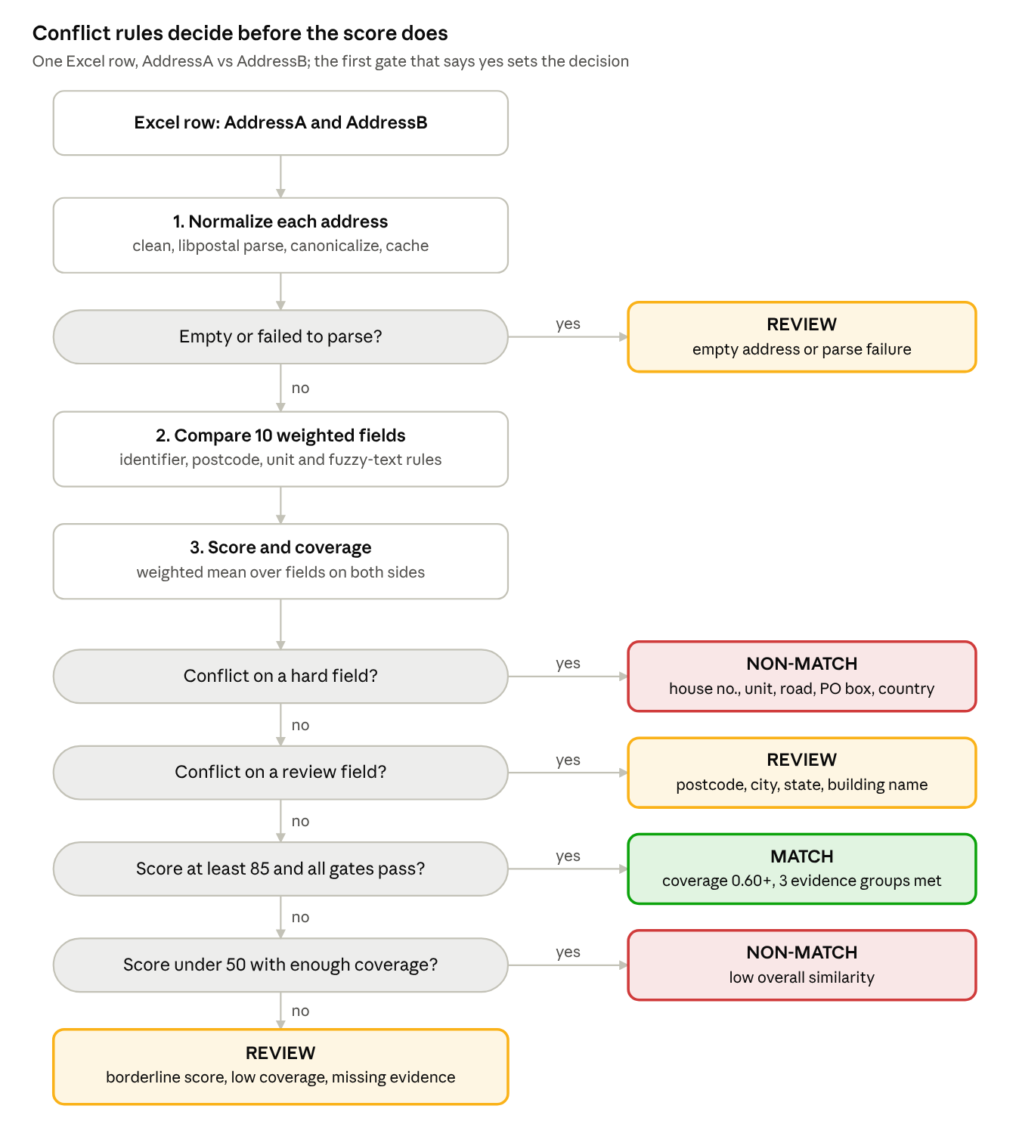
per-row matching flow · 3 stages, 5 decision gates
Each row is normalized, compared field by field and scored, then a fixed ladder of gates decides; a hard-field conflict is NON-MATCH even with a high score, and MATCH needs both score and specific evidence.

1. Normalization and parsing
Each address is cleaned, parsed by libpostal into labelled parts, mapped onto about ten comparison fields, and each field is canonicalized with a type-specific rule (normalization.py, components.py).
- Guard. Blank, None or NaN cells become status EMPTY. Control characters are stripped and whitespace collapsed. Input over 500 characters (MAX_ADDRESS_CHARS) becomes FAILED.
- Parse. postal.parser.parse_address returns (value, label) pairs. A parser exception or no recognised components gives FAILED. Normalization never raises.
- Label mapping. libpostal labels are folded into comparison fields; values sharing a field are joined.
- Canonicalize per field (below). Each field keeps a tuple of candidate forms; the first is the display form, all are used in comparison.
- Normalized string. A comma-separated string in fixed field order (house number and road emitted together), written to the output's normalized_AddressA/B columns.
- Cache. CachingNormalizer memoizes on the cleaned text (LRU, 50,000 entries), so repeated addresses in a file are parsed once.
libpostal label(s) | Comparison field | Canonical form
house_number | house_number | Lowercase alphanumerics joined by -; drops "no", "number", "nr" ("No. 12-A" to 12-a)
po_box | po_box | Same, also drops "po", "box", "post office"; shown as po box 45
postcode | postcode | Lowercase as parsed; compared later with spaces and punctuation removed, uppercase
road | road | libpostal expand_address with the street dictionary, up to 5 expansions + parser form; a reading ending in a street type (street, avenue, marg, nagar...) is shown first
unit, level, staircase, entrance | unit | Expansions with unit dictionaries; at compare time designators (apt, flat, floor, #...) are removed to get identifier tokens
house | building_name | Expansions with the name dictionary
suburb, city_district | locality | Expansions with toponym dictionary
city | city | Expansions with toponym dictionary
state_district | district | Expansions; unweighted, used only for city cross-label lookup
state | state | Expansions with toponym dictionary
country | country | Expansions with toponym dictionary
island, country_region, world_region, category, near | same name | Kept in the normalized string, not scored
libpostal is loaded once per process (about 2 GB RAM) behind a lock, and warmed with a dummy call so the load does not happen mid-job. An optional LIBPOSTAL_LANGUAGES setting restricts expansion dictionaries.

2. Candidate selection
There is no candidate selection, blocking or indexing step in the code. The uploaded workbook must have AddressA and AddressB columns, and every row is one pre-paired comparison: row N's AddressA is compared only with row N's AddressB.
- Input handling (excel_io.py): .xlsx only, max 20 MB upload and 200 MB uncompressed, max 100,000 rows; the first sheet whose header has both columns is used; formulas are read as literal text and never evaluated.
- Rows are stored in a per-job SQLite store and processed in batches of 200 (BATCH_SIZE).
- Duplicate pairs are counted in job metrics but still processed; the normalization cache absorbs the repeated parsing cost.
For the architecture review this is the key scoping fact: the system is a pair verifier, not a record linker. Matching one address against a master list would need a new blocking stage (for example by postcode, or city plus road prefix) in front of the comparison engine described next.

3. Per-field comparison
Every weighted field gets one of six outcomes, MATCH, SIMILAR, CONFLICT, MISSING_A, MISSING_B or MISSING_BOTH, plus a similarity from 0 to 1 when both sides have it (comparison.py). The comparator depends on the field type.
Field type | Fields | Rule | MATCH | SIMILAR | CONFLICT
Identifier | house_number, po_box | Exact compare of canonical identifiers | Identical (1.0) | Never | Different (0.0); same digits but different suffix, e.g. 12A vs 12B (0.5)
Postcode | postcode | Uppercase alphanumerics only | Equal, or US ZIP equals first 5 of ZIP+4 (1.0) | One is a prefix of the other, at least 3 chars (0.6) | Otherwise (0.0)
Unit | unit | Sets of identifier tokens after removing designators; "4 b" and "4-b" rejoined to 4b | Same token set (1.0) | One set is a strict subset, e.g. "4b" vs "floor 2 unit 4b" (0.7) | Disjoint sets (0.0); units with no identifier fall back to fuzzy text
Free text | road, building_name, locality, city, state, country | Best RapidFuzz score over all candidate forms on both sides: max of token_sort_ratio and ratio | Similarity at least 0.90 | 0.75 to under 0.90 | Under 0.75
Two special rules sit on top of the free-text comparator:
- Numbered streets. If both roads contain numbers and the number sets differ (5th Ave vs 6th Ave), the road is a CONFLICT with similarity capped at 0.5, however close the strings are.
- City cross-label recovery. libpostal may label the same place as city on one side and suburb, district or state on the other. If city is not already a MATCH, the city value from one side is matched against all area fields of the other; a score of at least 0.90 upgrades city to MATCH.
Because every libpostal expansion is kept as a candidate, abbreviation differences (St vs Street, Rd vs Road) usually resolve to an exact 1.0 before fuzzy scoring is needed.

4. Weights, score and thresholds
The score is a weighted average of similarity over fields present on both sides, scaled to 0-100 (scoring.py). It is a similarity, not a probability.
\text{score} = \operatorname{round}\left(100 \cdot \frac{\sum_{f \in B} w_f \, s_f}{\sum_{f \in B} w_f}\right) \qquad \text{coverage} = \frac{\sum_{f \in B} w_f}{\sum_{f \in E} w_f}
Here B is the set of fields present on both sides, E the set present on either side, w the weight and s the field similarity. If B is empty the score is N/A. Coverage measures how much of the available evidence could actually be compared.
Field | Weight | Share of total 110 | On conflict
house_number | 25 | 23% | NON-MATCH
road | 20 | 18% | NON-MATCH
postcode | 15 | 14% | REVIEW
unit | 10 | 9% | NON-MATCH
city | 10 | 9% | REVIEW
po_box | 10 | 9% | NON-MATCH
building_name | 5 | 5% | REVIEW
locality | 5 | 5% | score only
state | 5 | 5% | REVIEW
country | 5 | 5% | NON-MATCH

Setting | Value | Meaning
similarity.text_match | 0.90 | Free-text MATCH cut-off
similarity.text_similar | 0.75 | Free-text SIMILAR cut-off; below is CONFLICT
similarity.max_expansions | 5 | libpostal expansions kept per field
thresholds.match | 85 | Minimum score for MATCH
thresholds.non_match | 50 | Below this, NON-MATCH (if coverage is enough)
thresholds.min_coverage | 0.60 | Coverage needed before MATCH or score-based NON-MATCH
rules.match_requires | 3 groups | At least one MATCHED field from each: {road, po_box}; {house_number, building_name, po_box}; {postcode, city, locality}
rules.review_if_missing_one_side | house_number, unit | Present on one side only blocks MATCH
The config is validated on load (thresholds ordered, weights non-negative, known contradiction actions) and fingerprinted with SHA-256, so cached job results are not reused after a config change.
Illustrative example (assumed parse, not a test run): "12 Main St, Apt 4B, Springfield IL 62701" vs "12 Main Street #4B, Springfield, Illinois 62701". House number, road, unit, postcode and city match at 1.0 (weight 80); suppose state scores 0.80 as SIMILAR (weight 5). Score = 100 x (80 + 4) / 85 = 99, coverage 1.0, all three evidence groups met, so MATCH. Change the house number to 21 and the result is NON-MATCH from the hard conflict, even though the score would still be about 70.

5. Final decision and outputs
The decision is a fixed precedence ladder in decision.py; the first rule that fires wins, and the score is consulted only after the conflict rules.
Order | Condition | Decision | Reason code
0 | Either address empty or normalization failed (matcher.py) | REVIEW | empty_address, normalization_failed
1 | No weighted field present on both sides | REVIEW | no_comparable_components
2 | CONFLICT on a non_match field (house number, unit, road, PO box, country) | NON-MATCH | <field>_conflict
3 | CONFLICT on a review field (postcode, city, state, building name) | REVIEW | <field>_conflict
4 | Score at least 85, coverage at least 0.60, every evidence group met, no house number or unit on one side only | MATCH | strong_agreement
5 | Score under 50 and coverage at least 0.60 | NON-MATCH | low_score
6 | Anything else | REVIEW | <field>_missing_one_side, insufficient_evidence:..., low_coverage or borderline_score
An unexpected exception on a row becomes REVIEW with processing_error, so a bad row never drops out of the file.
Explanation. explanation.py builds up to four clauses only from computed comparisons, e.g. "Building number differs: 12 vs 21; street, postal code and city match."
Output. The result workbook has exactly five columns: AddressA, AddressB, normalized_AddressA, normalized_AddressB and Result, where Result reads MATCH | Score: 99/100 | <explanation>. Per-field details and reason codes are kept as JSON in the job store for the chat and Reasons tab.
Orchestration and UI. A LangGraph workflow (workflow.py) runs validate_input, process_batch (looping per 200 rows), write_output and finalize, with resume from the last saved batch on retry and an atomic file write. The Streamlit app (app/streamlit_app.py) uploads the file, starts a background job, shows progress, a Preview and Reasons tab, the download, and a follow-up chat. The chat answers fixed intents (summary, rows by decision, rows by field conflict, top reasons, export); an optional OpenAI-compatible LLM only classifies the question into an intent and never sees addresses.

6. Design notes for review
The engine is conservative by design: it prefers REVIEW over a wrong MATCH, and the main open question is calibration, not structure.
Strengths
- Deterministic and auditable: same input and config give the same output, every explanation clause traces to a computed comparison, and the config fingerprint ties results to settings.
- Clean separation: parsing (libpostal), comparison, scoring and decision are separate modules with a narrow NormalizerBackend interface, so libpostal could be swapped or mocked.
- Safe failure: empty, unparsable or erroring rows become REVIEW with a reason; jobs resume from the last batch; output is written atomically.
- LLM is kept out of the decision path entirely.
Risks and gaps
Area | Observation | Suggested action
Calibration | All weights and thresholds are judgement values, as scoring.toml itself states | Label a few hundred real pairs and run scripts/evaluate.py --sweep to tune for precision, false-match rate and review rate
Road conflicts | Road similarity under 0.75 is a hard NON-MATCH, so local aliases ("MG Road" vs "Mahatma Gandhi Road") or transliteration may be wrongly rejected | Consider review for road, or an alias dictionary before fuzzy scoring
City aliases | Bombay vs Mumbai type pairs fall to REVIEW, adding manual load | Add a city alias table
Parser dependence | A libpostal mislabel (common on Indian and free-form addresses) flows straight into a false conflict | Track <field>_conflict rates by region; consider a fallback parse or REVIEW when libpostal confidence is low
House number ranges | "12-14" vs "12" canonicalize differently and conflict | Add range handling if the data has them
Scope | Pairwise only; no blocking or candidate search | Needed only if the use case becomes "find this address in a master list"
Throughput | libpostal calls are serialized by a lock and default MAX_CONCURRENT_JOBS is 1; about 2 GB RAM per process | Scale with processes, not threads
Repo hygiene | app/ has three versions of the Streamlit app (streamlit_app.py, streamlit_app copy.py, streamlit_app_modified.py), plus an Excel lock file and .DS_Store committed | Keep one entry point and remove stray files

