Graph-Based Feature Selection & PCA for Land-Cover Classification
Data Structures and Algorithms: Project Report
M.Tech Artificial Intelligence and Machine Learning
School of AI, Bennett University
Kshitiz
Yashovardhan Kushva

Abstract
Satellite images give each pixel many correlated spectral features. Keeping all of them raises memory and running time and slows distance-based classifiers such as k-nearest neighbours. This project reduces the feature set for land-cover classification on the UCI Statlog Landsat data, which has 6435 samples, 36 features and six classes. We model feature redundancy as a graph in which an edge links two features whose absolute correlation exceeds a threshold t. Features are ranked by their mutual information with the class label and held in an indexed max-heap. The best feature is popped and kept, and its neighbours, found with breadth-first search, are removed. The result is a maximal independent set of the graph. The kept features are then compressed with principal component analysis, written from scratch with power iteration and deflation, and classified with a k-nearest-neighbour classifier built on our own KD-tree. All data structures are written from scratch and checked against standard libraries. The selection step returns the same subset as a naive sorted filter and is 9 times faster at 1600 features, but building the graph takes 97% of the total time, so the whole procedure is slower than the naive filter. On the official test split, selection at t = 0.90 keeps 11 of 36 features and loses 3.15 accuracy points, with 2.6 times faster queries. PCA alone keeps 6 components at an accuracy of 0.8950, against 0.9045 for all features. Selecting features before PCA gave no further gain.

1. Introduction

1.1 Background and Motivation
A satellite sensor records how bright the ground is in several spectral bands, and a classifier turns those readings into a land-cover label such as red soil, cotton crop or damp grey soil. The Statlog (Landsat Satellite) dataset from the UCI repository [3] gives each sample as 36 numbers: four spectral bands for each of the nine pixels in a 3x3 neighbourhood. Pixels that sit next to each other see almost the same piece of ground, so many of these numbers say nearly the same thing. In our data, the same band at two adjacent pixels has an absolute correlation of 0.95 (features 0 and 4).
Redundant features cost something. They take memory and time, and they slow down distance-based classifiers such as k-nearest neighbours (kNN). The search structures that make kNN fast, like the KD-tree, work well in a few dimensions and lose most of their advantage in many. Two standard remedies exist. Feature selection keeps a subset of the original features. Dimensionality reduction, such as PCA or SVD, builds a smaller number of new features out of combinations of the old ones. Selection keeps the meaning of each feature, while reduction usually compresses better.
Guyon and Elisseeff [1] review both families. One point from their paper shaped our design: ranking features one by one is cheap and works well as a baseline, but it can keep several copies of the same information and miss features that are only useful together, so redundancy has to be dealt with on purpose. Peng et al. [2] state the same idea as the mRMR criterion, which prefers features that are relevant to the label and not redundant with the ones already chosen.

1.2 Dataset and Scope
The dataset has 6435 samples, split officially into 4435 for training and 2000 for testing. There are 36 numeric features and six classes, and no value is missing. The classes are not equal in size (from 626 to 1533 samples), so we report macro-averaged F1 next to accuracy. The course gave us two topics, feature selection and dimensionality reduction, and this project covers both on this dataset.

1.3 Problem Statement
We have d features and m labelled samples. The task is to pick a small subset of features, with little redundancy inside it, that classifies almost as well as the full set, and then to shrink that subset further with PCA. Since this is a Data Structures and Algorithms project, the question we care about most is how to organise the computation: which data structures and algorithms give a selection procedure that is correct, easy to follow and possible to analyse.

1.4 Objectives
- Model feature redundancy as a graph, and use BFS, DFS and Union-Find to find groups of redundant features.
- Rank features by relevance with a custom max-heap, and select features greedily.
- Write the core data structures from scratch (heap, merge sort, graph, Union-Find, KD-tree) and check them against standard libraries.
- Reduce dimensions with PCA/SVD written from scratch.
- Measure accuracy, query time and complexity against baselines, and report the trade-offs as they come out.

1.5 Contributions
We make three contributions. The first is a heap and graph formulation of redundancy-aware feature selection. Our tests show that it returns the same subset as a naive greedy filter that goes through the features in order of relevance, so what we offer is the data-structure design and its analysis, not a better selection result. The second is a set of modules written from scratch, each checked against heapq, scikit-learn or SciPy. The third is an experimental study on the Landsat data (accuracy, macro-F1 and query time across correlation thresholds), together with a runtime study of the selection step against the naive filter on synthetic data.

1.6 Organization of the Report
Section 2 reviews existing solutions and Section 3 describes our method. Section 4 gives the complexity analysis and the experiments. Section 5 lists the weaknesses and limitations, Section 6 concludes, and Section 7 holds the references.

2. Existing Solutions
[About 5 pages. Cover: filter methods (variance, correlation, mutual information, chi-square), wrapper methods (forward selection, backward elimination, RFE), embedded methods (LASSO, tree importance), mRMR, and dimensionality reduction (PCA, SVD, LDA, t-SNE, UMAP). Include the limits of each and the research papers reviewed. Use the same content as slides 3 to 13.]

3. Proposed Methodology

3.1 Overview and Data Flow
Figure 3.1 shows the pipeline from raw data to evaluation, and Figure 3.2 shows the same system as a data flow diagram. Both describe one run for a single correlation threshold t. To see the effect of t, we repeat the run from the graph-building step for each threshold.
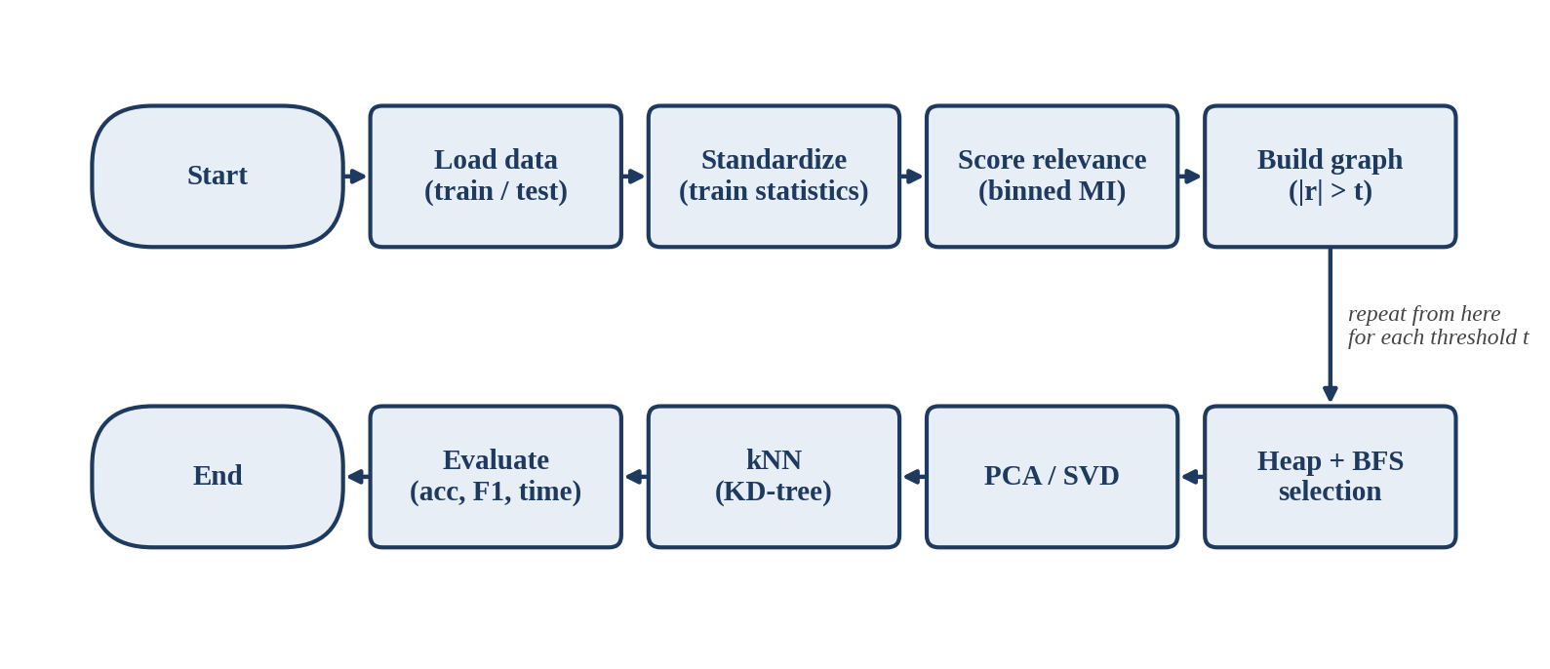
Figure 3.1: Flow chart of the pipeline
The data flow diagram has six processes. Process 1 standardizes the features with the mean and standard deviation of the training set. Process 2 scores each feature by its mutual information with the class label. Process 3 builds the redundancy graph from the correlation matrix. Process 4 uses the scores and the graph to choose features with the heap and BFS. Process 5 reduces the chosen features with PCA/SVD. Process 6 trains the kNN classifier on the reduced features and measures accuracy, macro-F1 and query time on the test set.
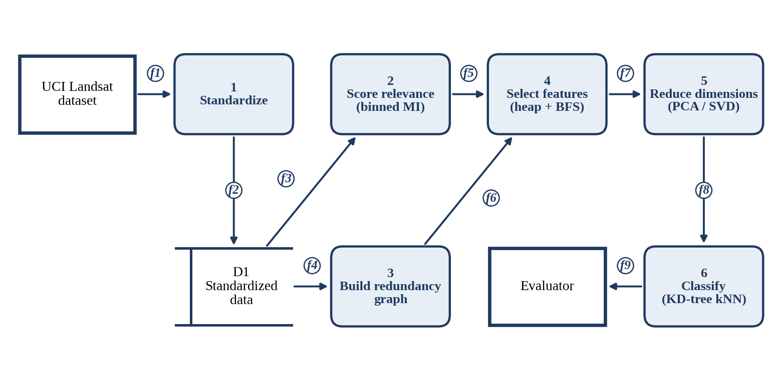
Figure 3.2: Data flow diagram. D1 is a data store, the rectangles with thick borders are external entities, and f1 to f9 are the data flows listed in Table 3.1
Table 3.1: Data flows
Flow | From | To | Data
f1 | UCI Landsat dataset | 1 Standardize | Raw training and test samples
f2 | 1 Standardize | D1 | Standardized features and labels
f3 | D1 | 2 Score relevance | Features and labels
f4 | D1 | 3 Build redundancy graph | Features
f5 | 2 Score relevance | 4 Select features | Relevance score of each feature
f6 | 3 Build redundancy graph | 4 Select features | Redundancy graph
f7 | 4 Select features | 5 Reduce dimensions | Selected features
f8 | 5 Reduce dimensions | 6 Classify | Reduced features
f9 | 6 Classify | Evaluator | Accuracy, macro-F1, query time

We chose a filter method rather than a wrapper for two reasons. A filter does not retrain a classifier for every candidate subset. It also lets the selection itself be written with plain data structures that can be analysed. The graph makes redundancy explicit: a connected component is a group of features linked by high correlation, and the neighbours of a feature are the ones it makes unnecessary. The heap supplies the order in which features are considered, so the most relevant feature of each group is the one we keep.

3.2 Redundancy Graph and Heap-Based Selection
This section describes how features are scored, linked in a redundancy graph, and selected with a heap. The design follows the idea behind mRMR [2], which is to choose features that are relevant to the class label and not redundant with each other. It uses a hard correlation threshold in place of the incremental mutual-information score of the original criterion.

3.2.1 Relevance Scoring
The relevance of a feature is its mutual information with the class label. Each feature is cut into 10 equal-width bins, and the probabilities are estimated from frequency counts, as Guyon and Elisseeff describe for discrete variables [1]:
I(X; Y) = sum over x and y of P(x, y) ln [ P(x, y) / ( P(x) P(y) ) ]
Here X is the binned feature and Y is the class label. One pass over the m samples gives all the counts, so scoring the d features costs O(dm). Our implementation agrees with the mutual_info_score function of scikit-learn on the same bins to within 1e-9. Standardization, bin edges and all scores are computed from the training set only, so no test data influences the selection.

3.2.2 Redundancy Graph
The absolute Pearson correlations of the standardized features form a d x d matrix C. The redundancy graph G = (V, E) has one node per feature, and an edge joins features i and j when C[i][j] is greater than a threshold t. The graph is stored as an adjacency list. Computing C costs O(d^2 m) and building the graph from C costs O(d^2).
The connected components of G, found with BFS or Union-Find, group features that are linked by chains of high correlation. On the full Landsat data the graph has 2 components at t = 0.7 and at t = 0.8, 4 components at t = 0.9 and 24 components at t = 0.95. The threshold therefore controls how strongly the features are grouped.

3.2.3 Indexed Max-Heap
Features are kept in an array-based binary max-heap keyed by relevance. A second array stores the position of every feature in the heap. This gives constant-time membership checks and allows the key of a feature to be changed in O(log d). Push and pop cost O(log d), and a heap can be built from d keys in O(d) by bottom-up heapify. Each pop returns the most relevant feature that has not been handled yet. The heap was tested against Python's heapq on random keys, including key updates.

3.2.4 Greedy Selection with BFS
Algorithm 1 shows the selection procedure.
Algorithm 1: Heap and BFS feature selection
Input: relevance scores r[f], redundancy graph G
Output: selected set S
1 H = max-heap of all features keyed by r[f]
2 S = empty set; removed = empty set
3 while H is not empty:
4 f = H.pop()
5 if f in removed: continue
6 add f to S
7 for each neighbour g of f (BFS, depth 1):
8 add g to removed
9 return S

A feature that has a selected neighbour was already marked as removed, so it is skipped when it is popped. Otherwise it is selected and its direct neighbours are removed. The result has two properties, which our tests check at several thresholds: no two selected features are joined by an edge, and every discarded feature has a selected neighbour. In graph terms, S is a maximal independent set of G, built greedily in order of relevance.
The heap is built in O(d) and the d pops cost O(d log d). Each selected feature scans its adjacency list once, and these scans add up to O(E) over the whole run, so the selection step costs O(d log d + E) once the graph exists.

3.2.5 Variant and Baseline
As a variant, we group the features with Union-Find, using path halving and union by rank, and keep the most relevant feature of each connected component. The unions cost O(E) times the inverse Ackermann function of d, which is almost constant. This variant is more aggressive, because correlation links form chains and a component can contain features that are not directly correlated with each other. On the full Landsat data it keeps 2 features at t = 0.8 and 4 at t = 0.9, against 5 and 10 for Algorithm 1.
As a baseline we use a naive filter. It sorts the features by relevance with merge sort and keeps a feature only if no already kept feature has a correlation above t. It costs O(d log d + d|S|), where |S| is the number of kept features, which is at most O(d^2). Our tests show that it returns exactly the same subset as Algorithm 1, on the real data at every threshold and on synthetic data.
Table 3.2: Cost of each step (d features, m samples, E edges, |S| selected features)
Step | Structure or algorithm | Cost
Relevance scores | Binned counts | O(dm)
Correlation matrix | Pairwise Pearson | O(d^2 m)
Graph build | Adjacency list | O(d^2)
Selection (Algorithm 1) | Max-heap and BFS depth 1 | O(d log d + E)
Per-component variant | Union-Find | O(E) times inverse Ackermann
Naive baseline | Merge sort and pairwise checks | O(d log d + d|S|)

3.3 PCA/SVD from Scratch
After selection, the remaining features are compressed with principal component analysis (PCA), which we also wrote ourselves. PCA finds orthogonal directions along which the standardized data varies most. These directions are the eigenvectors of the covariance matrix C = X^T X / (m - 1), and each eigenvalue is the variance along its direction. Equivalently, if X = U S V^T is the singular value decomposition, the columns of V are the same directions and S^2 / (m - 1) are the eigenvalues. We compute the eigenvectors from C directly with power iteration, because it needs only matrix-vector products.
Algorithm 2 shows the procedure. The data are standardized with the mean and standard deviation of the training set, and C is built in O(m d^2). For each component we start from a random unit vector v and repeat v = Cv, v = v / |v| until v stops changing. The vector converges to the eigenvector with the largest remaining eigenvalue, and lambda = v^T C v is that eigenvalue. We then deflate, C = C - lambda v v^T, so that the next round finds the next direction. We stop when the components explain 95% of the total variance and project the data with Z = X V_k.
Algorithm 2: PCA by power iteration with deflation
Input: standardized data X (m x d), variance target q
Output: projected data Z, eigenvalues lambda
1 C = X^T X / (m - 1)
2 for j = 1, 2, ...:
3 v = random unit vector
4 repeat until v stops changing:
5 v = C v; v = v / |v|
6 lambda_j = v^T C v
7 C = C - lambda_j v v^T
8 stop when lambda_1 + ... + lambda_j reaches q of the total
9 V = [v_1 ... v_k]; Z = X V
10 return Z, lambda
Each component costs (number of iterations) x O(d^2), so k components cost O(k x iterations x d^2) on top of the covariance. With d = 36 this is small. On the Landsat training set, 6 components reach 95% of the variance.
We tested the module against numpy and scikit-learn on random correlated data. The eigenvalues and explained variances agree to a relative tolerance of 1e-4, the components agree up to sign, and the components are orthonormal. Two eigenvalues that lie close together converge slowly under power iteration, so the stopping rule watches the change in the vector, not in the eigenvalue. Judging by the eigenvalue alone stopped too early and gave components that differed from scikit-learn's by about 0.02.

3.4 KD-Tree and kNN Classification
The classifier is kNN with k = 5, built on a KD-tree that we wrote ourselves. The tree is built recursively. At depth j it splits the points on axis j mod d, using merge sort to find the median along that axis, and it stops splitting when a node holds 10 points or fewer, which then become a leaf. Because we sort at every level, the build costs O(n log^2 n) for n points. A linear-time median selection would bring that down to O(n log n), but the build is small next to the queries here (0.13 to 0.17 s in our runs).
A query goes down to the leaf that contains the query point and scans it, keeping the k best points seen so far in a short sorted list. Since k is small, inserting into that list is cheap. On the way back up, the other side of a split is visited only if the splitting plane is closer to the query than the current k-th best distance. In few dimensions this prunes most of the tree and a query takes about O(log n). In many dimensions it prunes little and the cost moves towards O(n).
This matters for our results. On the Landsat test set, the raw 36-feature queries took 12.05 s, while the two-feature selection at t = 0.7 took 0.21 s. The tree is simply more useful when there are fewer dimensions, which is a practical reason to reduce them.
Prediction is a majority vote among the k neighbours, and a tie goes to the smaller class label. We tested the tree against brute-force search on random data, where the k smallest distances matched, and we tested the classifier against scikit-learn's kNN, where the predictions were identical. On the real data our raw accuracy equals scikit-learn's exactly, 0.9045.

4. Analysis

4.1 Complexity Analysis
Table 3.2 lists the cost of each step. Two things stand out. The correlation matrix and the graph build both look at every pair of features, so they are quadratic in d. The selection step does not: with the graph already built, it needs one heap build and d pops, and the neighbour scans add up to the number of edges.
To check this, we timed each stage on synthetic data. The features come in blocks of four that share a common signal plus noise, which gives a correlation of about 0.8 inside a block and about 0 between blocks. With t = 0.7 the graph therefore has about 1.5d edges, and the selection keeps one feature per block, so |S| is about d/4. We used m = 500 samples and d from 50 to 1600. At every size we checked that Algorithm 1 and the naive filter returned the same subset. Each time is a single run measured with a wall clock.
Table 4.1: Running time in milliseconds on synthetic data
d | Graph build | Selection only | Heap + BFS total | Naive filter
50 | 0.26 | 0.13 | 0.39 | 0.15
100 | 0.72 | 0.25 | 0.98 | 0.42
200 | 2.72 | 0.54 | 3.26 | 1.14
400 | 11.52 | 1.26 | 12.78 | 4.04
800 | 44.25 | 2.83 | 47.08 | 14.28
1600 | 175.03 | 5.98 | 181.00 | 55.27
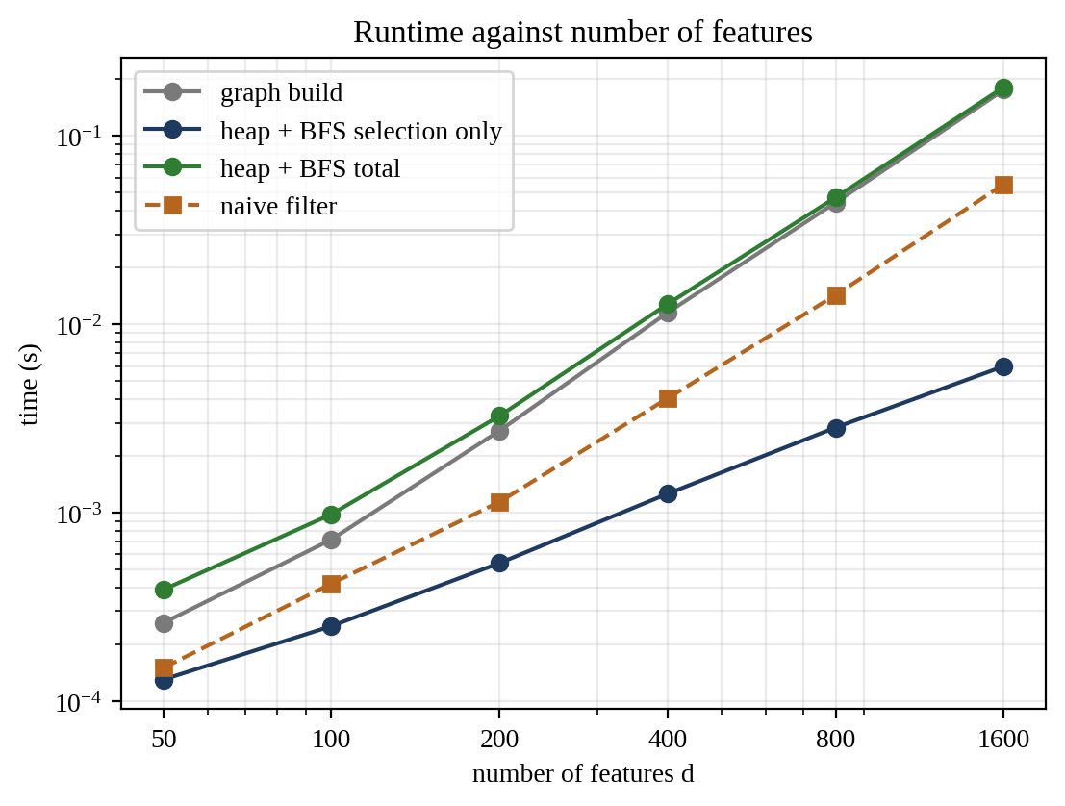
Figure 4.1: Running time against the number of features (log-log axes)
Figure 4.1 plots the same times on log-log axes. We fitted a straight line to log time against log d for d of 200 and above. The slope is the empirical exponent k in time proportional to d^k. The selection step has k = 1.16, close to the d log d + E we expect. The naive filter has k = 1.86 and the graph build has k = 2.00. The total for Algorithm 1, graph build plus selection, has k = 1.93. The correlation matrix has k = 1.43, which is below the theoretical 2 because numpy spends a large share of the time on fixed overhead at these sizes, so we do not treat that number as a clean measurement.
The result is mixed, and we report it as it is. The selection step alone is 9 times faster than the naive filter at d = 1600 (6.0 ms against 55.3 ms), and it grows more slowly. But building the graph takes 175 ms at that size, which is 97% of the time of Algorithm 1, so the whole procedure is about 3.3 times slower than the naive filter (181 ms against 55 ms). Overall both are quadratic in d. The graph pays for itself only when it is used more than once, for example for several selections on the same graph, for neighbour queries, or for the component analysis we use in the threshold study. These timings come from our pure-Python code and single runs, so the constants say more about the implementation than about the algorithms.

4.2 Experiments and Results
We used the official train/test split. Features were standardized with training statistics, and relevance scores and correlations were also computed from the training set only. For each threshold we ran Algorithm 1, trained our kNN classifier (k = 5) on the selected features and classified the 2000 test samples. We report accuracy, macro-averaged F1 and the time taken to classify the test set, which we call query time. As a check, our kNN gives 0.9045 accuracy on all 36 features, exactly the value we get from scikit-learn's kNN.
Table 4.2: Feature selection with Algorithm 1 on the Landsat test set (kNN, k = 5)
Setting | Features | Accuracy | Macro-F1 | Change in accuracy | Query time
Raw (all features) | 36 | 0.9045 | 0.8916 | - | 12.05 s
t = 0.95 | 25 | 0.8950 | 0.8800 | -0.95 points | 9.28 s
t = 0.90 | 11 | 0.8730 | 0.8531 | -3.15 points | 4.65 s
t = 0.80 | 5 | 0.8520 | 0.8291 | -5.25 points | 1.30 s
t = 0.70 | 2 | 0.7845 | 0.7440 | -12.00 points | 0.21 s
PCA alone (95% variance) | 6 | 0.8950 | 0.8768 | -0.95 points | 5.59 s*
t = 0.95, then PCA | 6 | 0.8935 | 0.8765 | -1.10 points | 5.13 s*
t = 0.90, then PCA | 5 | 0.8640 | 0.8417 | -4.05 points | 4.21 s*
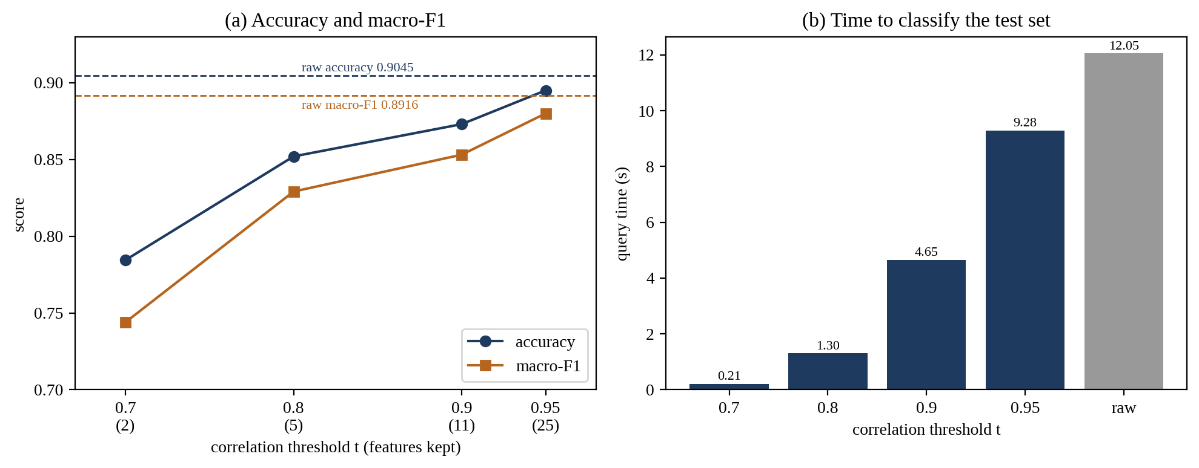
Figure 4.2: Effect of the correlation threshold on accuracy, macro-F1 and query time
Selection alone did not improve accuracy at any threshold. What it gives is a trade: fewer features and faster queries in exchange for some accuracy. At t = 0.95 the loss is small, 0.95 points, and 11 of the 36 features are dropped. At t = 0.90 we keep 11 features, lose 3.15 points and answer queries 2.6 times faster. At t = 0.70 only two features survive, accuracy falls by 12 points and queries are 57 times faster, which is too little information for six classes. The raw run is slow because our KD-tree is pure Python and 36 dimensions leave little to prune.
Why does accuracy drop? Guyon and Elisseeff show that correlated variables are not always redundant, because averaging several noisy copies of a signal reduces the noise [1]. The features we drop are mostly the same band seen at neighbouring pixels, so they may be acting as such copies. We have not tested this explanation directly, so we only say that it is consistent with the paper.
Table 4.2 also includes PCA alone and PCA after selection, with PCA keeping 95% of the variance. PCA alone reduces the 36 features to 6 components and reaches 0.8950 accuracy, 0.95 points below the raw features and equal to selection at t = 0.95, which keeps 25 features. Selecting features before PCA did not help. At t = 0.95 the result is 6 components at 0.8935, and at t = 0.90 it is 5 components at 0.8640, which is lower than either step alone. This is expected, since PCA already removes the correlation between features, so a correlation filter in front of it has little left to remove. The reason to keep selection is interpretability: the kept features are original spectral bands, while each component mixes all 36 of them. The PCA rows were measured in a second run on a slower machine, marked with an asterisk in the table. There the raw features took 33.14 s, so those query times are comparable only within that run. PCA alone took 5.59 s, about one sixth of the raw time.

5. Weaknesses and Limitations

5.1 Limits of the Method
Correlation is not the same as redundancy. Guyon and Elisseeff give examples where two highly correlated variables still help each other, and where a variable that is useless alone helps when combined with another [1]. Our graph looks only at pairwise correlation, so it can throw away a feature that carries something the kept one does not. The accuracy drop in Table 4.2 is at least consistent with this.
The threshold t has to be chosen, and the outcome depends strongly on it: two features at 0.7 and 25 at 0.95. We have no rule for picking it other than looking at the trade-off.
Relevance is measured one feature at a time with binned mutual information. We used 10 equal-width bins and did not tune that number. Features that matter only in combination get no credit, and the estimate changes with the bin count.
The greedy procedure gives a maximal independent set of the graph, not the largest one, and the result depends on the relevance order. Two features with nearly equal scores can swap places and change the subset.
Finally, selection alone cost accuracy at every threshold. The selected subset never classified better than the full feature set.

5.2 Limits of the Evaluation
All real results come from one dataset with 36 features and one official train/test split, without cross-validation. The thresholds are compared on the test set, so in real use t should be chosen on a validation split. The scaling study uses synthetic data with a very regular block structure, which is cleaner than real data, and the real dataset is too small to show scaling at all. Each timing is a single run.

5.3 Limits of the Implementation
Everything is written in pure Python, so absolute times are large. The KD-tree build sorts at every level and is O(n log^2 n). Queries on 36 dimensions take 12 s for 2000 samples, which a library implementation would do much faster. The graph build uses a double loop over all pairs and dominates the cost of Algorithm 1. It could be made faster by a constant factor, but not asymptotically, because every pair has to be examined.

6. Conclusion
This project built a feature selection pipeline for the Landsat land-cover data out of basic data structures: an indexed max-heap, a graph with BFS, Union-Find, merge sort and a KD-tree, all written from scratch and checked against library implementations. The selection procedure ranks features by mutual information with the label, links features whose correlation exceeds a threshold, and picks features greedily with the heap, removing the neighbours of each pick. The result is a maximal independent set of the redundancy graph, and it matches the output of a naive greedy filter exactly.
The experiments show a trade-off, not a free improvement. At t = 0.90 the method keeps 11 of 36 features, loses 3.15 points of accuracy and makes kNN queries 2.6 times faster. The selection step scales close to linearly, but building the graph is quadratic and dominates, so in our implementation the whole procedure is slower than the naive filter. The graph is worth its cost only when it is reused.
Written from scratch, PCA reduces the 36 features to 6 components with an accuracy of 0.8950, about one point below the raw features. Selecting features before PCA gave no further gain, so in our experiments PCA alone gave the best balance between size and accuracy, and selection is worth keeping for interpretability.
Possible next steps are choosing t on a validation split, replacing the hard threshold with an mRMR-style score that uses mutual information for redundancy, and testing the method on a dataset with many more features, where the cost of the graph build would show more clearly.

7. References
[1] I. Guyon and A. Elisseeff, "An Introduction to Variable and Feature Selection," Journal of Machine Learning Research, vol. 3, pp. 1157-1182, 2003.
[2] H. Peng, F. Long and C. Ding, "Feature selection based on mutual information: criteria of max-dependency, max-relevance, and min-redundancy," IEEE Transactions on Pattern Analysis and Machine Intelligence, vol. 27, no. 8, pp. 1226-1238, 2005.
[3] Statlog (Landsat Satellite) data set, UCI Machine Learning Repository.
[4] I. T. Jolliffe and J. Cadima, "Principal component analysis: a review and recent developments," Philosophical Transactions of the Royal Society A, vol. 374, 2016.

