Michael Soha  
May 31, 2022  
Foundations of Programming: Python  
Assignment 07

Files & Exceptions

Introduction

In this assignment we are asked to research code, and create a demo for both pickling and error handling. Picking is: primarily used in serializing and de-serializing a Python object structure. Benefits are in that it allows a writer to serialize basically any object having to add extra code. Error handling is used to help trace and resolve errors.

Observations

* Both the course and review videos had excellent examples to draw from and build demo code:

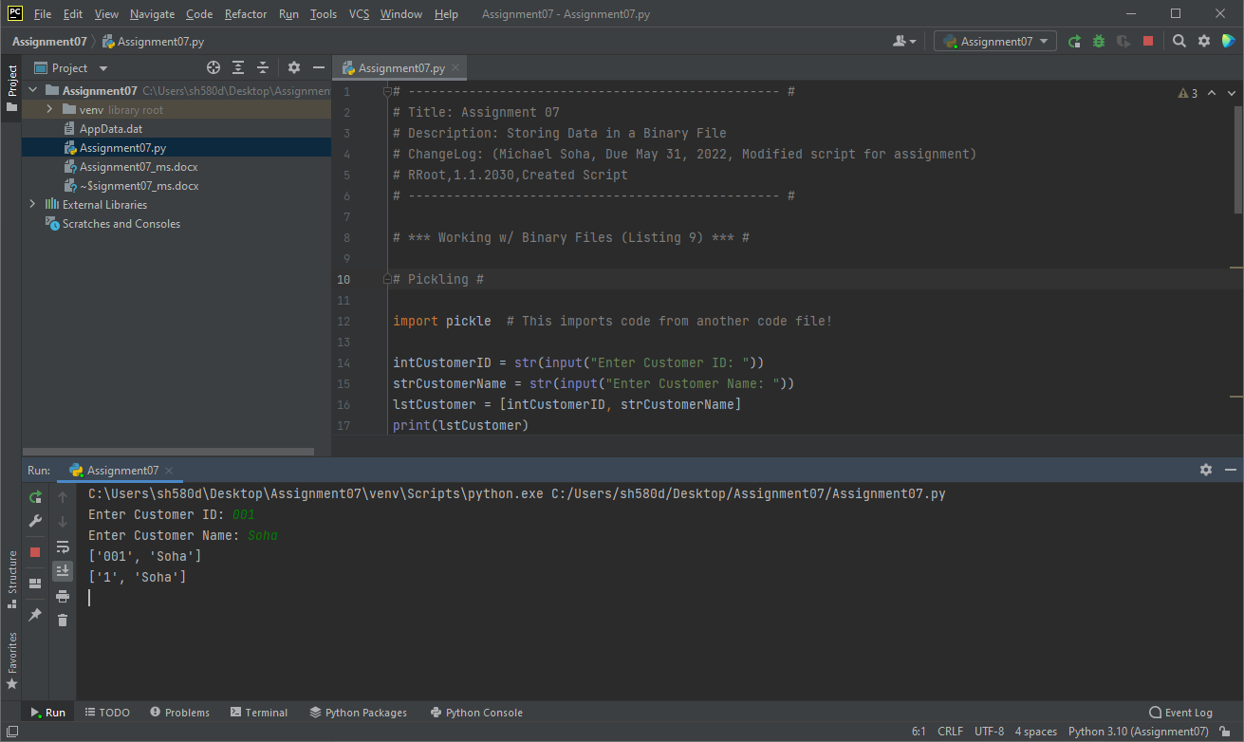

* And shown with an error written into the code:

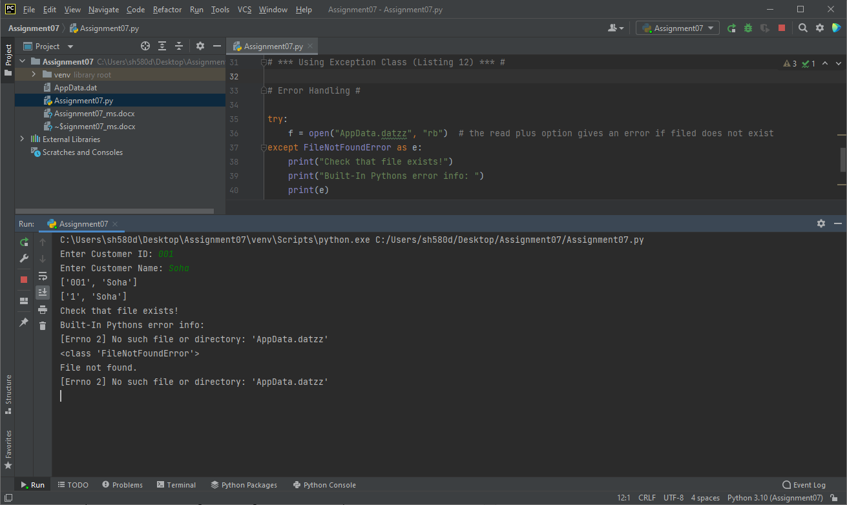

* It certainly helps both creator and user identify where an error may be
* Shown from Command Prompt:

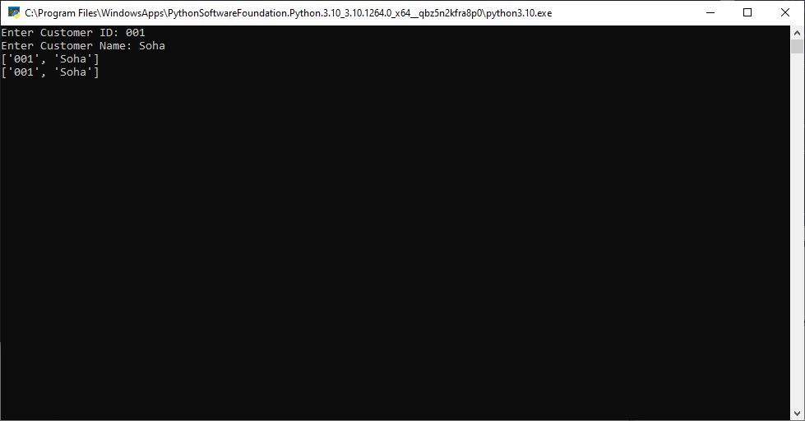

Summary

GitHub Link: