# Test Assessment approach document

## Introduction

We’d like to invite you to do the code assessment as discussed during your interview. During this review the reviewers will ask you to explain your code and ask questions about why you took the approach you did, how you would change the program if certain requirements changed and some technical questions.

The code assessment is not a puzzle; it's not a hard or tricky assignment. It's just a regular piece of code; you know the details of what you programmed, and we know the details about what we asked so we hopefully have a common understanding. If you have any questions do not hesitate to contact us, we'll be glad to answer them.  
  
Note that you’ll be expected to share your screen while you show us through your code, make sure this works on your computer.  
  
This is the assessment:

1. Download three CSV files from Amazon S3 :

[https://s3-eu-west-1.amazonaws.com/lunatechassessments/countries.csv](http://workable.com/nr?l=https%3A%2F%2Fs3-eu-west-1.amazonaws.com%2Flunatechassessments%2Fcountries.csv)

[https://s3-eu-west-1.amazonaws.com/lunatechassessm...](http://workable.com/nr?l=https%3A%2F%2Fs3-eu-west-1.amazonaws.com%2Flunatechassessments%2Fairports.csv)

[https://s3-eu-west-1.amazonaws.com/lunatechassessments/runways.csv](http://workable.com/nr?l=https%3A%2F%2Fs3-eu-west-1.amazonaws.com%2Flunatechassessments%2Frunways.csv)

2. Write a web application in Java or Scala that will ask the user for two actions : Query or Reports.

2.1 Query Option will ask the user for the country name or code and print the airports & runways at each airport. The input can be country code or country name. For bonus points make the test partial/fuzzy. e.g. entering zimb will result in Zimbabwe :)

2.2 Choosing Reports will print the following:

* 10 countries with highest number of airports (with count) and countries with lowest number of airports.
* Type of runways (as indicated in "surface" column) per country
* Bonus: Print the top 10 most common runway identifications (indicated in "le_ident" column)

Feel free to use any library/framework as necessary but write it as a web application.

Please write the code as if you are writing production code, possibly with tests.

## Overview

## 

## Domain model

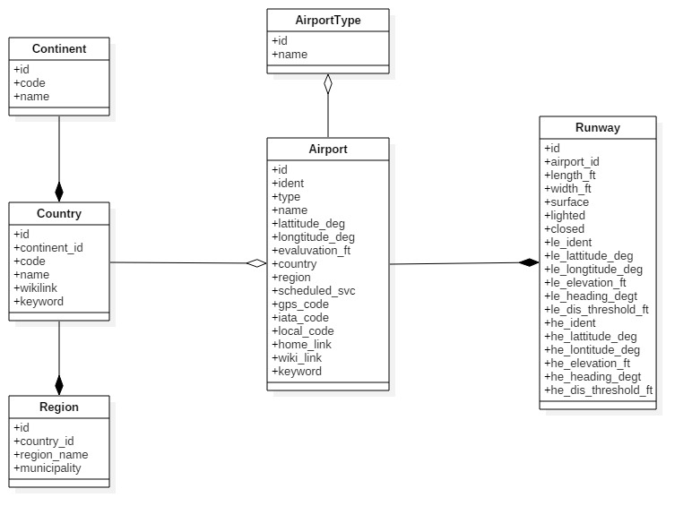

## Technology Stack

1. Java 8
2. Spring Framework 4.2.0.RELEASE
3. Spring MVC for Restful Web Services
4. Spring Security
5. MySQL
6. Spring JDBC Template
7. AngularJS 1.6
8. HTML5
9. CSS 3
10. Junit
11. Mockito
12. WebSphere Liberty Profile 8.0

## Screen Shots

1. Authentication

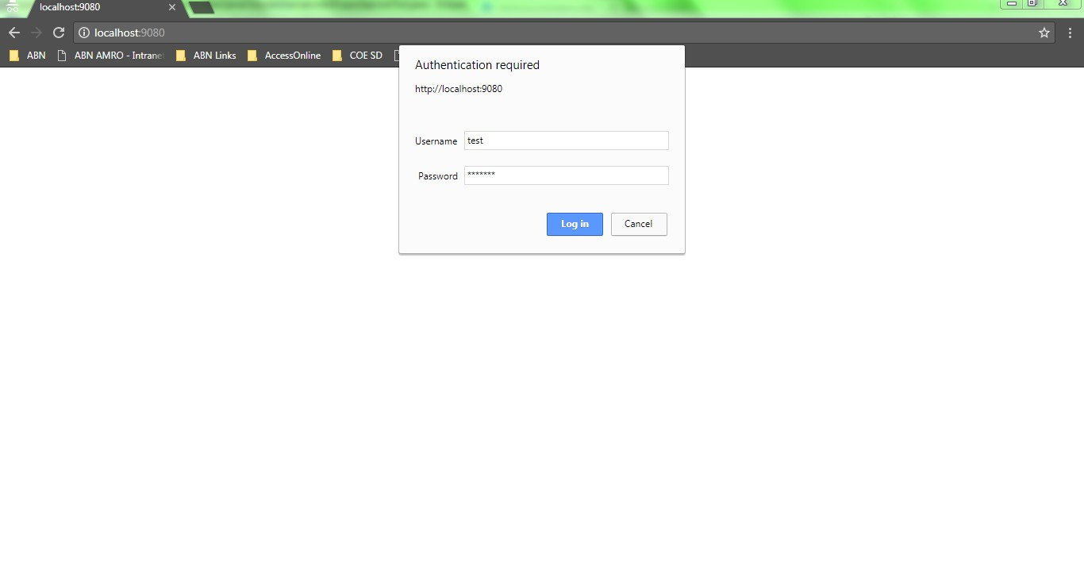

1. Main Page

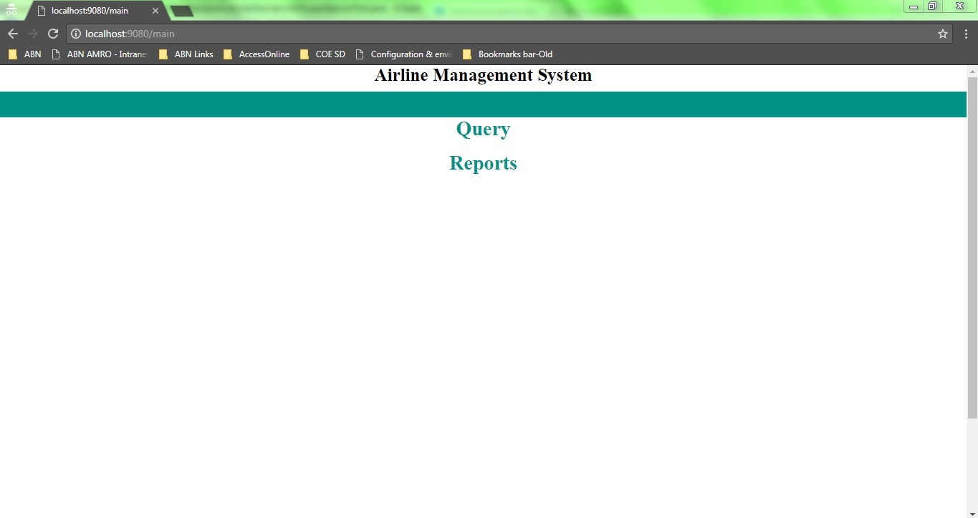

1. Query Search Page

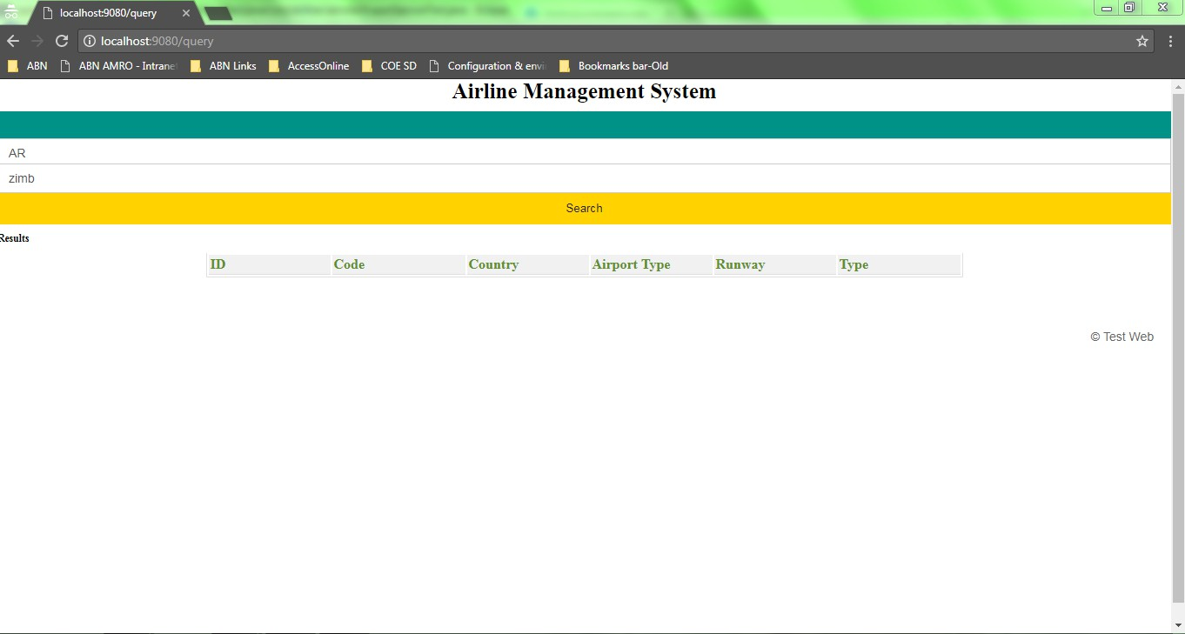

1. Query Results Page

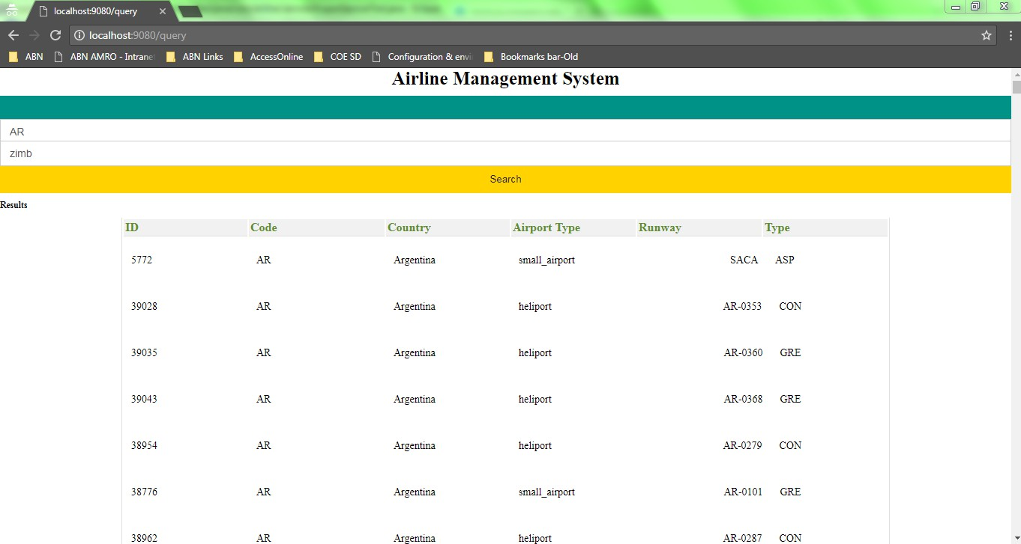

1. Reports Page

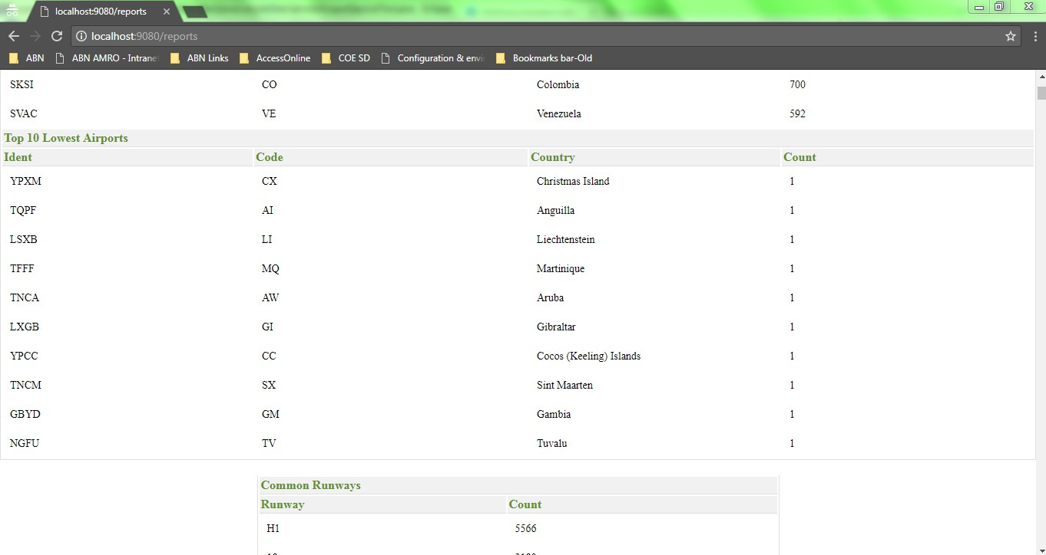

## References

1. Bit Bucket URL

<https://bitbucket.org/Muthukumarasamyraja/airline-management>