ANNEXURE ITEM 6 · MOBILINK MICROFINANCE BANK · CONTRACT LIFECYCLE MANAGEMENT
High-Level and Low-Level Design
Architecture, deployment topology, data model, lifecycle, interfaces and security design
Two levels in one document. The high-level design says what the system is made of and why the shape was chosen; the low-level design gives the detail an implementer or a reviewer needs to build against it. Every figure is drawn from the design rather than captured from a screen, so the diagram and the text cannot drift apart.
Annexure item 6. The design of the solution at two levels: the architecture and its reasoning, then the detail an implementer or a reviewer needs to build against it.
Part A — High-Level Design answers what the system is made of, how the pieces relate, and why the shape was chosen. Part B — Low-Level Design answers how each piece works: the deployment topology by network zone, the data model, the lifecycle, the interfaces, and the security design inside each tier.
Every figure is drawn from the design rather than captured from a running screen, so the diagram and the text cannot drift apart.

1. Design principles
Five decisions govern everything below. Each is a constraint accepted deliberately, and each has a cost stated alongside it — a principle with no cost attached has not been applied to anything.
Principle | What it means in practice | What it costs
On-premises, self-contained | No component requires a hosted service to function. Every dependency is either inside MMBL's perimeter or optional | Features that would be trivial with a cloud service are built rather than bought
Isolation in the database, not only the application | Access boundaries are enforced by Oracle Virtual Private Database, beneath the application | Every schema change must consider the policy as well as the table
Controls fail closed | If a security control cannot function, the operation is refused rather than allowed | An unreachable scanner blocks uploads. That is the intended behaviour
Evidence over assertion | Every state change is recorded in a tamper-evident trail, and signed documents verify without the system | Write amplification on every transaction, accepted for what it buys
Standard interfaces | Federation, provisioning, logging and gateway integration all use published standards | No proprietary connector, and no lock-in for MMBL

2. Solution architecture
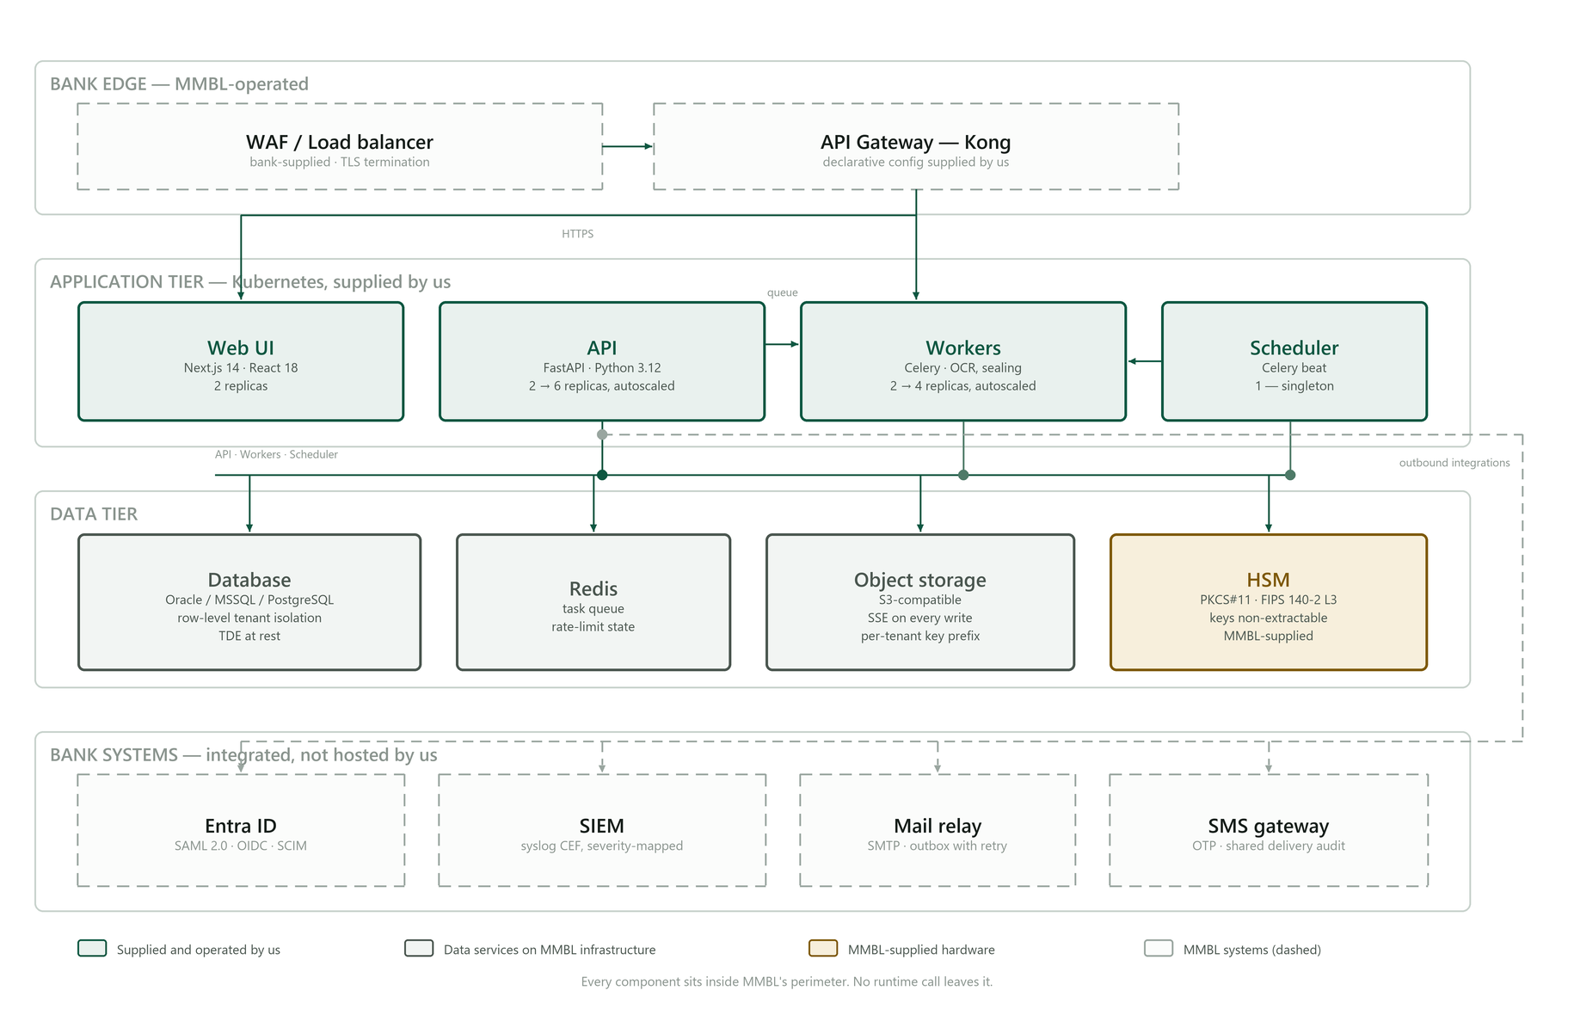
Figure 1 — Solution architecture. Every component sits inside the bank's perimeter.
Four tiers, deliberately not four services. The request tier answers users and integrating systems; the worker tier does everything slow — signing, rendering, sweeps — so a signature ceremony cannot make a page slow; the data tier holds the record; the secure zone holds key material and nothing else.
The worker tier is separated from the request tier because their failure modes and scaling profiles differ: a queue backlog must never become a timeout on a user's screen, and month-end renewal volume must be absorbable without provisioning request capacity for it.
Why a modular application rather than a distributed service mesh. RFP §4b expresses a preference for microservices. The deviation is declared here rather than left for an evaluator to notice. The operational requirement is a deployment MMBL's own team can run: a service mesh multiplies the operational surface — service discovery, distributed tracing across a dozen hops, partial-failure semantics, an order-of-magnitude harder debugging story — without serving any requirement in this RFP. The properties the preference exists to secure are all delivered: independent scaling of the heavy asynchronous work, horizontal scaling of the request tier, and API-driven modularity. The decomposition path remains available if MMBL later requires it, because the module boundaries already exist.

3. Component responsibilities
Component | Responsibility | Scaling
Request tier | Authentication, authorisation, business operations, REST and SOAP interfaces | Horizontal, stateless
Worker tier | Document rendering, cryptographic signing, sealing, bulk dispatch, extraction | Horizontal, queue-driven
Scheduler | Renewal sweeps, obligation reminders, revocation list publication, archival and purge | Single active instance
Document store | Executed and draft documents, encrypted at rest | MMBL's storage platform
Database | The system of record, including the audit trail | MMBL's Oracle platform
Certificate authority | Issuance, revocation, revocation responses | Within the secure zone
Hardware security module | Key generation and signing. Keys are non-extractable | MMBL-supplied appliance

4. Key architectural decisions
# | Decision | Alternative considered | Why this one
1 | Modular application, separate worker tier | Distributed microservices | Operability by MMBL's own team; the scaling properties are delivered without the operational surface
2 | Isolation by Virtual Private Database | Application-layer filtering alone | A defect in application logic still cannot read across the boundary
3 | Per-signatory certificates | One shared organisational certificate | A shared certificate cannot attribute a signature to a person, which is what the requirement asks for
4 | Keys generated inside the HSM | Keys generated then imported | An imported key existed outside the device once, and once is enough
5 | Audit chain ordered by sequence | Ordered by timestamp | Two entries in the same clock tick would otherwise order arbitrarily, and a chain that verifies under one ordering and not another proves nothing
6 | Evidence embedded in the document | Evidence held in the system | A signature that can only be verified by the system that made it is worth little in a dispute years later

5. Deployment topology
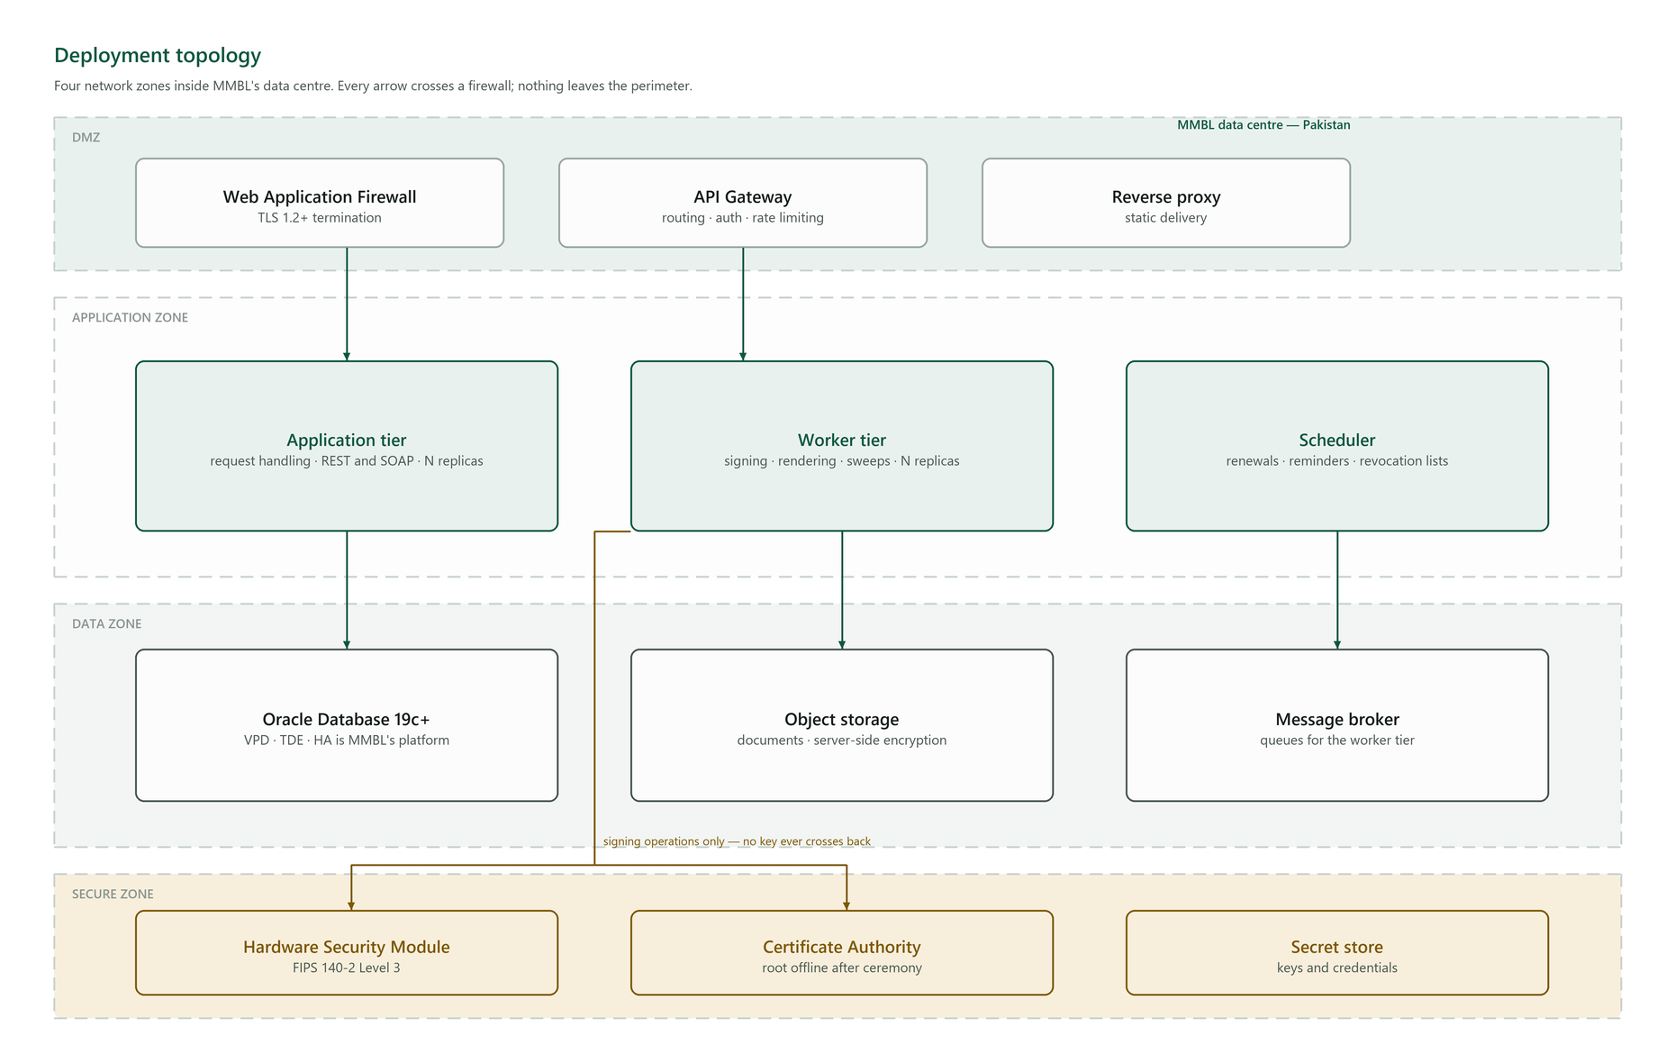
Figure 2 — Four network zones. Every arrow crosses a firewall.
Zone | Contents | Inbound from | Rule
DMZ | Web application firewall, API gateway, reverse proxy | MMBL's corporate network and, for signing links, the internet through the bank's own edge | TLS 1.2+ terminates here
Application | Request tier, worker tier, scheduler | DMZ only | No direct inbound from outside the DMZ
Data | Oracle database, object storage, message broker | Application zone only | No inbound from the DMZ at all
Secure | HSM, certificate authority, secret store | Worker tier only, for signing operations | No key material ever crosses back out

Every component declares the ports and destinations it requires, and default-deny network policy is supplied with the deployment manifests. Nothing requires a flat network or unrestricted egress, which is what makes the micro-segmentation requirement in §4d answerable rather than aspirational.
Environments. Development, UAT and production are separately credentialed and built from the same declarative configuration. One artefact is promoted by digest across all three, so what is accepted in UAT is bit-for-bit what reaches production.

6. Data model
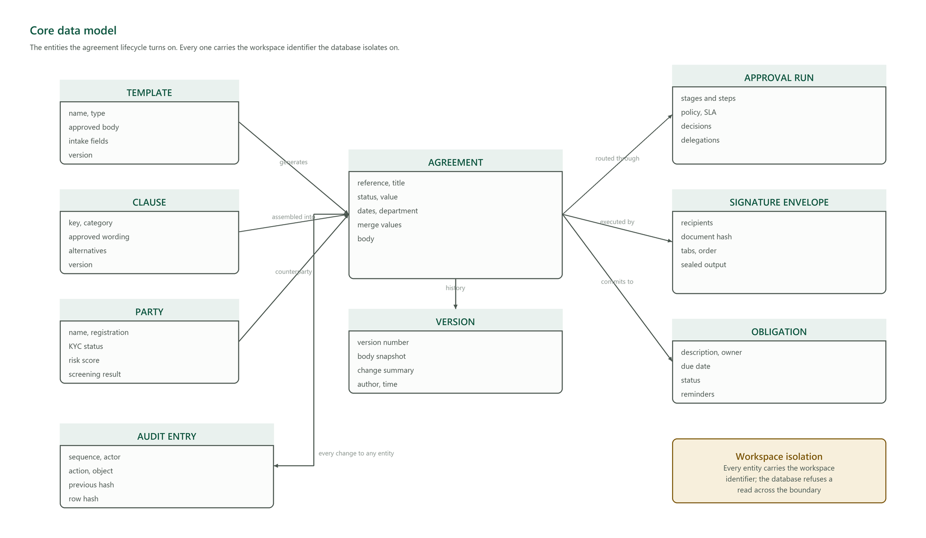
Figure 3 — The entities the agreement lifecycle turns on.
Entity | Holds | Notable design point
Template | Approved body, intake field definitions, version | The approved wording is frozen in a version snapshot, so "generated from the approved template" stays provable after the template is edited
Clause | Approved wording, ranked alternatives, version | A drafter may substitute only an approved alternative; the substitution is recorded
Party | Registration, KYC status, risk score, screening result | Duplicate onboarding is blocked; an override requires a reason and is audited
Agreement | Reference, status, value, dates, merge values, body | Carries the merge values it was generated from, so the draft can be explained later
Version | Body snapshot, change summary, author, time | A snapshot, not a diff — reconstructing a body from a chain of diffs fails the moment one is lost
Approval run | Stages, steps, policy, SLA, decisions, delegations | Stages are ordered; steps within a stage are concurrent
Signature envelope | Recipients, document hash, field placement, sealed output | The hash binds the envelope to exactly the content that was signed
Obligation | Description, owner, due date, status | Tracked across the whole portfolio, not per agreement
Audit entry | Sequence, actor, action, object, previous hash, row hash | Append-only; see §9

Every entity carries the workspace identifier the database isolates on. MMBL's installation is dedicated, so in practice it holds one workspace — the boundary exists so a subsidiary or a ring-fenced business unit can be separated later as configuration rather than a re-architecture.
Two columns are denormalised deliberately. The actor's name is copied into each audit entry so the record survives the user being renamed or deactivated, and the object's label is captured at the time of the action so an entry still reads correctly after the object is renamed. A record that changes meaning when unrelated data changes is not a record.

7. Agreement lifecycle
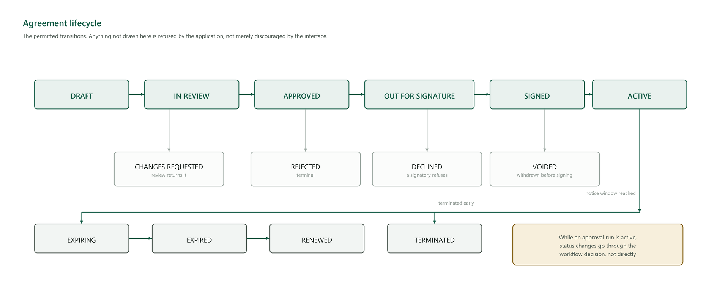
Figure 4 — Permitted transitions. Anything not drawn is refused.
The state machine is enforced in the service layer. An attempt to move an agreement to a state not reachable from its current one is refused with an explicit conflict, not silently ignored.
While an approval run is active, generic status changes are blocked — the agreement moves through the workflow decision instead. Without that rule, an agreement could be advanced past an approval that had not been given.
Suspension of a certificate and termination of an agreement are different things, and both are reversible only where the standard allows it. Certificate suspension is published as a real revocation hold that can be withdrawn; agreement termination is not reversible and requires multi-role sign-off.

8. Integration design
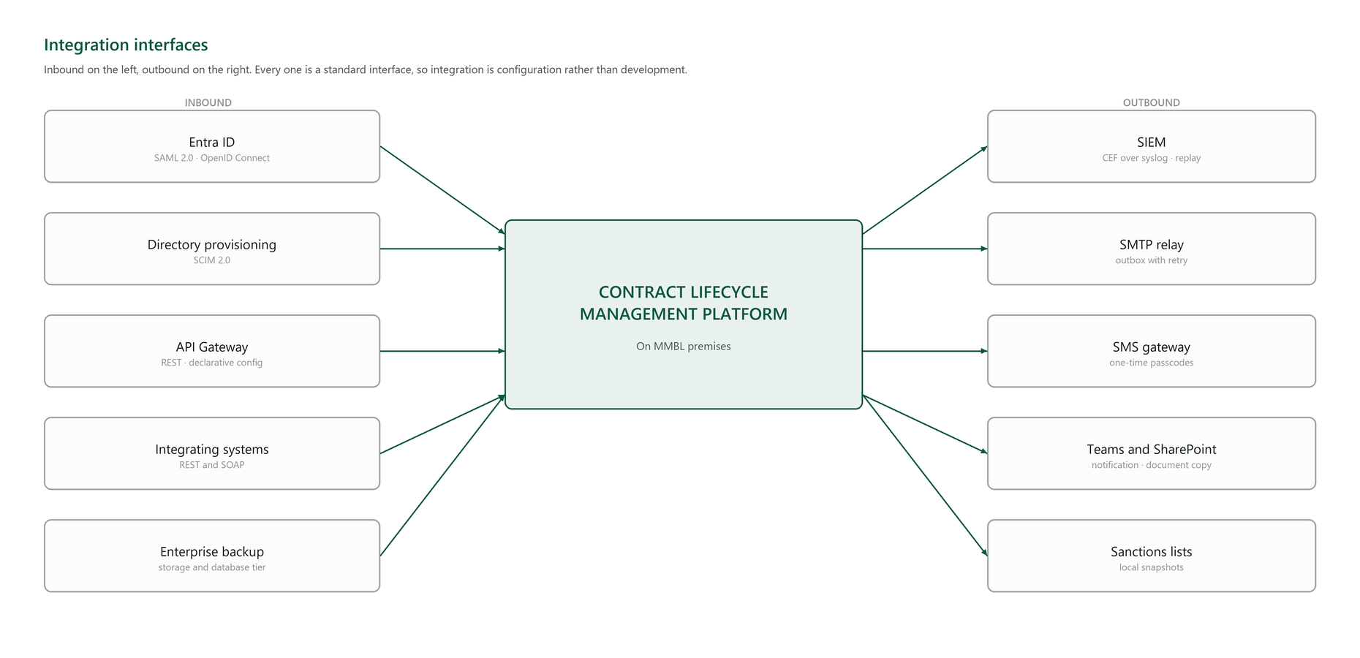
Figure 5 — Inbound and outbound interfaces.
Direction | Interface | Standard | Failure behaviour
Inbound | Single sign-on | SAML 2.0, OpenID Connect | Password with multi-factor remains available, so identity is never on the critical path
Inbound | User provisioning | SCIM 2.0 | Manual administration remains available
Inbound | Gateway | REST, declarative configuration | —
Inbound | Integrating systems | REST and SOAP | —
Outbound | SIEM | CEF over syslog | Buffered, with replay for the period a collector was unavailable
Outbound | Mail | SMTP relay | Outbox with retry; delivery state recorded rather than assumed
Outbound | SMS | HTTP gateway | Shares one delivery audit with mail
Outbound | Collaboration | Notification and document copy | Non-blocking; failure is recorded, not propagated

Delivery state is recorded, never assumed. A message that failed to send is a visible failed record with its reason, not an absence. The difference matters at exactly the moment somebody asks why a counterparty says they never received the agreement.

9. Security design

9.1 Authentication and authorisation
Enforced password policy; multi-factor by time-based one-time passcode, passkeys, or email fallback; federated sign-on where MMBL's identity provider is configured. The access token is short-lived and held in memory only — never in browser storage, where a script could read it. The refresh token is an httpOnly, secure, same-site cookie, rotated on every use, with reuse detection: presenting an already-rotated token revokes the entire session chain and raises an alert, because the only way a rotated token exists in a second place is that it was taken.
Authorisation is enforced in the service layer rather than by hiding controls, so an API call cannot reach what the interface does not show. Step-up re-authentication is bound to the specific action and object, single-use and time-limited.

9.2 Cryptography
Purpose | Mechanism
Data at rest — database | Oracle Transparent Data Encryption at the tablespace
Data at rest — secrets | AES-256 with a rotating key chain, so a database export alone yields nothing usable
Data at rest — documents | Server-side encryption on the object store
Data in transit | TLS 1.2 or higher, verified at start-up rather than assumed
Signing keys | Generated inside the HSM, marked non-extractable; the custody interface has no export method
Document signatures | PAdES-LTV — embedded chain, revocation data and trusted timestamp

9.3 The audit chain
Each entry carries the hash of its predecessor and its own keyed hash over both. Altering a field changes the entry's hash; because the next entry incorporates it, every subsequent entry fails to verify. Deleting an entry breaks the link between its neighbours. Inserting one gives it no valid predecessor.
Ordering is by a monotonic sequence assigned under a lock, and that is load-bearing. Ordering by timestamp would mean two entries written in the same clock tick order arbitrarily — an entry could chain past its true predecessor, and deleting the skipped entry would leave a chain that still verified. The one thing the mechanism exists to detect would become undetectable, on a tie that a coarse system clock makes common rather than rare.
The chain key is held in configuration, not in the database, so database access alone cannot recompute a valid chain over altered data. Verification is delivered to MMBL and reports the first divergent entry.

10. Performance and capacity design
Target | Design decision that carries it
Revocation response under 200 ms | Single indexed lookup on the serial; elliptic-curve responder key, because signature cost dominates the response
Search under 500 ms across ten years | Database-native full-text indexing, plus a hot/cold retention split so the searched set does not grow without bound
Signature ceremony under 5 s | Rendering and sealing are asynchronous; the user is not held while a document is produced
Month-end absorption | Worker tier scales independently of the request tier, so a batch cannot slow a page

Targets are proven by load and soak testing against a corpus sized to MMBL's ten-year volumes, not a demonstration set.

11. Availability and recovery design
Tier | Availability design | Owner
Request | Multiple replicas, disruption budgets, health probes | Solution
Worker | Multiple replicas; work is queued, so a lost worker is retried rather than lost | Solution
Scheduler | Single active instance; every job is idempotent, so a restart re-runs safely | Solution
Database | High availability on MMBL's Oracle platform | MMBL
Storage | Replication on MMBL's storage platform | MMBL

Every scheduled job is idempotent and reports its own outcome — success, failure, duration and how many items it acted on — so "the sweep ran and found nothing" is distinguishable from "the sweep did not run". Without that distinction a dead job and a quiet one look identical, and the first symptom is a renewal missed months later.
Backups are encrypted, held offsite and restore-verified. Documents and database are captured on the same schedule, so a restore produces a consistent state rather than records pointing at documents that no longer exist.

12. Figures
Figure | Subject | Level
1 | Solution architecture | HLD
2 | Deployment topology by network zone | LLD
3 | Core data model | LLD
4 | Agreement lifecycle | LLD
5 | Integration interfaces | LLD

The PKI design — certificate hierarchy, key custody, registration and issuance, signature format, and accredited-root chaining — is carried at the same level of detail in the PKI Architecture document, which is Annexure item 13.

Mobilink Microfinance Bank — Contract Lifecycle Management. Submitted as part of the technical proposal.

