PUBLIC KEY INFRASTRUCTURE
PKI and eSignature Architecture
Contract Lifecycle Management — Mobilink Microfinance Bank
An in-house Certificate Authority built from cryptographic primitives, not a wrapped third-party product. Every signatory receives their own certificate and their own private key — shared or role-based certificates are refused by a database constraint, not only by application logic. This document describes the architecture as built, the custody boundaries, and the limitations that are not yet closed.
Parameter | Specification
Root CA | EC P-384, 20 years, offline after key ceremony, pathLen = 1
Issuing CA | EC P-384, 10 years, online, pathLen = 0
Signatory certificates | EC P-256, 730 days internal / 7 days visitor
OCSP responder | EC P-256, 1 year, delegated, id-kp-OCSPSigning + OCSPNoCheck
Key custody | PKCS#11 HSM, keys non-extractable, FIPS 140-2 Level 3
Revocation | Full and delta CRL, plus RFC 6960 OCSP with nonce echo
Document signing | PAdES-LTV, one signature per signatory
Standards | RFC 5280, RFC 6960, RFC 3161, ETSI PAdES

Document | Revision | Status | Classification
PKI-ARCH-01 | 1.0 | For submission | Confidential — MMBL and bidder

1. Design constraint: primitives, not a wrapped CA
The RFP requires that the PKI and eSignature engine is engineered in house rather than assembled from an existing certificate authority product. The certificate authority, registration authority, certificate lifecycle, CRL generation and OCSP responder in this system are our own implementation, written against general-purpose cryptographic primitives — the same primitives any implementation of these standards is built on.
One component is deliberately not hand-rolled: embedding a signature into a PDF. That is a byte-range problem rather than a cryptographic one — reserve a gap in the file, hash everything around it, write the signature into the gap — and a hand-written implementation would be less trustworthy than a maintained library, not more. pyHanko performs that step and never receives a private key: it is handed a digest to sign and returns the assembled document.
OPEN COMMERCIAL QUESTION
Annexure item 11 requires a sworn undertaking that the engine is proprietary and not an open-source derivative. Whether the composition described above satisfies that undertaking as drafted is a question for MMBL's counsel and ours. It is raised here rather than discovered at signature.

2. Certificate hierarchy
Two tiers. The root signs once and goes cold; the issuing CA does the daily work and cannot extend the hierarchy beneath it.
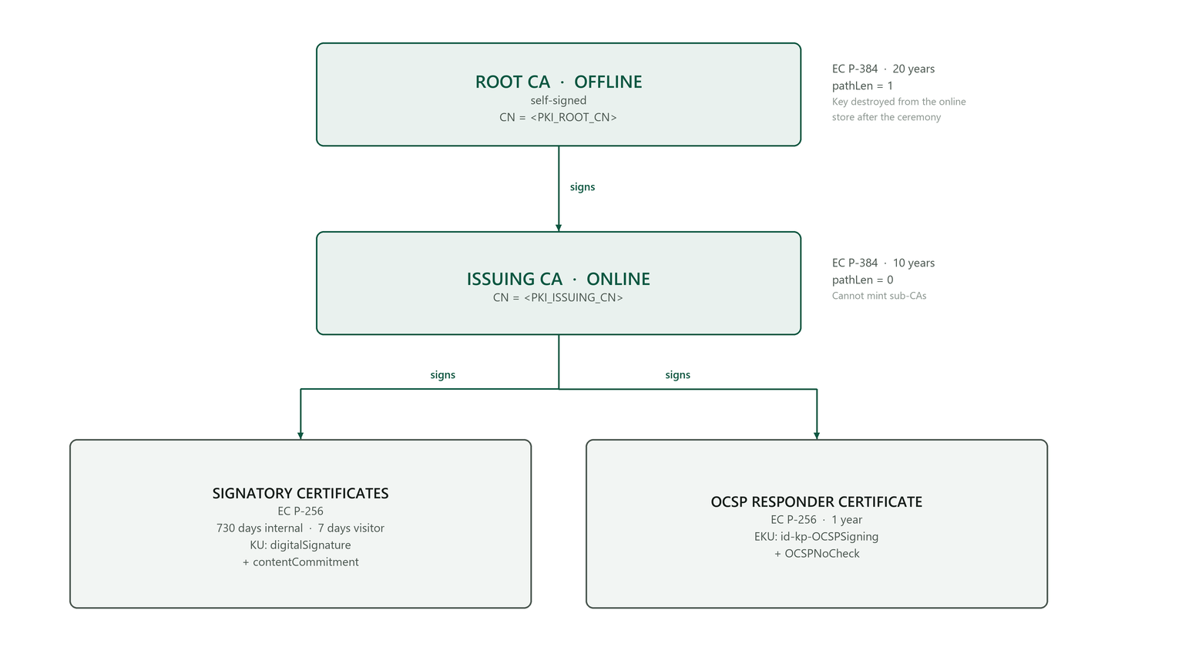
Figure 1 — Certificate hierarchy and what each key is permitted to sign.

2.1 Why this shape
- pathLen = 0 on the issuing CA. An attacker who compromises the online CA can issue end-entity certificates — serious, and recoverable by revoking that one CA. They cannot create a sub-CA and extend the hierarchy, which would be far harder to contain.
- A delegated OCSP responder. Signing OCSP responses with the CA key would place that key in a network-facing, publicly reachable service. The responder holds its own short-lived key and carries OCSPNoCheck, so relying parties do not recurse into checking the responder's own revocation status.
- contentCommitment on signatory certificates. This is the key-usage bit that distinguishes a certificate intended for signing an agreement from one intended for authenticating a session. Without it the legal weight of the signature is materially weaker.
- Elliptic curve rather than RSA. P-384 for authorities and P-256 for leaves gives equivalent or better security at a fraction of the signing cost. This bears directly on the OCSP latency target, where the response signature dominates the request.
Provisioning is a single idempotent operation: POST /pki/provision.

3. Key custody
One interface, two implementations, and deliberately no export method. A caller cannot serialise a private key out of the store, so code written against the software store runs unchanged against the HSM.
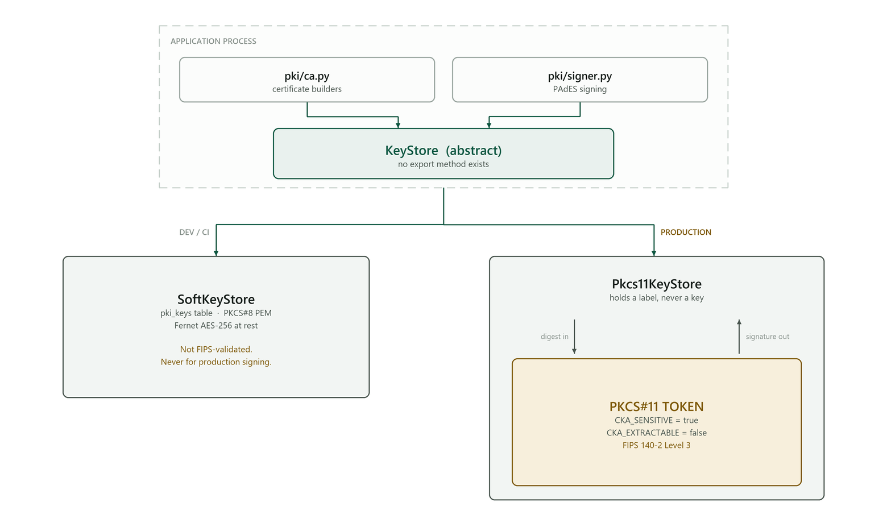
Figure 2 — The boundary a private key must never cross.

3.1 Software keystore — development and CI
Keys are generated in process and stored as PKCS#8 PEM, encrypted at rest with the same Fernet key chain used for MFA secrets. A database dump alone yields nothing usable.
It is honestly labelled: not FIPS-validated, not tamper-resistant, and not for production signing. The /pki/health endpoint returns a standing warning for as long as it is in use.

3.2 PKCS#11 keystore — production
Keys are generated inside the token and marked non-extractable, so "the private key never leaves the HSM" is a property enforced by the device rather than a promise made by this software. A thin proxy forwards each signing operation into the token, which is what allows the certificate builders to have one code path for both stores.
Device | FIPS 140-2 | PKCS#11 library path
SoftHSM2 (development and CI only) | Not validated | /usr/lib/softhsm/libsofthsm2.so
Thales Luna Network HSM 7 | Level 3 | /usr/safenet/lunaclient/lib/libCryptoki2_64.so
Utimaco CryptoServer CP5 | Level 3 | /opt/utimaco/lib/libcs_pkcs11_R3.so
Entrust nShield Connect XC | Level 3 | /opt/nfast/toolkits/pkcs11/libcknfast.so

Configuration:
KEYSTORE_PROVIDER = pkcs11
HSM_LIBRARY_PATH = /opt/nfast/toolkits/pkcs11/libcknfast.so
HSM_TOKEN_LABEL = cm-prod # preferred over HSM_SLOT: slot ids renumber across reboots
HSM_PIN = <from the secret store — never a file in the repository>

3.3 Key ceremony — taking the root offline
- Provision the hierarchy on the target host (POST /pki/provision).
- Under dual witness, call POST /pki/cas/{root_id}/offline.
- The response returns the root private key ONCE. Write it to two separate offline media, for example encrypted USB devices held in separate safes. It is not persisted anywhere afterwards and never appears in an audit entry — only the fact of the ceremony does.
- The keystore entry is destroyed and the CA record is flagged offline.
- Record the ceremony: date, participants, media serial numbers and safe locations.
Where an HSM is in use the key was never online, so this step only sets the flag; the equivalent control is the device's own key-backup and quorum procedure.

4. Registration Authority
No certificate is issued without an approved RA request. Identity evidence is captured at enrolment rather than at approval, so what the approver saw is on the record.
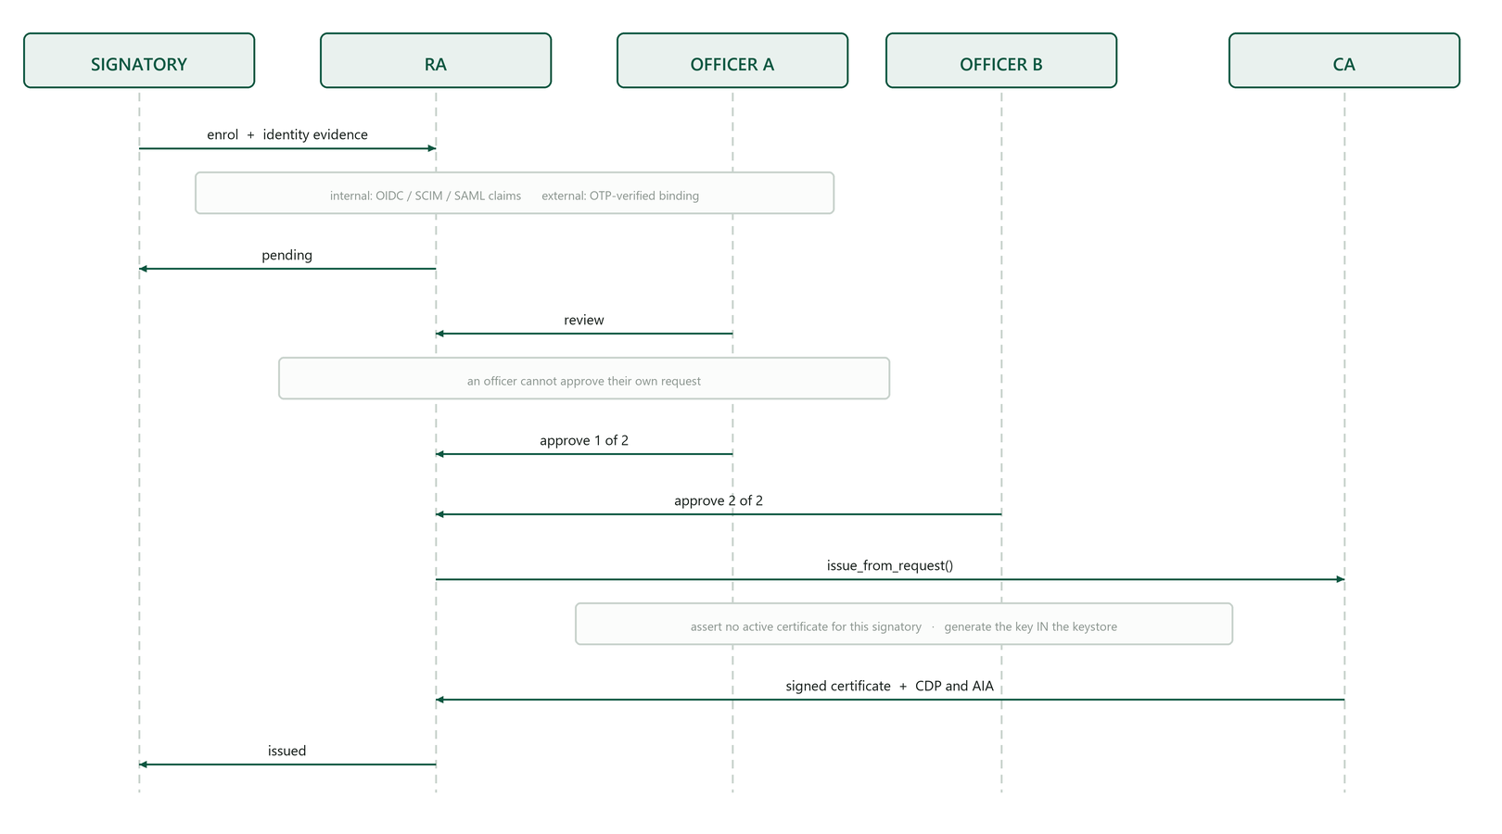
Figure 3 — Enrolment through issuance, with dual control on approval.
One certificate per signatory is enforced twice, deliberately. Once at issuance time with a clear error, and once by a partial unique index over the subject restricted to active certificates. A code path that forgets to call the lifecycle module still cannot create a second active certificate — a constraint that lives in only one place quietly rots the first time somebody adds a new issuance route.

5. Certificate lifecycle
Six states. Suspension is the only reversible one, and it is reversible because RFC 5280 provides a revocation reason that can be withdrawn.
Transition | Reversible | Notes
enrol → pending | n/a | RA request created with identity evidence
pending → rejected | No | RA declines; cannot issue
pending → active | n/a | Dual-control approval, then issuance
active → suspended | Yes | Published as certificateHold (reason code 6)
suspended → active | — | Published as removeFromCRL (reason code 8) in the next delta
active → active (renew) | n/a | New serial AND new key; subject binding preserved
active/suspended → revoked | No | Terminal. revoke() refuses to un-revoke
active → expired | No | notAfter passes; the sweep frees the signatory slot

Renewal changes both the serial and the key while preserving the binding to the signatory. A renewal that reused the key would leave the old and new certificates interchangeable, which defeats the purpose of renewing.
Suspension is implemented as a real hold, not an application flag. A relying party reading the CRL sees certificateHold and, when the hold lifts, sees removeFromCRL in the next delta — without needing to understand anything about this product.

6. Revocation publishing
Two channels, both signed. OCSP for freshness, CRL for offline and bulk verification.
Channel | Endpoint | Refresh | Contents
Full CRL | GET /pki/crl/{ca}.crl | Daily (24 h nextUpdate) | Every unexpired revoked serial
Delta CRL | GET /pki/crl/{ca}-delta.crl | Hourly (1 h nextUpdate) | Changes since the base CRL, including removeFromCRL
OCSP | POST /pki/ocsp | Real time | good / revoked+reason / unknown

6.1 Three details that separate a correct responder from one that returns bytes
- The response is signed by a delegated responder, not the CA key. The CA key stays cold. The responder certificate carries id-kp-OCSPSigning and OCSPNoCheck.
- The nonce is echoed (RFC 6960 §4.4.1). Without it an attacker can replay a stale "good" response for a certificate that has since been revoked. This is the single most commonly skipped requirement in an OCSP responder, and it is a real attack rather than a formality.
- "Unknown" means not ours, not not-found. A certificate this CA never issued receives unknown; one it issued with no revocation record receives good. Conflating the two would let an attacker distinguish issued serials from unissued ones by probing.
Performance: the lookup is a single indexed query on (workspace, serial number) and the responder key is elliptic curve to keep the signature cheap. The p95 < 200 ms target is architected for and is evidenced by load testing, not asserted here.

7. Per-signatory document signing
This is where the PKI stops being infrastructure and becomes evidence. A document signed by three people carries three independently verifiable signatures.
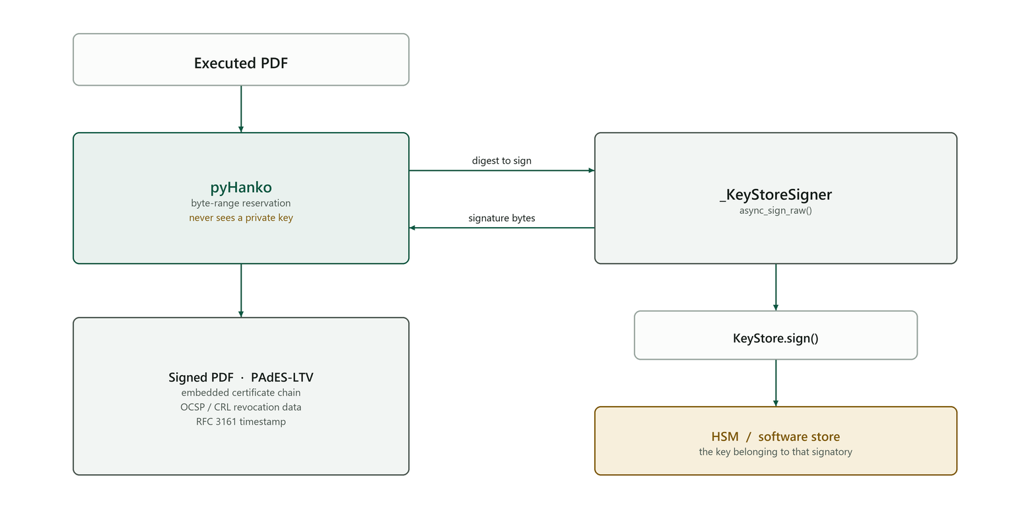
Figure 4 — PAdES-LTV signing. The private key never reaches the PDF layer.
CONFIGURATION THAT MATTERS
SIGNING_PROVIDER=pki signs once per signatory with that signatory's own certificate. SIGNING_PROVIDER=pades — a single shared organisational PKCS#12 — is retained only for deployments with no internal CA and is NOT the compliant setting, because shared certificates are precisely what the requirement forbids.

8. Validating certificates we did not issue
Overseas signatories who cannot be issued an MMBL certificate still sign, using their own certificate from DigiCert, GlobalSign, Sectigo, Entrust or a comparable authority. That requires validating a chain we did not build, against a trust store we control.
# | Check | What it establishes
1 | Chain construction | A path exists from the leaf to a configured trust anchor
2 | Signatures | Each certificate verifies against its issuer's public key — the step that actually matters
3 | Validity windows | Every certificate in the path, not only the leaf
4 | Basic constraints | Every intermediate is a CA and pathLen is respected
5 | Key usage | keyCertSign on intermediates; digitalSignature or contentCommitment on the leaf
6 | Revocation | OCSP first as the fresher source, CRL as fallback

The cryptography library ships a path validator, but it targets TLS server-authentication semantics: the wrong extended key usage, hostname checks that do not apply, and no notion of contentCommitment. Document-signing validation is a different policy over the same primitives, so the policy layer is written here while the signature mathematics is not.
PKI_REVOCATION_CHECK selects off, soft_fail (default) or hard_fail — whether an unreachable responder blocks a signature is a deployment decision, and not one to make silently on the bank's behalf.

9. ECAC chaining readiness
The requirement is that the issuing CA can later be re-chained to an accredited root without re-architecture and without reissuing existing certificates. Three design choices make that true, and all three are load-bearing.
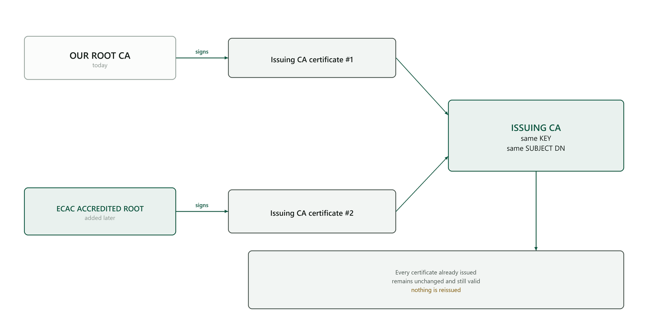
Figure 5 — Cross-certification: one key, two parents, nothing reissued.
- The issuing CA's key and subject DN are stable. A certificate verifies against the issuer's key, so anything that key signed remains verifiable under a new chain.
- Cross-certification issues a second CA certificate for the same key and DN, signed by a different parent. Both coexist as records and relying parties may build a path through either.
- Trust anchors are held in a table, not a file, so the accredited root is added at runtime rather than in a software release.

10. Implementation map
Module | Responsibility
pki/ca.py | Hierarchy, certificate builders, provisioning, cross-certification
pki/keystore.py | The custody boundary — software and PKCS#11 stores behind one interface
pki/ra.py | Registration Authority: enrolment, dual-control approval, evidence capture
pki/lifecycle.py | Enrol, issue, renew, suspend, resume, revoke
pki/crl.py | Full and delta CRLs, monotonic CRL numbers, hold and removeFromCRL
pki/ocsp.py | RFC 6960 responder — delegated signing, nonce echo, unknown vs good
pki/validate.py | RFC 5280 path validation for chains we did not issue
pki/signer.py | Per-signatory PAdES-LTV signing through the keystore
routers/pki.py | HTTP surface: provisioning, distribution points, RA queue, lifecycle, health

Approximately 2,600 lines of implementation, covered by 52 automated tests plus 7 further tests executed against a real PKCS#11 token in continuous integration.

11. Known limitations
Stated plainly, because an evaluation committee will find them regardless and a bidder who names them first is the one worth trusting.
# | Limitation | Position
1 | SoftHSM2 proves the code path, not the hardware | Continuous integration demonstrates that keys are generated inside a PKCS#11 token, that signing occurs in the token, and that the token refuses to disclose the private value. It cannot demonstrate tamper resistance or FIPS 140-2 Level 3 validation — those are properties of the device. Production must run against one of the devices in §3.2 and the deployment must evidence it.
2 | The software keystore remains the default | KEYSTORE_PROVIDER defaults to the software store. The production profile must set pkcs11; /pki/health warns until it does.
3 | Path validation omits name constraints and certificate policies | NameConstraints, CertificatePolicies and policy mapping are not implemented. For document-signing certificates from the major commercial roots this is not a practical gap, but it is a gap.
4 | OCSP p95 under 200 ms is designed for, not yet measured | The lookup is a single indexed query and the responder key is elliptic curve to keep the signature cheap. The load test that evidences the figure is scheduled.
5 | Oracle DDL for the partial unique index is unexercised | Written and unit-tested, never executed against a live Oracle instance. The first Oracle deployment is a named acceptance gate.

12. Test coverage
Area | What is proven
Hierarchy | Root self-signed; issuing CA chains to root; pathLen = 0; delegated OCSP responder with correct EKU and OCSPNoCheck; provisioning idempotent; serials unpredictable
Keystore | No export method exists; material encrypted at rest (asserted against raw SQL, not through the decrypting column type); sign and verify round-trip; destroy
Registration Authority | Issuance impossible without approval; rejected requests cannot issue; an officer cannot approve their own request; non-administrators cannot review; duplicate open requests refused; dual control requires two distinct officers; evidence reaches the audit entry
Issuance | Chains to the issuing CA; bound to the signatory; carries contentCommitment and not keyCertSign; CDP and AIA present; shared certificate rejected; a leaf never outlives its issuer
Lifecycle | Renewal changes serial and key while preserving binding; suspension blocks signing; resumption restores it; revocation terminal; unknown reason rejected; expired cannot sign; expiry sweep frees the slot
CRL | Revoked serial present and signed; active serial absent; CRL number monotonic; hold published as certificateHold; delta requires a base; delta marked with DeltaCRLIndicator
OCSP | good / revoked / hold with correct reasons; nonce echoed; signed by the delegated responder; unissued serial returns unknown; malformed request does not raise; foreign issuer receives unauthorized
Validation | Rejects with no anchors; accepts a valid third-party chain; rejects expired; rejects untrusted root; validates our own chain; anchors de-duplicate
ECAC | Cross-certification preserves existing certificates
Isolation | Certificates do not leak across workspaces

This document describes the implementation as built rather than a target state; where something is not finished it appears in §11 rather than in a diagram. The modules that implement it are named in §10.

