ANNEXURE ITEM 4 · MOBILINK MICROFINANCE BANK · CONTRACT LIFECYCLE MANAGEMENT
Project Implementation Plan
Milestones, dependencies and the commitments required from MMBL
Six milestones over twelve weeks, with every dependency tracked — including the ones that are MMBL's to supply. A plan that hides what the customer owes is a plan that slips in week three for a reason nobody wrote down.
Annexure item 4. Delivery within the RFP's 2–3 month window, followed by two years of onsite support after go-live.

1. Shape of the plan
Twelve weeks, six milestones, four workstreams running in parallel. The plan is built around one observation: the critical path is not our engineering — it is MMBL's dependencies. Eleven inputs are needed, most of them by week three, and a two-week slip on any of them consumes the float in a twelve-week window.
The plan is therefore arranged so that construction continues while an integration waits. The software keystore, console email and local storage backend all let work proceed against a functioning system, and each is a one-line switch to the real thing when it arrives.

2. Delivery schedule
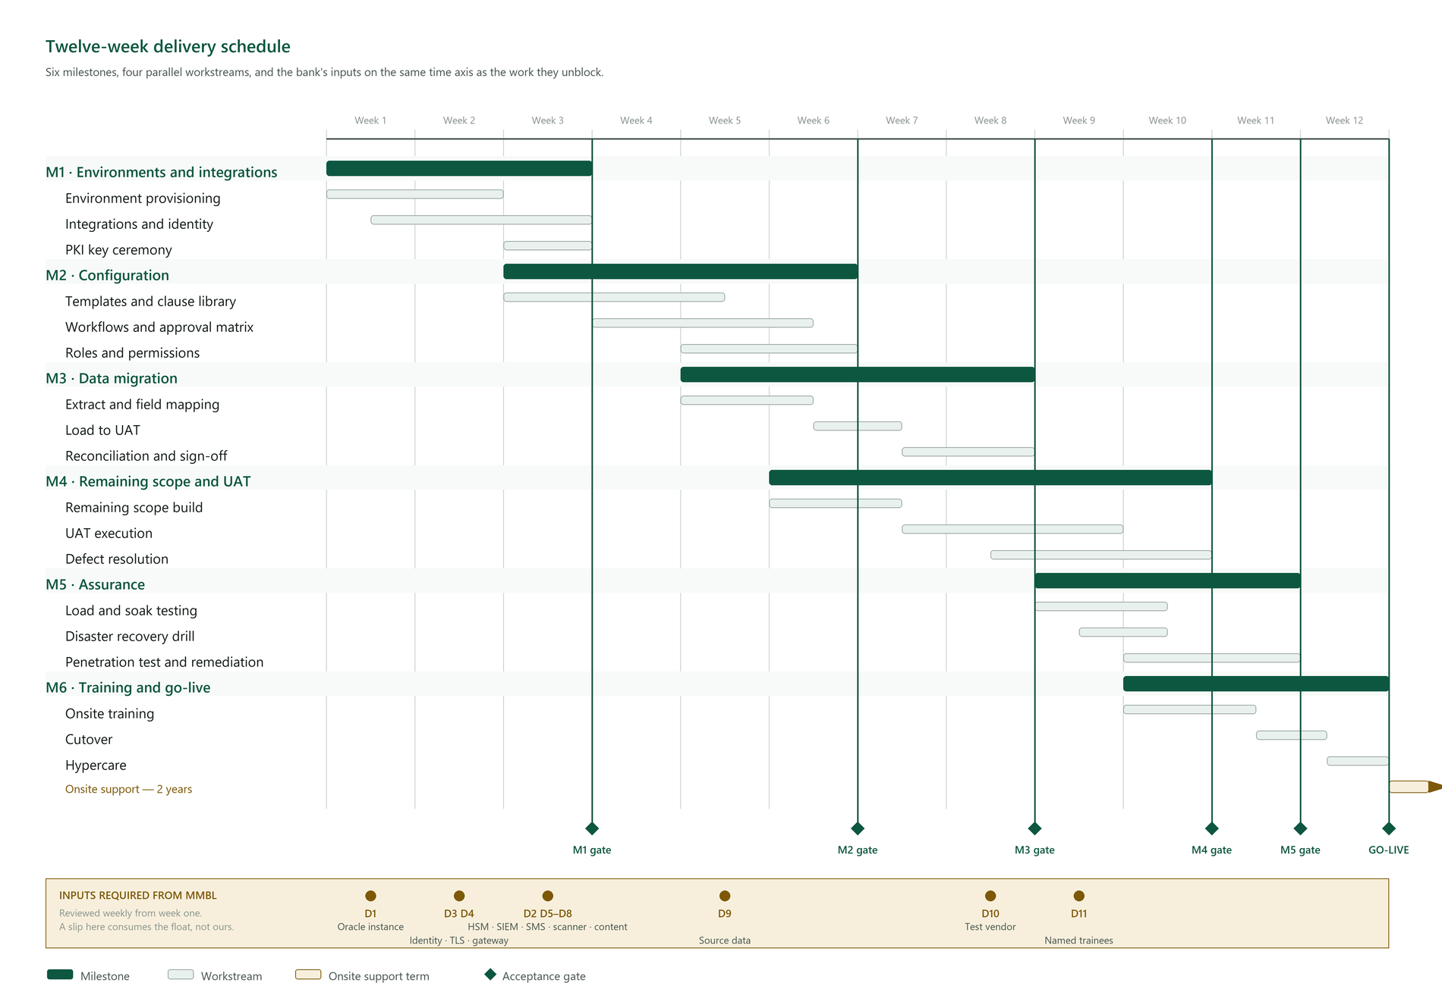
Figure 1 — Twelve weeks, six milestones and four parallel workstreams. The lower lane carries MMBL's inputs on the same time axis as the work they unblock, because the critical path runs through them rather than through our engineering.
Three things the chart is drawn to make visible.
The milestones overlap deliberately. Configuration begins before environments are finished and migration begins before configuration is signed off, because a strictly sequential plan does not fit twelve weeks. The cost of that overlap is that a slip early does not simply move the end date, it compresses the milestone downstream — which is why the dependency dates in the lower lane are the ones to watch.
Each gate is an acceptance, not a date passing. A milestone that ends is not a milestone that is accepted. Every gate has exit criteria stated in §3, and passing it is a joint decision recorded at the time.
The float is roughly one week, and it sits in weeks 6 to 8. It is stated rather than hidden in the bars, so that when it is consumed both parties know it has been.

3. Milestones

M1 · Environments and integrations — weeks 1–3
Task | Owner | Depends on
Provision Dev, UAT and Production | MMBL infra | —
Deploy the application to all three | Us | Environments
Oracle acceptance gate — full migration suite plus cross-workspace isolation against a live instance | Us | Oracle instance, week 1
Connect Entra ID (SAML/OIDC) and SCIM | Us | IdP metadata, reply URL, SCIM token
Configure the API gateway | MMBL + us | Kong instance
Connect the SIEM feed | Us | Collector endpoint, CEF format agreed
Connect mail relay and SMS gateway | Us | Relay details, SMS account
Connect the antivirus daemon | Us | Reachable ClamAV
Initialise the HSM and perform the key ceremony | MMBL + us, dual witness | HSM on site

Exit: a user authenticates through Entra ID, events reach the SIEM, and the CA hierarchy is provisioned with the root offline.
Highest-risk milestone. Nine of the eleven MMBL dependencies land here. The Oracle instance is requested in week one rather than week six: platform certification is the gate the whole delivery passes through (R-07), and finding a problem in week one is a correction while finding it in week eight is a re-plan.

M2 · Configuration — weeks 3–6
Task | Owner
Load approved templates and clause library | MMBL Legal + us
Configure playbook rules — required, prohibited, altered | MMBL Legal
Build approval workflows and the authority matrix | MMBL business + us
Map roles to real job functions; configure custom roles | MMBL + us
Configure retention, archival and legal-hold matters | MMBL Compliance
Configure notification templates and reminder schedules | Us

Exit: an agreement can be originated from a template, approved through the real workflow, and executed end to end in UAT.
MMBL's content is the dependency here. We can build the structure without it; we cannot validate the structure against content that does not exist.

M3 · Data migration — weeks 5–8
Task | Owner
Extract from source systems; profile the data | MMBL data owner
Map fields; agree the handling of gaps and duplicates | Joint
Trial load into UAT | Us
Reconcile against source counts | Joint
Correct, re-load, re-reconcile | Us

Exit: a reconciliation report accepted by the named data owner, variance under 0.5% or itemised and accepted in writing.
Loading into UAT first means a mismatch costs a re-run rather than a rollback.

M4 · Remaining scope and UAT — weeks 6–10
Task | Owner
Deliver bulk send (BB-09) | Us
Prepare the UAT book and brief testers | Us
Execute UAT scripts | MMBL business
Triage and resolve defects | Joint triage, we resolve
Regression test each fix | Us

Exit: every script executed with a recorded result; no open S1 or S2 defects; sign-off by the MMBL business owner.

M5 · Assurance — weeks 9–11
Task | Owner
Load test — 100 concurrent users, one hour | Us
Soak test — a day's peak signature volume | Us
Latency verification — OCSP p95 < 200 ms, search p95 < 500 ms | Us
DR drill — restore within the 4-hour RTO, verified working | MMBL infra + us
Third-party VAPT | MMBL's vendor
Remediate findings to the patch SLA | Us
Audit chain verification across the migrated history | Us

Exit: performance, recovery and security reports accepted. Critical VAPT findings block go-live — stated now so it is not negotiated later under schedule pressure.

M6 · Training and go-live — weeks 10–12
Task | Owner
Onsite training for ≥15 named resources | Us
Train-the-trainer for branch staff | Us
Production cutover | Joint
Hypercare — onsite floorwalking | Us
Transition to steady-state support | Us

Exit: production live, the training register complete, and the completion report showing at least fifteen people holding a valid certificate.

4. Team
Role | Allocation | Weeks
Delivery manager | 50% | 1–12
Solution architect | 100% | 1–6, 50% thereafter
Backend engineers (2) | 100% | 1–11
Frontend engineer | 100% | 1–10
PKI specialist | 100% | 1–3, on call thereafter
DevOps engineer | 100% | 1–4, 50% thereafter
QA lead | 100% | 4–12
Migration lead | 100% | 5–8
Trainer | 100% | 10–12

Every role has a named second. No single-person dependency survives contact with a twelve-week schedule (R-23).

5. MMBL commitment
This is the part most implementation plans understate, and it is the part that decides whether the dates hold.
Role | Commitment | When
Project manager | 50% | 1–12
Business owner | 25%, rising to 50% during UAT | 1–12
Legal content owner | 50% | 3–6
Data owner | 50% | 5–8
Infrastructure engineer | 50% | 1–4
Security lead | 25% | 1–3, 9–11
UAT testers (4–6) | 50% | 8–10
Trainees (≥15) | Full days as scheduled | 10–12

6. Dependency tracker
Reviewed weekly from week one — not discovered when the work blocks.
# | Dependency | Needed by | Blocks if late
D1 | Oracle instance | Week 1 | The platform certification gate — schema, isolation and query workload proven before any data is loaded
D2 | HSM appliances and issuing CA certificate | Week 3 | Per-signatory signing; falls back to the software store
D3 | Entra ID metadata, reply URL, SCIM token | Week 2 | Single sign-on and automated provisioning accepted at go-live
D4 | TLS certificates, WAF, load balancer | Week 2 | External access
D5 | SIEM collector endpoint and CEF format | Week 3 | Security monitoring
D6 | SMS gateway account | Week 3 | OTP identity verification
D7 | Antivirus daemon | Week 3 | Upload scanning — fails closed, so uploads block
D8 | Approved template and clause content | Week 3 | Configuration cannot be validated
D9 | Source data extract and named data owner | Week 5 | Migration
D10 | Appointed VAPT vendor and window | Week 8 | Security sign-off
D11 | Fifteen named trainees | Week 9 | Training acceptance

Escalation: any dependency unmet two weeks before its milestone goes to the steering group with the specific downstream impact named — not "there is a risk to timeline", but "SCIM provisioning cannot be accepted, so user onboarding falls back to manual at go-live".

7. Float, and where it is not
There is roughly one week of float across the plan, concentrated in weeks 6–8 where migration and UAT preparation overlap.
There is no float in M1. Nine dependencies land in the first three weeks and everything else sequences behind them. A slip there is a slip to go-live, not something absorbed later — which is why the dependency tracker starts in week one rather than at the first milestone review.
There is no float in M5. VAPT is externally scheduled and remediation follows findings. If the appointed vendor has earlier availability we will take it, precisely to create float that the plan does not otherwise have (R-14).

8. Cutover
Step | Timing | Rollback
Freeze source systems | Go-live − 2 days | Unfreeze
Final delta migration | Go-live − 1 day | Re-run
Reconcile | Go-live − 1 day | Abort cutover
Switch DNS and gateway routes | Go-live | Revert routes
Smoke test the critical paths | Go-live + 1 hour | Revert routes
Confirm or roll back | Go-live + 4 hours | Documented rollback

The decision point is four hours after cutover, and the rollback is rehearsed. A rollback plan nobody has executed is a paragraph, not a plan.

9. Post-go-live
Period | Activity
Weeks 1–2 | Hypercare — onsite floorwalking, daily triage
Weeks 3–4 | Transition to steady-state; adoption metrics reviewed
Month 2 | Refresher clinic; first monthly service report
Month 6 | Administrator deep-dive; capacity review
Ongoing | Two years onsite support per the SLA

Adoption is measured, not assumed: fewer than 60% of expected agreements originated in-system by week four triggers a targeted intervention, using the analytics to identify where people stop rather than scheduling another all-hands session (R-24).

Mobilink Microfinance Bank — Contract Lifecycle Management. Submitted as part of the technical proposal.

