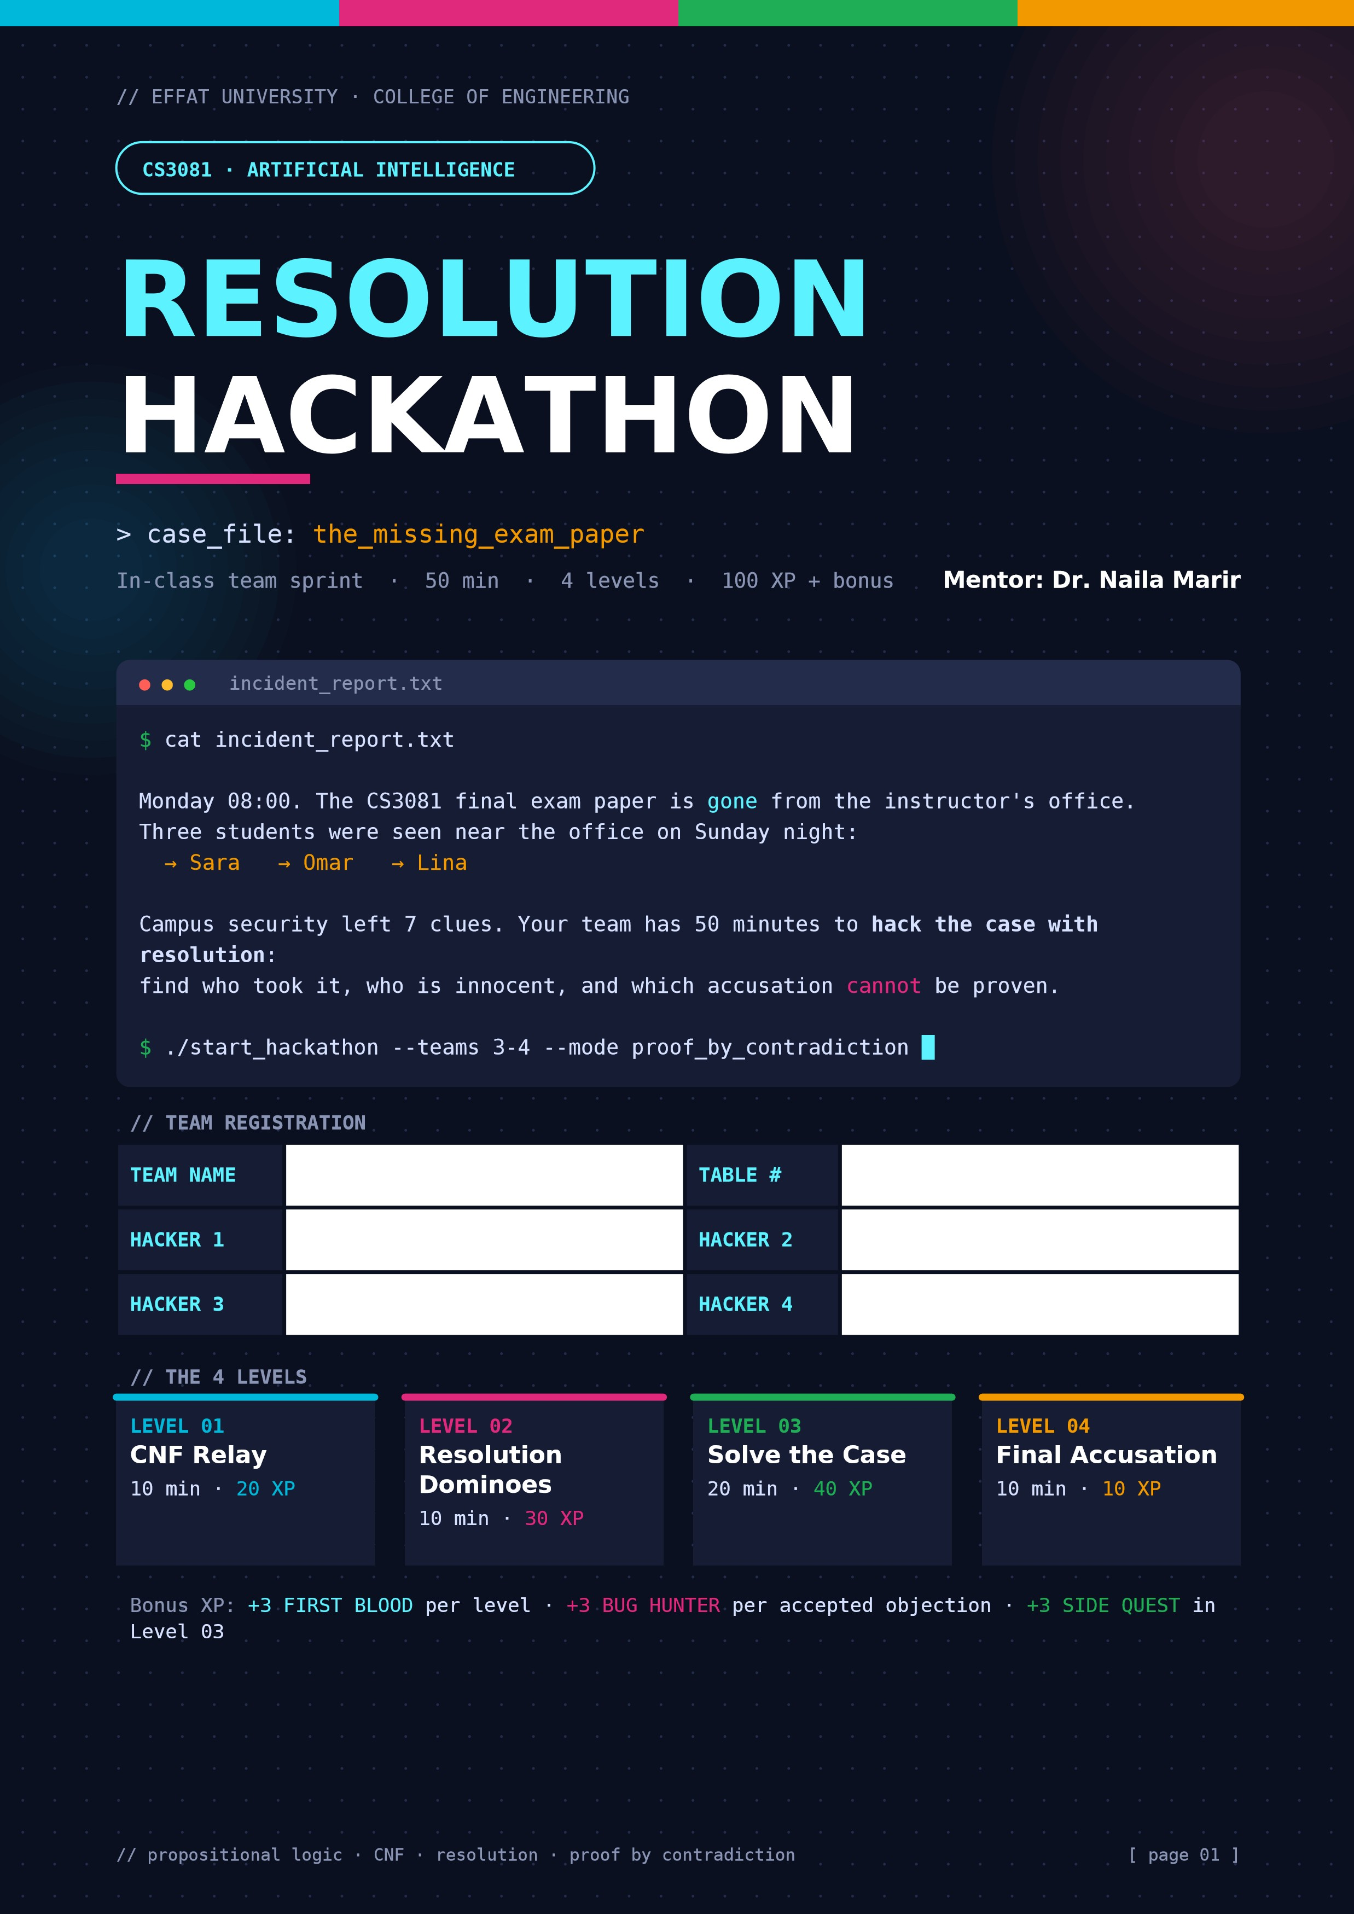
N
Jumaana Musa
Nas Acikgoz
Malaika Tanveer
JMN
README.md

Rules of the Hack
100
XP
50
MIN
▶ Pick your roles — rotate every level
C  CONVERTER  Turns logic into CNF: eliminate ↔ and →, De Morgan, distribution. | R  RESOLVER  Hunts complementary literals and builds new clauses (resolvents). | ✓  CHECKER  Debugs every step and writes the final answer. Nothing ships without the Checker.
▶ How the game runs
- Teams of 3–4. Play the four levels in order.

- When your team clears a level, raise your hand. The mentor checks it and unlocks the next level.

- First Blood: the first team to clear each level correctly gets +3 XP.

- Allowed moves only: eliminate ↔, eliminate →, De Morgan, distribution, resolution and factoring.

- Show every step. A correct answer with no steps earns only half the XP.
▶ XP table
LEVEL | CHALLENGE | TIME | XP
01 | CNF Relay — convert the clues | 10 min | 20
02 | Resolution Dominoes — match clause cards | 10 min | 30
03 | Solve the Case — proof by contradiction | 20 min | 40
04 | Final Accusation — present and object | 10 min | 10 + steals
 | Total | 50 min | 100 + bonus
[ page 02 ]
DATASET

The Evidence Board
7
CLUES
10
SYMBOLS
▶ Symbol table
SYMBOL | MEANING
D | The office door was unlocked
S | Sara took the exam paper
O | Omar took the exam paper
L | Lina took the exam paper
C | The security camera was switched off
F | The office door was forced open
Y | Lina had a copy of the office key
K | Khalid lent his office key
A | The alarm rang
▶ Clues from campus security
# |  | CLUE (ENGLISH) |  | LOGIC
1 |  | If the door was unlocked, then Sara or Omar took the paper. |  | D → (S ∨ O)
2 |  | The door was unlocked. |  | D
3 |  | If Sara took the paper or the door was forced, then the camera was off. |  | (S ∨ F) → C
4 |  | The camera was NOT off (it recorded all night). |  | ¬C
5 |  | Lina could only have taken it if she had a copy of the key. |  | L → Y
6 |  | Lina had a copy of the key if and only if Khalid lent his key. |  | Y ↔ K
7 |  | It is not true that Khalid lent his key AND the alarm rang. |  | ¬(K ∧ A)
 | CHEAT  CODE |  | To show KB ⊨ α: add ¬α to the KB, convert everything to CNF, and keep resolving. If you produce the empty clause ( ), it's a contradiction, so KB ⊨ α. If no new clauses can be made and there is no ( ), there is no entailment.
[ page 03 ]
LEVEL 01 / 04

CNF Relay
20
XP
10
MIN
RELAY | Pass the sheet around the team. Each hacker writes ONE step, then passes it on. Write the rule you used next to each step.

▶ Clue 1: D → (S ∨ O) [4 XP]
STEP | EXPRESSION | RULE USED | WRITTEN BY
1 | ¬ D ∨(S ∨ O) | Implication Elimination | Jumaana
2
3
▶ Clue 3: (S ∨ F) → C [6 XP]
STEP | EXPRESSION | RULE USED | WRITTEN BY
1 | ¬ (S ∨ F) ∨ C | Implication Elimination | Nas
2 | (¬S ∧ ¬F) ∨ C | De Morgans Law | Malaika
3 | (¬S ∨ C) ∧ (¬F ∨ C) | Distributive Property | Jumaana
▶ Clue 6: Y ↔ K [6 XP]
STEP | EXPRESSION | RULE USED | WRITTEN BY
1 | (Y → K) ∧ (K→Y) | Biconditional Elimination | Jumaana
2 | (¬Y ∨ K) ∧ (¬K ∨ Y) | Implication Elimination | Malaika
3
▶ Clue 7: ¬(K ∧ A) [4 XP]
STEP | EXPRESSION | RULE USED | WRITTEN BY
1 | ¬ K ∨ ¬ A | De Morgans | Nas
2
3

▶ Compile the final KB in CNF
List every clause from all seven clues, one per row, as K1, K2, K3, … You need these numbers in Level 03.
NO. | CLAUSE | NO. | CLAUSE
K1 | ¬ D ∨ S ∨ O | K6 | ¬ Y V K
K2 | D | K7 | ¬ K V ¬ A
K3 | ¬ S ∨ C | K8 | ¬C
K4 | ¬ F ∨ C | K9 | ¬ L v Y
K5 | ¬ K V Y | K10
[ page 04 ]

LEVEL 02 / 04

10 MIN 30 XP Resolution Dominoes
Cut out the 12 clause cards on the next page and shuffle them. Then:
01 Find pairs of cards that share a complementary literal (like P and ¬P). Each card belongs to exactly one pair.
02 |  |  | Place the two cards side by side like dominoes and write the resolvent below.
03 |  |  | If the resolvent has a duplicate literal, apply factoring and say so.
⚠ BUG |  |  | One pair is a trap. It looks like it gives ( ) but it doesn't. Think carefully about what one resolution step is allowed to do.
 | PAIR | CARD + CARD RESOLVED ON |  |  | RESOLVENT | FACTORING?
 | 1 | A + I |  |  | H ∨ ¬H | N
 | 2 | D + J |  |  | X ∨ Z ∨ W | N
 | 3 | E + L |  |  | ( ) Empty Clause | Y / N
 | 4 | B + G |  |  | U ∨ U | Y
 | 5 | C + H |  |  | ¬Q ∨ R ∨ P | N
 | 6 | F + K |  |  | B ∨ S ∨ R ∨ S | Y
▶ Bug report: the trap pair
Which pair is it? Explain in one or two sentences why it does NOT give the empty clause.
CARD_A is (G ∨ H) and CARD_I is (¬G ∨ ¬H). Resolving on G gives (H ∨ ¬H). This is always true, not the empty clause ( ).

[ page 05 ]
LEVEL 02 · ASSETS
CUT ON DASHED LINES

Clause Cards
CARD_A  (G ∨ H)  { resolve me } | CARD_B  (¬T ∨ U)  { resolve me } | CARD_C  (¬Q ∨ R)  { resolve me }
CARD_D  (X ∨ ¬Y ∨ Z)  { resolve me } | CARD_E  (M)  { resolve me } | CARD_F  (A ∨ B ∨ S)  { resolve me }
CARD_G  (T ∨ U)  { resolve me } | CARD_H  (P ∨ Q)  { resolve me } | CARD_I  (¬G ∨ ¬H)  { resolve me }
CARD_J  (Y ∨ W)  { resolve me } | CARD_K  (¬A ∨ R ∨ S)  { resolve me } | CARD_L  (¬M)  { resolve me }
[ page 06 ]
LEVEL 03 / 04

20 MIN 40 XP Solve the Case
Use your CNF KB (K1, K2, …) from Level 01. For each case, add the negation of what you want to prove, then resolve. Number new clauses R1, R2, R3, …
▶ Case 3A — Did Omar take the paper? Prove KB ⊨ O [15 XP] ADD TO KB:

STEP CLAUSE 1 (NO.) |  | CLAUSE 2 (NO.) | RESOLVED ON | NEW CLAUSE (RESOLVENT)
R1 | K1 (¬D ∨ S ∨ O) | K2 (D) | D | S ∨ O
R2 | R1 (S ∨ O) | ¬O (Negation) | O | S
R3 | R2 (S) | K3 (¬S ∨ C) | S | C
R4 | R3 (C) | K8 (¬C) | C | ( )
R5 | Empty clause reached
VERDICT: KB ENTAILS O, OMAR TOOK THE PAPER

▶ Case 3B — Is Sara innocent? Prove KB ⊨ ¬S [10 XP] ADD TO KB: S
STEP | CLAUSE 1 (NO.) | CLAUSE 2 (NO.) | RESOLVED ON | NEW CLAUSE (RESOLVENT)
R1 | K3 (¬S ∨ C) | S (Negation) | S | C
R2 | R1 (C) | K8 (¬C) | C | ( )
R3 | Empty clause reached
VERDICT: THE KB ENTAILS ¬S. SARA IS INNOCENT

LEVEL 03 / 04 · BOSS FIGHT

e 3C — What about Lina?
●

●

●
interrogation.log
Omar:
"Lina did it with me!"
Lina:
"I am innocent!"
$
try prove(L) && try prove(¬L)
▶ Attempt 1 — add ¬L and resolve
STEP | CLAUSE 1 (NO.) | CLAUSE 2 (NO.) | RESOLVED ON | NEW CLAUSE (RESOLVENT)
R1 | K9 (¬L ∨ Y) | ¬L (Negation) | L | Y
R2 | R1 (Y) | K5 (¬Y ∨ K) | Y | K
R3 | R2 (K) | K7 (¬K ∨ ¬A) | K | ¬A
R4 | No further resolution possible
▶ Attempt 2 — add L and resolve
STEP | CLAUSE 1 (NO.) | CLAUSE 2 (NO.) | RESOLVED ON | NEW CLAUSE (RESOLVENT)
R1 | K9 (¬L ∨ Y) | L (Negation) | L | Y
R2 | R1 (Y) | K5 (¬Y ∨ K) | Y | K
R3 | R2 (K) | K7 (¬K ∨ ¬A) | K | ¬A
R4 | No further resolution possible
▶ Conclusion
Can the detectives accuse Lina? Can they clear her? What does this mean about entailment?
Hint: look at where the literal L appears in the KB.
Can the detectives accuse Lina? No.
Can they clear her? No.
What does this mean about entailment? The KB does not entail L, nor does it entail ¬L. The literal L only appears in one clause (K9: ¬L ∨ Y), so it cannot be resolved to a contradiction. This means there is not enough information to prove her guilt or innocence.

SIDE  QUEST | Finished early? Prove that the door was not forced: KB ⊨ ¬F. Write your proof on the back of this page for +3 XP.
[ page 08 ]
LEVEL 04 / 04

10 MIN 10 XP Final Accusation
- The mentor picks one case (3A, 3B or 3C) for your team. Present it on the board in 2 minutes.

- While a team presents, the other teams are code reviewers. They look for an invalid step.

- To object, hold up your OBJECTION! card and name the exact step and the broken rule.

- A correct objection steals 3 XP from the presenting team. A wrong objection costs 2 XP.

- A clean presentation with no accepted objection earns the full 10 XP.
▶ Code review log
AGAINST TEAM STEP |  | WHAT WAS WRONG | ACCEPTED?
▶ Post-mortem (individual, one sentence each)
Why is resolution called a “proof by contradiction”? What does it mean when no empty clause can ever be produced?

[ page 09 ]
UNLOCKABLES
TICK WHAT YOU EARN

Achievements & Leaderboard
⚡
⚠
★
✓
FIRST BLOOD TRAP DETECTOR SIDE QUEST CLEAN BUILD
First team to clear a level. +3 Spotted and explained the Proved KB ⊨ ¬F in Level 03. Presented in Level 04 with
XP each time. trap pair in Level 02. +3 XP. zero accepted objections.
☐ earned ☐ earned ☐ earned ☐ earned
▶ Team scoreboard (mentor use)
L01 | L02 | L03 | L04 | BONUS | STEALS | TOTAL
/20 | /30 | /40 | /10 | + | ± | /100
// cut out and hold up during Level 04
ERROR 403: INVALID STEP
OBJECTION!
step ____ breaks rule: ________________
[ page 10 ]

