QM  7073 | FOUNDATIONS OF ANALYTICS
ILLUSTRATIVE STUDENT SAMPLE
Can Dr. K Trust the Café Data?
A fictional data-readiness audit and management recommendation
Important: All names, values, findings, and exhibits in this report are fictional. They do not use the student assignment dataset and are not an answer key.
Prepared for | Dr. K, Café Owner
Prepared by | Night Owls Analytics (fictional team)
Analysis period | January-March 2026 fictional training extract
Status | Illustrative sample for QM7073
SAMPLE ONLY | FALL 2026

Executive Summary
Decision: The fictional training extract is conditionally ready for descriptive management analysis after documented cleaning, but it is not ready for predictive staffing decisions.

What Dr. K should know
- The data can support a cautious operating comparison. After removing 9 exact duplicates and excluding 4 orders with unresolvable dates, 1,235 orders remained for revenue analysis. Six additional records lacked usable wait time, leaving 1,229 for service analysis.
- Most problems were repairable, but they were not harmless. Inconsistent categories, missing promotion entries, and recorded-total mismatches could have changed location or service-window comparisons if they were ignored.
- The late-night window deserves attention. Orders from 10 p.m. to midnight averaged 18.7 minutes of wait time, above the illustrative 15-minute threshold, while average satisfaction fell to 3.5 out of 5.
- A pilot is more defensible than a permanent staffing change. Test an additional employee from 9:30-11:30 p.m. on Fridays and Saturdays for three weeks, then compare wait time, satisfaction, and labor cost per order against a baseline.

Decision snapshot
Decision element | Illustrative conclusion
Readiness judgment | Conditionally ready for descriptive analysis
Primary operational concern | 10 p.m.-midnight service window
Recommended action | Three-week controlled staffing pilot
Do not conclude | That staffing caused the observed waits; staffing data were not included
Reading note: This page demonstrates an answer-first executive summary. A real team must replace every illustrative value with results verified from its own workbook.

The Decision Comes Before the Spreadsheet
Dr. K must decide whether the café's order data are reliable enough to compare performance and identify a practical operating priority. The analysis therefore begins with data readiness, not with the most colorful chart available.

Business context
Dr. K’s Late-Night Analytics Café is a fictional three-location business serving university students, hospital staff, and other night-shift customers. The café recently extended service to 2:00 a.m. and added mobile ordering. Sales appear to be growing, but customers have reported longer waits and managers disagree about which location and time period need attention most.
The records came from three point-of-sale exports that were combined for this training exercise. That history explains why location labels, service windows, promotion codes, dates, and calculated totals are not always recorded consistently. Before Dr. K adds late-night staffing—or buys one more espresso machine that may simply become expensive counter decoration—the management team needs evidence that the data are trustworthy and a clear description of what the cleaned data actually support.

Decision frame
Element | Illustrative definition
Decision maker | Dr. K, café owner
Decision | Whether to use the cleaned order data to select a short operating pilot
Primary question | Is the extract reliable enough to compare service windows, and where is the clearest concern?
Cost of a wrong decision | Added labor without service improvement, or continued delays that reduce satisfaction
Evidence boundary | Descriptive order, revenue, wait-time, and satisfaction fields only

Data scope and metric definitions
The fictional training extract contained 1,248 order rows from January through March 2026 across three locations and four service windows. The unit of analysis was an order, identified by Order ID.
Field | Role | Data type | Illustrative rule
Order ID | Identifier | Text | Expected to be unique and nonblank
Order date/time | Input | Date/time | Valid date and time within the analysis period
Service window | Derived category | Nominal | One of four controlled labels
Quantity | Input | Numeric discrete | Whole number from 1 to 12
Recorded total | Outcome/calculated | Currency | Quantity × unit price × (1 - discount)
Satisfaction | Outcome | Ordinal | Whole number from 1 to 5
Boundary: This sample does not claim that longer waits caused lower satisfaction. It shows an association that is useful for choosing a pilot, not proof of causation.

The Audit Found Concentrated, Fixable Risk
The audit identified six material issue families. Missing promotion codes were most frequent, but recorded-total mismatches and duplicate orders carried the greatest direct risk to revenue and volume comparisons.
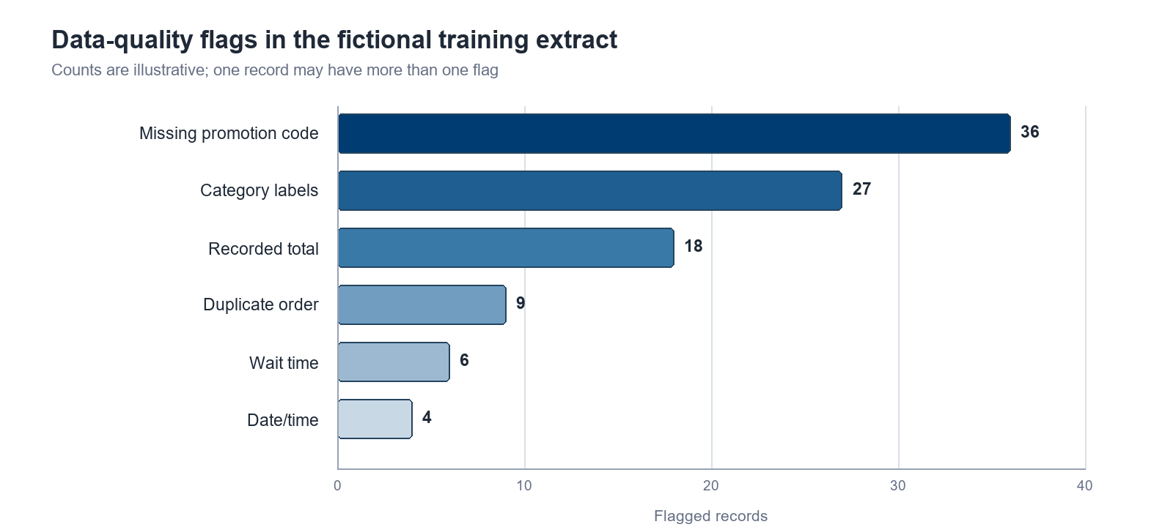
Figure 1. Fictional training extract; issue counts are illustrative and are not derived from the student dataset.

Reconciliation
Reconciliation step | Rows | Treatment
Raw order rows | 1,248 | Starting population
Exact duplicates removed | -9 | Same Order ID and identical order details
Unresolvable dates excluded | -4 | Excluded from all time-based and revenue comparisons
Revenue-analysis rows | 1,235 | Final order-level denominator
Rows without usable wait time | -6 | Retained for revenue; excluded only from wait analysis
Wait-analysis rows | 1,229 | Denominator for service-window results
So what: The final denominator changes by metric. Reporting 1,235 for revenue and 1,229 for wait time prevents a seemingly small missing-data issue from becoming a misleading comparison.

Cleaning Rules Made the Analysis Reproducible
The team preserved the downloaded data in an Original Data worksheet and performed all corrections in Cleaned Data. Each rule was recorded in the Data Quality Audit worksheet before it was applied.
Issue | Rule applied | Verification | Impact
Exact duplicate | Remove only when Order ID and all transaction fields match | Duplicate count before/after | 9 rows removed
Recorded total mismatch | Recalculate from quantity, price, and discount | Independent formula check on flagged rows | 18 totals corrected
Category label | Map spelling and spacing variants to a controlled label | Frequency table after mapping | 27 labels standardized
Missing promotion code | Use 'None recorded'; do not infer a promotion | COUNTBLANK and promotion cross-check | 36 values labeled
Invalid wait time | Set to missing; retain row for non-wait measures | Range check and denominator reconciliation | 6 waits excluded
Invalid date/time | Exclude when source cannot support a defensible correction | Date range and parse check | 4 rows excluded

Verification checks
- Row reconciliation: 1,248 - 9 - 4 = 1,235 revenue-analysis orders.
- Formula reconciliation: every retained recorded total matched the documented calculation within $0.01.
- Category validation: all service-window and location values matched the controlled lists.
- Metric-specific denominator: six missing waits were excluded only from wait-time calculations.
Why this matters: A cleaned workbook is not trustworthy merely because it looks tidy. The rules, row counts, and checks must let another analyst reproduce the result.

Late-Night Service Is the Clearest Operating Concern
The 10 p.m.-midnight window had the highest average wait time at 18.7 minutes. It also had the lowest average satisfaction at 3.5 out of 5. This pattern is consistent with a service-capacity problem, but the extract does not include staffing levels, task mix, or arrival bursts needed to establish the cause.
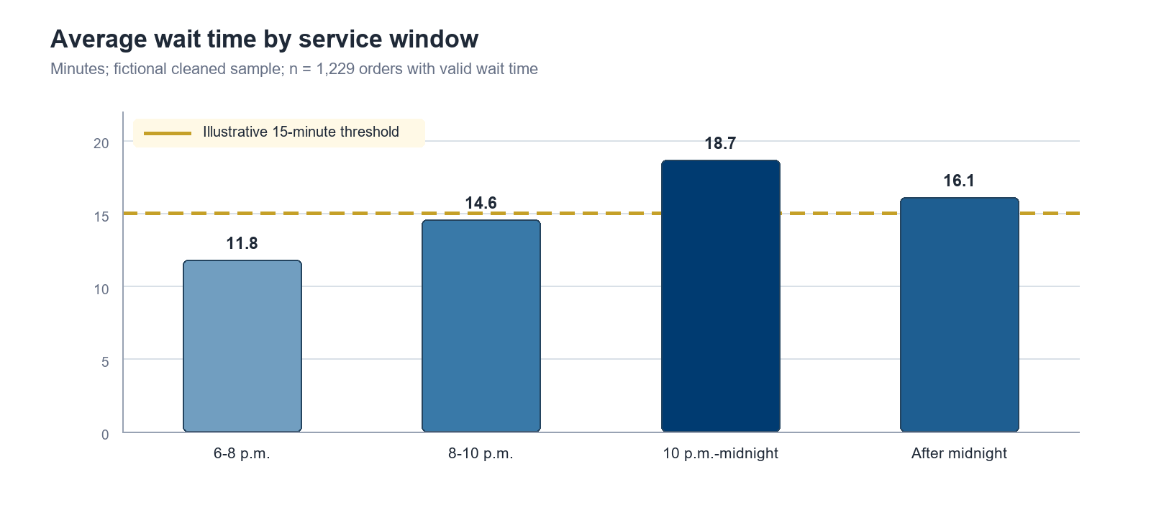
Figure 2. Fictional cleaned sample. The gold dashed line is an illustrative management threshold, not a course-provided standard.
Service window | Orders | Avg. wait | Avg. satisfaction | Interpretation
6-8 p.m. | 302 | 11.8 | 4.4 | Below threshold
8-10 p.m. | 334 | 14.6 | 4.1 | Near threshold
10 p.m.-midnight | 356 | 18.7 | 3.5 | Highest concern
After midnight | 237 | 16.1 | 3.8 | Secondary concern
Management meaning: The evidence is strong enough to prioritize a limited late-night experiment. It is not strong enough to justify a permanent schedule change or to claim that staffing alone explains the result.

Recommendation: Run a Controlled Late-Night Pilot
Dr. K should approve a three-week pilot that adds one cross-trained employee from 9:30-11:30 p.m. on Fridays and Saturdays at the location with the largest late-night order volume. Keep the existing schedule on comparable nights to create a practical baseline.

Pilot plan
- Week 0 - confirm data capture: staff scheduled, orders by 15-minute interval, wait time, satisfaction, and labor hours.
- Weeks 1-3 - run the added-staff pilot on designated nights while preserving comparison nights.
- End of Week 3 - compare outcomes, document trade-offs, and decide whether to continue, redesign, or stop.

Measurement plan
Metric | Illustrative baseline | Pilot target | Role
Average wait time | 18.7 min | Below 15.0 min | Primary outcome
90th-percentile wait | Not yet captured | Below 22 min | Add to pilot data
Average satisfaction | 3.5 / 5 | At least 4.0 / 5 | Customer guardrail
Labor cost per order | Establish Week 0 | No more than +8% | Financial guardrail
Order abandonment | Not captured | Track directionally | Further question

Limitations and further questions
- The extract does not contain staffing levels, labor hours, queue length, or order complexity.
- Satisfaction is available only for customers who responded; nonresponse may bias the average.
- The three-month fictional period may not represent seasonal demand.
- A future dataset should capture scheduled staff, order timestamps by process step, promotions, and local events.
Final judgment: Conditionally ready for descriptive decision support; not ready for causal or predictive claims without additional operating data.

Appendix A - Illustrative AI-Use Log
Sample disclosure: The entries below demonstrate transparent AI use. They are fictional examples and should not be copied as evidence of work your team did not perform.
Tool | Purpose | AI contribution | Team decision and verification
Claude (illustrative) | Brainstorm data-quality tests | Suggested deleting every row with a missing value | Rejected. The team compared missingness by field and retained rows when the affected metric was unrelated.
Codex (illustrative) | Review an Excel total-check formula | Identified an inconsistent cell reference | Revised and tested the formula on five known records and all 18 flagged mismatches before applying it.
ChatGPT (illustrative) | Critique the wait-time chart | Suggested a line chart | Rejected because service windows are categories, not a continuous time series. The team retained a bar chart with a threshold line.

Team ownership statement
Our team reviewed every AI-assisted suggestion against the workbook, assignment requirements, and documented business rules. We accepted, revised, or rejected suggestions ourselves. The team remains responsible for all formulas, visual choices, interpretations, and recommendations in this report.

Illustrative source note
Source: Fictional QM7073 training extract created solely to demonstrate report organization and analytical communication. The extract is not the Decision Lab 1 student dataset, and no values in this sample should be treated as expected assignment results.

What this sample demonstrates
- An executive summary that answers the management question before discussing methods.
- A transparent denominator and row reconciliation for each measure.
- Visuals placed next to interpretation and a clear 'so what.'
- A recommendation proportionate to the evidence, with limitations and guardrails.
- AI disclosure that shows verification and team judgment.
End of illustrative sample.

