Örnek:
import java.io.*;
class IstisnaOrnek1{
public void cokCalis(){
File f = new File("ornek.txt");
BufferedReader bf = new BufferedReader(new FileReader(f));
System.out.println(bf.readLine());
}
public void calis(){
cokCalis();
System.out.println("calis() yordami");
}
public static void main(String args[]){
IstisnaOrnek1 io1 = new IstisnaOrnek1();
io1.calis();
}
}
Çıktı:
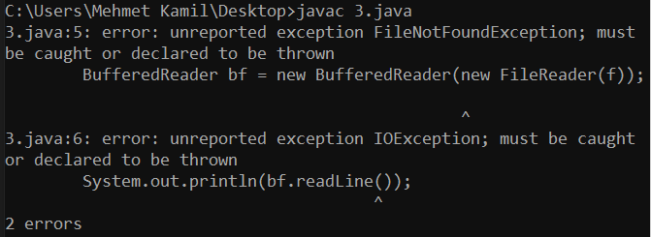

Örnek:
import java.io.*;
class IstisnaOrnek3{
public void cokCalis() throws IOException{
File f = new File("ornek.txt");
BufferedReader bf = new BufferedReader(new FileReader(f));
System.out.println(bf.readLine());
}
public void calis(){
try{
cokCalis();
System.out.println("calis() yordami");
} catch(IOException ex){
System.out.println("Hata yakalandi! - calis() = " + ex);
}
}
public static void main(String args[]){
IstisnaOrnek3 io3 = new IstisnaOrnek3();
io3.calis();
System.out.println("main() yordami");
}
}
Çıktı:
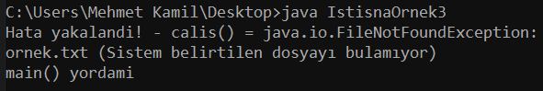

Örnek:
import java.io.*;
class IstisnaOrnek4{
public void cokCalis() throws IOException{
File f = new File("ornek.txt");
BufferedReader bf = new BufferedReader(new FileReader(f));
System.out.println(bf.readLine());
}
public void calis() throws IOException{
cokCalis();
System.out.println("calis() yordami");
}
public static void main(String args[]){
try{
IstisnaOrnek4 io4 = new IstisnaOrnek4();
io4.calis();
System.out.println("main() yordami");
} catch(IOException ex){
System.out.println("Hata yakalandi! - main() = " + ex);
}
}
}
Çıktı:
