**DESIGNING**

**PROFESSIONAL BOOK COVER**

1. **INTRIDUCTION**

A book cover is any protective covering used to bind together the pages of a book. **“Bookcover**” is often used for a book cover image in library management software.

* 1. **Book Cover Typography** The typography on your cover should include three things:your book’s title, the subtitle (if you have one), and the author name. Make sure to use text hierarchy to bring attention to the more important text (for example, you’ll want your title text to be larger than your subtitle text). Book cover design is comprised of text and images that conveys a single message. Learn the anatomy of a book cover to take your cover to the next level. Book cover.

**2.1Purpose of the book cover:**  The purpose of book cover design is to draw the attention of your potential readers away from all those other tomes and novellas and sell them on the idea that your page-turner is the next book they need on their nightstand.

**2. PROBLEM DEFINTION AND DESIGN THINKING**

**2.1 Empathy map:** 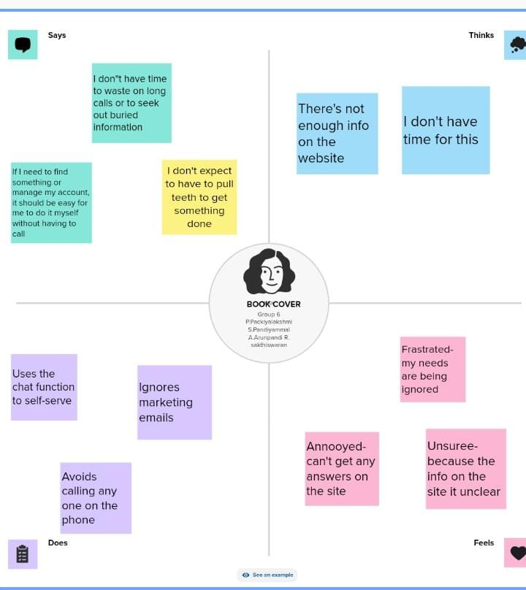 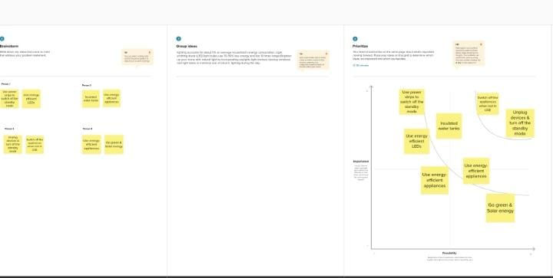

**3.** RESULT



**4. ADVANTAGES AND DISADVANDAGES**

Advantages:

The primary goal of a book cover is to grab the reader’s attention and persuade them to buy the book. A well-designed cover can help to accomplish this goal by standing out on the shelf or online, and by piquing the reader’s interest.

**Benefits:**

A book sleeve provides a layer of protection that can help to prevent scratches, thears, and other types of damage that cvan make your books look worn and tattered over time.

In addition to providing protection, a book sleeve can also help to keep your books clean.

A riveting title for the book. Your title must be cleverly devised

An evocative subtitle. Provide additional information about your book through a clear line that complements the book title…..

Book covers offer the first glimpse into the content of a given text. That first glimpse can be the sole deciding factor in determining whether the potential readers pick up the book or not.

Chileren’s books, for example, entice their young targer audience with colors, typefaces and images.

**Disadvantages**:

Demands Time. Set aside quality time to read a book and comprehend every element. Additionally, because most boks have a lot of pages, you minght need more time to read them.

Something that puts one in an unfavorable position or condition: his bad temper is a disadvantage.injury to interest,reputation,credut,prifut,etc.:your behavior is a disadgantage to your family’s good name.

A disadvantgesw is an unfavorable position that makes it more difficult to thrive and achieve goals. These include social, economic,l personal and situational disadvantages that make this more difficult for a person or community.

**APPLICATION**S

A well-designed book cover is important because it serves as the face of the book, and entices readers to purchase it. A book cover uses design elements like color, font, images or illustrations to reflect key themes that are relevant to the text, and helps readers to understand a little more of what it's about

**CONCLUSION**

Conclusion. In the realm of books, a good cover is more than just a pretty face. It serves as a powerful marketing tool that can attract potential readers, conveys the essence of the story, and enhance sales. The importance of a good book cover design cannot be overstated, and Bingo-media understands this significance

**FUTURE SCOPE**

In the future, e-books may evolve into a wholly new form that we cannot fully envision today. This future will arrive as publishers and authors add en- hancements and interactivity, embrace new business models, and explore new methods of collaboration, and as readers engage with these new forms.

Promotional tool more interactive.