## *DESIGGNILNG* PROFSSIONAL LOGO INTRODUCTION Make an iconic logo intro with Adobe Express.

Your brand is one-of-a-kind, and so your logo intro should be, too. The color palette, typography, and graphics all communicate essential information about your brand, and you get to shape these key signals when you use Adobe Express. Each step in the design process empowers you with various choices, allowing you to experiment with multiple outline shapes, backgrounds, color schemes, and layouts. Enjoy the freedom of having countless options and feel confident in making the final call about what’s best for your design. Make something you’ll be excited to share with everyone, everywhere, so you can tell your brand’s story. And remember to continue using your logo intro on your future branded Adobe Express

# OVERVIEW OF THE PROJECT

Capture your online audience with show-stopping YouTube intros. Nearly all successful YouTubers use an intro to tell the viewer who they are watching and to build brand recognition.

You don’t need professional video editing or motion design experience to make them on Canva’s free intro maker. Our customizable templates and easy drag-and-drop approach to making intros will get your YouTube channel and brand up and running in no time

## Create an intro with no watermarks

Canva’s intro maker for YouTube is free to use—customize a template, then download your videos with no pesky watermarks. There is no limit to the number of intros you can create and download on our maker tool. Only pay when you use additional features on Canva, such as premium stock video, music, photo, and illustration content.

# 

## Create anytime, anywhere, with anyone

Canva's YouTube intro maker creates professional-level intros that are simple to make—you can even customize and edit your video intro with others in real-time. Make a YouTube intro online in 60 seconds. With no new skills to learn and no software to download, simply pick a video template and edit it to your liking. Find plenty of video elements in our media library to polish your design, invite your friends to collaborate, and download it in seconds.

## Keep your YouTube channel on brand

Canva is an all-around design tool that cares about your brand and channel. From learning to create [channel art](https://www.canva.com/learn/the-complete-guide-to-designing-your-youtube-channel/) and a branded logo to [YouTube intros](https://www.canva.com/learn/how-to-make-youtube-intro-video/), Canva has your back.

Access our intro maker for free to work off pre-built templates and unleash your creativity. Whether fun and quirky, something minimalist, or something serious like [news intros](https://www.canva.com/create/news-intros/), creating assets for your YouTube brand is a breeze. Don't just create a YouTube video intro! Build the rest of your YouTube channel brand profile .

EMPATHY MAP;

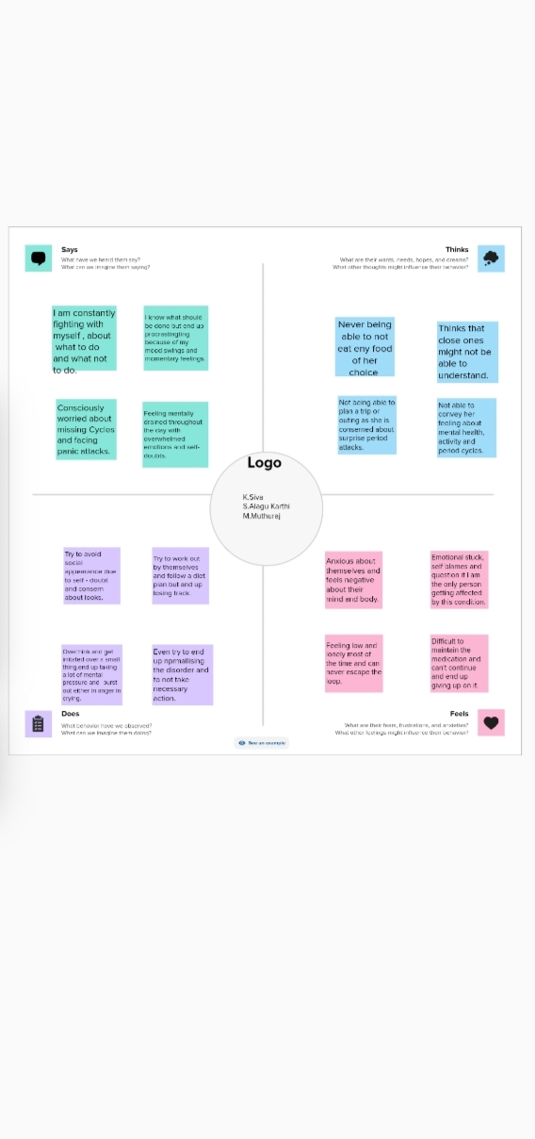

BRAINSTORM MAP;

