Walkthrough - Admin Birthday Celebration (Mukesh Kumar)

I have successfully implemented a comprehensive and premium birthday celebration system for Admin Mukesh Kumar. This project evolved through three phases to create a truly special and professional experience for both students and the Admin.

ðŸŒŸ Project Evolution

````carousel
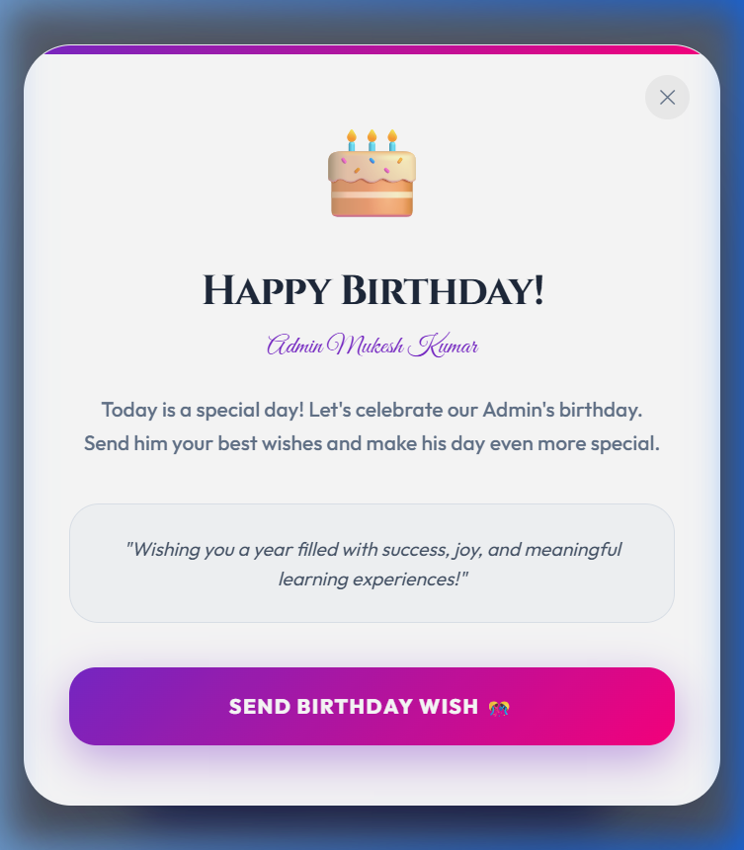
<!-- slide -->
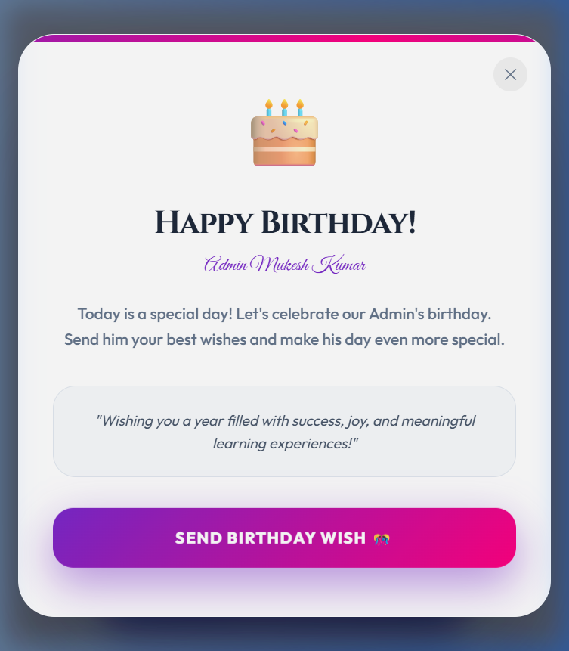
<!-- slide -->
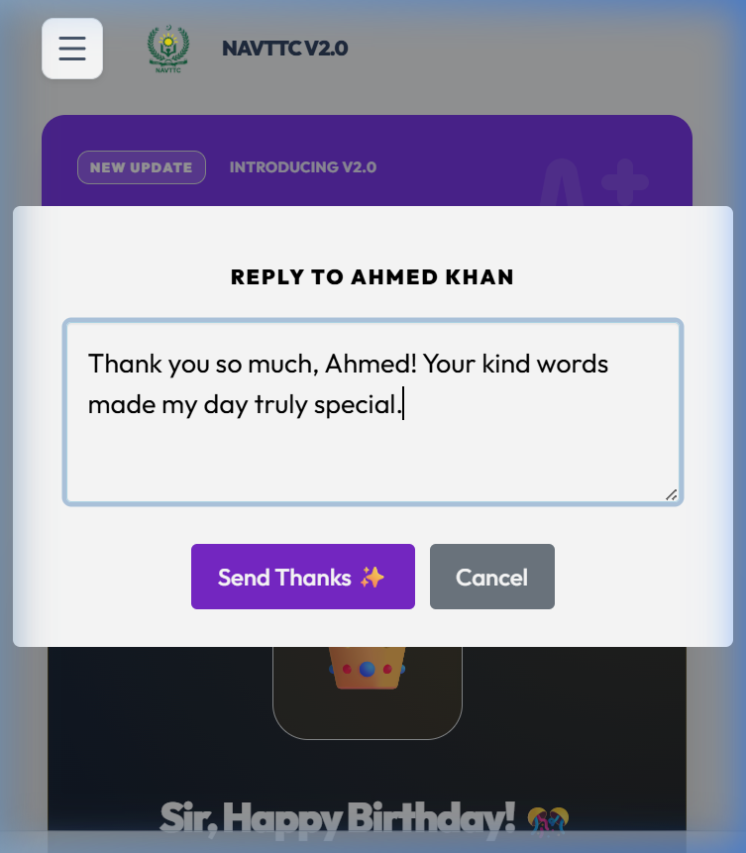
````

---

ðŸŽ“ The Student Experience
Students are greeted with a high-end **Birthday Card** upon logging in.
- **Premium UI**: Features a "Bday Glow" gradient backdrop and a glassy shimmer effect on the CTA button.
- **Festive Animations**: Floating emojis and `canvas-confetti` trigger instantly to set the mood.
- **One-Click Tribute**: Students can send a professional, pre-formatted wish directly to the Admin.

ðŸ‘‘ The Admin Experience (Mukesh Kumar)
For the Admin, the dashboard transforms into a festive tribute hub.
- **Royal Banner**: A gold-themed banner celebrating Mukesh Sir's leadership.
- **Live Wish Tracker**: A real-time counter showing the total tributes received.
- **Tribute Wall**: A dedicated interactive wall to read student messages.
- **Professional Replies**: NEW! Admin can now click "Say Thanks âœ¨" to send a personalized reply back to any student.

âš¡ Real-time & Professionalism
- **Festive Notifications**: The Admin receives instant "Celebratory Toasts" and a professional sound alert when new wishes arrive.
- **Strict Expiry**: All birthday UI elements are strictly date-bound. Every festive element will automatically disappear at **midnight tonight**, returning the LMS to its standard state.

---

âœ… Comprehensive Verification

````carousel
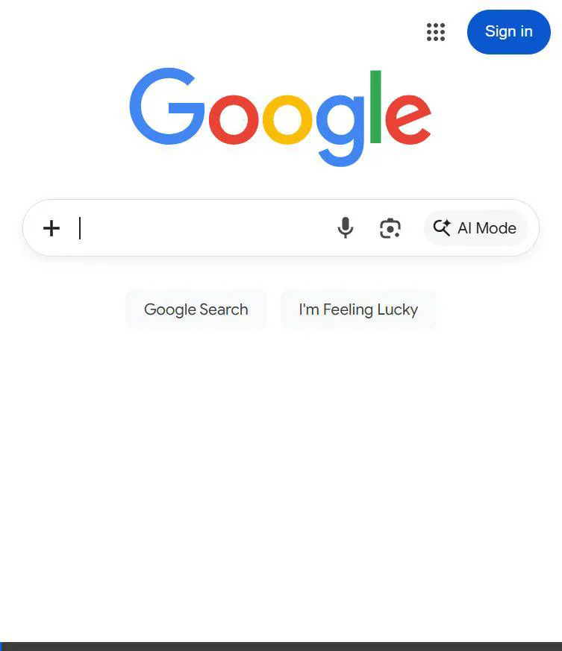
<!-- slide -->
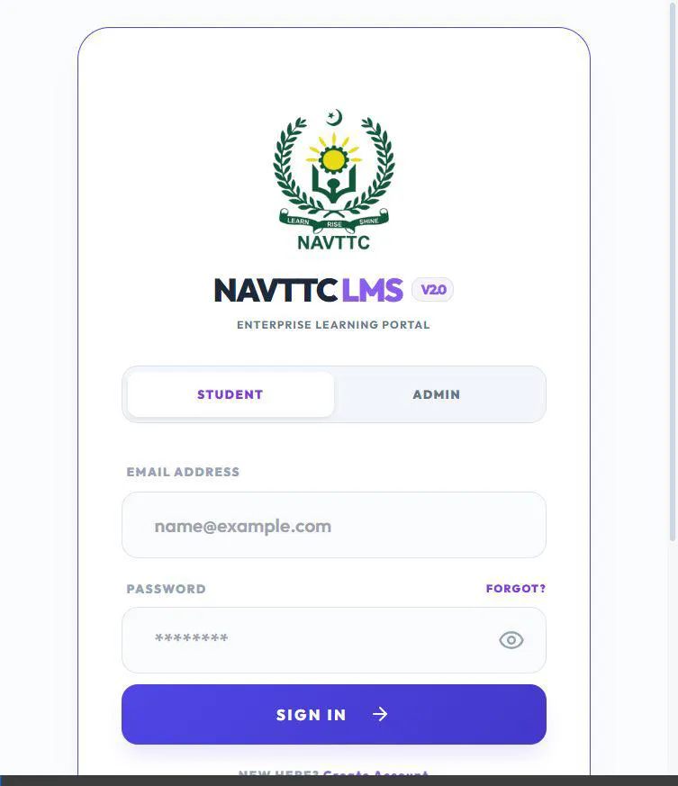
<!-- slide -->
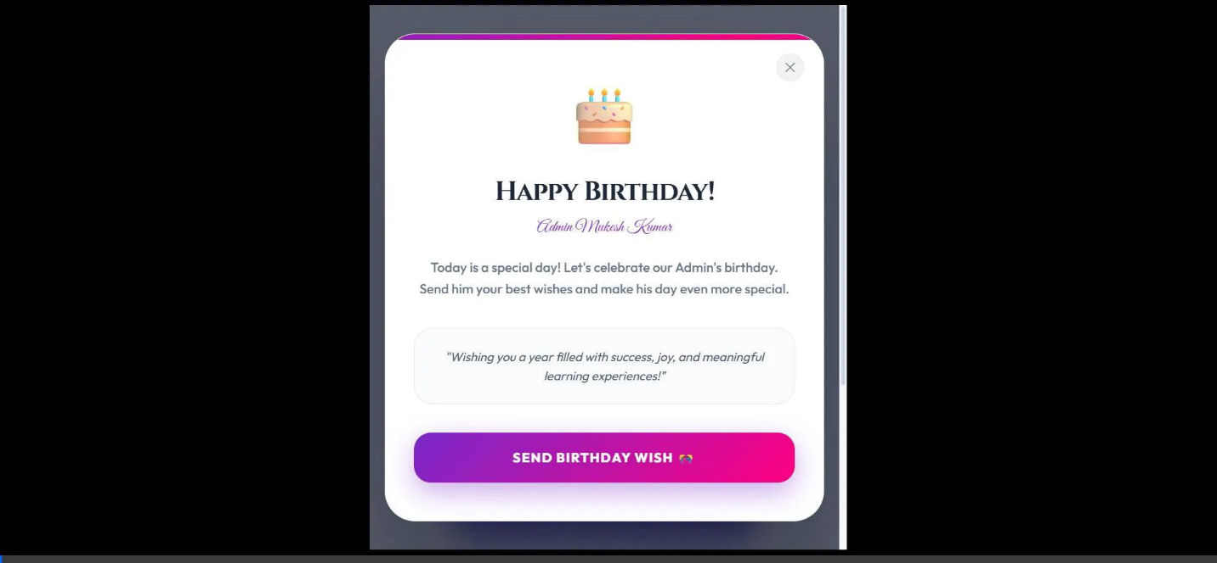
````

> [!NOTE]
> All technical logic uses Supabase real-time channels and strict date-checking to ensure a seamless and high-performance experience.

