Onkyo RI Protocol
- Published on 11 June 2011
- by Fred.

Onkyo DX-701 CD Player
I own that 20 years old CD Player, it still sounds very good : 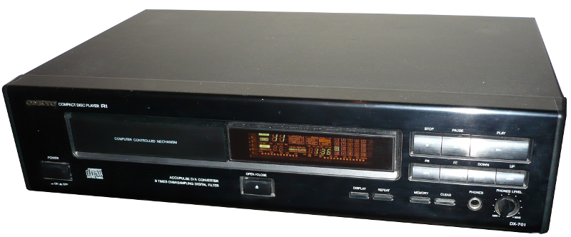
At the back of the player you find the RI port (Remote Interactive). It is a 3.5mm mono jack that can be used to connect other Onkyo elements : 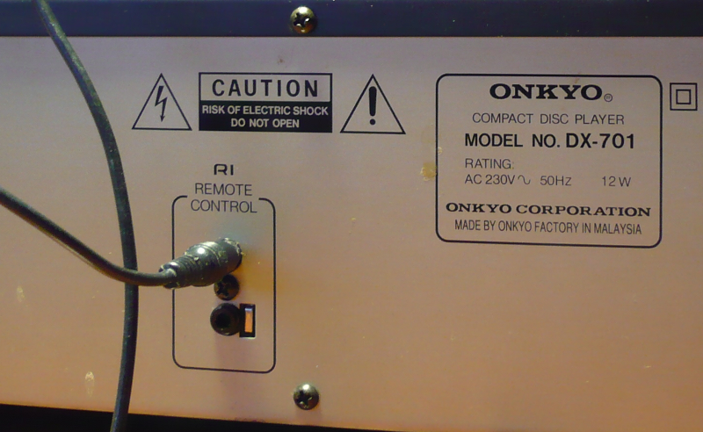
For example if you connect an Onkyo amplifier with an IR remote, the amplifier IR remote can control both the amplifier and the player thanks to the Remote Interactive port. In fact you can daisy chain several onkyo elements (Tape player, DVD player, etc.) and control all the elements with a single remote.
This is a very clever idea and today all Onkyo HIFI elements still sport a Remote Interactive port.

Onkyo RI protocol
The LIRC project provides information about the RI protocol :
- http://lirc.sourceforge.net/remotes/onkyo/Remote_Interactive
- http://lirc.sourceforge.net/remotes/onkyo/Remote_Interactive_TX-SR505SE
The files give the pulses encoding under LIRC format is as follows (durations are in µseconds) :
bits 12
flags SPACE_ENC|CONST_LENGTH
eps 30
aeps 100

header 3000 1000
one 1000 2000
zero 1000 1000
ptrail 1000
gap 67000
toggle_bit 0
From there it is very easy to draw the form of the signal. It is space encoded, with a header and a trailer and the message is composed of 12 bits :
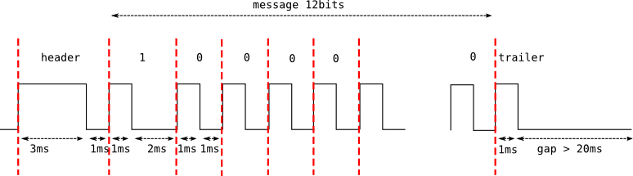
Now we know the waveform and the encoding of the Remote Interactive signal, what about the signal level ?
Given the age of the CD Player (and of the RI protocol) the signal is TTL, that is :
- 0 (low) is 0 Volt
- 1 (high) is 5 Volts
For more details about TTL you may refer to Wikipedia

RI Codes for DX-701
The codes for my DX-701 CD Player cover all the functionalities that are accessible on the device facade :
# RI codes for DX-701 CD Player
# RI codes for DX-701 CD Player
CD_Forward 0x0F00
CD_Rewind 0x0F01
CD_Repeat 0x0F06
CD_Clear 0x0F08
CD_Memory 0x0F09
CD_Display 0x0F0A
CD_Eject 0x0F0B
CD_8 0x0F0C
CD_9 0x0F0D
CD_0 0x0F0E
CD_Digits 0x0F0F
CD_1 0x0F10
CD_2 0x0F11
CD_3 0x0F12
CD_4 0x0F13
CD_5 0x0F18
CD_6 0x0F19
CD_7 0x0F1A
CD_Play 0x0F1B
CD_Stop 0x0F1C
CD_Next 0x0F1D
CD_Prev 0x0F1E
CD_Pause 0x0F1F
CD_Random 0x0F46

