1. Write a MongoDB query to display all the documents in the collection restaurants

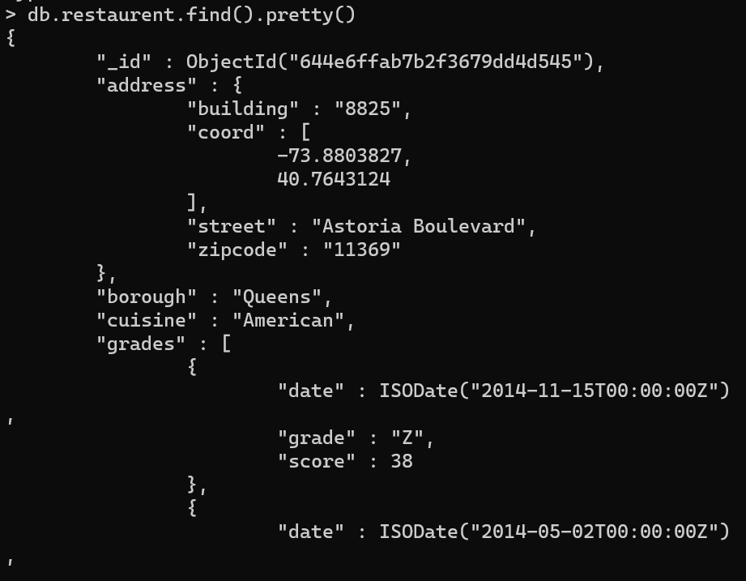

2. Write a MongoDB query to display the fields restaurant_id, name, borough and cuisine for

all the documents in the collection restaurant.

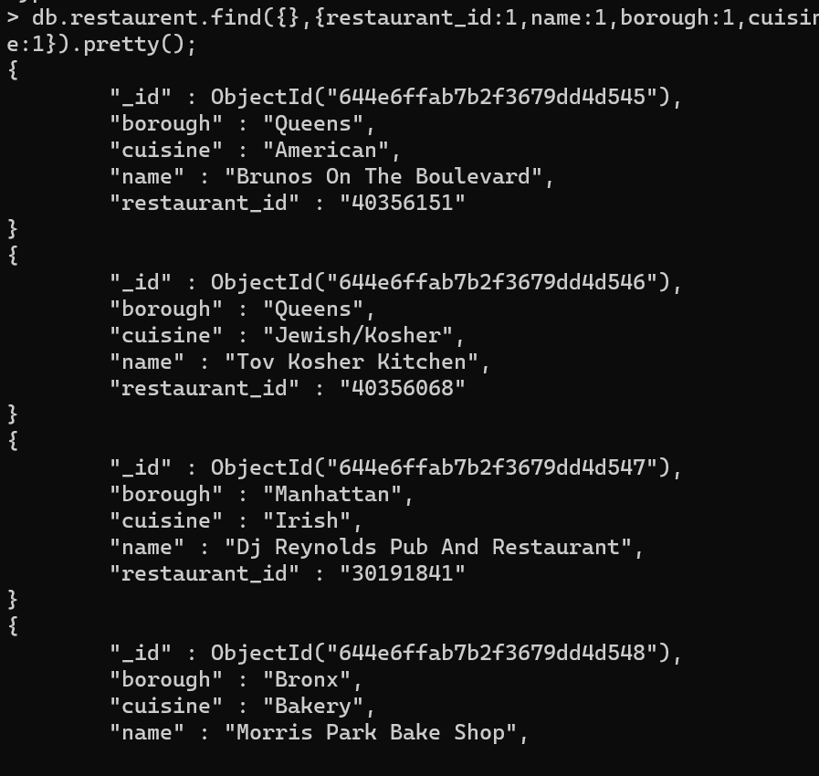

3. Write a MongoDB query to display the fields restaurant_id, name, borough and cuisine,

but exclude the field _id for all the documents in the collection restaurant.

db.restaurent.find({},{_id:0,restaurant_id:1,name:1,borough:1,cuisine:1}).pretty();

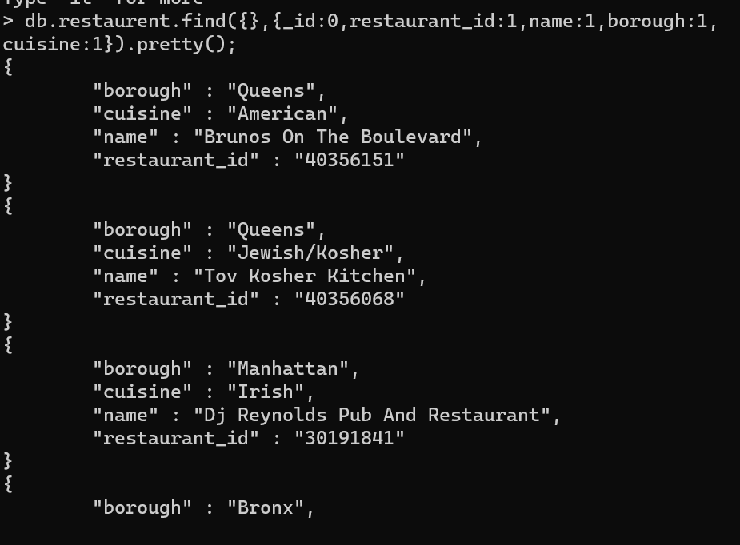

4. Write a MongoDB query to display the fields restaurant_id, name, borough and zip code,

but exclude the field _id for all the documents in the collection restaurant.

db.restaurent.find({},{_id:0,restaurant_id:1,name:1,borough:1,”address.zipcode”:1}).pretty();

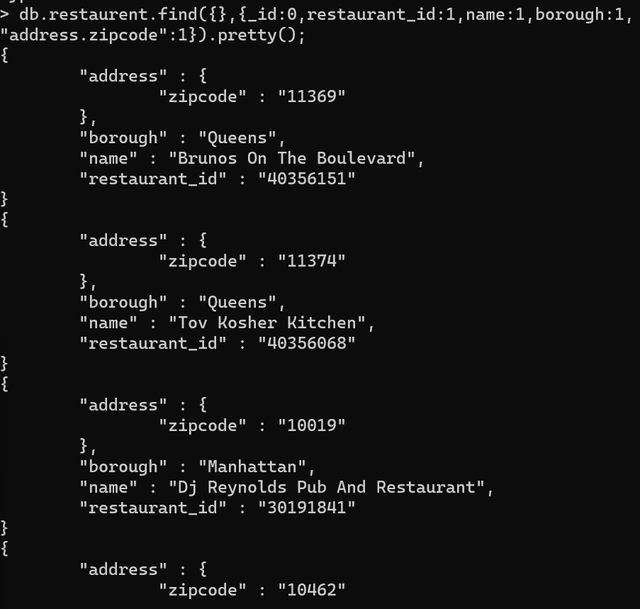

5. Write a MongoDB query to display all the restaurant which is in the borough Bronx

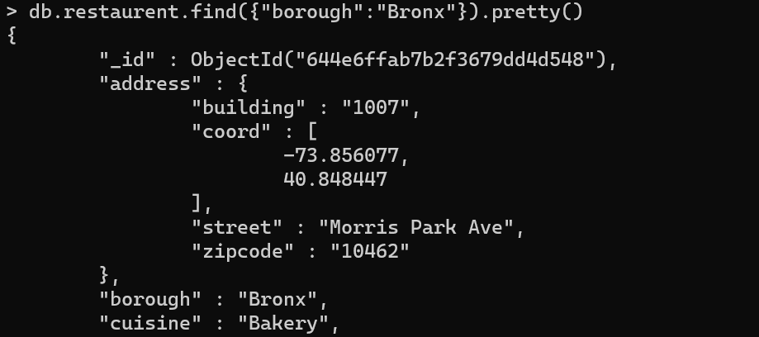

6. Write a MongoDB query to display the first 5 restaurant which is in the borough Bronx.

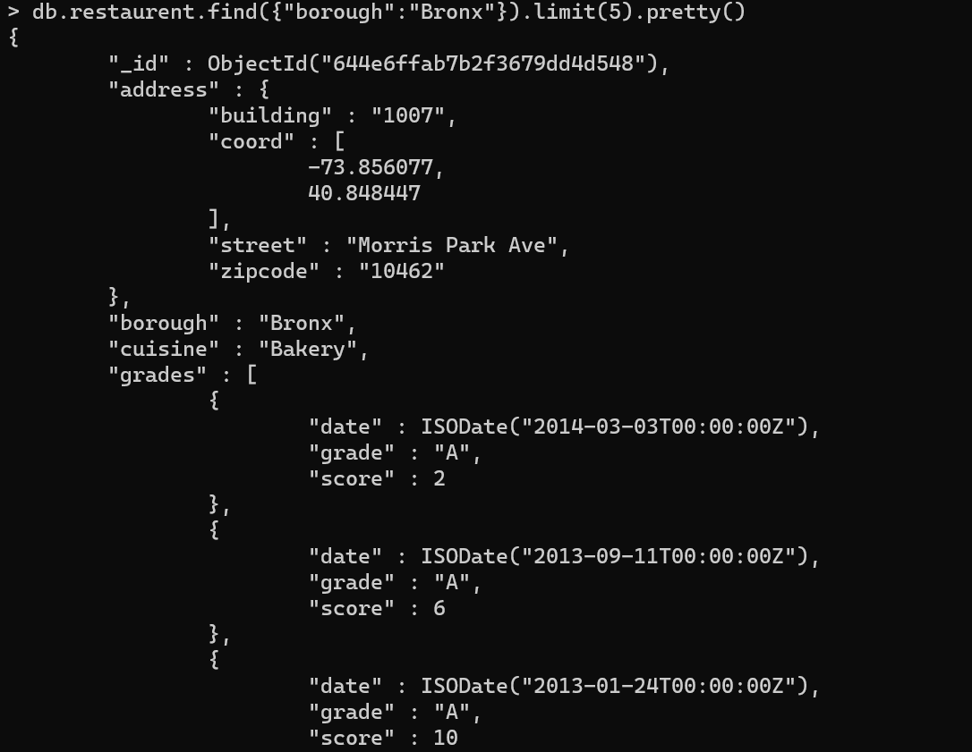

7.Write a MongoDB query to display the next 5 restaurants after skipping first 5 which are in

the borough Bronx.

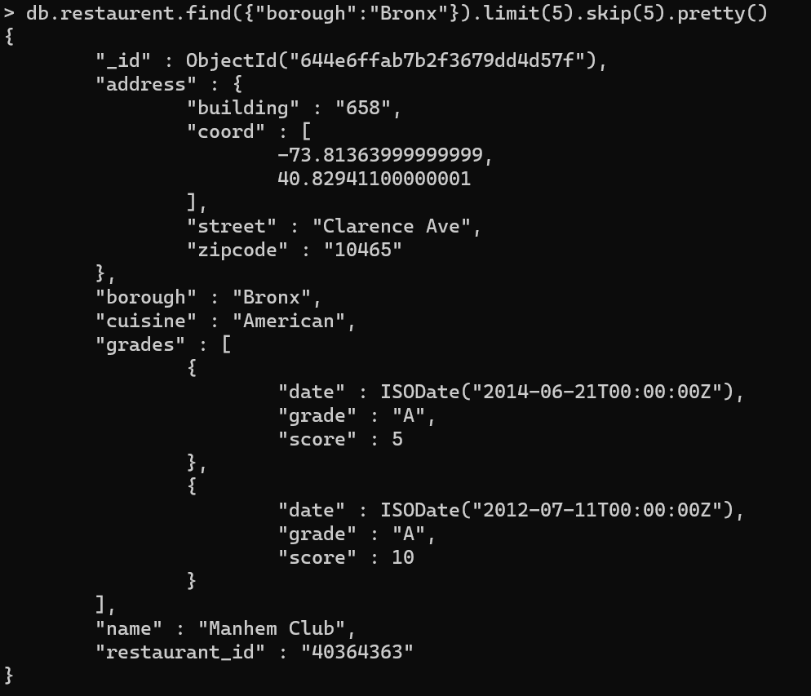

8. Write a MongoDB query to find the restaurants who achieved a score more than 90.

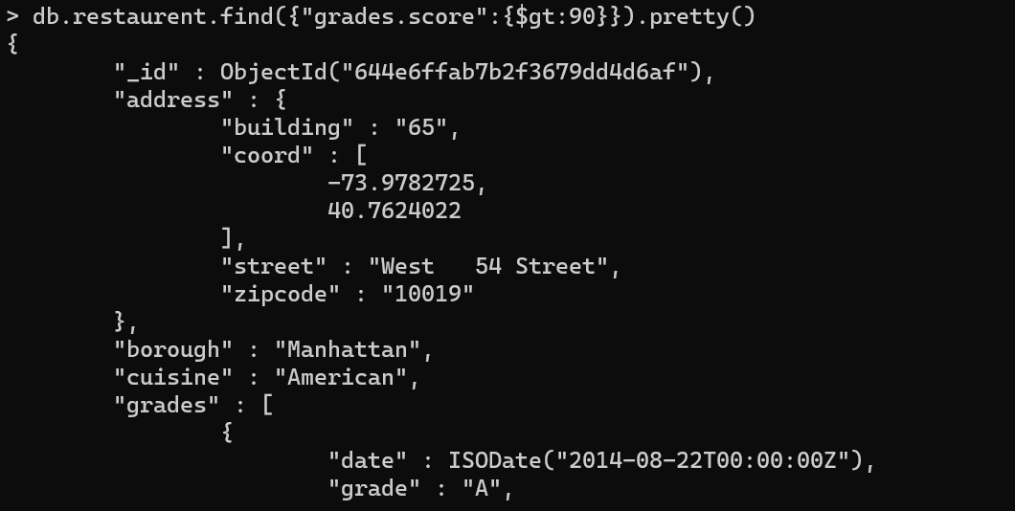

9. Write a MongoDB query to find the restaurants that achieved a score, more than 80 but

less than 100.

db.restaurent.find({"grades.score":{$gt:80,$lt:100}}).limit(1).pretty()

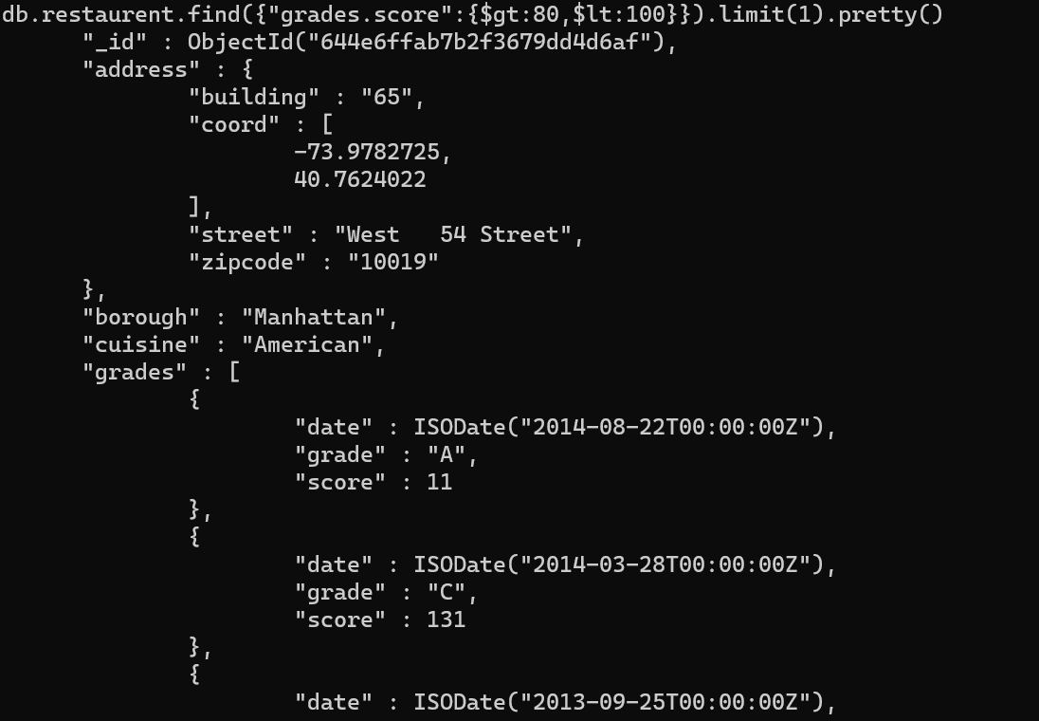

10. Write a MongoDB query to find the restaurants which locate in latitude value less than -

95.754168.

db.restaurent.find({"address.coord.2":{$lt: 95.754168}}).limit(1).pretty()

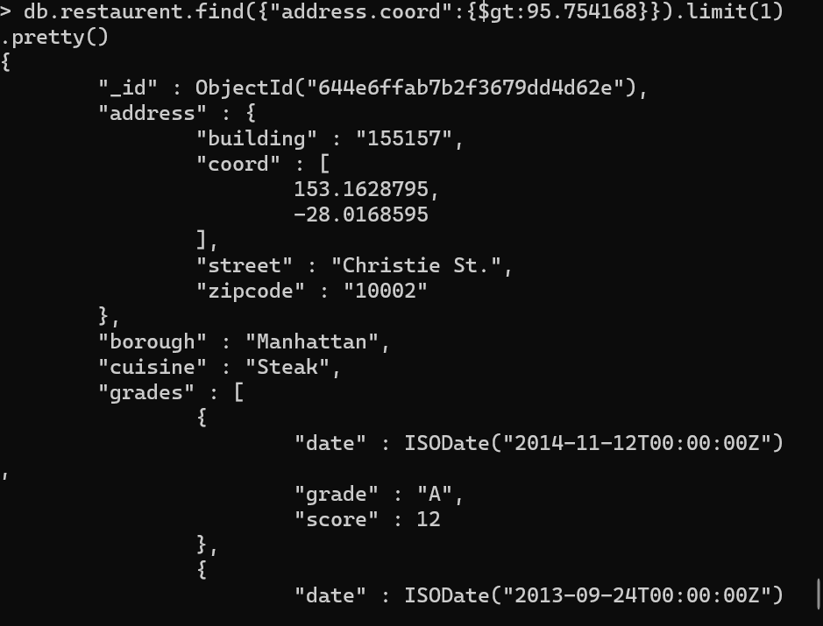

11. Write a MongoDB query to find the restaurants that do not prepare any cuisine of

'American' and their grade score more than 70 and latitude less than -65.754168.

db.restaurent.find({"address.coord.0":{$lt: -65.75}, "grades.score":{$gt:70}}).pretty();

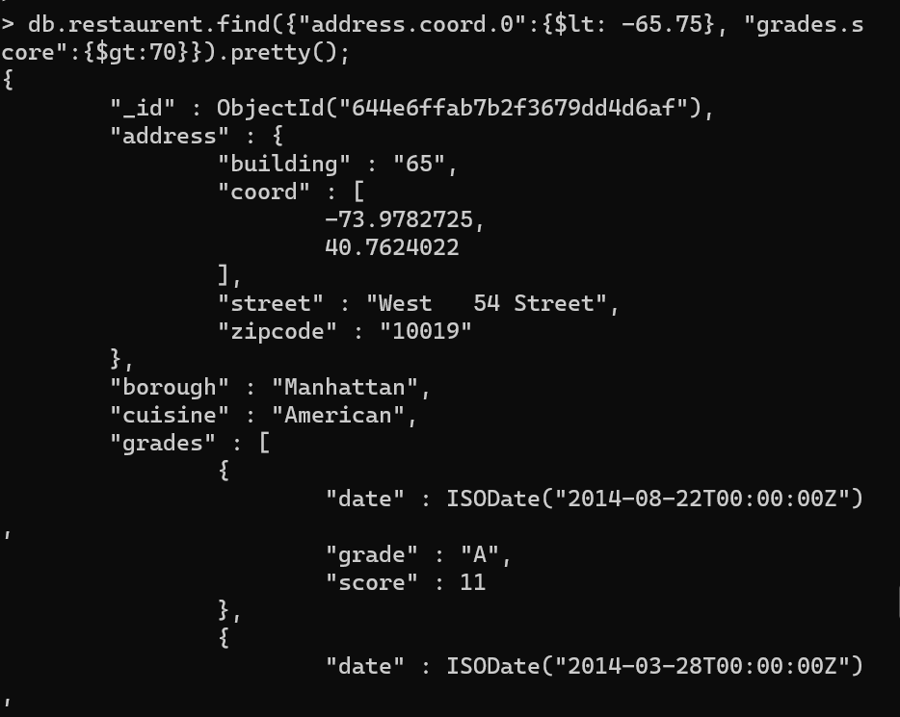

12. Write a MongoDB query to find the restaurants which do not prepare any cuisine of

'American' and achieved a score more than 70 and located in the longitude less than -

65.754168.

db.restaurent.find({cuisine:{$ne:"American"},"grades.score":{$gt:70},"address.coord.1":{$lt:65.754168}}).pretty();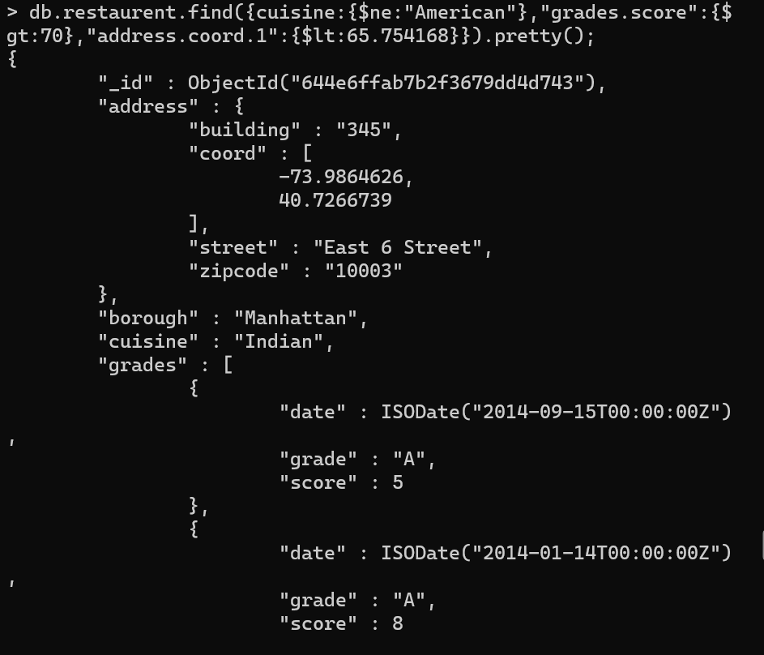

13. Write a MongoDB query to find the restaurants which do not prepare any cuisine of

'American ' and achieved a grade point 'A' not belongs to the borough Brooklyn. The

document must be displayed according to the cuisine in descending order.

db.restaurent.find({cuisine:{$ne:"American"},"grades.grade":"A",borough: {$ne: "Brooklyn"}}).sort({cuisine:-1}).pretty();

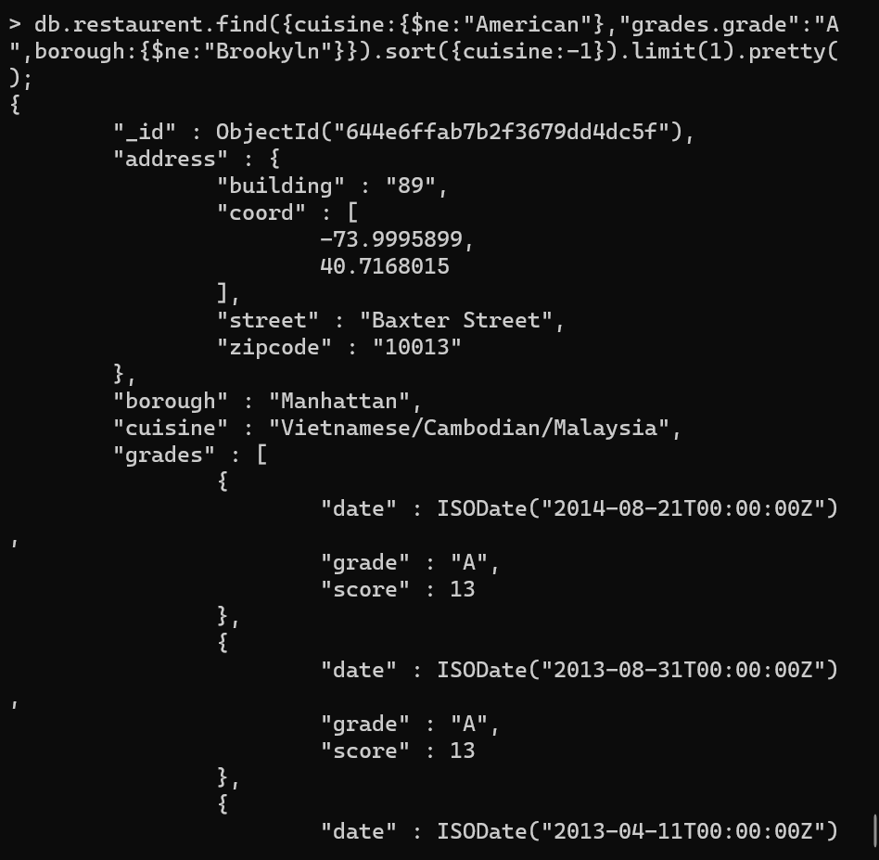

14. Write a MongoDB query to find the restaurant Id, name, borough and cuisine for those

restaurants which contain 'Wil' as first three letters for its name.

db.restaurent.find({name:/^WIL/},{restarant_id:1,name:1,cuisine:1}).pretty();

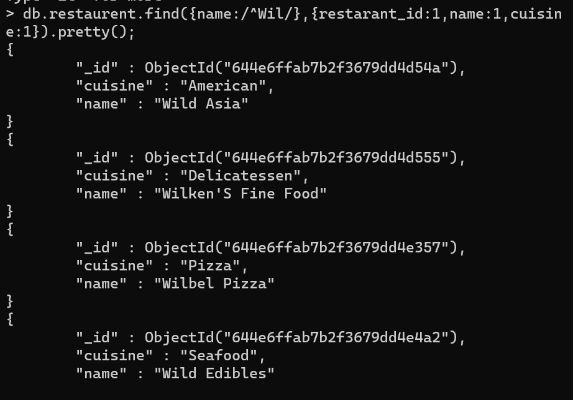

15. Write a MongoDB query to find the restaurant Id, name, borough and cuisine for those

restaurants which contain 'ces' as last three letters for its name.

db.restaurent.find({name:{$regex:’/^.*ces$/’}},{restarant_id:1,name:1,borough:1,cuisine:1}).pretty();

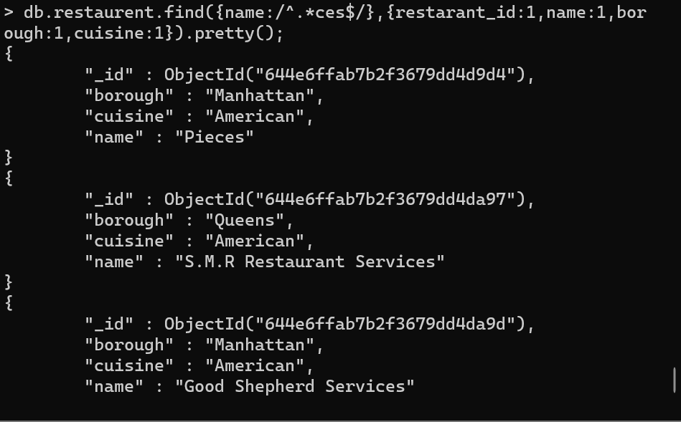

16. Write a MongoDB query to find the restaurant Id, name, borough and cuisine for those

restaurants which contain 'Reg' as three letters somewhere in its name.

db.restaurent.find({name:/^.*ces.*/},{restarant_id:1,name:1,borough:1,cuisine:1}).pretty();

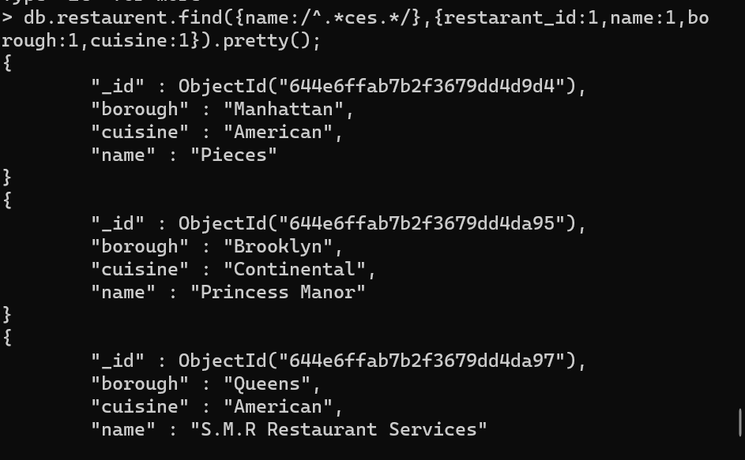

17. Write a MongoDB query to find the restaurants which belong to the borough Bronx and

prepared either American or Chinese dish.

db.restaurent.find({borough:"Bronx",cuisine:{$in:["American", "Chinese"]}},{restarant_id:1,name:1,borough:1,cuisine:1}).pretty();

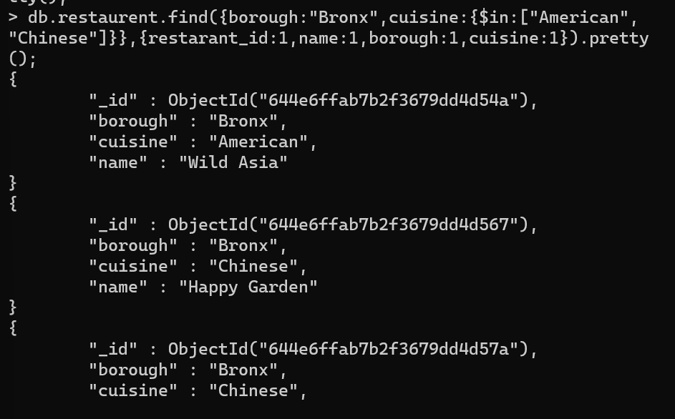

18. Write a MongoDB query to find the restaurant Id, name, borough and cuisine for those

restaurants which belong to the borough Staten Island or Queens or Bronxor Brooklyn.

db.restaurent.find({borough:{$in:["Staten Island","Queens","Bronoxor Brooklyn"]}},{restarant_id:1,name:1,borough:1,cuisine:1}).pretty();

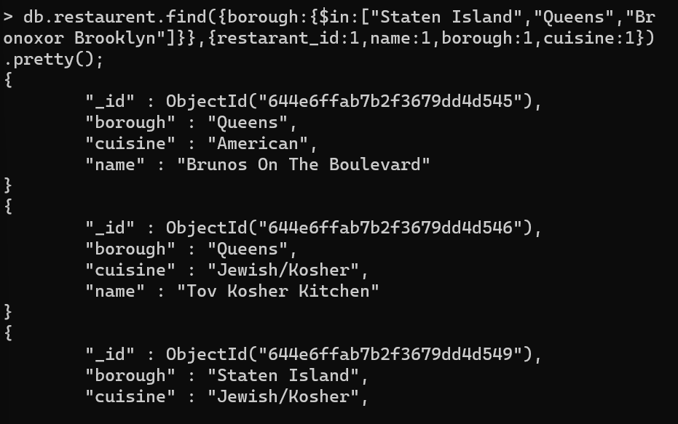

19. Write a MongoDB query to find the restaurant Id, name, borough and cuisine for those

restaurants which are not belonging to the borough Staten Island or Queens or Bronxor

Brooklyn.

db.restaurent.find({borough:{$nin:["Staten Island","Queens","Bronoxor Brooklyn"]}},{restarant_id:1,name:1,borough:1,cuisine:1}).pretty();

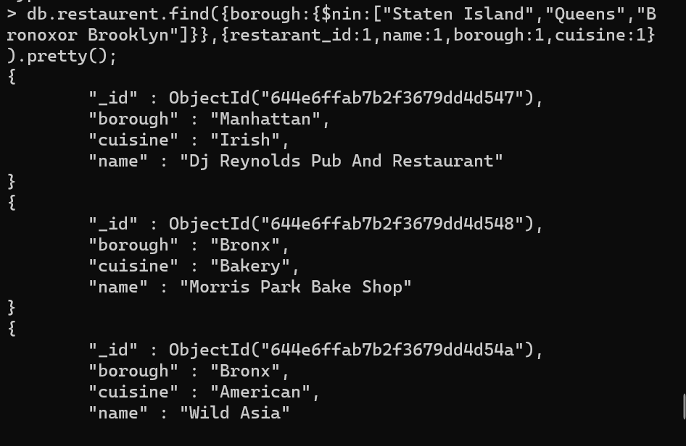

20. Write a MongoDB query to find the restaurant Id, name, borough and cuisine for those

restaurants which achieved a score which is not more than 10.

db.restaurent.find({"grades.score":{$lt:10}},{restarant_id:1,name:1,borough:1,cuisine:1}).pretty();

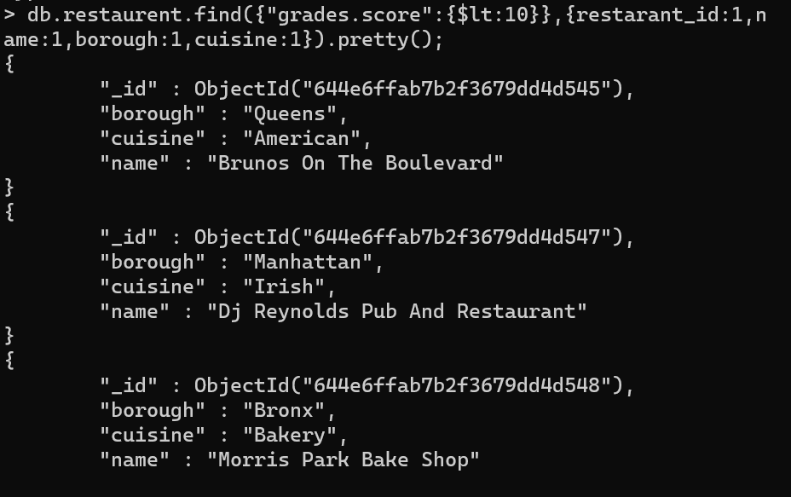

21. Write a MongoDB query to find the restaurant Id, name, borough and cuisine for those

restaurants which prepared dish except 'American' and 'Chinees' or restaurant's name begins

with letter 'Wil'.

db.restaurent.find({cuisine:{$nin:[ 'American','Chinees']}, name:/^Wil/},{restaurant_id:1,name:1,borough:1,cuisine:1}).pretty()

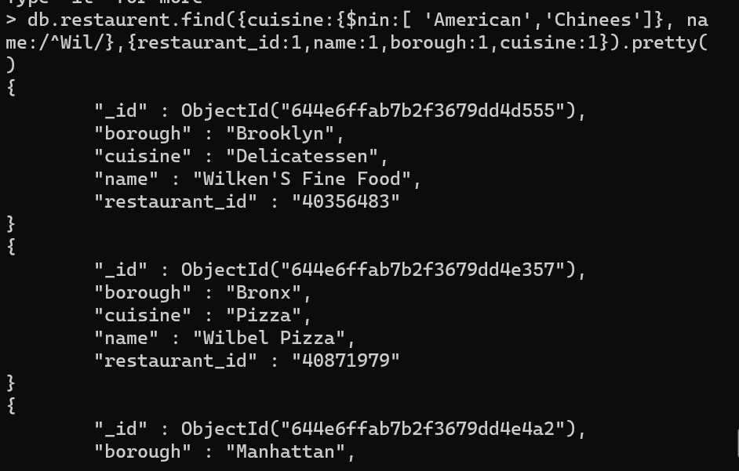

22. Write a MongoDB query to find the restaurant Id, name, and grades for those restaurants

which achieved a grade of "A" and scored 11 on an ISODate "2014-08-11T00:00:00Z"

among many of survey dates

db.restaurent.find({"grades.score":11,"grades.grade":'A',"grades.date":ISODate("2014-08-11T00:00:00Z")},{restaurant_id:1,name:1,grades:1}).pretty()

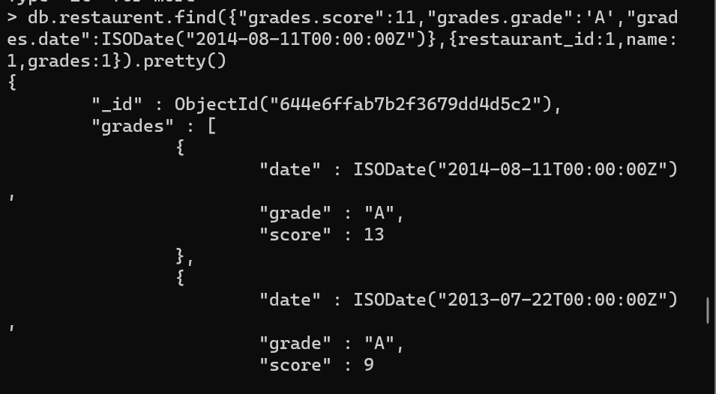

23. Write a MongoDB query to find the restaurant Id, name and grades for those restaurants

where the 2nd element of grades array contains a grade of "A" and score 9 on an ISODate

"2014-08-11T00:00:00Z".

db.restaurent.find({"grades.score":9,"grades.1.grade":'A',"grades.date":ISODate("2014-08-11T00:00:00Z")},{restaurant_id:1,name:1,grades:1}).pretty()

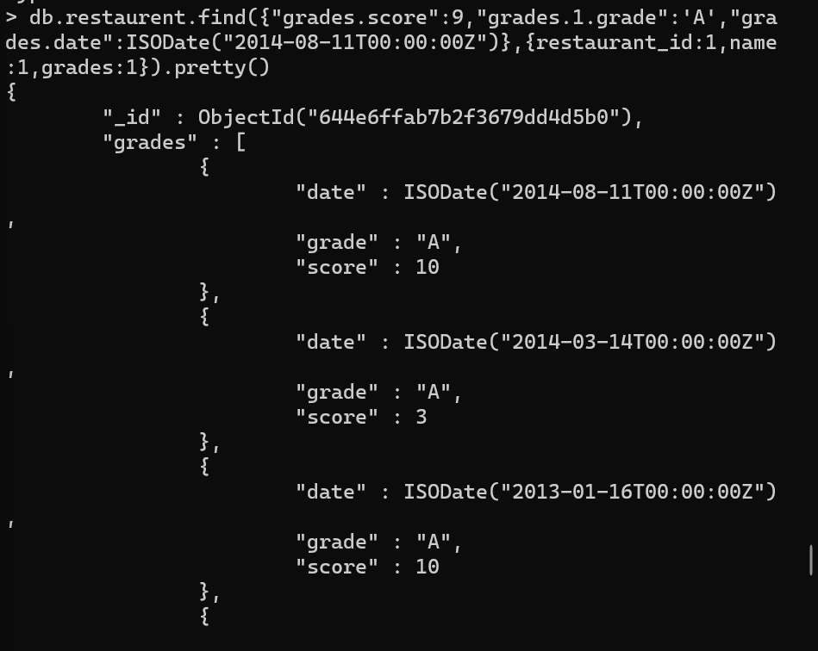

24. Write a MongoDB query to find the restaurant Id, name, address and geographical

location for those restaurants where 2nd element of coord array contains a value which is

more than 42 and upto 52

db.restaurent.find({"address.coord.1":{$gt:42,$lt:53}},{restaurant_id:1,name:1,address:1}).pretty()

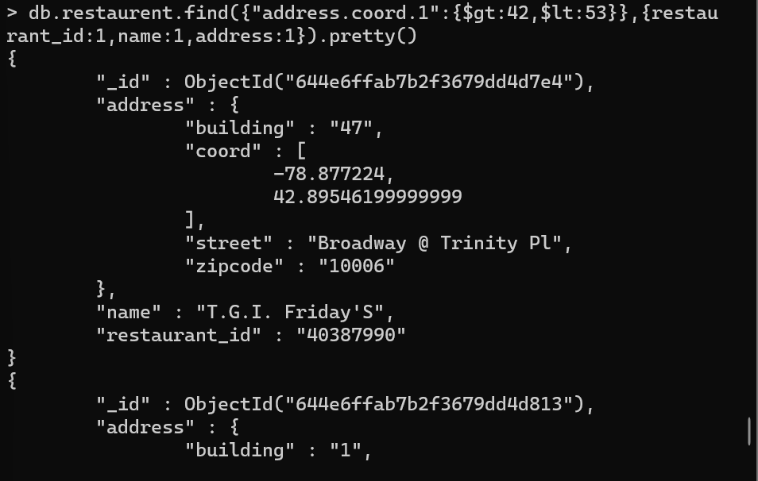

25. Write a MongoDB query to arrange the name of the restaurants in ascending order along

with all the columns.

db.restaurent.find({},{restaurant_id:1,name:1}).sort({name:1}).pretty()

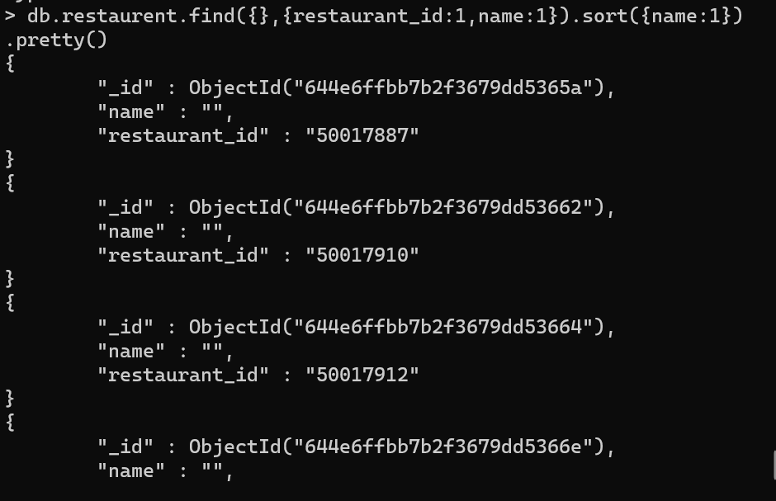

26. Write a MongoDB query to arrange the name of the restaurants in descending along with

all the columns.

db.restaurent.find({},{restaurant_id:1,name:1}).sort({name:-1}).pretty()

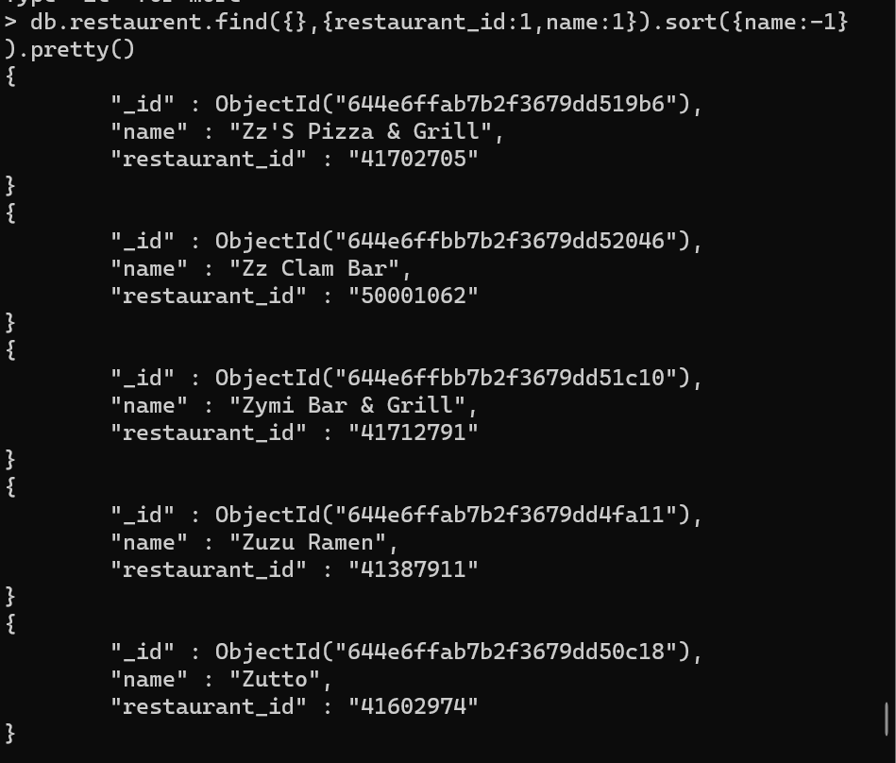

27. Write a MongoDB query to arranged the name of the cuisine in ascending order and for

that same cuisine borough should be in descending order.

db.restaurent.find({},{restaurant_id:1,name:1,cuisine:1,borough:1}).sort({cuisine:1,borough:-1}).pretty()

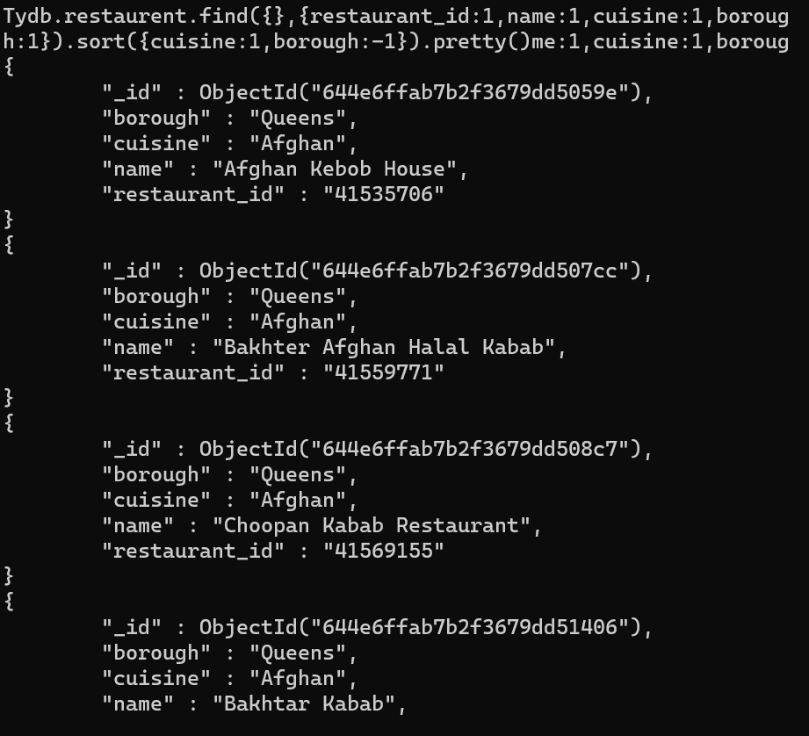

28. Write a MongoDB query to know whether all the addresses contains the street or not.

db.restaurent.find({},{“address.street”:{$exists:true}}).pretty()

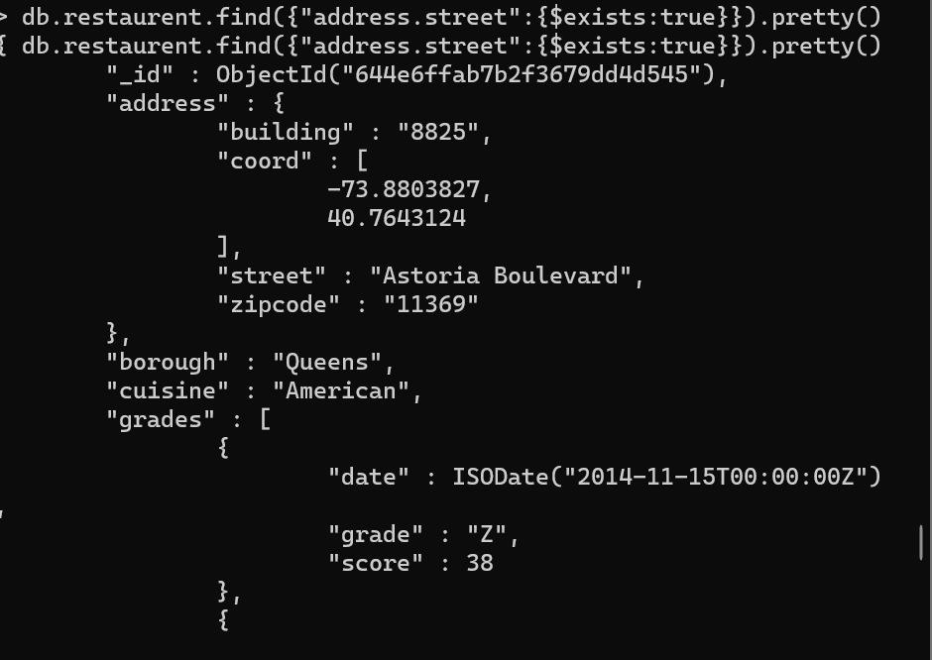

29. Write a MongoDB query which will select all documents in the restaurants collection

where the coord field value is Double.

db.restaurent.find({'address.coord':{$type:1}}).pretty()

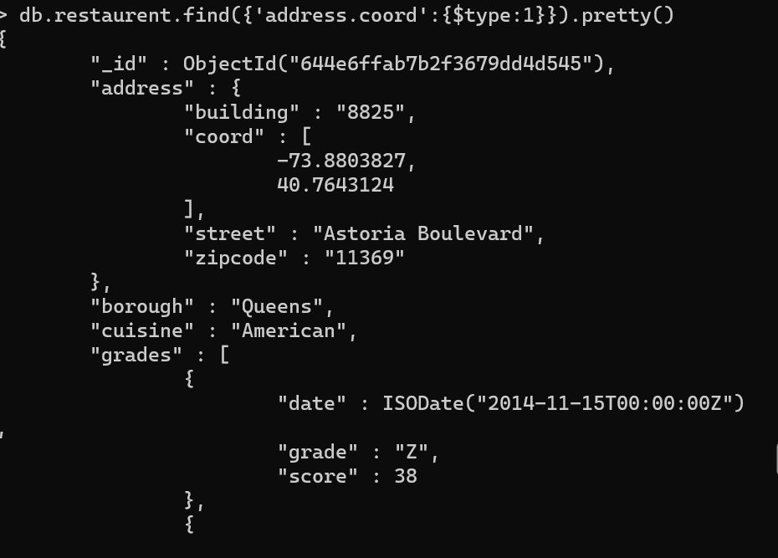

30. Write a MongoDB query which will select the restaurant Id, name and grades for those

restaurants which returns 0 as a remainder after dividing the score by 7.

db.restaurent.find({“grades.score”:{$mod:[7,0]}},{restaurant_id:1,name:1,grades:1}).pretty()

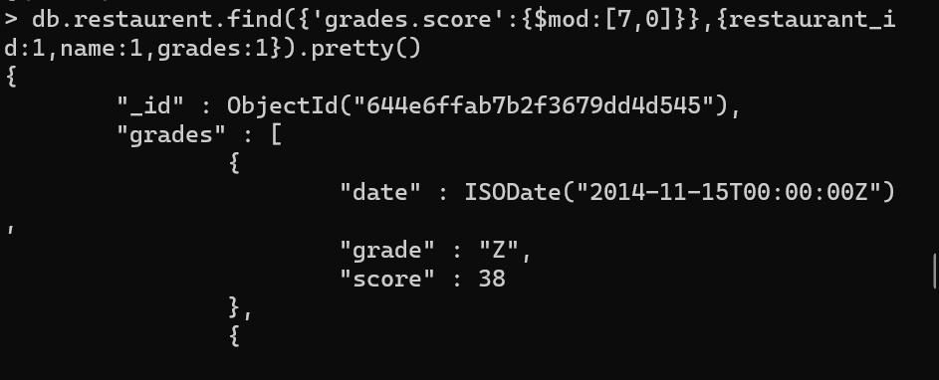

31. Write a MongoDB query to find the restaurant name, borough, longitude and attitude and

cuisine for those restaurants which contains 'mon' as three letters somewhere in its name.

db.restaurent.find({name:/^.mon./},{name:1,borough:1,”address.corrd”:1}).pretty()

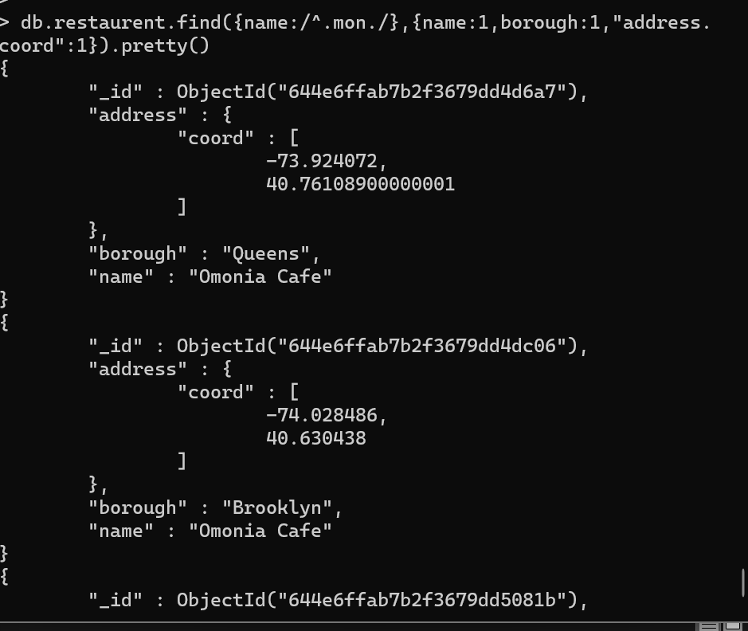

32. Write a MongoDB query to find the restaurant name, borough, longitude and latitude and

cuisine for those restaurants which contain 'Mad' as first three letters of its name.

db.restaurent.find({name:/^Mad*./},{name:1,borough:1,"address.coord":1,cuisine:1}).pretty()

