practice DQL statement

Write SQL statement for the following

1. To find all managers with salary >1500

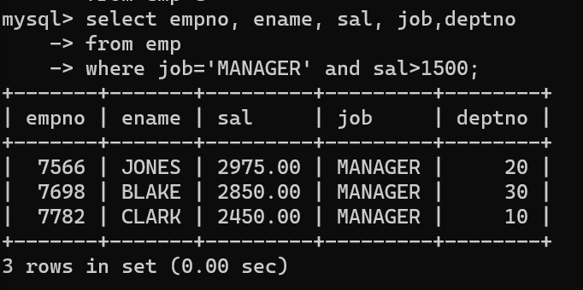

2. list all employees with sal >1200 and < 2000

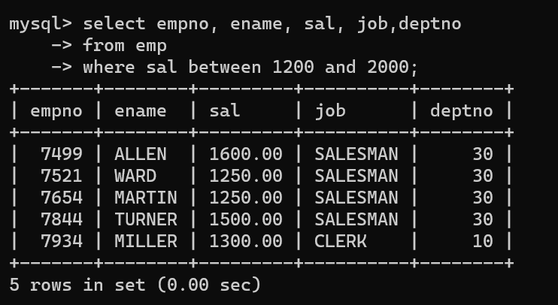

3. list all employees with sal is 1600 or sal is 800 or sal is 1900

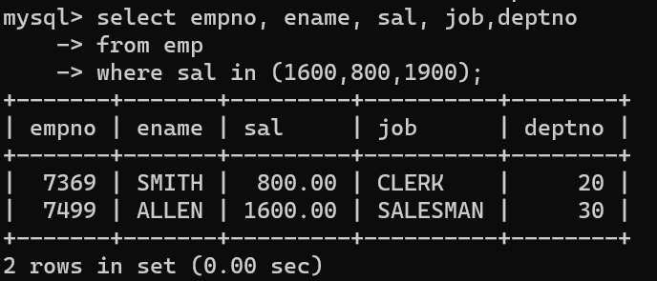

4. list all employees with R at second last position in name

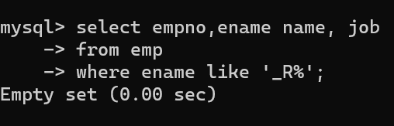

5. List all employees with name starts with A and ends with N

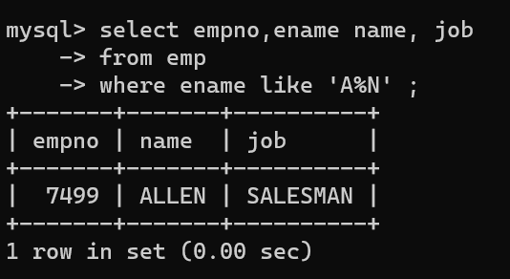

Q2. Solve following

1. list all employees with salary > 1250 and dept no=30

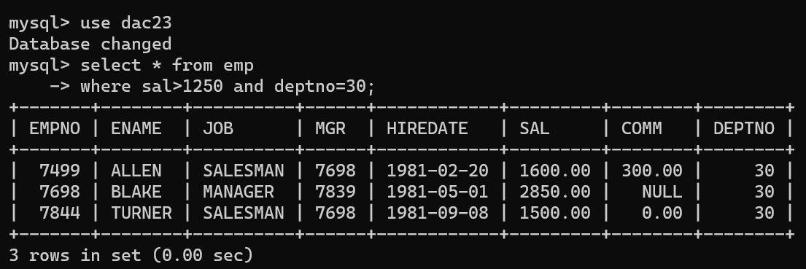

2. list all employees with salary >=1250 and <= 3000

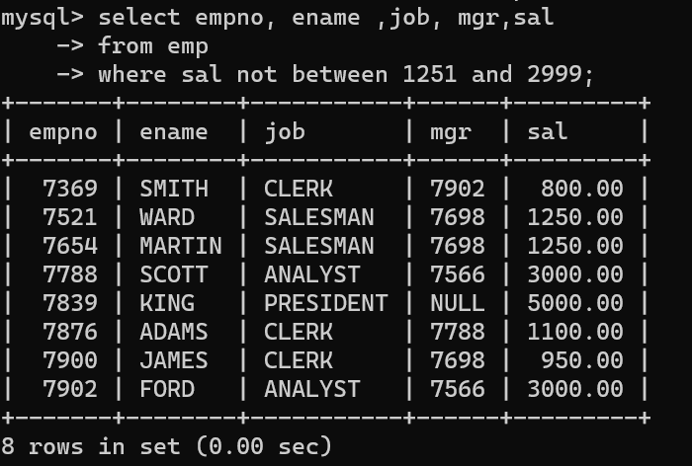

3. list all employees with salary >1250 and < 3000

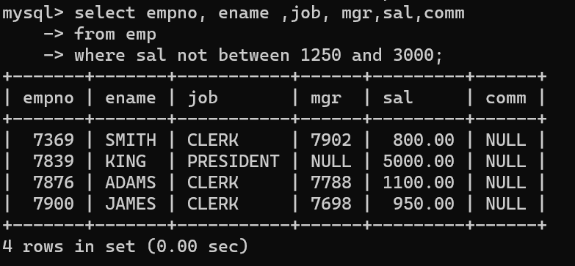

4. list all employees with salary either equal to 3000 or 1250 or 2500

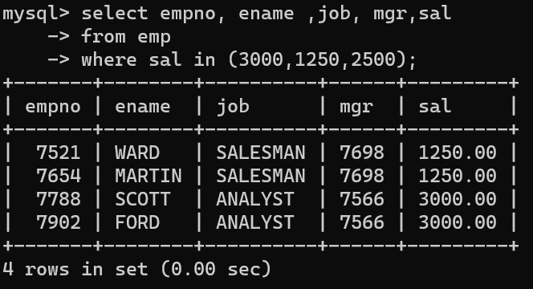

5. list all employee with name=SMITH

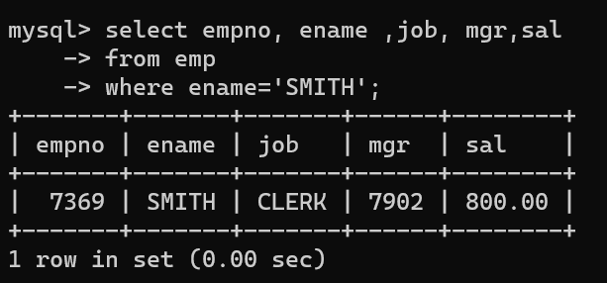

6. list all employees with name starting with S

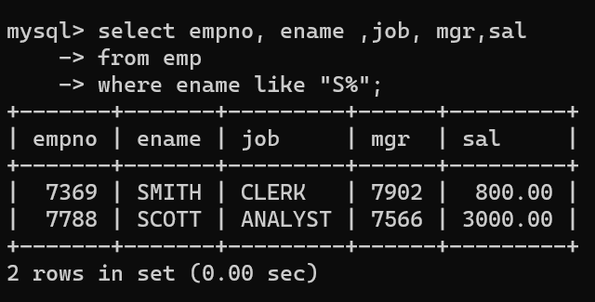

7. list all employees with name ending with S

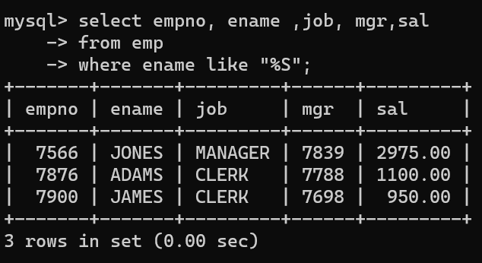

8. list all employees with name contains I at 2nd position

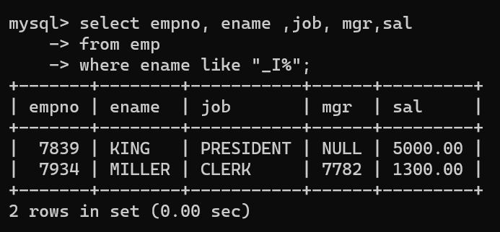

9. list all employees with name starts with A ends with N and somewhere in between L is there

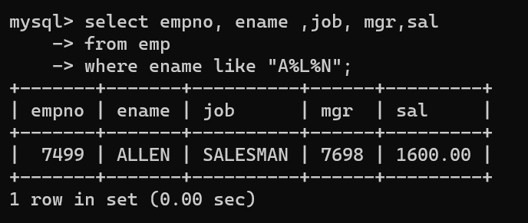

10. list all employees with name starts with A and B at 3 rd position and P at second last position

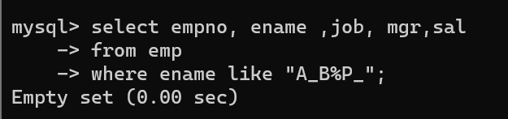

11. List all employees with name starts with either A or starts with S or starts with W

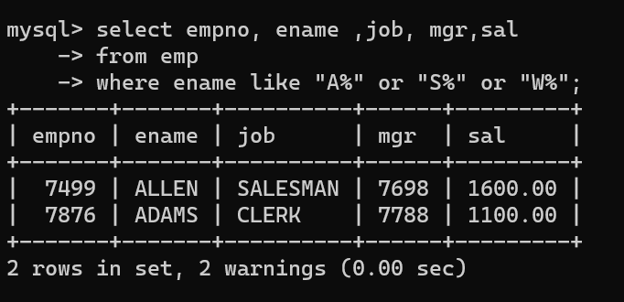

practice Aggregate functions

12. find max sal and min sal for each job

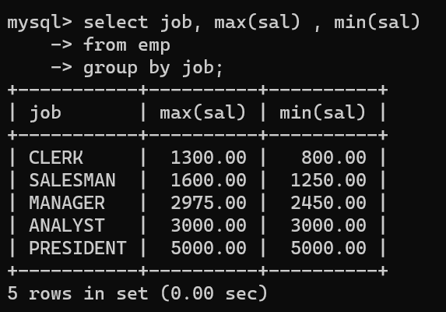

13. find how many employess have not received commission

14. find sum of sal of all employees working in dept no 10

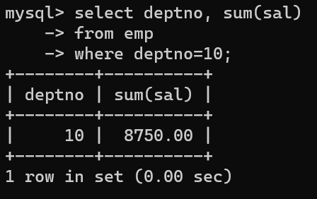

15. find maximum salary,average sal for each job in every department

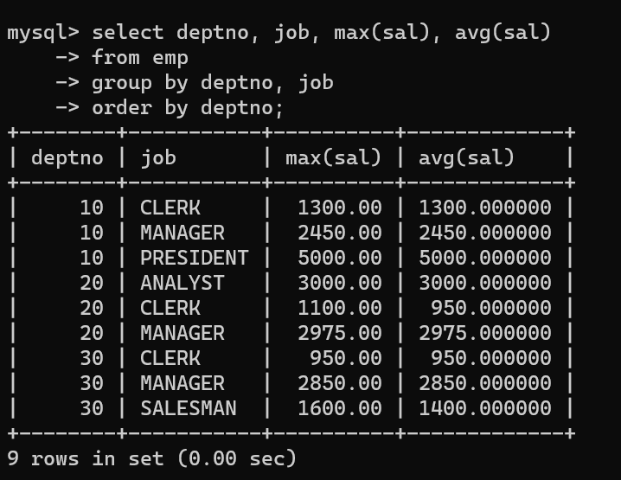

16. find max salary for every department if deptno is > 15 and arrange data in deptno order.

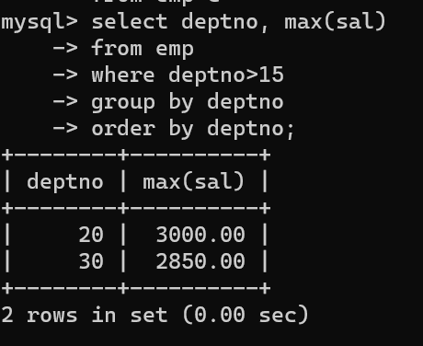

17. find sum salary for every department if sum is > 3000

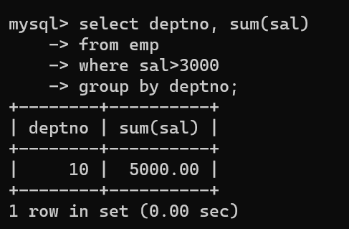

18. list all department which has minimum 5 employees

19. count how many employees earn salary more than 2000 in each job

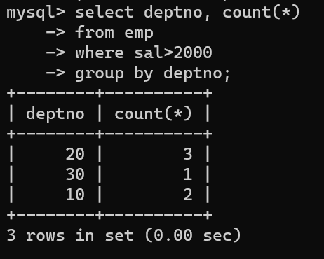

20. list all enames and jobs in small case letter

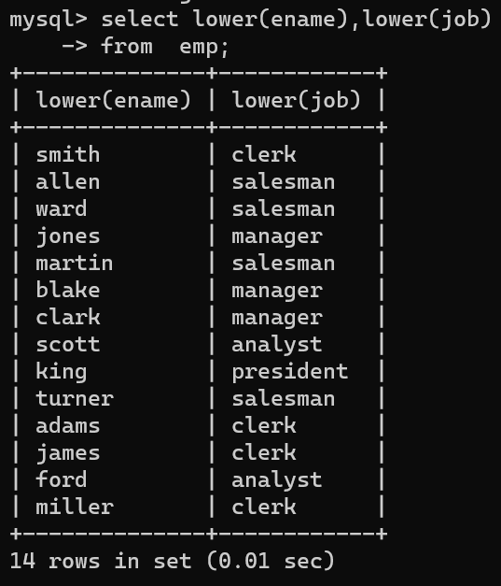

21. list all names and jobs so that the length of name should be 15 if it is smaller then add spaces

to left

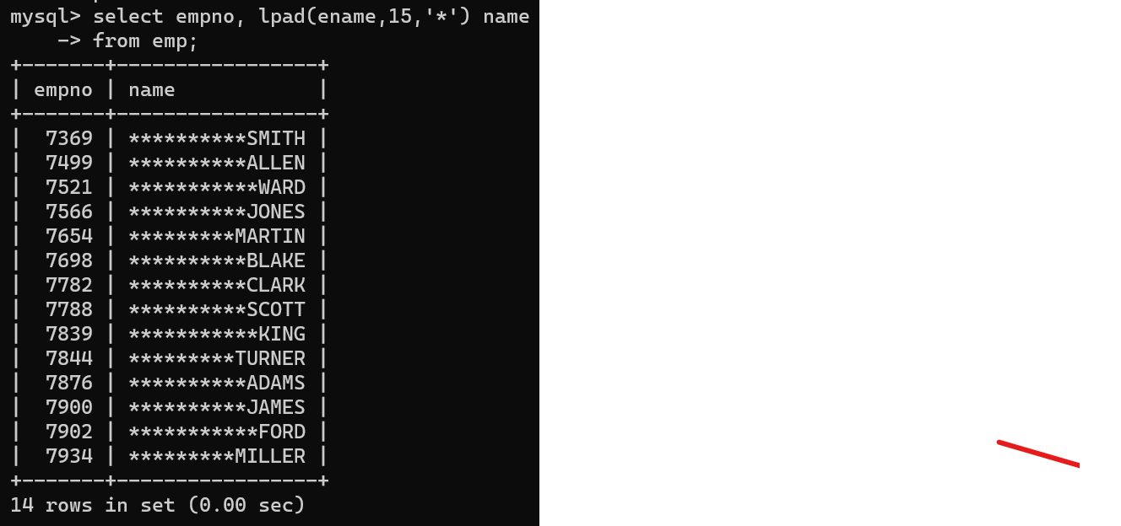

22. display min sal,max sal, average sal for all employees working under same manager

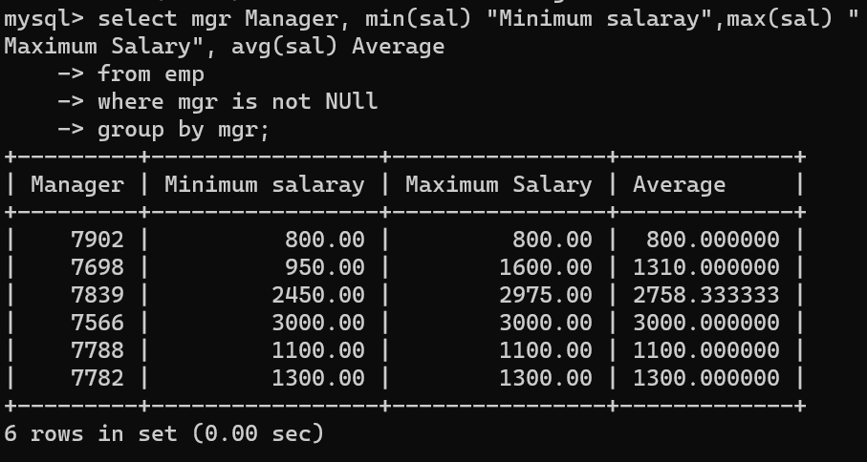

23. find sum of total earnings(sal+comm), average of sal+comm for all employees who earn sal >

2000 and work in either dept no 10 or 20

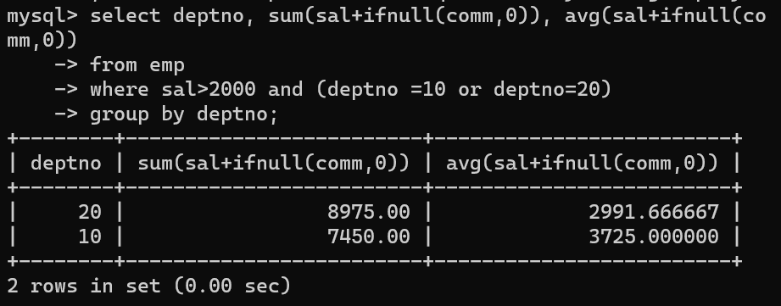

24. list all employees who joined in Aug 1980 and salary is >1500 and < 2500

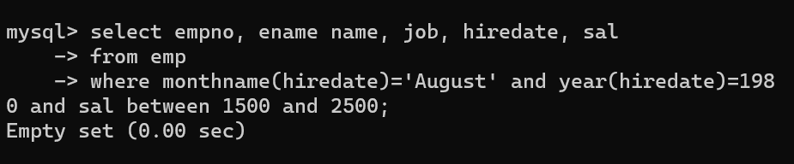

25. list all employees joined in either aug or may or dec

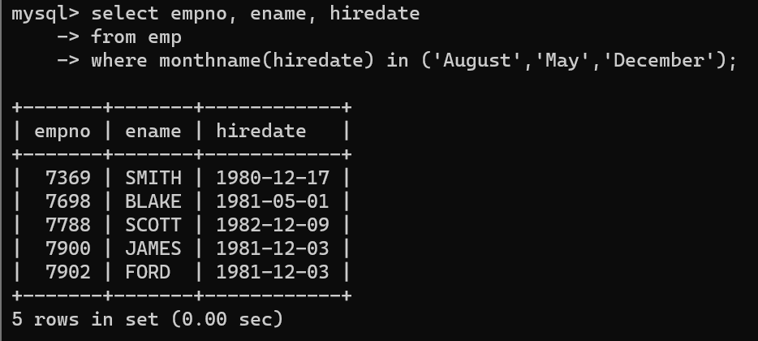

26. display name and hiredate in dd/mm/yy format for all employees whose job is clerk and they

earn some commission

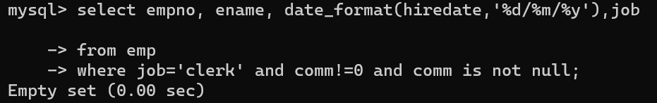

27. list empcode,empno,name and job for each employee. (note :empcode is 3 to 5 characters

from name and last 2 characters of job)

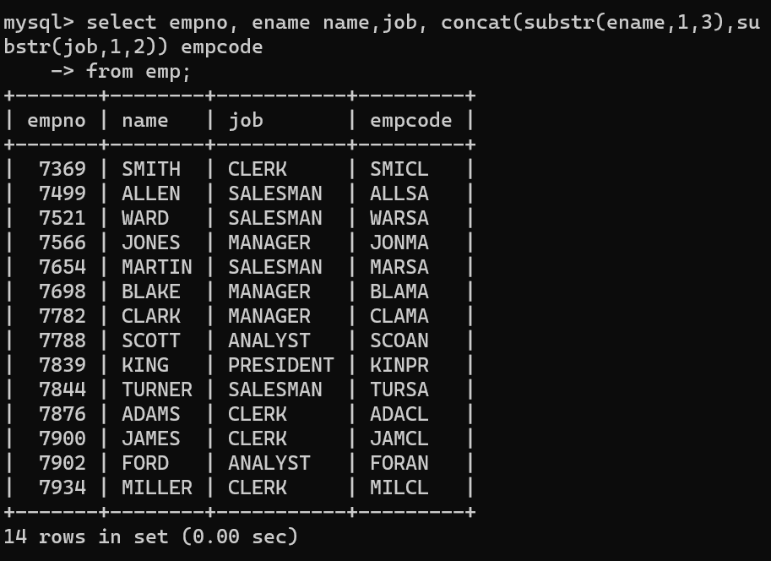

28. display thousand separator and $ symbol for commission if it is null then display it as 0 for all

employees whose name starts with A and ends with N

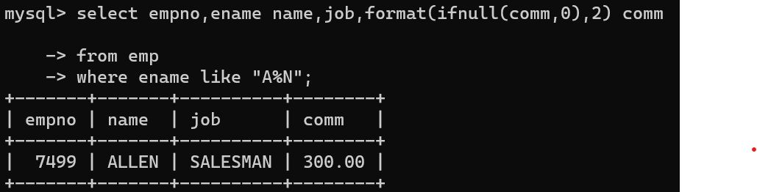

29. Display empid,name,sal,comm,remark Remark should base on following conditions

comm >= 600 "excellent Keep it up"

if it < 600 or not null "good"

otherwise "Need improvement"

select empno, ename, sal, comm,case

when comm >= 600 then "excellent keep it up"

when comm < 600 and comm >=1 then "Good"

else "Need improvement" end as remark

from emp;

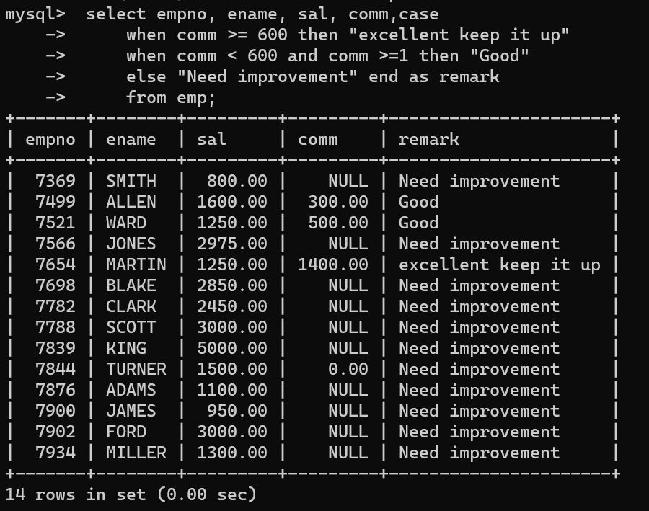

30. Display empid, name, deptno and department name by using following conditions.

dept 10 then "Hr"

if 20 then "Admin"

if 30 then "accounts"

otherwise purchase

select empno empid, ename name,deptno,

case

when deptno =10 then "Hr "

when deptno=20 then "Admin "

when deptno=30 then "accounts "

else "Purchase "

end as Departnment

from emp;

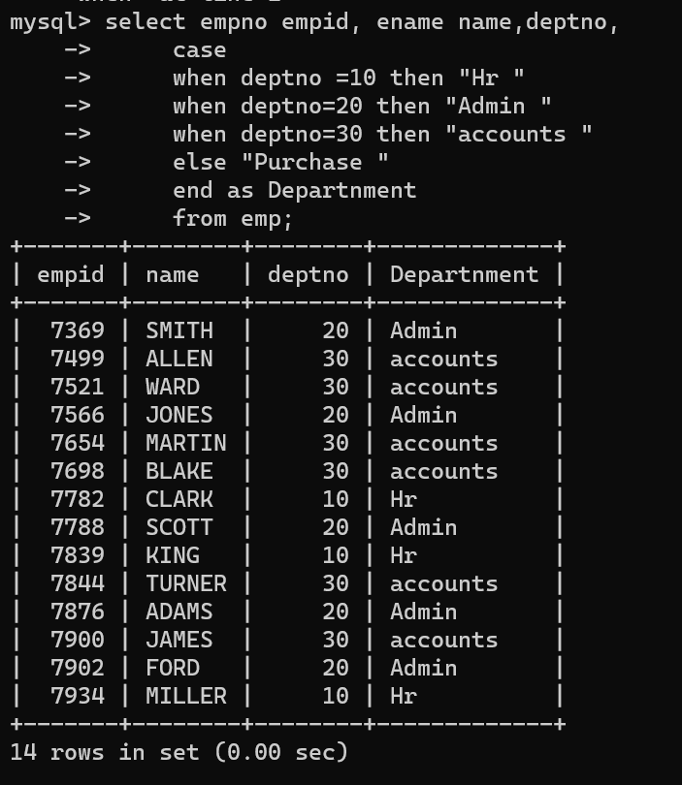

Topic ----------------- create Table, DML , subquery and joins

31. Practice creating following tables

create table mydept_DBDA

(

deptid int primary key,

dname varchar(20) not null unique,

dloc varchar(20)

)

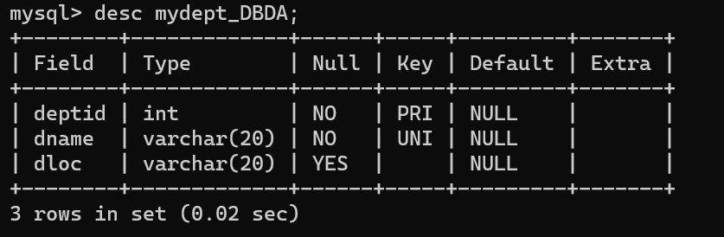

insert into mydept_DBDA values(30,'Purchase','Mumbai');

create table myemployee

(

empno int primary key,

fname varchar(15) not null,

mname varchar(15),

lname varchar(15) not null,

sal double(9,2) check(sal >=1000),

doj date default sysdate,

passportnum varchar(15) unique,

deptno number constraint fk_deptno references mydept_DBDA(deptid) on delete

cascade

)

32. Create following tables Student, Course

Student (sid,sname) ---------------- sid ---primary key

Course(cid,cname)-------------- cid ---primary key

Marks(studid,courseid,marks)

Sample data for marks table

studid,courseid,marks

1 1 99

1 3 98

2 1 95

2 2 97

create table marks(

studid number,

courseid number,

marks number,

constraint pk primary key(studid,courseid),

constraint fk_sid foreign key (studid) references student(sid) on delete cascade,

constraint fk_cid foreign key (courseid) references course(cid)

)

33. Create empty table emp10 with table structure same as emp table.

create table emp10 as

(

select *

from emp

where 1=2;

)

34. Solve following using alter table

add primary key constraint on emp,dept,salgrade

emp ----→ empno

dept---→ deptno

salgrade---→ grade

add foreign key constarint in emp

deptno --->> dept(deptno)

add new column in emp table netsal with constraint default 1000

35. Update employee sal ---- increase sal of each employee by 15 % sal +comm, change the job to

manager and mgr to 7777 for all employees in deptno 10.

36. change job of smith to senior clerk

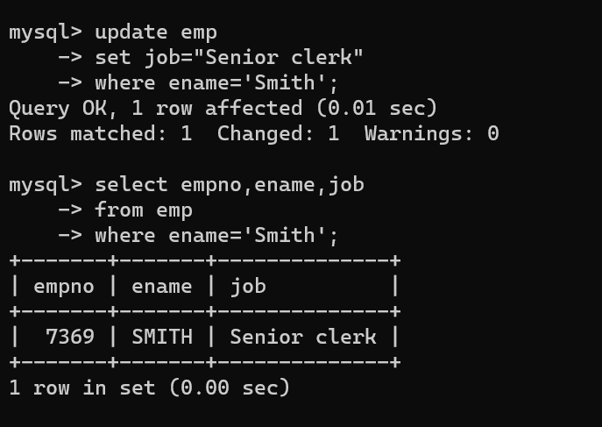

37. increase salary of all employees by 15% if they are earning some commission

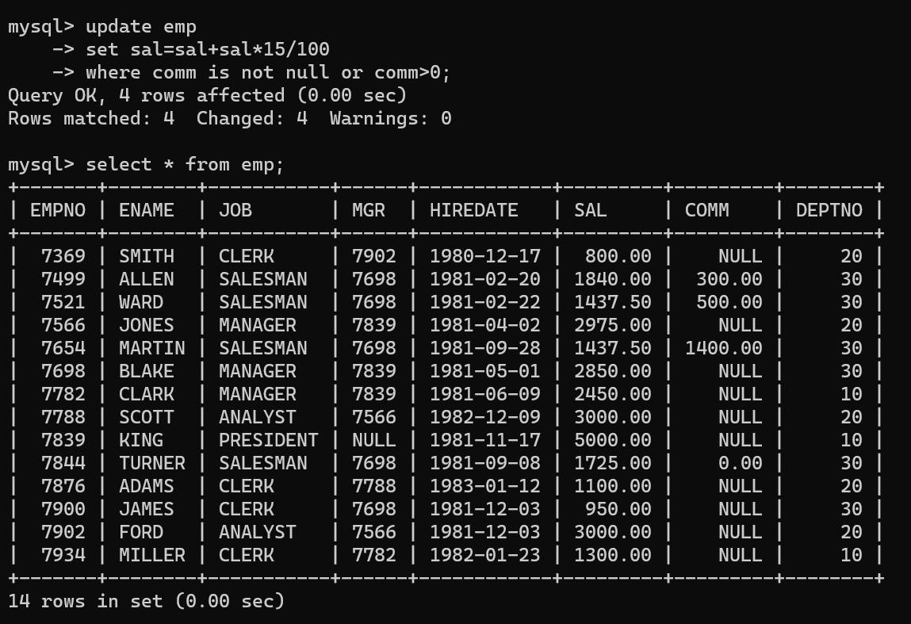

38. list all employees with sal>smith's sal

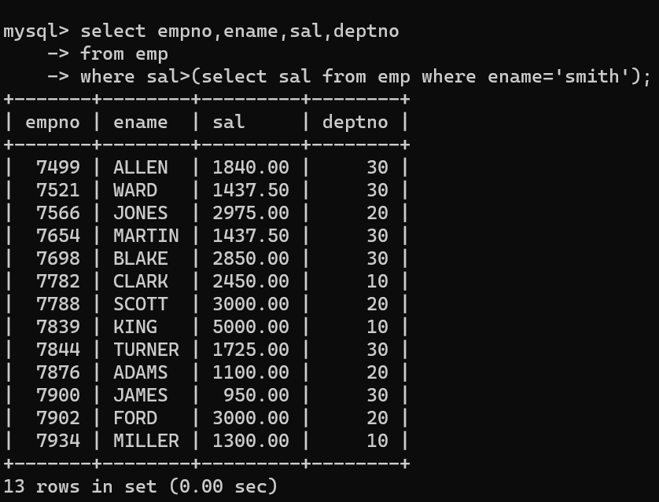

39. list all employees who are working in smith's department

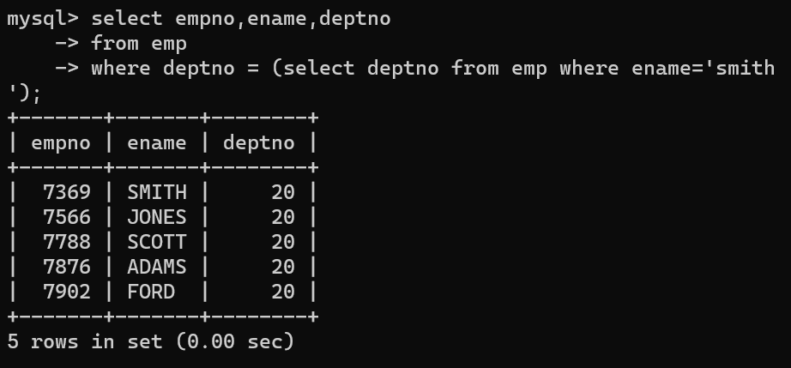

40. list all employees with sal < rajan's sal and salary > revati's sal

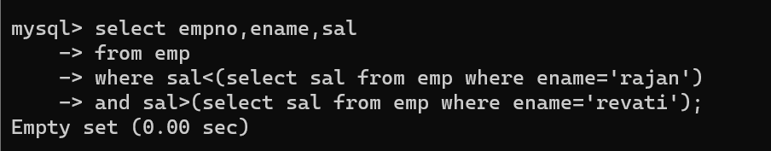

41. delete all employees working in alan's department

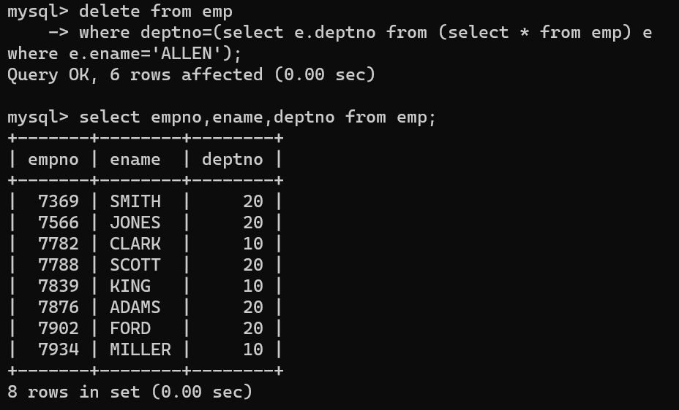

42. change salary of Alan to the salary of Miller.

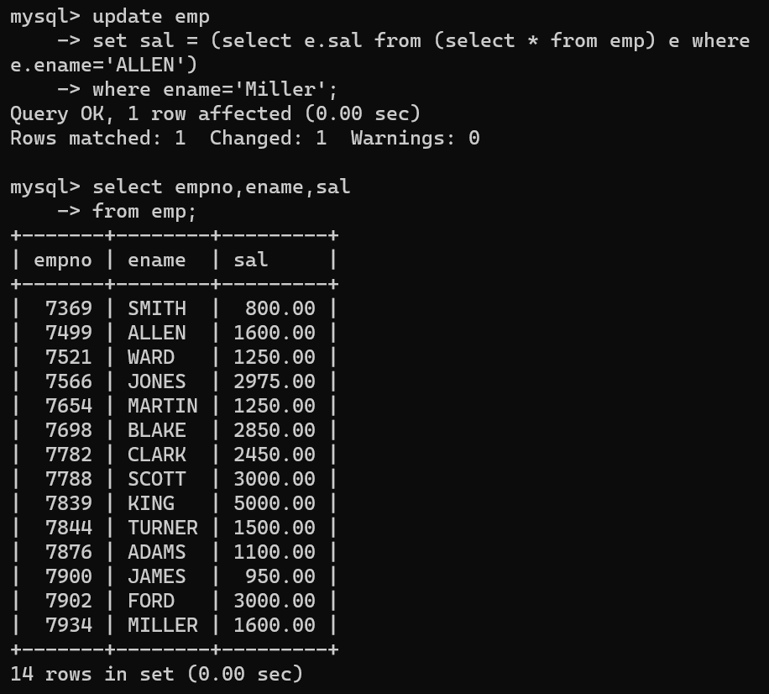

43. change salary of all emplees who working in Wall's department to the salary of Miller.

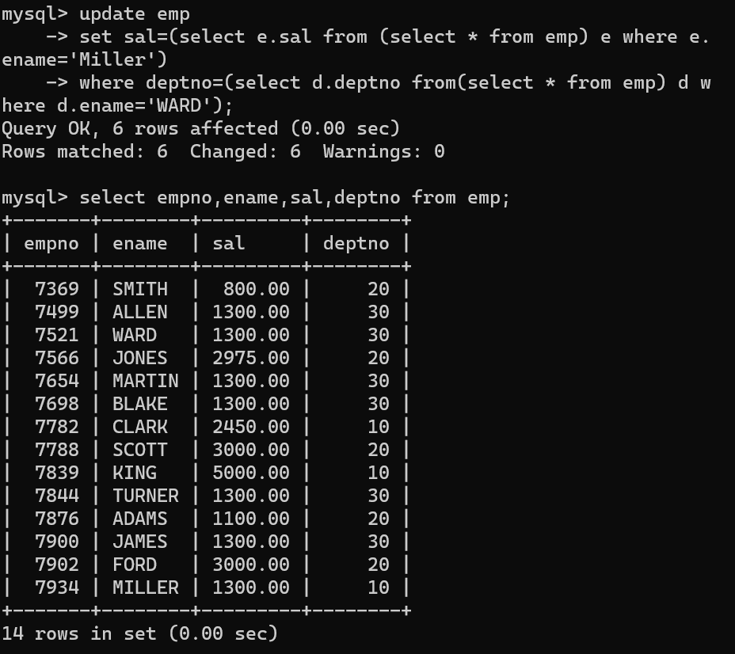

44. list all employees with salary > either Smith's salary or alan's sal

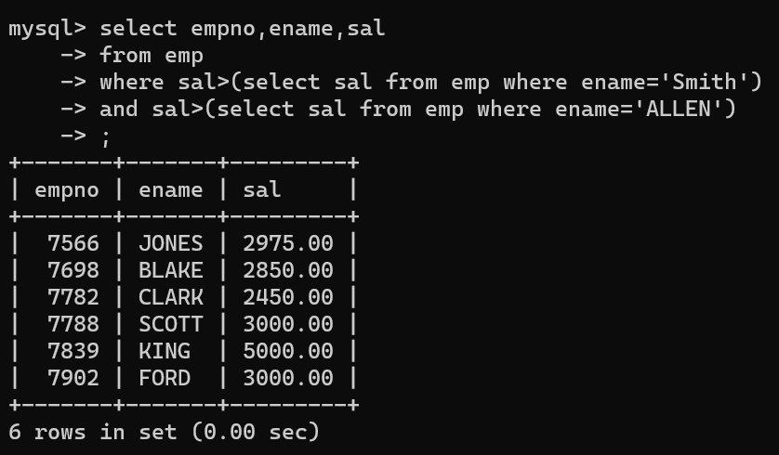

45. list all employees who earn more than average sal of dept 10

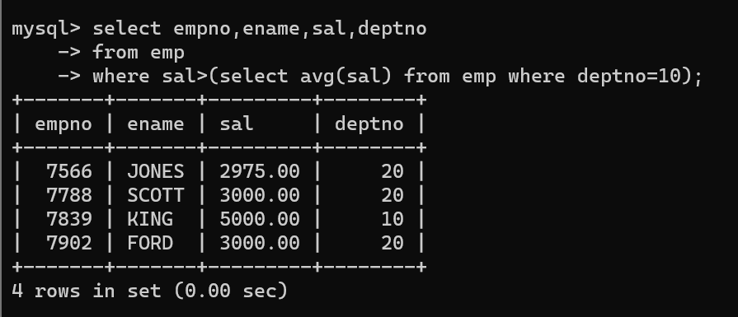

46. list all employees who earn more than average sal of Alan's department

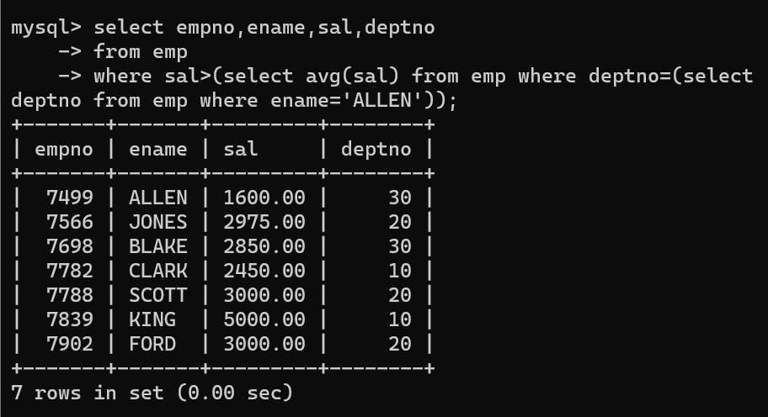

47. list all employees who are working in purchase department

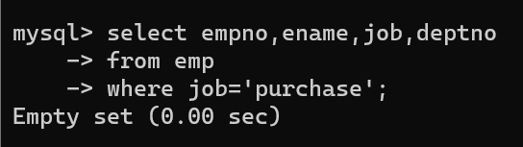

48. list all employees who earn more than average salary of their own department

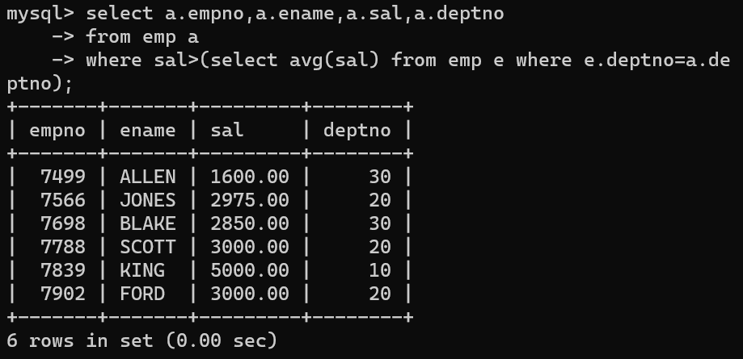

49. list all employees who earn sal < than their managers salary

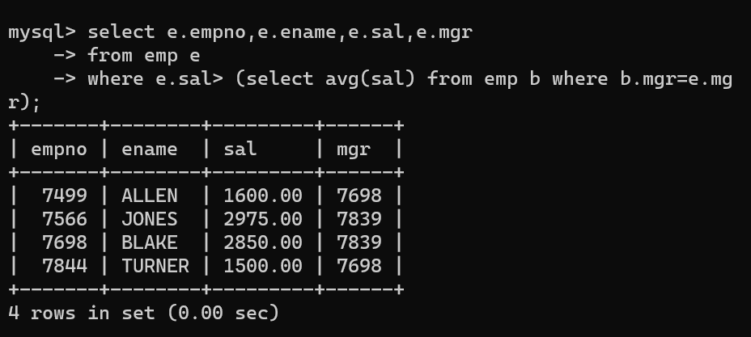

50. list all employees who are earning more than average salary of their job

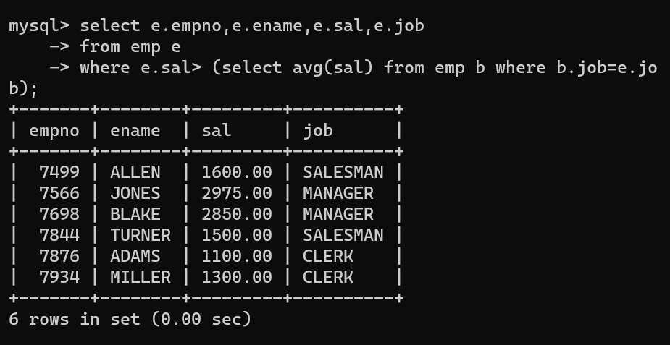

51. display employee name and department

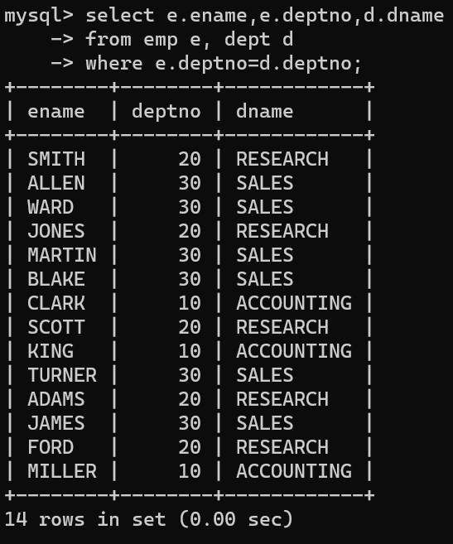

52. display empno,name,department name and grade (use emp,dept and salgrade table)

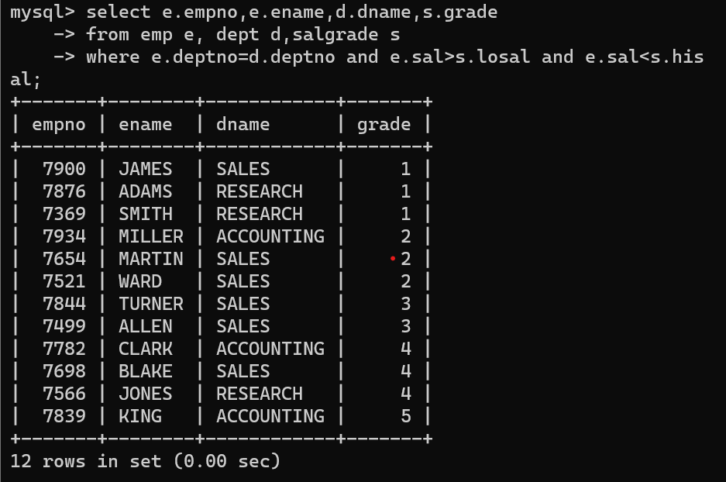

53. list all employees number,name, mgrno and manager name

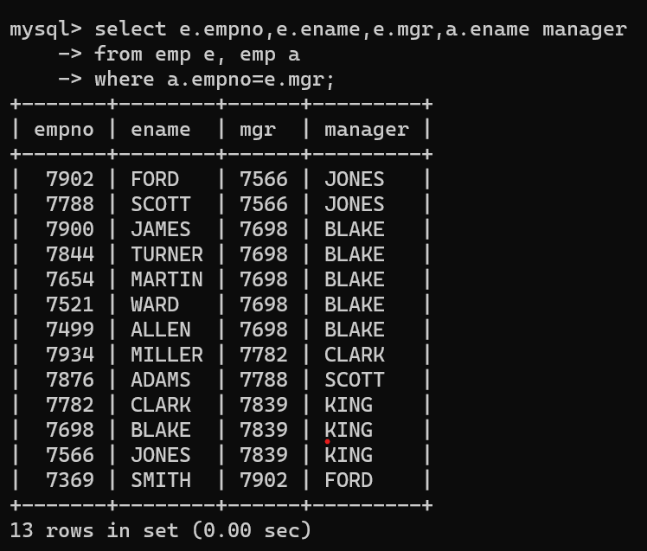

54. create following tables and solve following questions(primary keys are marked in yellow)

foreign keys are marked in green

product(pid,pname,price,qty,cid,sid)

salesman (sid,sname,address)

category(cid,cnam,descritpion)

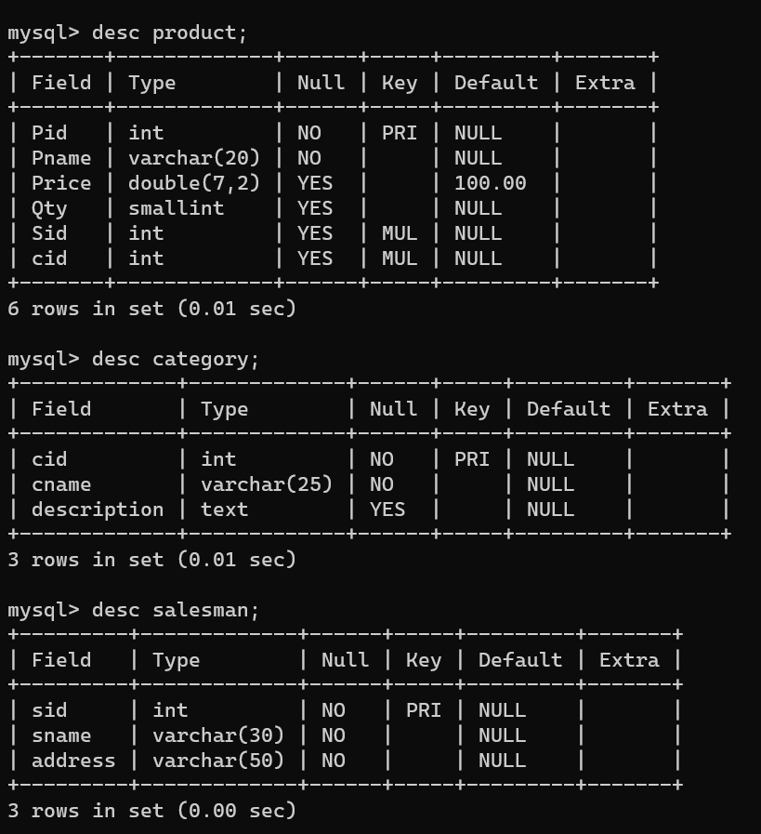

1. list all product name,their category name and name of a person, who sold that product.

Select p.pname,c.cname,s.sname

From product p, category c, salesman s

Where p.sid=s.sid and p.cid=c.cid;

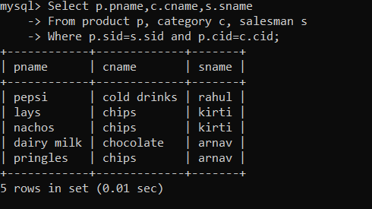

2. list all product name and salesman name for all salesman who stays in pune.

Select p.pname ,s.sname

From product p inner join salesman s on p.sid = s.sid

Where s.address =”pune”;

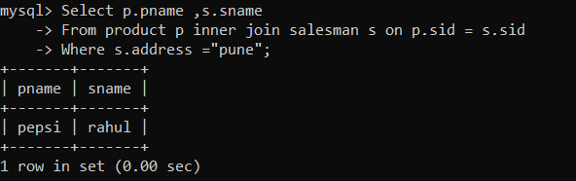

3. list all product name and category name

Select p.pname , c.cname

From product p right join category c on p.cid=c.cid

Union

Select p.pname , c.cname

From product p left join category c on p.cid=c.cid

Where p.cid is null;

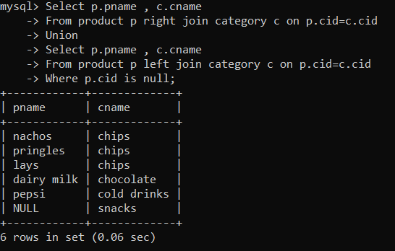

55. create following tables and solve following questions(primary keys are marked in yellow)

foreign keys are marked in green

faculty(fid,fname,sp.skill1,sp.skill2)

courses(cid,cname,rid,fid)

room(roomid,rname,rloc)

faculty

fid fname spskill1 spskill2

10 kjzhcjhz a b

11 sdd x z

12 lksjk a x

13 ksdjlkj a b

courses

cid cname rid fid

121 DBDA 100 10

131 DAC 101

141 DTISS

151 DIOT 105 12

Room

roomid rname rloc

100 jasmin 1st floor

101 Rose 2nd floor

105 Lotus 1st floor

103 Mogra 1st floor

Solution:

Create table course(

cid int primary key,

cname varchar(30) not null,

rid int,

fid int,

constraint rk_rid foreign key (rid) references room(roomid) on delete set null on update cascade,

constraint fk_fid foreign key (fid) references faculty(fid) on delete set null on update cascade

);

Create table faculty(

Fid int primary key,

Fname varchar(30) not null,

Sp_skill1 varchar(30),

Sp_skill2 varchar(30)

);

Create table room(

Roomid int primary key,

Rname varchar(30) not null,

Rloc varchar(30) not null

);

Insert into faculty values (10,”kjzhcjhz”,”a”,” b”);

Insert into faculty values (11,”sdd“,”x”,” z”);

Insert into faculty values (12,”lksjk”,”a”,” x”);

Insert into faculty values (13,”ksdjlkj”,”a”,” b”);

Insert into course values(121,”DBDA”,100 ,10);

Insert into course(cid,cname,rid) values(131,”DAC “,101);

Insert into course(cid,cname) values(141,”DTISS”);

Insert into course values(151,”DIOT”,105,12);

Insert into room values(100,”jasmine”,”1st floor”);

Insert into room values(101,”Rose”,”2nd floor”);

Insert into room values(105,”Lotus”,”1st floor”);

Insert into room values(103,”Mogra”,”1st floor”);

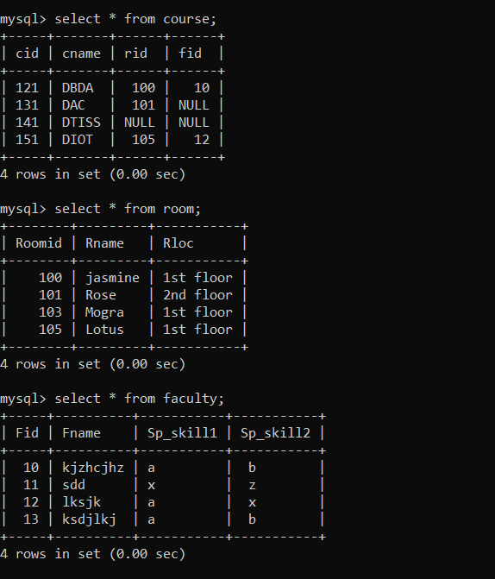

1. list all courses for which no room is assigned and all rooms for which are

Available.

Select cname,rname

From course c left join room r on c.rid =r.rid

Union

Select cname,rname

From course c right join room r on c.rid =r.rid

Where cid is null;

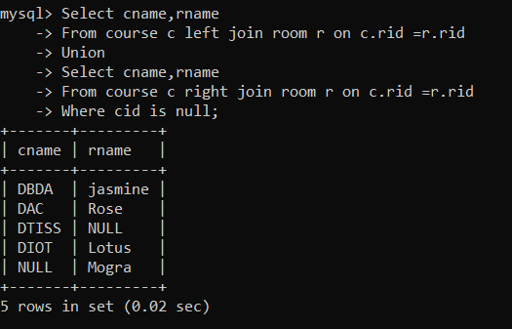

2. list all faculties who are not allocated to any course and rooms which are not

allocated to any course.

Select fname ,cname,rname

From faculty f left join course c on f.fid = c.fid  left join room r on r.rid =c.rid

where c.cid is null

union

select null,cname,rname

from room r left join course c on r.rid =c.rid

where c.cid is null;

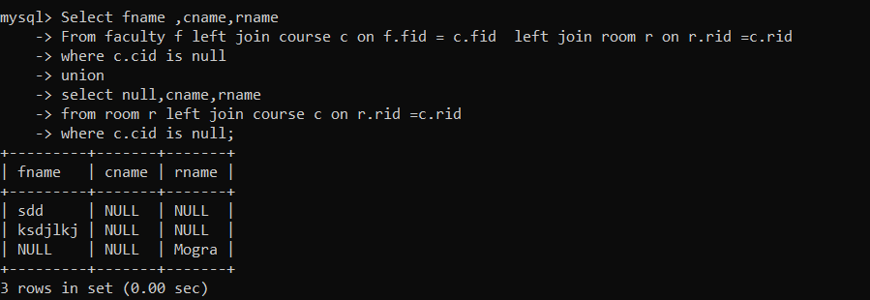

3. list all rooms which are allocated or not allocated to any courses.

Select c.cname,c.cid, r.rname,r.rid,r.rloc

From room r left join course c on r.rid = c.rid

Order by cid desc;

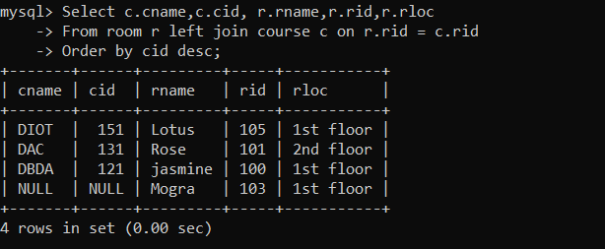

4. list all rooms which are not allocated to any courses.

Select r.rid,r.rname,r.rloc

From room r

Where not exists (select * from course c where c.rid = r.rid);

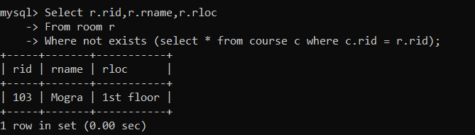

5. display courses and faculty assigned to those courses whose special skill is

Database.

Select c.cname,f.fname

From course c inner join faculty f on f.fid = c.fid

Where sp_skill1 = “database” or sp_skill1 = “database”;

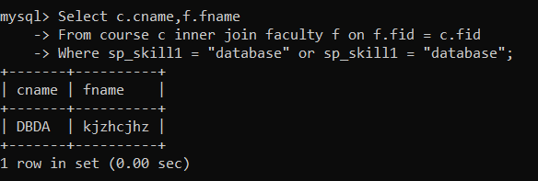

6. display time table --- it should contain course details , faculty and room

Details.

Select cid,c.cname ,f.fname,r.rname

From course c, faculty f, room r

Where c.fid =f.fid  and r.rid = c.rid;

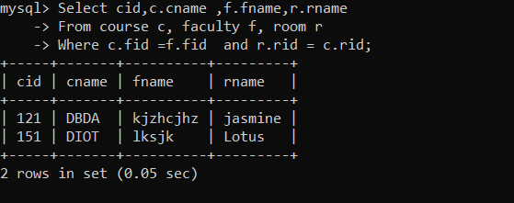

56. create following tables with given constraints

product---- qty >0, default 20.00,pname not null and unique

prodid pname qty price catid sid

123 lays 30 30.00 1 12

111 pepsi 40 50.00 4 11

134 nachos 50 50.00 1 12

124 ,‘dairy milk’,60.00,40, 14,2

125,’pringles’,60.00,40,14,1

saleman ----- sname -----not null

sid sname city

11 Rahul Pune

12 Kirti Mumbai

13 Prasad Nashik

14 Arnav Amaravati

category ---- cname unique and not null

cid cname description

1 chips very crunchy

2 chocolate very chocolaty

3 snacks yummy

4 cold drinks thanda thanda cool cool

1. List all products with category chips.

Select *

From product

Where cid = (select cid from category where cname = “chips”);

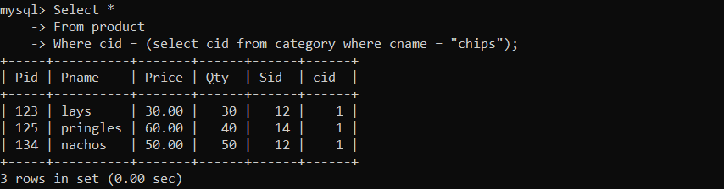

2. display all products sold by kirti.

Select *

From product

Where sid=(select sid from salesman where sname = “kirti”);

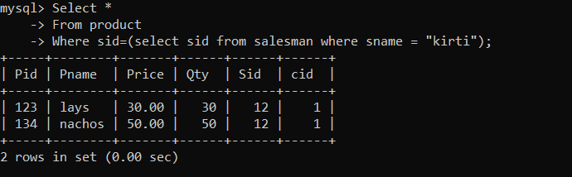

3. display all salesman who do not sold any product.

Select *

From salesman s

Where not exists  (select * from product p where p.sid=s.sid);

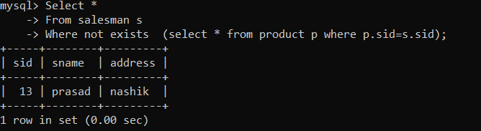

4. display all category for which no product is there.

Select *

From category

Where not exists (select * from product where product.cid =category.cid);

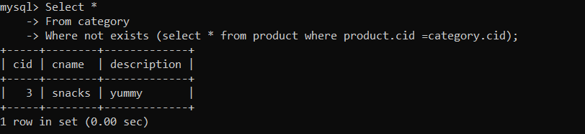

5. display all products with no category assigned.

Select *

From product

Where cid is null;

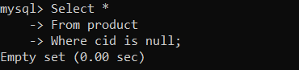

6. list all salesman who stays in city with name starts with P or N.

Select *

From salesman

Where address like “P%” or address like “N%”;

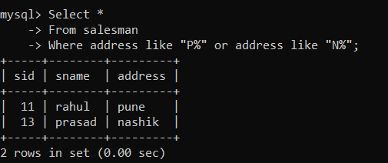

7. add new column in salesman table by name credit limit.

Alter table salesman

Add column credit_limit double(9,2);

