Ques 6:

Step 1: Create public repository in github

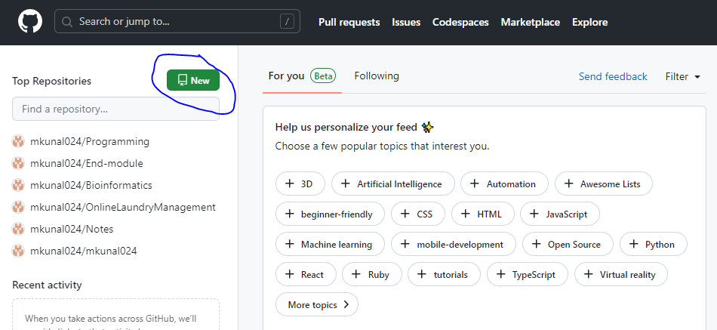

Step 2: Enter name and tick public and add a readme file and click on create repository.

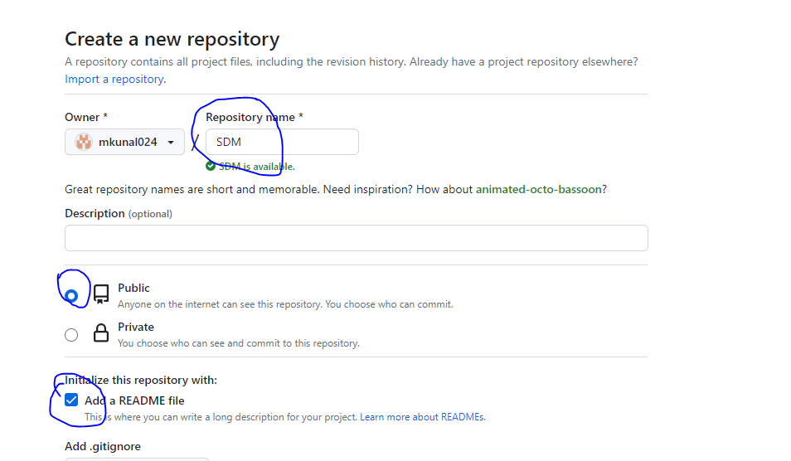

Step 3: Repository is created.

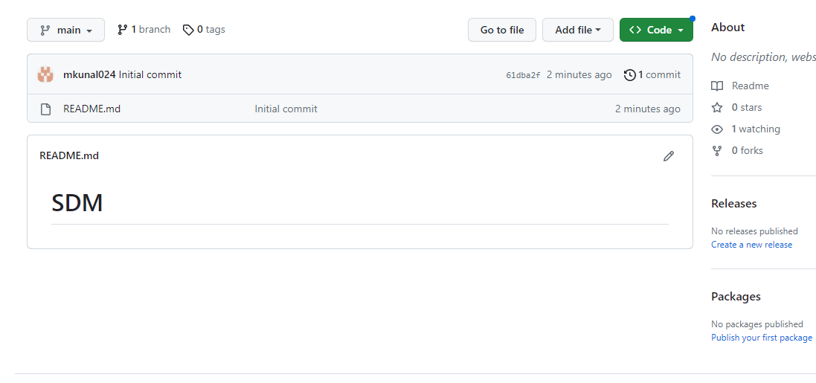

Ques 7.

Step 1: Click on code -> copy repository path

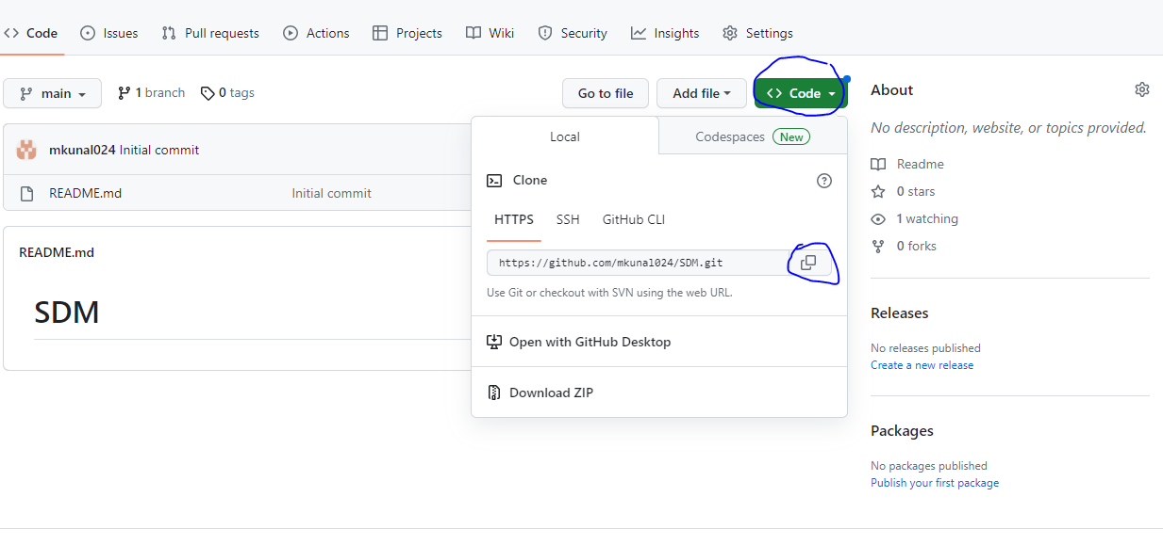

Step 2: Go to local folder and left click -> bash and paste url

With cmd-

git clone <https://github.com/mkunal024/SDM.git>

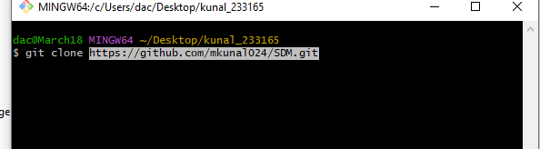

And press enter

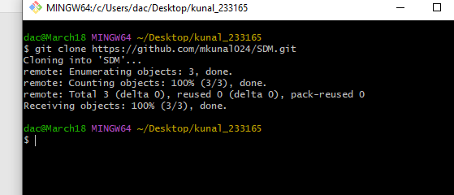

Repository is cloned.

Ques 8:

Copy all srs.txt,bussiness.txt to local repository.

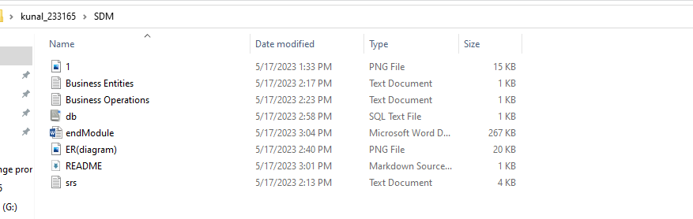

Ques 9:

Git clone given source file of web application.

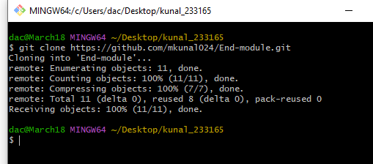

Ques 10:

Deploy data to git repository.