

**TABLE OF CONTENTS**

|  |  |  |  |
| --- | --- | --- | --- |
| **Sr. no** | **Topic** | | **Page no.** |
| 1 | Introduction | | 3 |
| 2 | Overview | | 4-6 |
| 3 | Methodology | | 7 |
| 4 | SRS | | 8-13 |
| 5 | Database Diagram | | 14-16 |
| 6 | Figma Design | | 16-17 |
| 7 | | UI of all pages | 17-20 |
| 8 | | References | 21 |

**INTRODUCTION**

**Project Overview**

Aura Amore is an e-commerce platform focused on selling a wide range of makeup and beauty products. This website will offer customers a convenient, user-friendly experience for browsing and purchasing their favorite beauty products online. The platform is designed to be aesthetically pleasing, easy to navigate, and provide secure transactions.

**Problem Statement**

In today’s busy world, customers often struggle to find time to shop for beauty products in physical stores. They also face challenges in discovering the right products that match their preferences and needs. Aura Amore aims to solve these issues by providing an online platform that makes it easier to explore, compare, and buy beauty products from the comfort of home.

**Project Scope**

The Aura Amore project encompasses the design, development, and deployment of a fully functional e-commerce website. This includes user interfaces for customers, administrative dashboards, secure payment processing, and product management systems. The project focuses on offering a seamless shopping experience from browsing to checkout.

**Project Significance**

Aura Amore holds significance as it caters to a growing demand for online beauty shopping. It allows customers to easily access a diverse range of products, receive personalized recommendations, and enjoy a secure and convenient buying process. For beauty brands and sellers, the platform provides an excellent opportunity to showcase their products to a broader audience.

**OVERVIEW**

**Aura Amore** is an online platform designed to enhance the beauty shopping experience by offering a wide variety of makeup and beauty products. The website focuses on providing key features like personalized recommendations, seamless navigation, and secure transactions. Developed using modern technologies like HTML , CSS , Javascript ,React.js. Aura Amore targets beauty enthusiasts and professionals who prefer a convenient and reliable online shopping experience. With plans for future enhancements like virtual try-on features and mobile apps, Aura Amore aims to continuously evolve and cater to the ever-changing needs of its customers.

**Key Features:**

* **Product Catalog:** A wide range of beauty products categorized for easy browsing.
* **Product Search and Filters:** Advanced search with filters like brand, price range, skin type, etc.
* **Secure Payment Gateway:** Integration of multiple payment options (credit/debit cards, wallets, etc.).
* **User Accounts:** Registration, login, wish lists, and order tracking for customers.
* **User Reviews and Ratings:** Customer reviews and ratings to assist in making informed choices.
* **Responsive Design:** Ensures the platform is accessible on desktops, tablets, and smartphones.

**Objectives:**

* Develop a visually appealing, intuitive, and responsive website.
* Ensure a smooth shopping experience with minimal load times.
* Implement secure, reliable payment methods.
* Provide personalized customer experiences through recommendations and user preferences.
* Build a scalable platform that can accommodate future growth.

**Development Technologies:**

* **Front-End:** HTML, CSS, JavaScript
* **Database:** MongoDB
* **Payment Integration:** Stripe, PayPal
* **Design Tools:** Figma
* **Version Control:** Git, GitHub

**Target Audience:**

* Makeup enthusiasts and professionals.
* Beauty bloggers and influencers.
* Individuals seeking skincare, haircare, and cosmetic products.
* Both male and female customers interested in grooming products.

**Future Enhancements:**

* Add multiple languages
* Add a Secure Payment System

**CUSTOMERS**

**1. Guest Users:**

* Can browse products and view details but must register to make a purchase.
* Limited access to certain features like wish lists and order tracking.

**2. Registered Users:**

* Full access to all features including personalized recommendations, wish lists, order tracking, and faster checkout.
* Can save payment methods, manage their profile, and view past orders.

**3. Administrators:**

* Manage product listings, update inventory, process orders, and respond to customer inquiries.
* Access to analytics tools to track sales trends, customer behavior, and website performance.

**FUNCTIONALITY**

* **Browsing Products:** Customers can easily browse categories like makeup, skincare, and haircare, with intuitive filters.
* **Product Details Page:** Each product has a dedicated page with images, descriptions, ingredients, and customer reviews.
* **Shopping Cart and Checkout:** Users can add items to their cart, apply discount codes, and complete a secure checkout process.
* **Order Tracking:** Customers can view the status of their orders from the time of purchase to delivery.
* **Wish Lists:** Users can save products they’re interested in for future purchases.
* **Account Management:** Registered users can update their profile information, payment methods, and view purchase history

**Methodology**

The AuraAmore project will be meticulously organized and managed to ensure efficient execution and timely delivery. Key project management activities include:

* **Planning:** Defining the project scope, objectives, and deliverables.
* **Task Breakdown:** Dividing the project into manageable tasks and assigning responsibilities.
* **Resource Allocation:** Identifying and allocating necessary human and technical resources.

The development process will center around the needs and preferences of the target audience, adhering to a user-centered design approach. Key stages of development include:

* **Structure and Content:** Defining the organization and structure of the Store’s content and features.
* **User Interface Design:** Creating an attractive, intuitive, and user-friendly interface.
* **Plateform Mechanics:** Building and integrating E-commerce mechanics, logic, and features using HTML, CSS, JavaScript, Bootstrap and Node.js.
* GameVerse will primarily utilize HTML, CSS, JavaScript, Bootstrap, and Node.js.

as its core technologies. Additional libraries and frameworks may be explored to enhance development efficiency. Key technologies and tools include:

* **HTML5:** For structuring the Platform’s content and layout.
* **CSS3:** For styling and positioning product elements.
* **JavaScript:** For implementing platform logic, user interactions, and dynamic content.
* **Git:** For version control and collaborative code management.

Effective project management and team collaboration are crucial for the success of AuraAmore. Key strategies include:

* **Iterative Development:** Adopting an iterative and flexible development approach.
* **Communication:** Maintaining clear and open communication among team members.
* **Code Management:** Utilizing Git for efficient code management and collaboration.

Software Requirements Specification (SRS) for **AURA AMORE**

**User Registration and Authentication**

**1.1 User Sign-Up**

* **Email Sign-Up**: Users can create an account using their email. The system will require a unique email and a strong password (containing a mix of upper and lower case letters, numbers, and special characters).

**1.2 User Login**

* **Email and Password Login**: Users log in using their registered email and password.
* **Remember Me Option**: Users can opt to stay logged in on their device.

**1.3 User Profiles**

* **Profile Customization**: Users can personalize their profiles by adding a profile picture, bio, and other personal information.
* **Account Management**: Users can update account details, change passwords, and view activity history (e.g., past purchases).

**Product Catalog**

**2.1 Product Search and Filtering**

* **Search Functionality**: Users can search for products by name, category, or keyword. Search results can be filtered by categories like price, ratings, popularity, and more.
* **Auto-Suggestions**: As users type in the search bar, auto-suggestions will show popular products and related terms.

**2.2 Product Metadata and Media**

* **Images and Videos**: Each product page will feature high-quality images and videos. Trendy products will revolve in a carousel at the top of the homepage.
* **Product Details**: Each product page will include specifications like size, color, material, etc.

**Shopping Cart and Checkout**

**3.1 Shopping Cart**

* **Add to Cart**: Users can add multiple items to the cart, which updates in real-time.
* **Cart Overview**: The cart page shows the selected items, prices, total cost, and options to adjust quantities or remove items.

**3.2 Checkout Process**

* **Payment Methods**: Support for multiple payment options, including credit/debit cards, PayPal, Google Pay, and Apple Pay.
* **Order Summary**: Before finalizing the order, users will see an itemized summary with costs, taxes, and shipping.
* **Order Confirmation**: Upon successful payment, a confirmation email with order details and status link will be sent to the user.

**Product Reviews and Ratings**

**4.1 Posting Reviews**

* **Review Submission**: Registered users can submit reviews, including a star rating (1-5 stars), a title, and comments.
* **Review Moderation**: Reviews are moderated to ensure they meet community guidelines. Inappropriate reviews can be flagged or removed.

**4.2 Review Management**

* **Editing Reviews**: Users can edit reviews, with edited reviews being marked with a timestamp.

**UML DIAGRAM**

Unified Modeling Language (UML) is a standardized modeling language used in software engineering to specify, visualize, and document the design of software systems. UML provides a set of diagrams to represent different aspects of a system’s architecture and behavior. Here’s an overview of the main types of UML diagrams and their purposes:

**Use Case Diagram**

The Use Case Diagram illustrates the interactions between different types of users and the AURA AMORE system. It highlights the functionality of the system from the user’s perspective:

• **Actors**: External entities interacting with the system:

* **User**: Registered or guest customers.
* **Payment Gateway**: Third-party service for transactions.
* **Email Service**: Handles email verification and notifications.

• **Use Cases**: Major functionalities provided by the system:

* **User Registration and Login**: Sign-up, login, email verification, password recovery.
* **Product Search and Browse**: Searching and filtering products.
* **Shopping Cart and Checkout**: Adding to cart, making purchases, payment processing.
* **Review and Ratings**: Submitting and managing product reviews.

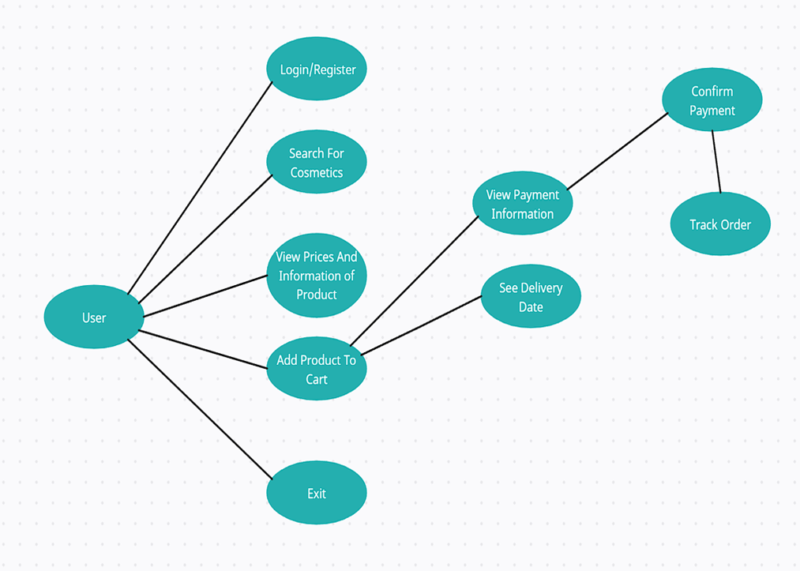

**Class Diagram**

The Class Diagram represents the static structure of the AURA AMORE system, showcasing its classes, attributes, and relationships:

**Classes**: These represent the core entities in the system.

* **User**: Attributes like userID, email, password, name, profilePic. Methods for registration, login, profile update.
* **Product**: Attributes like productID, name, price, description, stockQuantity, rating. Methods for adding/editing products, updating stock, and calculating ratings.
* **Cart**: Attributes like cartID, userID, totalAmount, cartItems[]. Methods for adding/removing items, calculating totals.
* **Review**: Attributes like reviewID, userID, productID, rating, comment, timestamp. Methods for submitting and editing reviews.

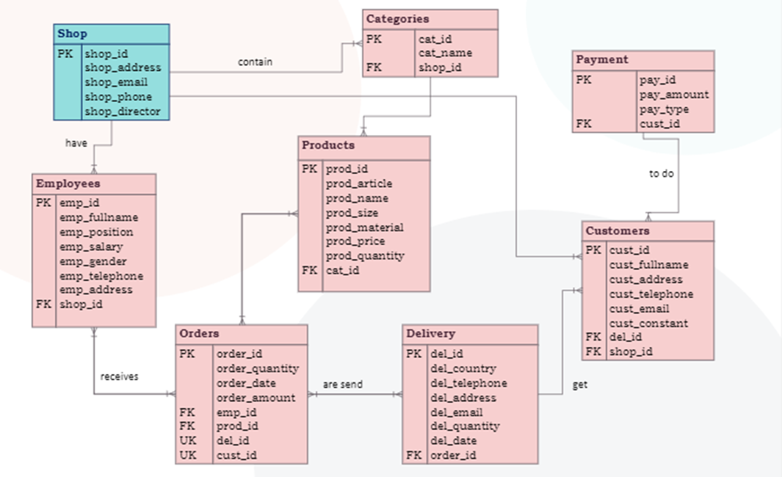

**Database**

**1. Introduction**

The database for the cosmetics website project is designed to support various functionalities, including user management, product catalog, shopping cart, and order processing. This report provides an overview of the database schema, its design, and its implementation.

1. **Database Design Overview:**

The database is based on a relational model, utilizing tables to represent entities such as users, products, and orders. An Entity-Relationship Diagram (ERD) is provided to illustrate the relationships between these entities.

1. **Entities and Attributes**

Provides a detailed description of each entity in the database schema. For each entity, include:

* **Entity Name**: The name of the table (e.g., User, Product).
* **Attributes**: List the columns of the table with data types and constraints.
  + Example for the User entity:
    - userID (INT, Primary Key, Auto Increment)
    - username (VARCHAR(50), Unique, Not Null)
    - password (VARCHAR(255), Not Null)
    - email (VARCHAR(100), Unique, Not Null)
    - isAdmin (BOOLEAN, Default FALSE)

1. **Implementation Details:**

* **Database Management System (DBMS)**: The DBMS used MYSQL.

1. **Security and Data Integrity**

Sensitive data, such as user passwords, is secured using hashing algorithms. Foreign key constraints are used to maintain referential integrity between tables.

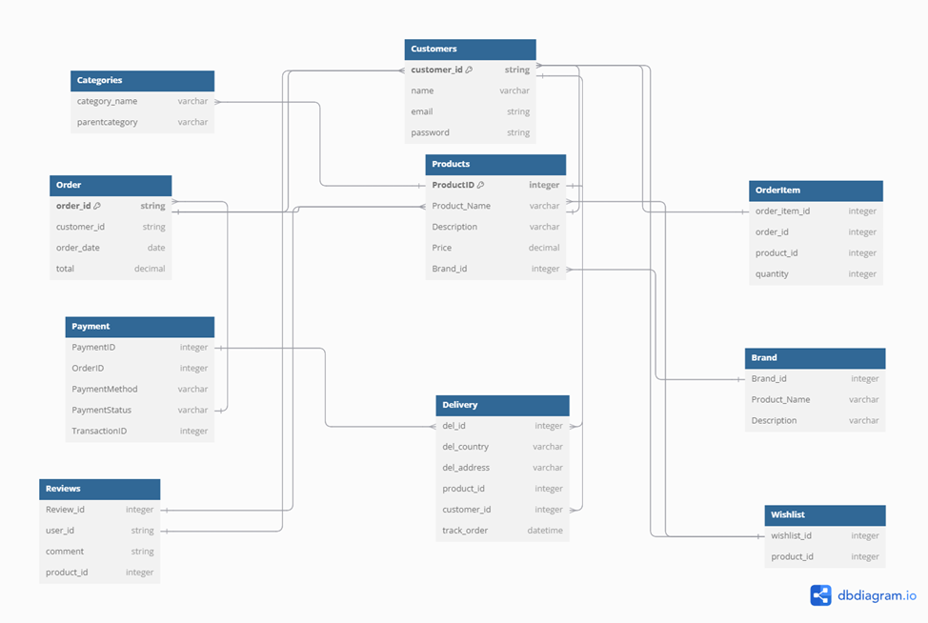

**Conclusion :**

The database design effectively supports the cosmetics website's functionality, providing a robust framework for managing users, products, and orders. Future enhancements will focus on scalability and additional features to improve the system’s performance

**FIGMA DEGISN**

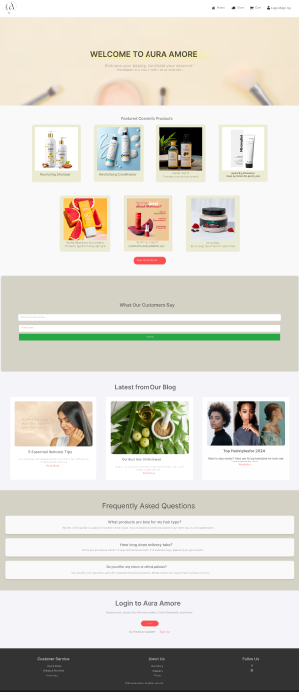

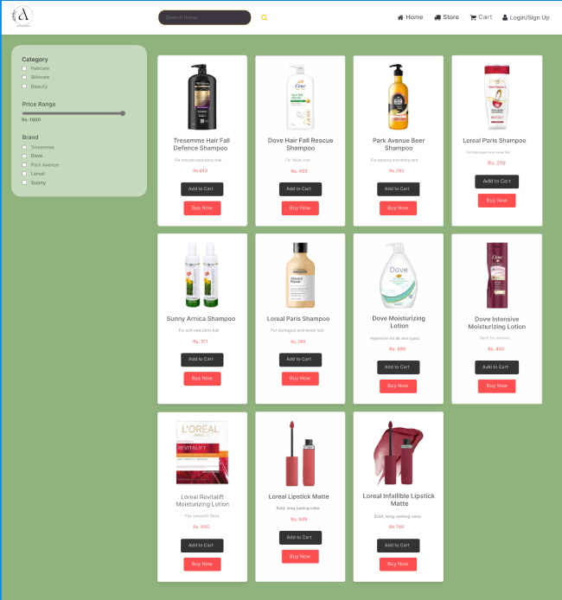

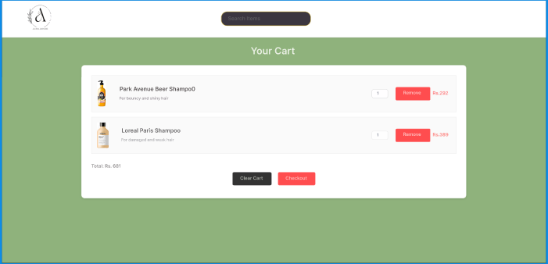

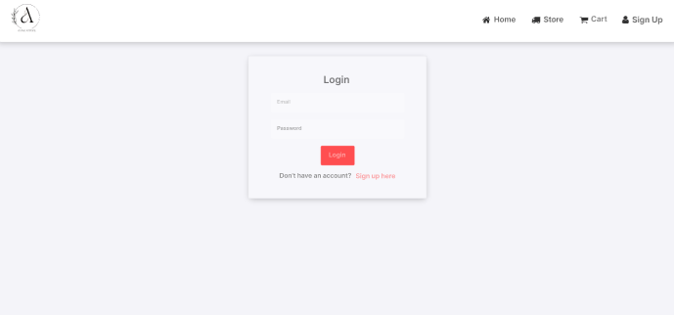

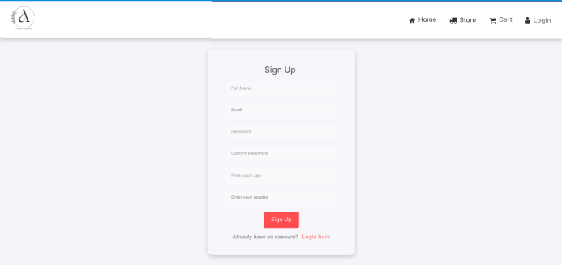

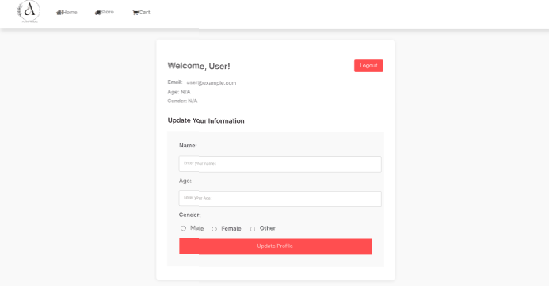

# REFERENCES :-

1. <https://www.nykaa.com>

2. https://www.amazon.in

3. www.google.com

4. https://chatgpt.com/

5.[www.github.com](http://www.github.com)

6.[www.geeksforgeeks.com](http://www.geeksforgeeks.com)

7. www.youtube.com