**Design Template**

|  |
| --- |
| [Company] |
| Software Project Template |
| [Document subtitle] |

|  |
| --- |
| Marc Rios 787989  7-4-2020 |

Contents

A. Introduction 3

A.1. Purpose Statement 3

A.2. Overview of the Problem 3

A.3. Goals and Objectives 3

A.4. Prerequisites 3

A.5. Scope 3

A.6. Environment 3

B. Requirements 4

B.1. Business Requirements 4

B.2. User Requirements 4

B.3. Functional Requirements 4

B.4. NonFunctional Requirements 4

C. Software Development Methodology 5

C.1. Advantages of the waterfall method 5

C.2. Disadvantages of the waterfall method 5

C.3. Advantages of {a different method} 5

C.4. Disadvantages of {a different method} 5

C.5. Best suited 5

D. Design 6

D.1. Storyboard or Flowchart (Change title to fit needs) 6

D.2. UML Diagram (Change title to fit needs) 7

D.3. GUI (Change title to fit needs) 8

E. Testing 9

E.1. Testing Type (change name to fit your needs) 9

E.1.1. Test Name 1 9

E.1.2. Test Name 2 9

E.1.3. Test Name 3 10

F. Sources 12

# Introduction

1. Provide a brief introduction to the proposed system. This section should be no longer than one paragraph.

A Customer Relationship Management (CRM) system helps manage customer data. It supports sales management, delivers actionable insights, and facilitates team communication. A CRM system helps businesses keep customer contact details up to date, track every customer interaction, and manage customer accounts. It is designed to help businesses improve customer relationships, also Customer Lifetime Value (CLV). Every time someone picks up the phone and talks to a customer, goes out to meet a new sales prospect, or follows up a promising lead, they learn something new and potentially valuable. (Cited 1) A CRM system will be beneficial to The American Video Game company’s sales department because they can gather data on their customers and leverage that information to cater to their customers; moreover, they learn who their target customer base is from the current customers, and can now market to the correct audience which will mean more sales in the future. The system will allow for the company to efficiently manage current or potential customers’ information and categorize them appropriately.

# A.1. PUrpose Statement

The purpose of this document is to provide solutions to the American Video Game Company based off the CRM Requirements document.

# A.2. Overview of THE PROBLEM

Provide a brief overview of the problem that the proposed solution will solve.

# A.3. Goals and Objectives

Provide the goals and objectives for the project and solution.

# A.4. Prerequisites

Outline any aspects that need to be in place prior to the design, development, and implementation of the project proposed in this document. Be sure to be clear and concise for all listed prerequisites. Also, clearly outline why each prerequisite is needed.

*Note: If no prerequisites are needed, include a paragraph justifying why there are no prerequisites.*

|  |  |  |  |
| --- | --- | --- | --- |
| Number | Prerequisite | Description | Completion Date |
|  |  |  |  |
|  |  |  |  |
|  |  |  |  |
|  |  |  |  |

# A.5. Scope

Provide a brief overview of what the proposed solution will cover and what the proposed solution will not cover. It is important to set clear boundaries for the project.

# A.6. Environment

Describe the IT and hardware environments that the solution will be deployed in.

# Requirements

Provide a brief introduction on requirements. You may select the correct subsections that match the needs of your solution and the key requirements that you identified from the profile document.

*Note: All requirements must be in your own words and interpret the requirements found in the “CRM Requirements” attachment. Please do not copy and paste word for word from the requirements in the “CRM Requirements” attachment.*

# Business Requirements

Provide a brief introduction to the business requirements for the proposed system.

# User Requirements

Provide a brief introduction to the user requirements for the proposed system.

# Functional Requirements

Provide a brief introduction to the functional requirements for the proposed system.

# NonFunctional Requirements

Provide a brief introduction to the nonfunctional requirements for the proposed system.

# Requirements

The American Video Game Company is outgrowing their current systems ability to efficiently manage and track their clients and contacts. A new CRM system will be able to handle the surge in growth.

1. The new system will consolidate and integrate any spreadsheets from the company’s previous client management processes to ensure no old data is lost in the transition.
2. Communication between the user and any contact will be tracked and the user will be prompted by the system program to input who they spoke to, what the communication was about, and to schedule a follow up call or email.
3. Each individual user will have their own set of permissions that grant or deny certain actions within the system program, like creation and deletion of items. In other words, this will restrict access to certain features of the program.
4. The CRM system will be capable of creating predetermined and custom reports by the management of the company (or those with right permissions). There will be a user interface that the user will be able to use to access the data generated by the CRM system. The use can filter, format, query, and export data for the use of management decisions and of course creating reports for meetings.
5. Anyone that interacts with the video game company will be defined under data- types within the system as contacts, stakeholders, and businesses.

# Business Requirements

Provide a brief introduction to the business requirements for the proposed system.

# User Requirements

Provide a brief introduction to the user requirements for the proposed system.

# Functional Requirements

Provide a brief introduction to the functional requirements for the proposed system.

# NonFunctional Requirements

Provide a brief introduction to the nonfunctional requirements for the proposed system.

# SOFTWARE DEVELOPMENT METHODOLOGY

This document follows the waterfall model, which means every software development phase is completed sequentially; in other words, the output of one phase directly impacts the next phase. The phases present in this document in subsequent order: requirements, system design, implementation, integration and testing, deployment of system, and maintenance.

1. The requirements document provided for this CRM system provides all the information needed for the requirements phase of the waterfall method.

2. The system design phase uses the information from the previous phase to create a design of the software program. The components for a successful program are examined and executed in this phase; moreover, the overall system architecture is defined here.

3. Small units or segments of the program are created utilizing the system design from the previous phase. During this implementation phase, the units of code are tested to ensure full functionality of desired attributes or functions.

4. In the integration and testing phase, the units of code from the previous phase are integrated into a system and tested constantly to make certain that the system works without errors or flaws, so when the system or program goes live, there will be no problems, especially during the installation process.

5. The deployment of the system into the work environment only happens once the functional and non-functional testing of the system is completed.

6. The maintenance phase occurs after the deployment, and this period involves modifying the system, changing the units’ features, or just improving the program’s performance. There are a few ways these modifications can arise: from the customer initiating change requests, or bugs or deficiencies exposed during live deployment.

*The company has selected the waterfall software development methodology for this project. Examine the waterfall methodology and compare it to other software development methodologies (e.g., Agile). Include a brief introduction to the development process as well.*

*Note: All subsections are required. Refer to the requirements section and rubric section of the assessment for additional information.*

# Advantages of the waterfall method

Describe the advantages of the waterfall methodology and how they will benefit this project.

# disAdvantages of the waterfall method

Describe the disadvantages of the waterfall methodology and how they may hinder this project.

# Advantages of {A DIFFERENT METHOD}

Describe the advantages of a different methodology and how they will benefit this project.

# disAdvantages of {A DIFFERENT method}

Describe the disadvantages of a different methodology and how they may hinder this project.

# best SUITED

Describe why the waterfall methodology is the best software development methodology for this project.

**OR**

Provide the details of a different development process and outline why you would have selected it and how it would have been better suited for this project.

# Design

Provide a brief overview of the proposed design.

*Note: These subsections may be copied, rearranged, and modified to fit the needs of the solution. At least two visual representations of your design need to be present.*

# Storyboard or Flowchart (Change title to fit needs)

Provide a storyboard or flowchart of the application.

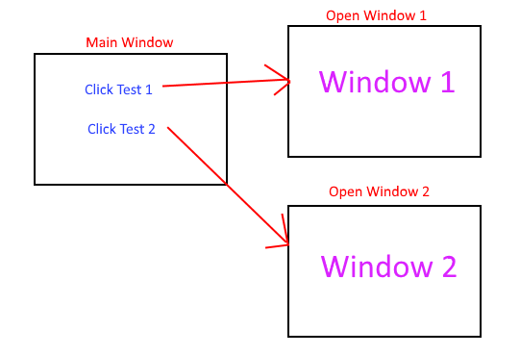

Figure : Sample Storyboard

# UML Diagram (Change title to fit needs)

Provide a set of UML diagrams that cover the proposed solution. This can include but is not limited to class diagrams, database diagrams, and use case diagrams. Also, ensure that all diagrams are clearly discussed and noted.

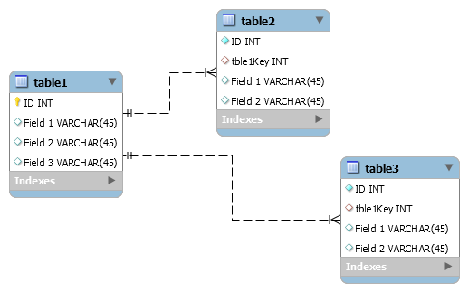

Figure : Sample Database

# GUI (Change title to fit needs)

Provide a mock-up of the proposed GUI forms that will be used in the proposed solution. Also, clearly indicate where the GUI components point inside the application.

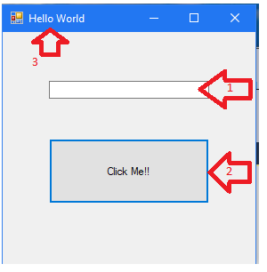

Figure : Sample GUI Mock-up

|  |  |  |  |
| --- | --- | --- | --- |
| GUI Control Mapping | | | |
| ID | Control | Property | Data Source |
| 1 | Textbox | On application open text = “” or null | NA |
| 1 | Textbox | On click of button text = “Hello World” | Internal Variable |
| 2 | Button | On click change text of textbox 1 to “Hello World” | Internal Variable |
| 3 | Form | Text= “Hello World” |  |

# Testing

Provide a brief introduction to the proposed testing solution. The tests need to be from 3 completely different functionality aspects. Testing the same aspect with slightly different criteria is not acceptable.

**Note: *Add and remove subsections as needed to cover all the testing needs.*

# Testing Type (change name to fit your needs)

Provide a brief introduction paragraph.

# Test Name 1

|  |
| --- |
| Requirement to be tested |
| Preconditions: Conditions that must be present before test case can successfully run |
| Steps: The steps the tester must execute to test the feature. |
| Expected results: Expected results and any side effects such as updating a database, writing to a file, etc. |
| Pass/Fail: Mark whether the test case passed or failed. The results can be compiled and used to determine if the application is ready for delivery/release. |

# Test Name 2

|  |
| --- |
| Requirement to be tested |
| Preconditions: Conditions that must be present before test case can successfully run |
| Steps: The steps the tester must execute to test the feature. |
| Expected results: Expected results and any side effects such as updating a database, writing to a file, etc. |
| Pass/Fail: Mark whether the test case passed or failed. The results can be compiled and used to determine if the application is ready for delivery/release. |

# Test Name 3

|  |
| --- |
| Requirement to be tested |
| Preconditions: Conditions that must be present before test case can successfully run |
| Steps: The steps the tester must execute to test the feature. |
| Expected results: Expected results and any side effects such as updating a database, writing to a file, etc. |
| Pass/Fail: Mark whether the test case passed or failed. The results can be compiled and used to determine if the application is ready for delivery/release. |

# Sources

Place the sources that you used here.

*Note: See the sources section in the requirements and rubric. If you did not use any outside sources, you may delete this section.*