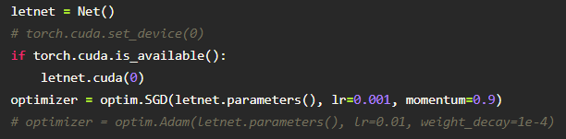

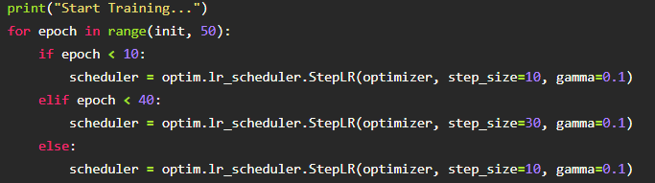

Start Training...

epoch: 0 cross_accuracy: 0.2221

epoch: 1 cross_accuracy: 0.2782

epoch: 2 cross_accuracy: 0.3345

epoch: 3 cross_accuracy: 0.3539

epoch: 4 cross_accuracy: 0.3764

epoch: 5 cross_accuracy: 0.3923

epoch: 6 cross_accuracy: 0.41

epoch: 7 cross_accuracy: 0.4108

epoch: 8 cross_accuracy: 0.4535

epoch: 9 cross_accuracy: 0.4555

epoch: 10 cross_accuracy: 0.4721

epoch: 11 cross_accuracy: 0.4781

epoch: 12 cross_accuracy: 0.4836

epoch: 13 cross_accuracy: 0.4857

epoch: 14 cross_accuracy: 0.4796

epoch: 15 cross_accuracy: 0.5045

epoch: 16 cross_accuracy: 0.4993

epoch: 17 cross_accuracy: 0.5178

epoch: 18 cross_accuracy: 0.503

epoch: 19 cross_accuracy: 0.5309

epoch: 20 cross_accuracy: 0.5316

epoch: 21 cross_accuracy: 0.5515

epoch: 22 cross_accuracy: 0.5432

epoch: 23 cross_accuracy: 0.5553

epoch: 24 cross_accuracy: 0.5443

epoch: 25 cross_accuracy: 0.5584

epoch: 26 cross_accuracy: 0.5431

epoch: 27 cross_accuracy: 0.5648

epoch: 28 cross_accuracy: 0.566

epoch: 29 cross_accuracy: 0.5649

epoch: 30 cross_accuracy: 0.5747

epoch: 31 cross_accuracy: 0.5733

epoch: 32 cross_accuracy: 0.5669

epoch: 33 cross_accuracy: 0.5703

epoch: 34 cross_accuracy: 0.591

epoch: 35 cross_accuracy: 0.5727

epoch: 36 cross_accuracy: 0.5911

epoch: 37 cross_accuracy: 0.5841

epoch: 38 cross_accuracy: 0.582

epoch: 39 cross_accuracy: 0.6001

epoch: 40 cross_accuracy: 0.5888

epoch: 41 cross_accuracy: 0.6044

epoch: 42 cross_accuracy: 0.592

epoch: 43 cross_accuracy: 0.6058

epoch: 44 cross_accuracy: 0.6082

epoch: 45 cross_accuracy: 0.5903

epoch: 46 cross_accuracy: 0.6124

epoch: 47 cross_accuracy: 0.6069

epoch: 48 cross_accuracy: 0.615

epoch: 49 cross_accuracy: 0.6159

Done Training!