Michael Kwok
Dec 17, 2024

S&P 500 Stock Market Prediction (677 Final Project)

The data science problem is to predict whether the stock market, often represented by the S&P 500 (the 500 largest companies listed on US stock exchanges), will go up or down in price tomorrow. If we can predict this, then we can make a lot of money. “SPY” is a popular tradable ETF (exchange-traded fund) that tracks the S&P 500, so this is the ticker of interest.

The features will be percentage price changes derived from daily prices (open, high, low, close, or OHLC) which are readily available online in csv-format datasets. An example hypothesis is that if today’s price change from low to close was large, is that generally associated with continued uptrend tomorrow (called “momentum”), or more so a downwards reversal (called “mean-reversion”)? Same goes for the other features, all depicted below:

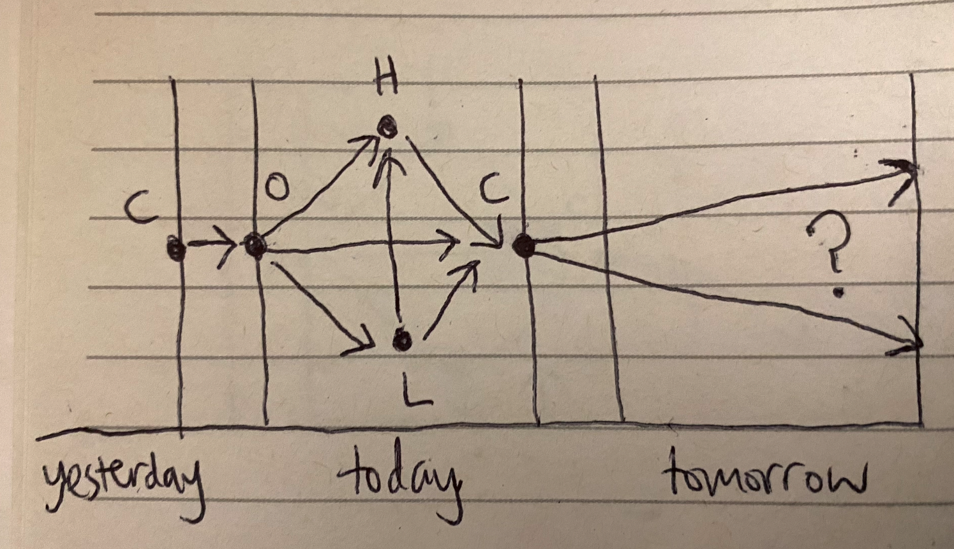

The stock market is known to be random and efficient, so groundbreaking results are not expected to be found just by using this unsophisticated featureset without much in-depth analysis and modification. The purpose is more so to see the baseline usefulness of these features.

Starting with correlation analysis, we already see that these features (x-axis) are highly uncorrelated with the binary target (‘Next_day_up’), so there are no meaningful conclusions to be drawn in terms of linear relationships:

Next day up | Weekday | High to close | Low to close | High to low | Open to high | Open to low | Open to close | Close to close | Close to open
 | -0.007 | -0.014 | -0.02 | -0.003 | -0.023 | -0.017 | -0.029 | -0.03 | -0.015

Next, we analyze the proportions of the target class labels, which are relatively balanced:

Next day up: | True | False
Proportion: | 54.4% | 45.6%

Then, we choose the models. To keep things simpler, we choose the target to be binary classification (as opposed to regression) and try six popular classification algorithms to get a sense of which ones, if any, perform better for this particular task: logistic regression, kNN, naive bayes, decision tree, random forest, and SVM.

Now, running all the models and with some light tuning (see jupyter notebook for more details), we get this summary table:

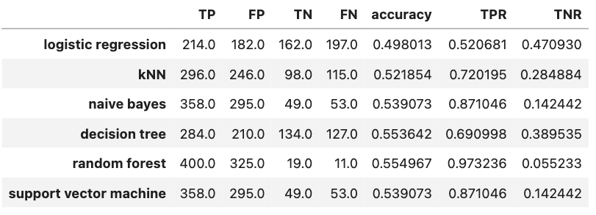

We see that all the accuracies are around 50% which is the effectiveness of a coin toss. The true positive rates are higher but at the cost of lower true negative rates. In other words, these models ended up mostly predicting that tomorrow will be an ‘up day.’ The model with the overall highest performance metrics is the decision tree.

From this project, we have seen that the proposed price-derived percentage price change features are not highly correlated with whether the stock market will be up or down tomorrow. More analysis can be done on each feature, perhaps to find a way to segment them so that there is a distinct relationship between each feature segmentation and each target class label. As for model selection, the decision tree appears slightly more well-rounded in the three assessed performance metrics (accuracy, TPR, TNR) amongst the tested models, so further tuning can be investigated. However, other models may have potential upon further tuning as well.

To conclude, predicting binary stock market movement is unsurprisingly not trivial, but that is what makes it an exciting intellectual challenge.

