Debugging:
1.
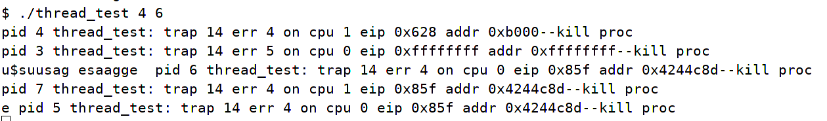
It seems like there are some problems in exit routine because the program can start but is unable to exit. I checked exit() and wait() using cprintf() to log because I modified these two functions. Finally I found I called freevm(p→pgdir) in exit() but it should be only called in parent process. So I added an indicator of only one thread is left which could be used in wait to safely free the memory pages.

2.
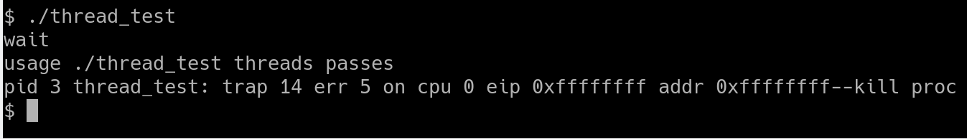

This is because exit() isn’t invoked before main returns.

3.
