Murders Report

Mubarraz Khan Zadran

2/21/2020

This is a report of us gun murder rates obtained form FBI reports. The origional data was obtained from the following wikipedia pages{<https://en.wikipedia.org/wiki/Murder_in_the_United_States_by_state>}

## -- Attaching packages ---------------------------- tidyverse 1.3.0 --

## <U+2713> ggplot2 3.2.1 <U+2713> purrr 0.3.2  
## <U+2713> tibble 2.1.3 <U+2713> dplyr 0.8.3  
## <U+2713> tidyr 1.0.0 <U+2713> stringr 1.4.0  
## <U+2713> readr 1.3.1 <U+2713> forcats 0.4.0

## -- Conflicts ------------------------------- tidyverse_conflicts() --  
## x dplyr::filter() masks stats::filter()  
## x dplyr::lag() masks stats::lag()

Next, we load the data we already wrangled.

load ("rda/murders.rda")

Murder rate by state is explained in the following paragraph

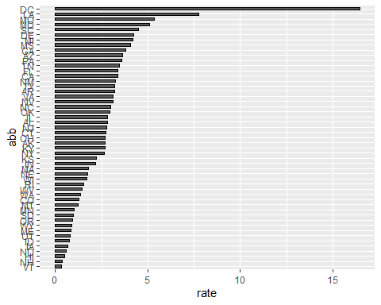

I hope this results in a good clean, explainable report.