**HOW TO ENABLE JMS CODE FROM COMMONS IN GTAS**

1).Install ActiveMQ.( **http://activemq.apache.org/getting-started.html#GettingStarted-InstallationProcedureforWindows**)

2).GO TO <installation directory>/bin/win64/ and double click activemq windows batch file to start the activemq in your local.

3).Type <http://localhost:8161/admin/> in the browser to view admin page.

4).Type admin/admin when it prompts for admin credentials.

5).This will open a page like the below.

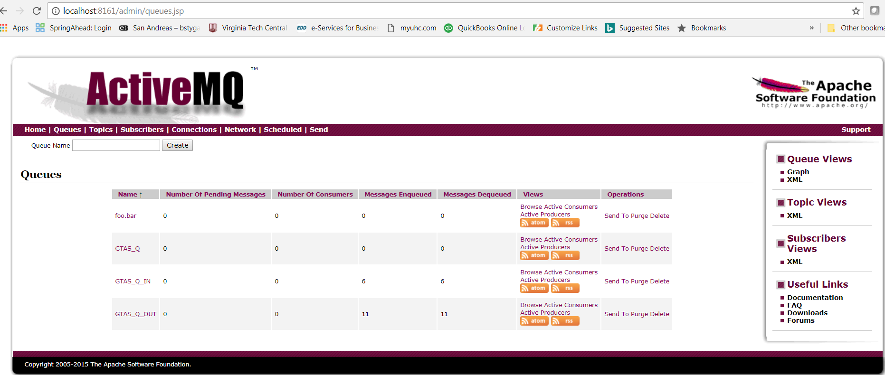6).Click on Queues🡪Create New

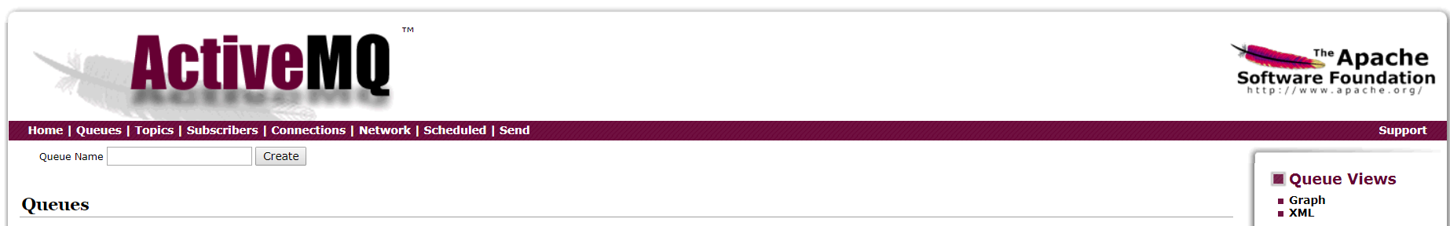

7).Create two new queues named GTAS_Q_IN and GTAS_Q_OUT

Now the activemq is ready with incoming queue and out going queue.

8).Now we can enable JMS Listeners against these queues from our java code.

9).go to \gtas-parent\gtas-commons\src\main\java\gov\gtas\jms\config\MessagingListnerConfiguration.java and uncomment //@EnableJms annotation

10).Uncomment //@Test annotations in gtas-commons\src\main\java\gov\gtas\services\JmsSenderTest.java to test the queues.

11).Build the application and deploy.

If everything goes well, running the test classes will produce the below stack trace in the console.

