Due: Nov 28, 2016 (Monday, 11:30pm)
Members: 7

A new company, Steve’s Cruise Line, would like to hire your team to develop an application.

- Features
  - Reservation module (kiosk and/or staff)
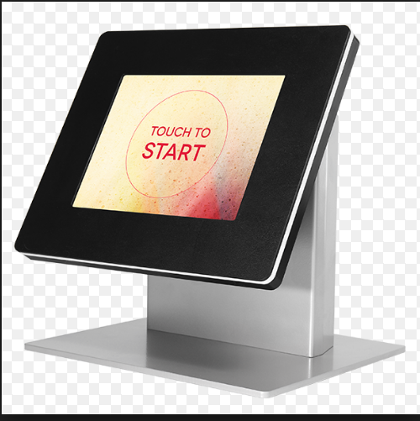

    - Client information
      - Firstname, lastname, date of birth, gender
    - Destination information
      - Name of the ship
      - Prices
        - Factors
          - Age: Senior, adult, children
          - Rooms: inside, ocean view, balcony
        - Need to consider the # of people per room
          - Typically, there is a maximum of 4 people per room. In some cases, you are not allowed to have more than 2 adults in the room
        - Season
        - # of days
      - Dates
      - Itinerary

Example:

http://www.cruise.com/

    - ship layout
      - location of the room with respect to the floor and side (port/starboard)

  - On board

    - Room information (when onboard)
      - Room # (first digit represents the floor),
      - Who is staying there, how many , room service? , assigned cleaner

    - Employees
      - Name
      - Rank

    - Schedule
      - Shifts
      - Employee assigned
      - Things to consider
        - How many dinning areas
          - Assigned chef
          - Assigned waiters
        - First and second sitting (applicable only for dinner)
    - Bar
      - Any drinks ordered by the passenger is charged to the room
      - Things to consider
        - Menu
        - Currency ($10.50 => $ means USD or CAD?)
        - Tax ?
        - Details ? like what was ordered, when, who took the order, etc..?

    - Gift Shop
      - Any items ordered by the passenger is charged to the room
      - Things to consider
        - Items sold
        - Pricing scheme – would there be any discount during the trip
        - Currency (be consistent)
        - Tax ?
        - Details? Product code?

    - Payment
      - Done at the end of the trip
      - Gratuities
        - Fix amount per person per day regardless of age
          - E.g. $10/person per day
            - For a 3 days cruise, $10 x 3 x how many in the room
        - Is the gratuity shared among all staff ?
          - Waiters? Cleaning crew? Who else?
          - If the guess gave extra gratuity (intended to cleaner) because he felt “special” with the services
      - Extra expenses
        - Bought a wine, gift items on board, etc …

- What you need to submit
  - Technical Manual
    - Table design
    - At least 10 test cases
Reference : http://reqtest.com/tutorials/how-to-develop-a-template-for-test-cases/
    - Program Documentation
      - General description what the class/method does
      - Describe the required parameters (if applicable)
      - Describe the return value (if applicable)

  - User Manual
    - How to use your system

  - Working program
  - Work load distribution

- Defense
- Markings [15 marks]
  - Test cases [3 marks]
    - This includes your assumptions and policies
  - Working program according to requirements [5 marks]
  - Technical Manual [1 mark]
  - User Manual [1 mark]
  - Defense [2 marks]
  - GUI [3 marks]

