Midterm Projects

Group Game Project and
2 Individual Projects(Survey Engine, Lab Tracker)

- Coded in C/C++ Classes
  - All Object oriented
  - UML Diagrams
  - Doxygen documented
- Databases are Random Access Files/Binary Files with records
  - Pre-filled with large amounts of random data
  - All tables to be searched/filtered/modified by record.

Login to the Survey Engine



Creation/Survey List/Link Modification Pages

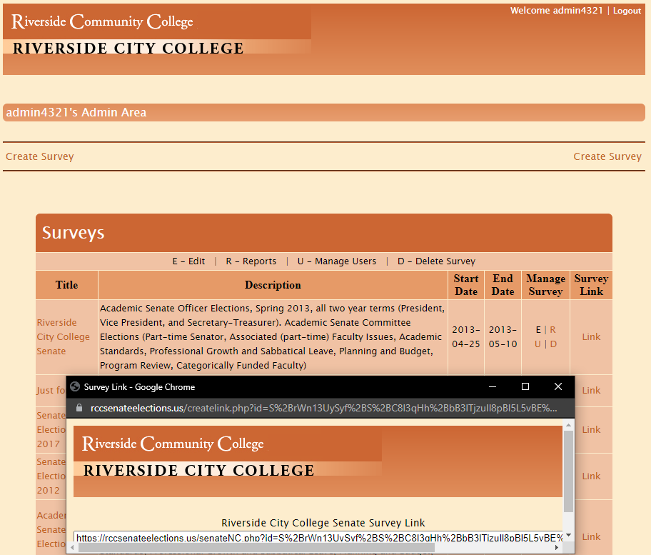
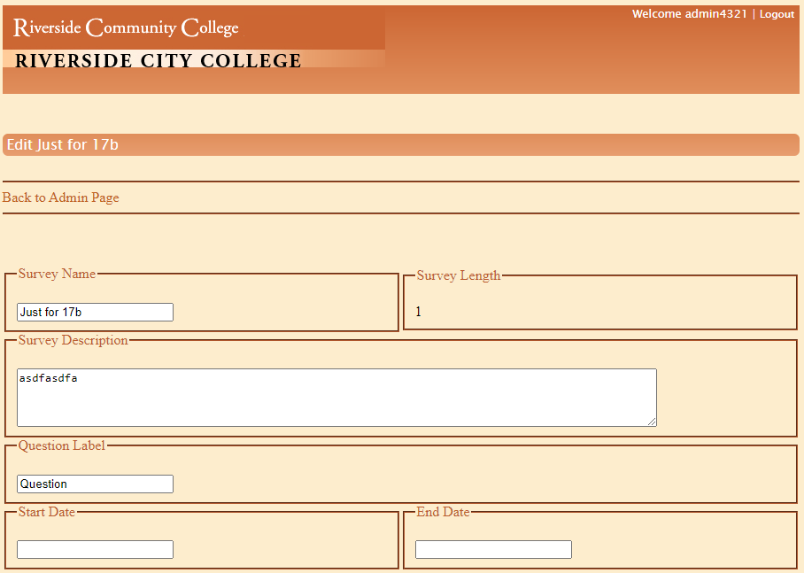
Survey Edit Page

Reporting of Survey Results
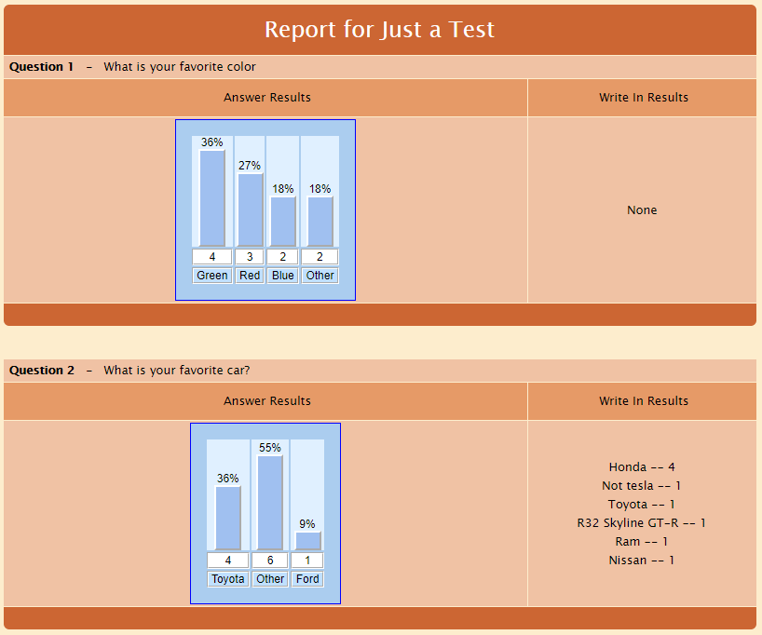

Survey Submission
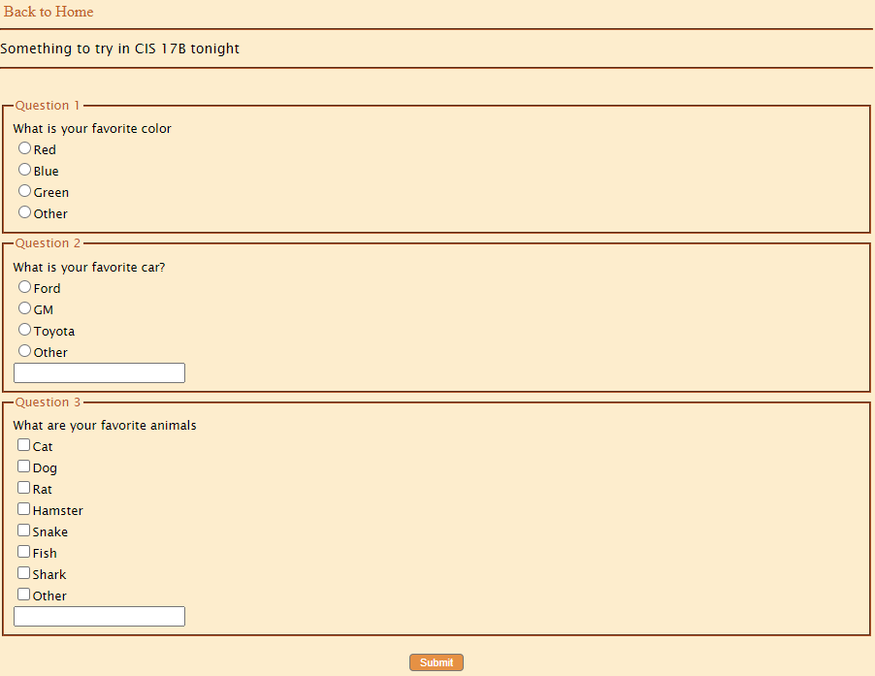

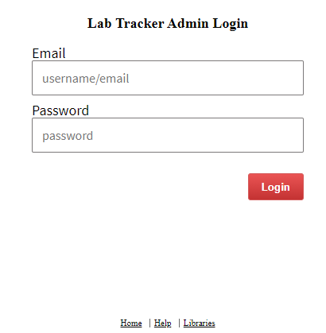
Lab Tracker Login/Help Files/etc

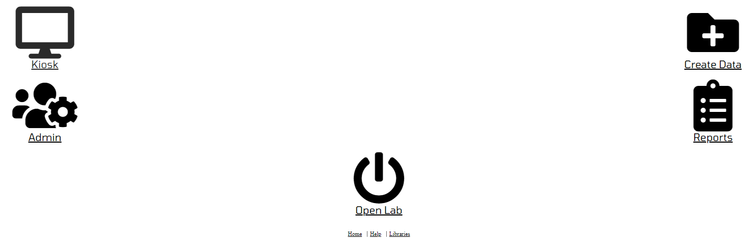
Menu for Admin Management
Menus for Admin Filtering/Modifications

Menus for Managing Courses and Term

Menu for Reporting out Information
User Interface

