**DeblueGAN-v2**

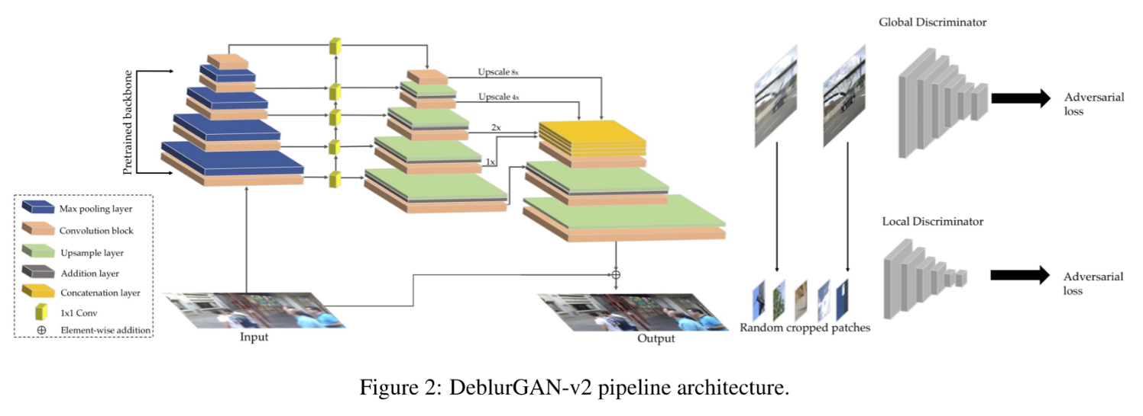

**deblurGAN-v2 Architecture**

1. Feature Pyramid Network(FPN)