To run the YOLO algorithm, user need download the following files . The URL is as follows: https://pjreddie.com/darknet/yolo/

1.https://github.com/AlexeyAB/darknet/blob/master/cfg/yolov3.cfg

2.https://github.com/AlexeyAB/darknet/blob/master/cfg/coco.names

3. download the yolov3.weights file. <https://github.com/AlexeyAB/darknet>

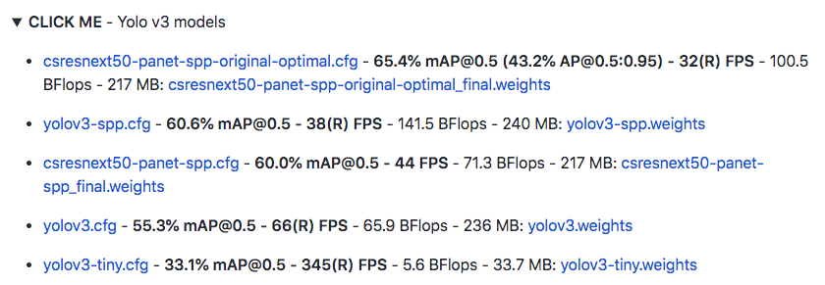

Clicking the yolov3.weights