**Music Store Management System**

**Project Overview**

This project is a **Management System for a Music Store**. It’s designed to handle the basics of running a store, like keeping track of inventory, orders, and employees.

It includes a login system with different roles for each user:

* **Employee**: Can take orders, manage inventory, etc.
* **Admin**: Has full access, including managing users.
* **Accountant**: Can view stats and financial info for the store.

**Demo time !**

(switch to Intelij)

**Development Journey**

The first thing I did was imagine what the final project would look like, then break it down into smaller, individual parts. For example, one main feature is **Order** management.

I sketched out some **UML diagrams** to get a clearer picture of how everything would connect, like classes and methods. Here’s what Initialy I came up with:

(initial plan)

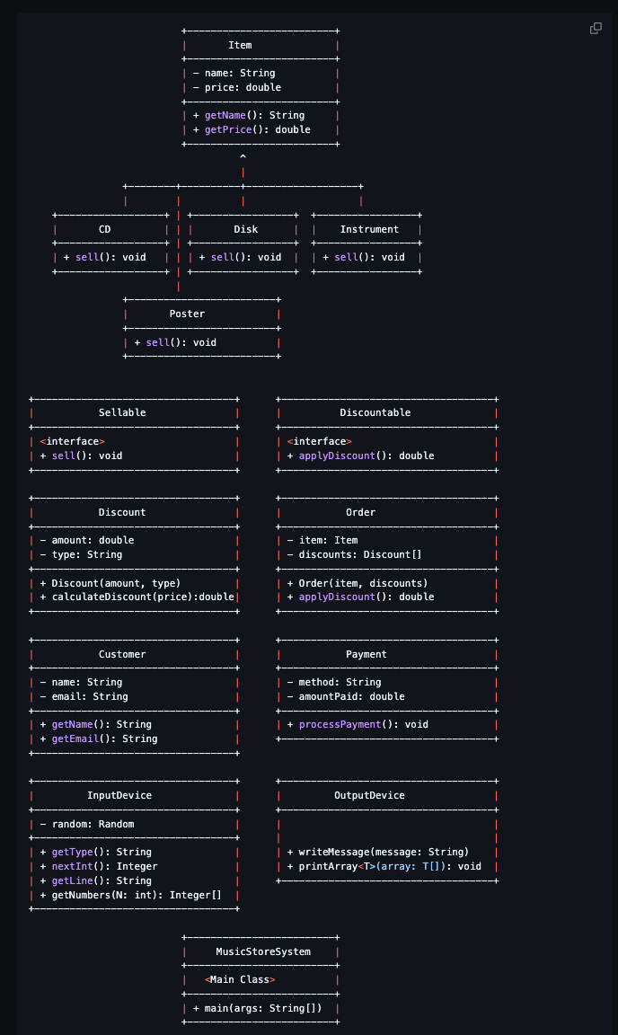

Once I had a plan, I dove into the code.

**Challenges and Fixes**

Some things didn’t go as planned:

* **Password Hashing**: I ran into a annoying bug with the User hashPassword method, where passwords would accidentally get double-hashed, locking users out. It took a long time to find the issue, but I fixed it by making sure hashing only happens once.

Things that went as planned:

* **User Roles**: For roles (Employee, Admin, Accountant), I created an **Enum** to make role assignments clear and consistent right from user creation.
* **All the methods that handle** user specific functionalities.

**Testing**

Testing also helped a lot, especially for **constructors** and **file storage** to make sure data saved and loaded correctly.

**Project Diagram**

(switch to Intelij)

**Data and Configuration**

I went by using JSON files for saving data.

Data is saved to files so it’s there when you reopen the app.

In the future I am planning using a database for storing data.

**Exception Handling and Validation**

I’ve set up some error handling to manage things like missing files (FileNotFoundException), I/O issues, and others. Also **custom**

**exceptions** that helps in specific situations.

Example:

* InvalidItemException when we add items to the inventory
* *AuthenticationException* used when we try to login the user.

**Input Validation**

Every input from users gets validated to avoid data issues and unexpected Exceptions.

**Future Ideas for the Project**

Here’s what I’m thinking:

* **User Interface (UI) Upgrade**: Currently, the system runs in the terminal, but I plan to transform it into a more user-friendly graphical user interface (GUI)
* **Suport for any type of item + a way to change Order statuses.**
* **Enhanced Reporting for the Accountant Role**: I’d like to add more detailed financial and sales reports, including monthly revenue summaries and inventory turnover rates, so the accountant can gain better insights.
* **PDF Report Generation**: The Accountant Role should be able to generate PDF reports summarizing the store's monthly performance.
* **Database Integration**: Move data storage to a database for better data management and scalability.
* **Code Structure Improvements**: Organize the code with a more consistent and structured convention.

**Any Questions are welcome !**