JobFit
Ranking entry-level job postings by transparent, repeatable requirement coverage
Final Project Report — Generative AI
Group members: [add names and UNIs]
Code: [add GitHub repository URL]
November 2026

Abstract
Entry-level candidates typically mass-apply with one generic resume and get no feedback on why applications fail. Pasting a resume and a job description into a chatbot helps for one posting at a time, but its scores vary between runs, it does not show what a score is based on, and it cannot rank thousands of postings. JobFit is an API with a web demo that answers one question: given my resume, which jobs should I apply to? It (1) converts every job description and the resume into a fixed structured schema (LLM extraction with a JSON schema, or a deterministic rule-based fallback), (2) links each stated requirement to the closest resume evidence with exact taxonomy matching plus calibrated sentence-embedding similarity, (3) combines requirement coverage, experience, education and role alignment with an explicit formula into a 0–100 score with sub-scores, and (4) explains the top results using only the structured match output. The pipeline is served by FastAPI in a Docker container and scores a resume against all 8,000 LinkedIn postings in our database in 146 ms (median) on a CPU.
On 586 Kaggle resumes with weak relevance labels, JobFit reaches nDCG@10 = 0.701, above keyword TF-IDF (0.695) and exact skill overlap (0.673) but below whole-document embedding similarity (0.742); a hybrid of the two reaches 0.739. Semantic matching raises recall on paraphrased evidence from 38% (keywords) to 69% with no false positives on hard negatives; scores are identical across repeated runs and move in the expected direction in 100% of counterfactual edits. Against a plain-LLM baseline (Gemini, five runs per pair) the LLM changed its score in 67% of pairs and would need ~11 hours to rank the database under free-tier limits, while agreeing with JobFit’s ordering (Spearman 0.83). We discuss what the weak labels can and cannot measure, and the limitations of the system, including a compressed absolute score scale.

1. Introduction
Graduate students in campus recruiting see the same pattern: the entry-level market is competitive, so most students send one generic resume to as many postings as possible. This takes hours each week, produces few responses and gives no feedback. Generic resumes are also more likely to be filtered by applicant-tracking systems. A better strategy is targeted applying: concentrating effort on roles where the candidate is a realistic fit.
The common shortcut — pasting a resume and a job description (JD) into ChatGPT — has three structural problems: it handles one posting at a time, its scores change between runs, and it does not show what the score is based on. JobFit is designed around these gaps. Its score is defined as how well the resume covers the posting’s stated requirements; it is explicitly not a probability of getting an interview.
Contributions.
- A structured-extraction layer with a fixed schema (requirements with category and required/preferred importance, minimum years, minimum degree and fields), implemented twice: with an LLM constrained by a JSON schema at temperature 0 and cached, and with a deterministic 115-skill taxonomy plus section heuristics that runs offline.
- A requirement-to-evidence matcher that combines exact taxonomy matches with calibrated sentence-embedding similarity, upgrading the word-vector approach from the course (Module 2) to sentence-level embeddings; descriptor-augmented requirement embeddings raise positive/negative separability (AUC) from 0.920 to 0.947.
- A transparent, repeatable scoring formula, implemented both per pair (with evidence) and vectorised over the whole job database for ranking at scale, with a test that guarantees both agree.
- A FastAPI service (/match, /rank, /rank/upload, …) extending the Module 3 service, a web demo, and a Docker image that runs fully offline.
- An evaluation with baselines, ablations, a paraphrase benchmark, counterfactual behaviour tests, stability/latency measurements, a measured comparison with the plain-LLM approach, and an LLM-vs-rule extraction study.

2. Data

2.1 Job postings
The job database comes from the Kaggle LinkedIn Job Postings (2023–2024) dataset (123,849 postings, with a companion table of LinkedIn job-function tags). We kept postings whose experience level is Entry level, Associate or Internship (47,983), then postings tagged with at least one target function — Finance (FIN), Accounting/Auditing (ACCT), Information Technology (IT), Consulting (CNSL) or Analyst (ANLS) — and with a description longer than 300 characters (12,065). Because IT accounts for about two thirds of these, we kept every posting with a non-IT target tag and filled the remainder with randomly sampled IT-only postings (seed 42), giving 8,000 postings: 5,079 entry level, 2,596 associate and 325 internships. Function counts (multi-label): IT 4,147, FIN 2,559, ACCT 1,620, ANLS 1,179, CNSL 573.
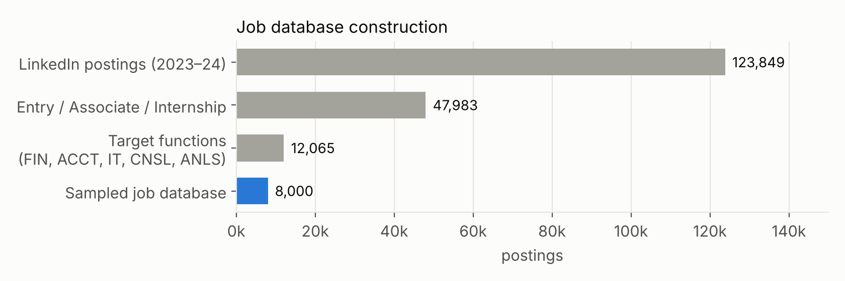
Figure 1. Construction of the 8,000-posting job database.
Descriptions were lightly normalised (whitespace, and re-inserting the sentence breaks LinkedIn often drops, e.g. “transactions.Oversee” → “transactions. Oversee”); an optional skills_desc field is appended. We store title, company, location, level, work type, remote flag, salary and URL for filtering and display.

2.2 Resumes
The Kaggle Resume Dataset contains 2,484 resumes in 24 categories. We use the 586 resumes in the five categories that correspond to our job functions — ACCOUNTANT (118), FINANCE (118), BANKING (115), INFORMATION-TECHNOLOGY (120) and CONSULTANT (115) — for testing and evaluation only; nothing is trained on them. The raw text encodes bullet and section boundaries as runs of spaces, which we convert to line breaks so that each bullet becomes an evidence unit. Two properties matter for interpreting results: most resumes describe experienced professionals rather than students (median parsed experience is well above entry level), and categories are coarse (many CONSULTANT resumes are IT consultants).

2.3 Data preparation is reproducible
scripts/download_data.sh → scripts/prepare_data.py → scripts/build_index.py regenerate everything from the public datasets. The processed database and the pre-built index (~19 MB) are committed so the API and Docker image work without Kaggle access.

3. System design
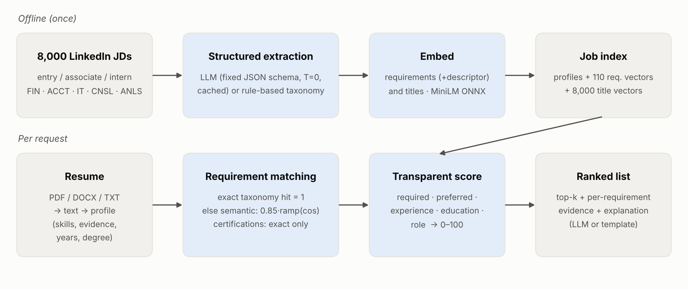
Figure 2. JobFit architecture. JD extraction and embedding run once; per request only the resume is processed and every posting is scored.

3.1 Structured extraction
Both the JD and the resume are mapped onto fixed pydantic schemas (Table 1). The schema is the contract between components: matching, scoring, explanations and the API depend only on it, so the extractor can be swapped without touching the rest.
Object | Fields
Requirement | text (≤12 words) · category (skill / tool / certification / domain / other) · importance (required / preferred) · canonical skill
JD profile | requirements[] · min_years_experience · education_level (none … doctorate) · education_fields[]
Resume profile | skills[] (canonical) · evidence[] (bullets / sentences) · years_experience · education_level · education_fields[]
Table 1. Extraction schema (app/schemas.py).
LLM extractor. The LLM (Gemini 3.5 Flash-Lite through the native Gemini API; any OpenAI-compatible model can be substituted) receives the posting and an instruction to list only qualifications — not duties or benefits — with importance required unless the posting marks it preferred, and to put years and degrees in their own fields. Output is constrained by a response JSON schema, temperature is 0, and every (model, prompt) pair is cached in SQLite, so each JD is extracted exactly once. Free-text skill names are canonicalised onto the taxonomy so exact matching still applies. Any failure falls back to the rule-based extractor.
Rule-based extractor. A 115-skill taxonomy over finance, accounting, banking, IT, data, consulting and soft skills (each with aliases, e.g. SQL ← postgresql, t-sql) is matched on word boundaries. Each JD segment is labelled by section — requirement, preferred, duty, benefit, other — from heading cues (“Requirements”, “Preferred qualifications”, “What you’ll do”, “Benefits”) and inline cues (“… is a plus”). Skills in a requirement list are required; skills only in duties are preferred when an explicit requirement list exists; if that would leave no required skill, duty skills are promoted. Minimum years come from patterns such as “3+ years of … experience”; resume years are the union of employment date ranges with overlaps merged. Degrees and fields are parsed with regular expressions. On the 8,000 postings the extractor finds on average about 9 requirements; 129 postings (1.6%) yield none and receive the prior coverage.

3.2 Semantic matching
For each requirement we look for the strongest resume evidence. Resume evidence units are bullets/sentences (at least 3 words) plus the canonical skills found in the resume. An exact taxonomy hit gives strength 1. Otherwise we take the maximum cosine similarity between the requirement and any evidence unit, using all-MiniLM-L6-v2 sentence embeddings run on ONNX Runtime (no GPU or PyTorch needed), and map it through a linear ramp:
semantic(r) = s_max · clip((max_e cos(r, e) − lo) / (hi − lo), 0, 1), s_max = 0.85
Related evidence is therefore worth at most 85% of direct evidence, and certifications/licences (CPA, CFA, Series 7) are exact-only — a licence is either held or not. Two design details matter:
- Descriptor-augmented requirements. A bare tool name carries little meaning for a sentence encoder: “Power BI” vs “Built interactive Tableau dashboards” has cosine 0.15. Embedding “Power BI (business intelligence dashboards and data visualization)” raises it to 0.55. Every skill is embedded with a short descriptor (hand-written for 33 tools, aliases otherwise).
- Data-driven calibration. lo and hi are set from 2,629 positive pairs (a skill and a resume sentence that mentions it) and 3,000 negative pairs (a skill and a sentence with no skill from the same group): lo = 95th percentile of negatives (0.324), hi = max(75th percentile of positives, lo + 0.2) (0.524).
Embedding model | Bare skill name AUC | With descriptor AUC | Calibrated lo / hi
all-MiniLM-L6-v2 (selected) | 0.920 | 0.947 | 0.324 / 0.524
bge-small-en-v1.5 | 0.855 | 0.900 | 0.631 / 0.831
Table 2. Calibration: probability that a positive pair scores higher than a negative pair (AUC).

3.3 Scoring formula
All constants are in app/config.py; nothing is learned, so every number in the output can be traced back to the formula.
w_i = importance_weight(r_i) × (0.5 if r_i is a soft skill else 1), importance_weight: required 1, preferred 0.5
coverage(S) = ( Σ over i in S of w_i · strength_i + k · p ) ÷ ( Σ over i in S of w_i + k ), k = 2, p = 0.3
experience = min(1, years_resume / years_JD); education = 0.6 · level_fit + 0.4 · field_fit
role = ramp(0.5 · cos(title, resume headline) + 0.5 · mean top-3 cos(title, evidence))
overall = 100 · ( Σ_c W_c · sub_c ) ÷ ( Σ_c W_c ), summing only over sub-scores that are defined
Smoothing (k pseudo-requirements at prior p) prevents a posting with a single matched requirement from scoring 100. Soft skills are down-weighted because nearly every resume claims them. Sub-scores that do not apply (a JD with no stated years) are dropped and the weights renormalised, rather than counted as zero. Over-qualification is not penalised. Education level fit is 1 if the resume meets the minimum degree, 0.5 if one level below; field fit gives partial credit (0.7) within a family (e.g. accounting ↔ finance).
Component | Weight W_c | What it measures
Required coverage | 0.45 | Weighted, smoothed strength of evidence for required qualifications
Preferred coverage | 0.10 | Same, for nice-to-have qualifications
Experience | 0.15 | Resume years vs. the posting’s minimum years
Education | 0.10 | Degree level and field vs. the posting’s minimum
Role alignment | 0.20 | Similarity between the job title and the resume’s headline/evidence
Table 3. Sub-scores and weights.
Each requirement is reported with status matched (strength ≥ 0.75), partial (≥ 0.35) or missing, the method (exact / semantic) and the resume sentence used as evidence (Figure 3).

3.4 Ranking at scale
The per-pair scorer is clear but slow in Python. For ranking, all requirements of all 8,000 postings are laid out in compressed-sparse-row arrays; the requirement texts are deduplicated (110 unique texts with the rule extractor), so one matrix product between the unique requirement embeddings and the resume evidence embeddings gives every requirement’s best similarity, and per-posting coverage is computed with bincount. Ranking all postings takes 146 ms median (p95 246 ms) including resume parsing and embedding; only the top-k are then re-scored in detail for evidence and explanations. Re-posts with the same title and company are de-duplicated in the results. A test asserts that the vectorised and per-pair scores agree for random postings.

3.5 Explanations
The top results receive a short explanation. The primary design uses an LLM whose prompt contains only the structured match output (requirements, status, evidence snippet, sub-scores) — not the raw resume or JD — so it can only talk about requirements that were actually matched or missed. The deterministic fallback composes the same information with a template: band and score, how many required qualifications are covered (naming the strongest), related-but-not-exact evidence with a quoted snippet, missing requirements, and the experience comparison. The template is free, consistent and is what the Docker image uses by default when no API key is configured.
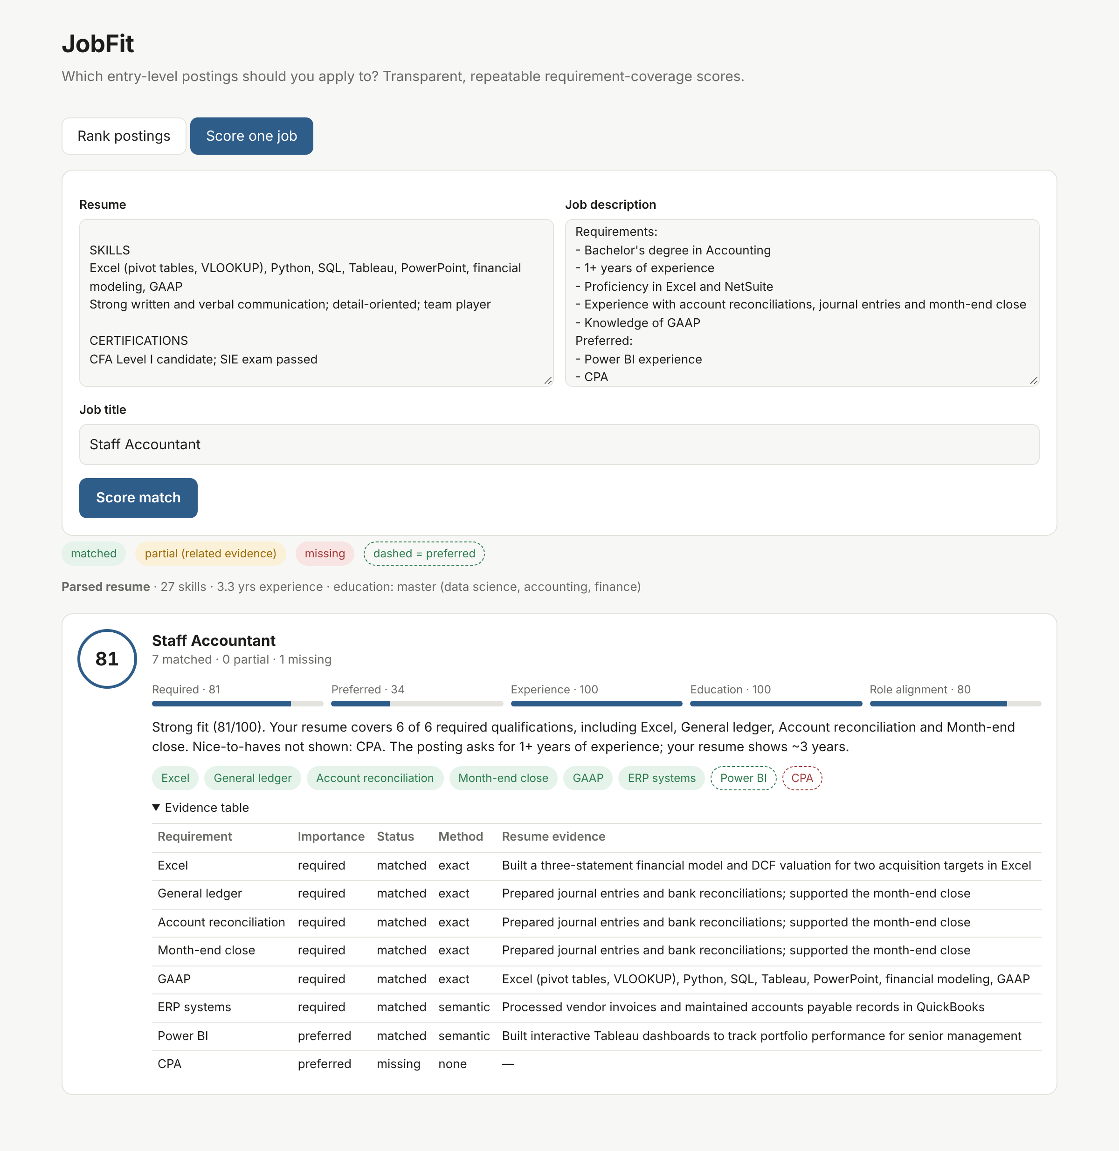
Figure 3. Web demo, single-posting mode: score, sub-score bars, explanation, colour-coded requirements and the evidence table. “Power BI” is supported semantically by the Tableau bullet; CPA is a certification and therefore exact-only.

3.6 API and deployment
The pipeline is served by FastAPI (extending the Module 3 service). Interactive documentation is generated at /docs.
Endpoint | Purpose
GET /health | Service status, index manifest, active extractor / LLM / embedding model
POST /rank | Rank all postings for a resume; filters: level, function, remote, location; top_k; number of explanations
POST /rank/upload | Same, with a PDF / DOCX / TXT upload (5 MB limit; 415 for unsupported types)
POST /match | One resume vs one pasted JD; returns match, JD profile and resume profile
POST /jobs/{id}/match | Score a resume against a stored posting
GET /jobs/{id} | Posting metadata, extracted profile and description
POST /extract/jd, /extract/resume | Structured extraction only
Table 4. API endpoints.
The Docker image (Python 3.12-slim, ~316 MB compressed) installs pinned dependencies, downloads the embedding model at build time and copies the pre-built index, so the container starts and runs offline as a non-root user with a health check. docker compose up --build serves the API and demo on port 8000; setting GEMINI_API_KEY enables the LLM extractor/explainer, with the LLM cache on a volume. The test suite (26 tests) covers parsing, extraction, the formula, batch/pair agreement, determinism and every endpoint.

4. Evaluation

4.1 Set-up and weak labels
There is no public ground truth of resume–posting fit, so we use weak labels: a posting is relevant to a resume if its LinkedIn function tags match the resume’s category (ACCOUNTANT → ACCT = 2, FIN = 1; FINANCE → FIN = 2, ACCT/ANLS = 1; BANKING → FIN = 2; INFORMATION-TECHNOLOGY → IT = 2; CONSULTANT → CNSL = 2, ANLS/IT = 1). For each of the 586 resumes every one of the 8,000 postings is scored, and we report nDCG@10 (graded), P@10 (any relevance), strict P@10 (grade 2) and MRR of the first grade-2 posting, with 95% confidence intervals over resumes. 48% of resume–posting pairs are relevant (29% strictly).
What the weak labels measure. They reward topical/category alignment. They do not know whether a candidate meets a specific posting’s requirements, so a method that only measures topic similarity is not disadvantaged, and a method that measures coverage is not rewarded for being right about requirements. We therefore complement them with targeted tests of the matcher (§4.4–4.6).

4.2 Ranking quality
Method | nDCG@10 | P@10 | Strict P@10 | MRR
Random | 0.343 ± 0.014 | 0.467 | 0.282 | 0.467
TF-IDF (keyword) | 0.695 ± 0.025 | 0.832 | 0.632 | 0.707
Embedding doc-cosine | 0.742 ± 0.022 | 0.854 | 0.687 | 0.792
Skill Jaccard (exact) | 0.673 ± 0.025 | 0.791 | 0.612 | 0.706
Coverage only (required+preferred) | 0.635 ± 0.024 | 0.766 | 0.561 | 0.705
JobFit (full) | 0.701 ± 0.023 | 0.820 | 0.642 | 0.730
Hybrid: JobFit + doc-cosine (z-avg) | 0.739 ± 0.022 | 0.852 | 0.684 | 0.773
Table 5. Ranking over all 8,000 postings for 586 resumes (weak labels).
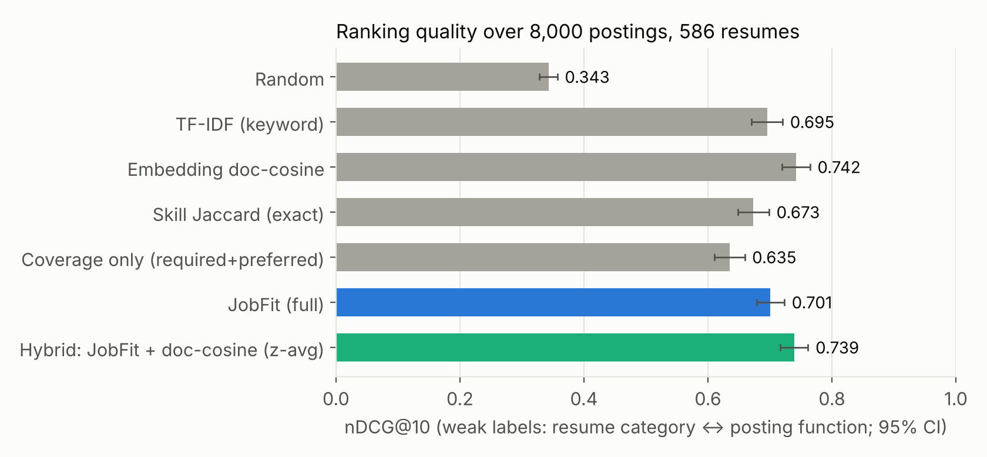
Figure 4. nDCG@10 with 95% confidence intervals.
JobFit (0.701) improves clearly on its closest structured baseline, exact skill overlap (0.673), and on the proposal’s coverage-only formula (0.635); it is on par with TF-IDF (0.695, within the confidence interval). It is below whole-document embedding similarity (0.742). We report this plainly: a dense document embedding is an excellent topic retriever and the weak labels are topic labels. Combining the two (average of per-resume z-scores) recovers 0.739, indistinguishable from doc-cosine, while keeping JobFit’s per-requirement evidence. The doc-cosine score, however, has no notion of requirements: it cannot say which qualifications are missing, does not change when a required skill is removed from a resume that stays on-topic, and its absolute value is not interpretable. In a deployed system we would use document similarity as a first-stage retrieval prior and JobFit’s coverage score for ordering and explanation (§6).

4.3 Ablations
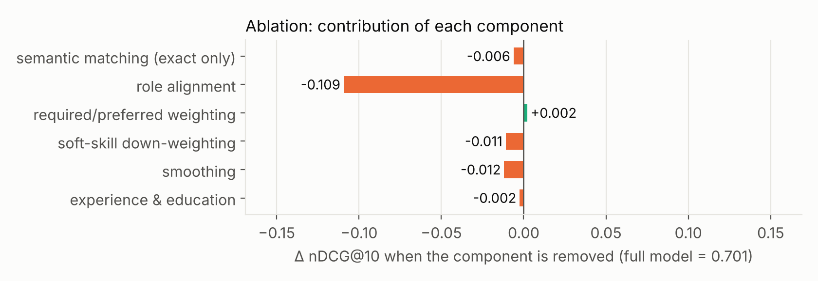
Figure 5. Change in nDCG@10 when one component is removed (negative = the component helps).
Role alignment is by far the most important component on these labels (-0.109 when removed), which is consistent with the labels being about job family. Smoothing (-0.012) and soft-skill down-weighting (-0.011) each help by about one point: without smoothing, postings with very few extracted requirements are over-ranked. Semantic matching adds a small amount (-0.006); its main value is in paraphrase recall (§4.4) rather than category ranking. Experience and education (-0.002) and required/preferred weighting (+0.002) have no measurable effect here — expected, since these resumes are mostly experienced (experience is saturated) and weak labels say nothing about whether a specific requirement is mandatory. We kept them because they matter for the real use case (students with 0–2 years of experience) and for explanations, but we flag them as unvalidated by this evaluation.

4.4 Paraphrase benchmark for requirement matching
We wrote 42 test cases, each a requirement, a resume bullet that evidences it without necessarily using the same words (e.g. Account reconciliation ↔ “Matched bank statements to internal records every month and resolved discrepancies”), and a hard negative with similar wording (“Greeted visitors and managed the reception area”). A requirement counts as matched if its strength reaches the partial threshold.
Matcher | Recall (positives) | False-positive rate (negatives) | Pairwise accuracy
Keyword / taxonomy only | 38% | 0% | —
MiniLM, bare skill name | 67% | 0% | 95%
MiniLM + descriptor (JobFit) | 69% | 0% | 100%
bge-small + descriptor | 86% | 0% | 100%
Table 6. Requirement matching on paraphrased evidence (keyword ∪ semantic). Pairwise accuracy: positive scores higher than its negative.
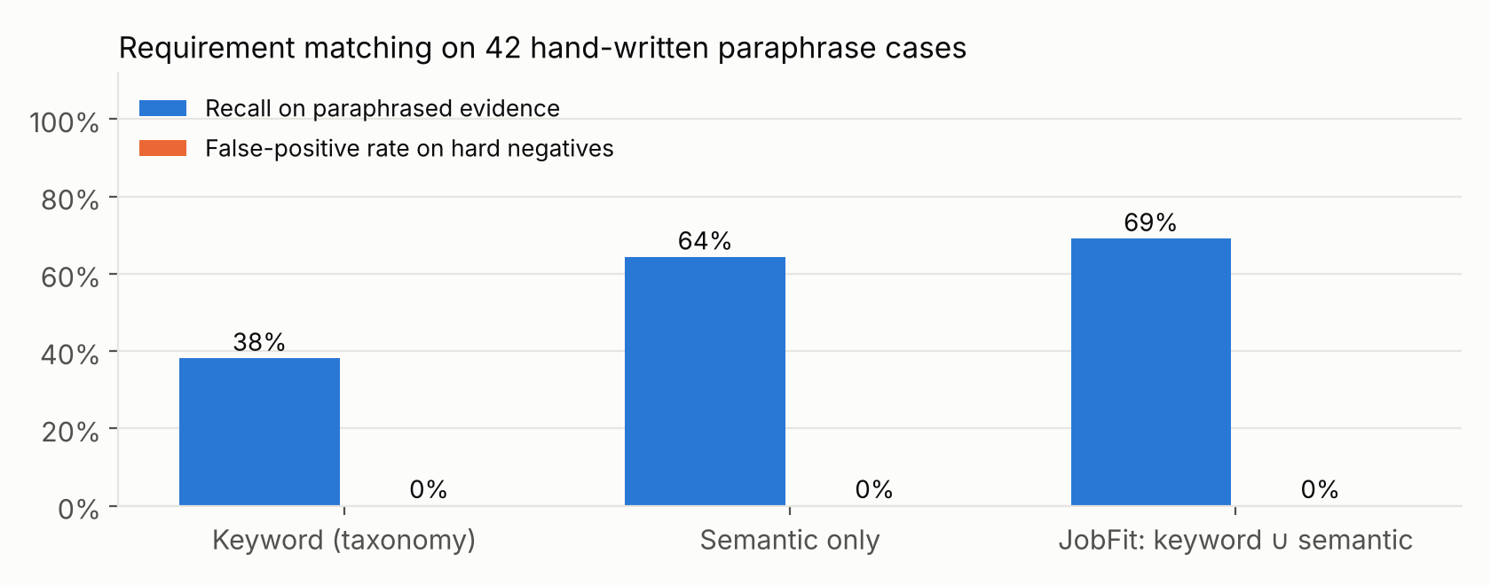
Figure 6. Keyword matching vs semantic matching vs JobFit’s combination (MiniLM + descriptor).
Keywords find 38% of the evidence; JobFit finds 69% with no false positives, and always ranks the true evidence above the hard negative. Descriptors are responsible for a large part of the gain. bge-small finds more paraphrases (86%) on this small benchmark but separates the larger calibration set less well (AUC 0.900 vs 0.947); with 42 cases the difference is suggestive, and switching models is a one-line configuration change (JOBFIT_EMBED_MODEL plus re-calibration).

4.5 Counterfactual behaviour tests
A transparent score should move in the right direction when the resume changes. For 150 random resumes we took each one’s top posting and (a) deleted every resume line that evidences one exactly-matched required skill, and (b) appended one line naming a required skill that was missing.
Edit | Cases | Mean score change | Score moved as expected
Remove evidence for a matched required skill | 98 | -6.7 | 100%
Add evidence for a missing required skill | 17 | +3.3 | 100%
Table 7. Counterfactual edits (fewer ‘add’ cases because top postings rarely had a missing required skill).

4.6 Repeatability and latency
Ranking the same resume three times produced identical rankings and scores for 100% of 30 resumes — by construction, since extraction is deterministic (rule-based, or LLM at temperature 0 with caching) and the formula has no randomness. A request that scores all 8,000 postings takes 156 ms on average (p50 146 ms, p95 246 ms) on a 4-core CPU, including parsing and embedding the resume.

4.7 Comparison with the plain-LLM approach
eval/llm_baseline.py measures the “paste resume + JD into a chatbot” approach on the same pairs: for each of 30 resume–posting pairs (a mix of top, mid and random postings) it asks the LLM for a 0–100 fit score five times at default sampling temperature, and reports the run-to-run standard deviation and range, the share of pairs whose score changed, latency per pair, the extrapolated time to rank all 8,000 postings, and the Spearman correlation with JobFit’s score.
Measure (30 pairs × 5 runs) | Plain LLM (gemini-3.5-flash-lite, T = 1) | JobFit
Pairs whose score changed between runs | 67% | 0%
Mean run-to-run std. dev. / range (points) | 3.6 / 8.5 | 0 / 0
Time to score one resume against 8,000 postings | ~11 h (5.0 s per call*) | 178 ms
Rank agreement with JobFit (Spearman) | 0.83 | —
Table 8. Plain-LLM baseline vs JobFit on the same pairs. *Measured under the Gemini free tier (15 requests/min), so per-call time includes rate-limit waiting; even at 1 s per call, 8,000 calls take over 2 hours.
The plain LLM changed its score in 67% of pairs across five identical requests (mean range 8.5 points, e.g. 35 → 45 for one Financial Analyst posting), whereas JobFit is exactly repeatable. The two rankings agree strongly (Spearman 0.83), which suggests that JobFit captures much of what the LLM judges — at a tiny fraction of the cost and with evidence. The comparison also exposed a weakness: for clearly off-target postings (e.g. a service-technician or meeting-planner role for a finance resume) the LLM answers 0 while JobFit still gives 50–70, because role alignment and generic soft-skill matches keep a floor under the score. JobFit’s scores are reliable for ordering but their absolute scale is compressed; calibrating them (e.g. against LLM or human judgements) is future work, and the demo labels results by rank rather than promising an absolute meaning.

4.8 LLM extraction and explanations
We ran the Gemini extractor on a stratified sample of 200 postings (40 per primary function; 200/200 succeeded) and compared it with the rule-based extractor.
 | Rule-based | LLM (gemini-3.5-flash-lite)
Requirements per posting | 9.2 | 8.1
Share marked required | 68% | 74%
Minimum years found | 49% | 62%
Minimum degree found | 53% | 76%
Requirements mapped to a taxonomy skill | 100% | 22%
nDCG@10 within the sample (586 resumes) | 0.657 ± 0.019 | 0.647 ± 0.021
MRR within the sample | 0.769 | 0.811
Table 9. Rule-based vs LLM extraction on 200 postings.
The two extractors capture quite different things: only 39% of rule-extracted requirements have a close counterpart in the LLM output and 42% vice versa. The rule extractor flags every taxonomy skill mentioned anywhere (including duties such as “insurance” or “lending” in an accountant posting); the LLM lists the stated qualifications as short phrases (“Understanding of journal entries, debits, and credits”, “Proficiency in QuickBooks”) and finds years and degrees far more often (62% vs 49%, 76% vs 53%). On the weak labels the two give statistically indistinguishable ranking quality (nDCG@10 0.657 vs 0.647, overlapping intervals; the LLM has higher MRR). We read this as: LLM extraction produces requirements that are more faithful to the posting and more useful in explanations, but category-level labels cannot reward that. Extracting all 8,000 postings was not possible within the free-tier quota (~9 h at 15 requests/min), so the shipped index uses the rule-based extractor and scripts/build_index.py --extractor llm builds the LLM index when a paid key is available.
Explanation faithfulness. For 12 LLM explanations we checked automatically whether every taxonomy skill mentioned in the explanation appears in the structured input it was given. 58% pass this strict lexical check. In the two flagged cases we inspected, the failure came from the check rather than from invention: one paraphrased evidence (calling Oracle Financials “accounting software”) and one repeated a requirement whose original wording was misspelled in the posting (“project managements”). The other three flagged cases were not saved, so we cannot rule out unsupported content there; a manual audit of a larger sample is needed before relying on LLM explanations, which is why the deterministic template remains the default.

5. Value added over off-the-shelf LLMs
 | Plain LLM chat | JobFit
Scale | One posting per call (~11 h for 8,000 on the free tier) | All 8,000 postings per request (~0.15 s), with filters
Repeatability | Score changed in 67% of pairs across 5 runs | Identical output for identical input (tested)
Transparency | Opaque number + prose | Per-requirement status, method and quoted resume evidence; explicit formula
Faithfulness of explanation | Can mention anything | Generated only from the structured match output
Cost / availability | One LLM call per pair | JD extraction cached once; ranking needs no LLM; fully offline mode
Evaluation | None | Baselines, ablations, paraphrase, counterfactual and stability tests
Table 10. What JobFit adds.

6. Limitations and ethical considerations
- Weak labels. Category labels measure topic, not fit; resumes in the Kaggle dataset are mostly experienced, not students. A small human-annotated set of resume–posting pairs (e.g. 3 annotators × 200 pairs, graded 0–3) would be the most valuable next evaluation and would let us fit the weights instead of setting them by hand.
- Extraction coverage. The rule-based extractor only knows its 115-skill taxonomy and section heuristics; requirements outside it (e.g. “experience with German credit regulations”) are invisible. The LLM extractor addresses this, at the cost of an API key, and its quality should be audited on a labelled sample of JDs.
- Ranking vs document similarity. On topic labels, document embeddings rank slightly better. A two-stage design — document-similarity retrieval of a few hundred candidates, then JobFit scoring — is a straightforward improvement.
- Compressed score scale. Off-target postings still score 50–70 (role alignment and generic soft skills set a floor), while an LLM scores them near 0; scores should be read as a ranking, and calibrating the absolute scale is future work.
- Experience parsing relies on date ranges and may miscount gaps, part-time roles or non-standard formats; over-qualification is not penalised.
- Fairness. The score uses only skills, experience and education; names, addresses and demographic proxies are ignored by the formula, but evidence text and embeddings can still carry bias (e.g. wording style). The score should help candidates prioritise, not be used by employers to screen people.
- Privacy. Uploaded resumes are processed in memory and not stored; with the LLM enabled, resume text is sent to the LLM provider, which users should be told about.

7. Conclusion and future work
JobFit turns a one-off chatbot interaction into a repeatable, explainable ranking service: structured extraction once per posting, calibrated semantic evidence matching, and an explicit scoring formula that ranks thousands of postings in a fraction of a second and shows exactly why each posting scored as it did. Our evaluation shows it clearly beats exact keyword-overlap scoring and recovers most paraphrased evidence without false positives, while being honest that topic-level document similarity remains a strong ranking signal on weak labels.
Next steps: (1) a human-labelled fit set to validate and fit the weights; (2) two-stage retrieval with document similarity; (3) LLM-extracted index and the measured plain-LLM comparison; (4) resume-improvement suggestions generated from the missing requirements of the top postings; (5) refreshing the job database from live postings.

Appendix A. Reproducing the results
Step | Command
Run the API | docker compose up --build (then open http://localhost:8000)
Download data | bash scripts/download_data.sh
Prepare data | python scripts/prepare_data.py
Build index | python scripts/build_index.py [--extractor llm]
Calibrate | python scripts/calibrate.py
Evaluate | python eval/evaluate.py && python eval/make_figures.py
Plain-LLM baseline | GEMINI_API_KEY=… LLM_RPM=14 python eval/llm_baseline.py
LLM extraction study | GEMINI_API_KEY=… LLM_RPM=14 python eval/llm_extraction.py
Tests | pytest -q
Table 11. Commands (see README.md).
Data sources. Kaggle Resume Dataset (snehaanbhawal/resume-dataset); Kaggle LinkedIn Job Postings 2023–2024 (arshkon/linkedin-job-postings). Models. sentence-transformers/all-MiniLM-L6-v2 (ONNX, via fastembed); optional Gemini 3.5 Flash-Lite through the OpenAI-compatible endpoint.

