**Fill-in-the-blank**

1 - 3

The function in Question 1

*Public void setElectric(boolean isElectric) {*

*This.electric = isElectric;*

*return this.electric;*

*}*

Is invalid. Because the function return type is void. But the function has a return statement. Second, I am not sure what “The general type of method” means in Question 2. I assume it is function return type. In return value void case, the answer of question 2 is void and the answer of question 3 is @Param and no second @. In boolean return case, the answer of question 2 is boolean and the answer of question 3 is @Param and @return

4. The Java complier takes high-level source code and converts it into **bytecode**.

5. By default, the literal 99.9, in Java, would be considered a value of the data type of float.

6. A conventional package name be for a Java package that is distributed by the website <http://applets.nyu.edu>, would be **edu.nyu.applets**.

7. Fill in the blanks to set up the code to receive a line of input from the user’s keyboard:

Scanner inp = new Scanner(System.in);

String veggie = inp.nextLine();

8. Using Boolean operator always results in an expression that evaluates to the boolean data type.

9. The code, x % 2, where x is an even integer evaluates to 0.

10. Two-dimensional array are a useful data structure for storing and manipulating grid-like tabular data in code.

11. An object is an instance of a class

12. The “new” operator in Java is used to create object.

13. Dot-notation (using the period “.” In code) is used to indicate field or property (choose the word professor mostly used in class)

14. Fill in ….. Answer: extends and super()

15 The “static” keyword is used to indicate that a method or data field is a class method or field not an instance method or field.

16. Three of the core concepts of object oriented programming are: inheritance, abstraction and polymorphism.

17. Implementing an interface means that a class must have the methods contained within the interface definition.

18. A method that contains code that may trigger an exception must either throws or catch it to handle the exception, or pass the exception down the call stack, respectively.

19. A method that is recursive must contain a call to itself.

20. The Integer, Character, and BigDecimal classes are known as Wrapper classes, because ……

**Multiple choice**

1 Integers have a higher bit depth than longs in Java

b. False

2. String is a primitive data type in Java.

b. False – Java has only 8 prime types: byte, short, int, long, float, double, char, and boolean.

3. To reliably compare the value of two strings, one should use:

b. string1.equals(string2)

4. The correct answer to the previous question is better because…

c. String with identical values can sometimes be stored in different parts of memory.

5. Which of the following data would not be appropriate to store as a static variable?

a. The value of pi, 3.14159

b. The two gender values of a class Mammal, which allows only one of two genders for any object instantiated from it (if more than one choice is allowed, this is the second one)

c. The name property of an object of a class Human, which allows any name to be assigned to an object instantiated from it

d. “All of the above”

e. “None of the above”

6. The break keyword can be used to escape out of … (select all that apply):

a. for loops

b. while loops

c. if/else statements

d. switch statements

e. “None of the above”

7. Two sets of random numbers generated from the same starting seed will be identical.

a. True.

8. Arrays can store any data type, including your own custom data types.

a. True

9. An ArrayList that is initialized with 15 … can have a 16th element added to it

a. True

10. Each element in a two-dimensional array must have the same number of sub-elements

b. False

11. A try/catch block can handle more than one types of exception.

a. True

12 – 14

Same questions in Sample1.

15. Taken from a large class definition, we can say for sure that the method accepts as its parameter (select all that apply)

Public static void whoopDeeDoo(DooWop whoopDee) {

whoopDee.doo();

}

1. A DooWop object, passed by value
2. A DooWop object, passed by reference
3. A static DooWop object
4. A static DooWop class
5. -None of the above

16 – 17

Same questions in Sample1.

18. The Swing GUI toolkit provides (select all that apply)

Don’t know answer

19. An ActionListener in Swing (select all that apply)

a. is a class.

b. can be used to handle button click events.

c. is an interface that can be implemented by a class

d. can be inherited by a class

20. A method that throws a FileNotFoundException must, as a requirement of the language, contain code to try/catch a FileNotFoundException

b. False

Note: it is not the method itself, but the method which calls the method throwing FileNotFoundException must have try/catch

**Short Answers**

1 Draw …..

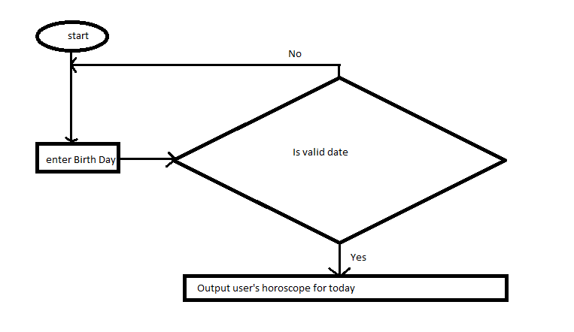

2. Imagine your coding a Saxophone class ….

See SaxophoneApp class in edu.nyu.cs.finale.saxophone package in final-exam-solution project.

3. Imagine you are coding …..

See OverloadedApp class in edu.nyu.cs.finale.saxophone package in final-exam-solution project.

**Overload is different from Override. Overload constructors means there are more than one constructors in the same class with different parameters. Override means a class and its parent class both have a constructor with the same parameters. We say the class constructor override its parent constructor.**

**It is same for method. Overload method means a class has several methods all have the same name but with different parameters. Override method means a class and its parent class both have a method with same method name and method parameters. We say the class method override its parent class’s method. *However, method return type does not apply. A class cannot have two methods with the same name and parameters but different return types. The same for a class override its parent method – a class cannot have a method which name and parameters are the same as those of one method of its parent, but those two functions have different return type. See OverloadError and OverrideError classes in edu.nyu.cs.finale.overrideAndOverload package in final-exam-problem project.***

4. Explain the benefit of abstraction in software development.

**Abstraction is one of the 3 pillars of Object Oriented Programming(OOP). It literally means to perceive an entity in a system or context from a particular perspective. We take out unnecessary details and only focus on aspects that are necessary to that context or system under consideration, which simplifies the software development.**