Create ml-final folder in c:

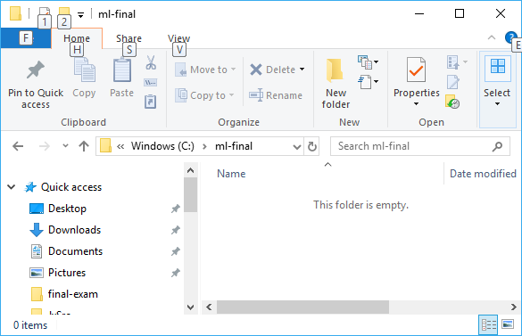

Copy downloaded mdl-final.zip to the above folder, file size 723kb

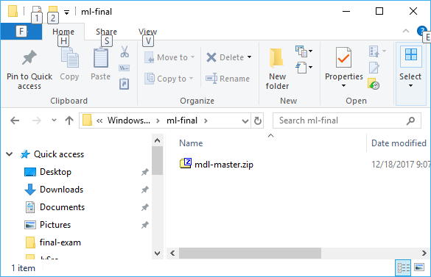

Click zip file and extract to the same folder

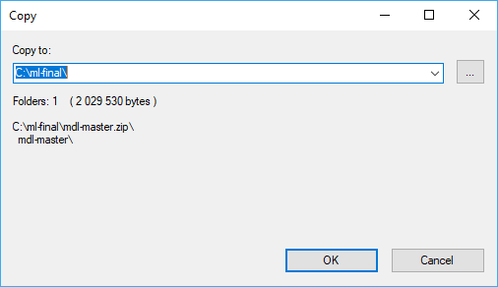

After extraction, you will see mdl-master folder

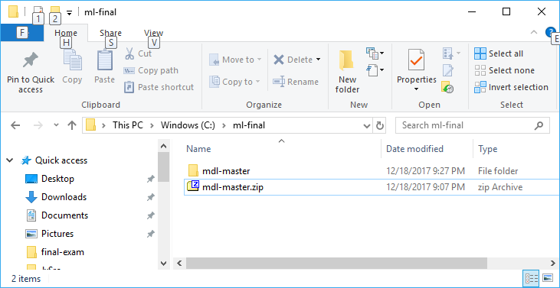

Open eclipse and select c:\ml-final\mdl-master

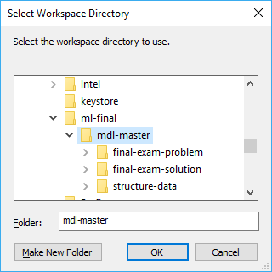

In eclipse, select File > import, then Maven, Existing Maven Projects

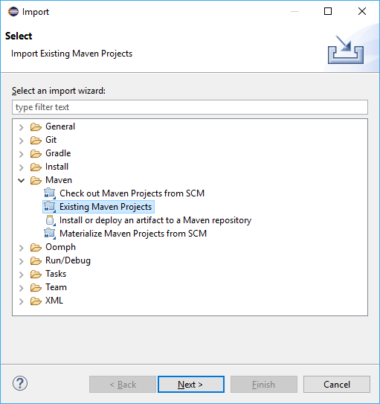

In Import Maven Projects, click Browser

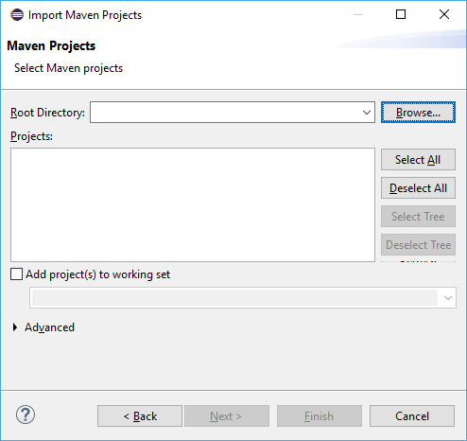

select c:\ml-final\mdl-master, then ok

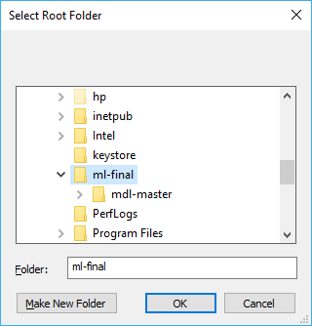

You should see window as below. Click finish

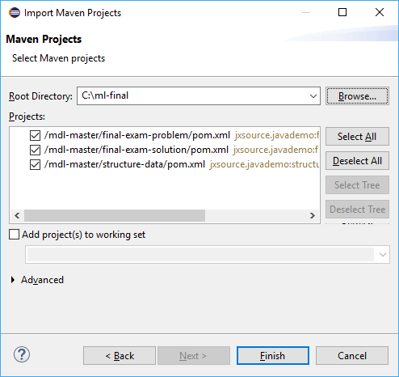

Then you should see three projects, final-exam-problem has error, but the other two should not

